Navigating Data Exchange Reports - User Guide
The reports have a number of functions which can change how the reports look. This can be useful when building a story or to help make analysing data easier. These changes can be applied to any visualisation in Qlik including graphs, charts and tables.
This task card discusses various features which enable you to view, drill into and customise Qlik reports using:
- Filters
- Selections
- Exploration Menu and
- Bookmarks

Navigation guide
Table 1 – Filter applied area navigation items
ITEM | DESCRIPTION
 | Select the step back function to undo the last selection.
 | Select the step forward function to redo a selection.
 | Select the clear selections function to clear all the filters selected.
 | Select the confirm button to confirm your filter selection.
 | Select the clear button to clear your filter selection.
 | Select the exploration button to expand the exploration menu.
 | Select the selections button to open the selections menu screen.
 | Select the bookmark icon to open the bookmarks screen.

Filters
The Data Exchange reports will allow you to filter data by selecting items from the available objects on the report sheet.
Filters can be applied to the following areas:
- Reporting Periods
- Activity
- Delivery Organisation
- Outlets
- Visualisations such as graphs and pie charts
- Maps
The default is for no filters to be applied and is shown as No selections applied.
Figure 1 – Filter applied area displaying no selections applied
To see what filters you have applied to a report: refer to the filters applied area which is the ribbon located at the top left of the screen.
Figure 2 – Filter applied area
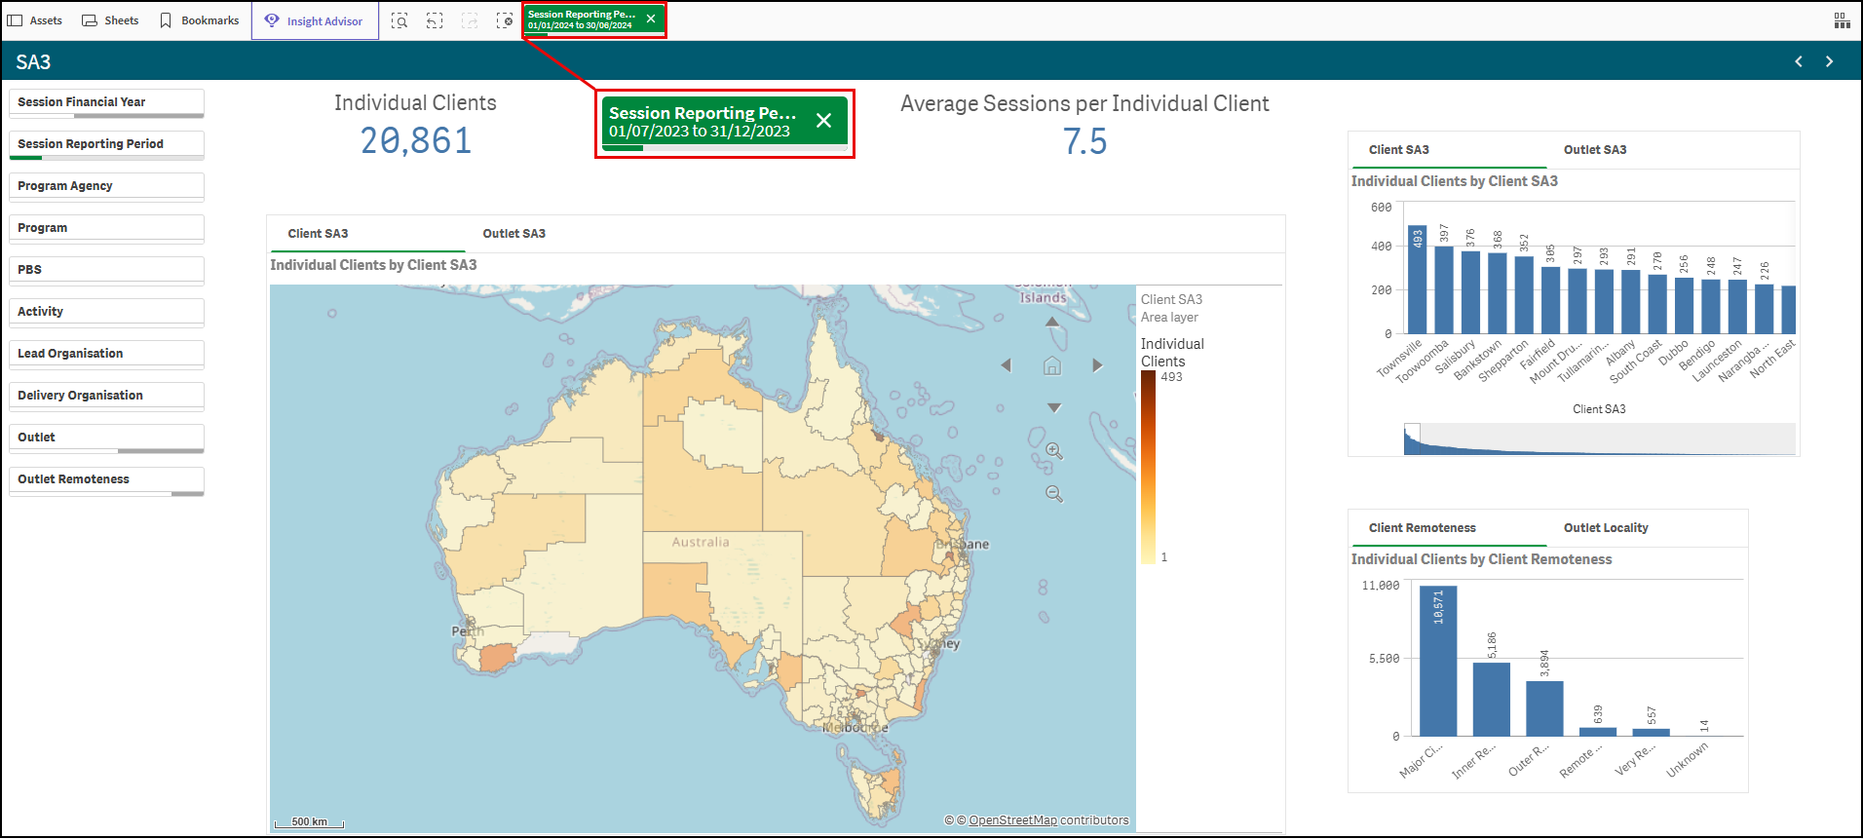

Select the item that you wish to display:
Figure 3 –Confirm and Clear filter icons
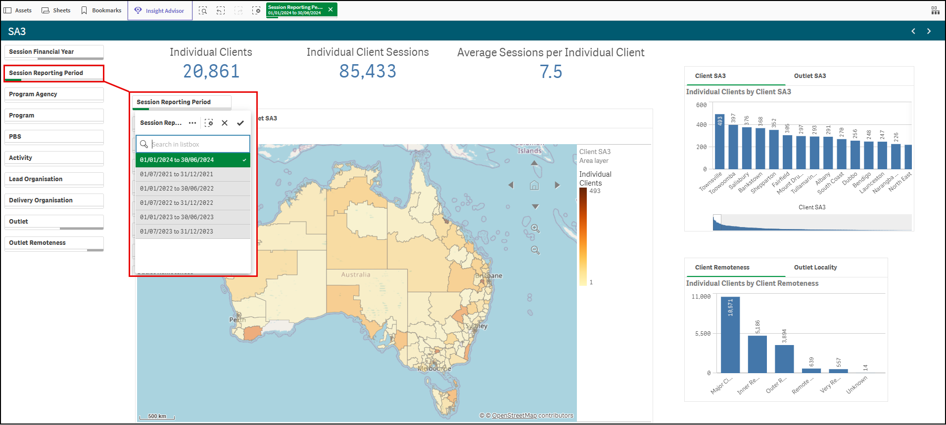
Select confirm to confirm this filter.
Select clear to clear your selection.
The sheet will automatically update and display the filtered items.
To change the filter selection:
- Click on the previously chosen selection and the item will change from green to grey.
- Click on the new selection (if required).
- Select confirm to confirm.
The sheet will update to reflect your selections.
Figure 4 – SA3 sheet highlighting the selection of one reporting period
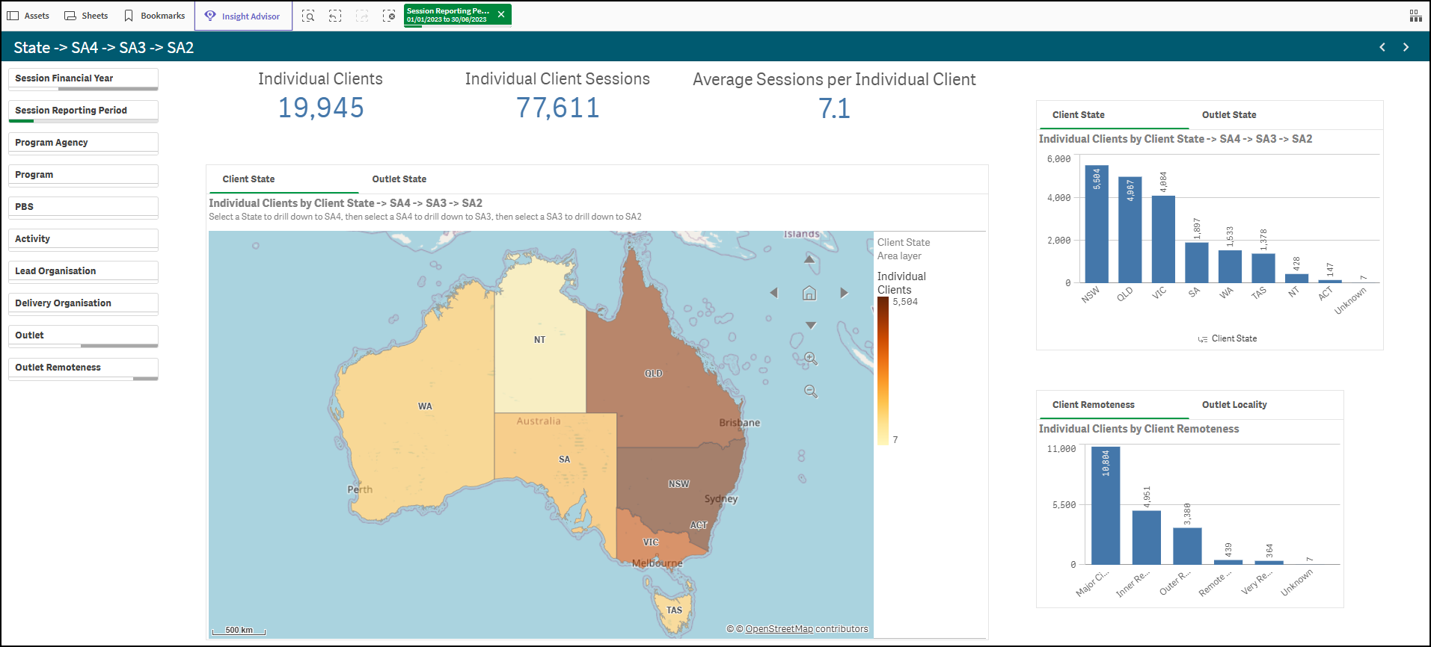
Select clear next to the filter you wish to remove.
Figure 5 – Clear filter button
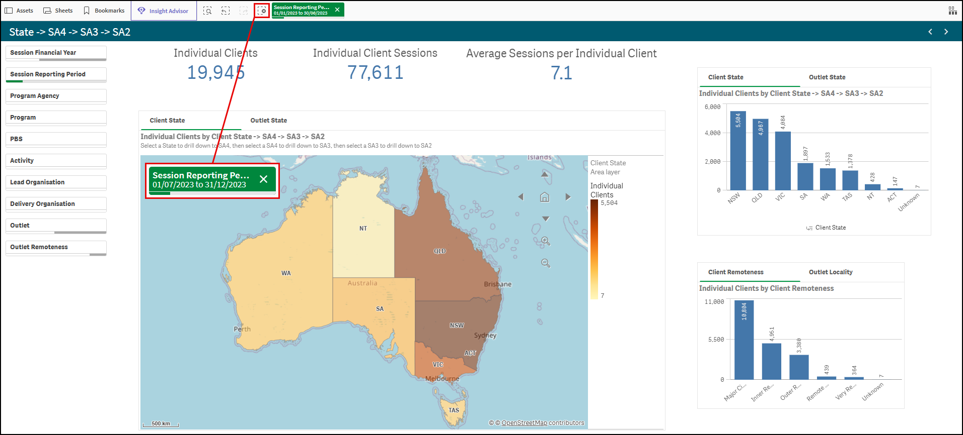
Figure 6 shows one reporting period selected (highlighted in green) even though six reporting periods can be selected.
This filter is then applied for this sheet and the remainder of the sheets. This filter remains in the Filter ribbon at the top of the screen.
Figure 6 – Filter displaying reporting periods
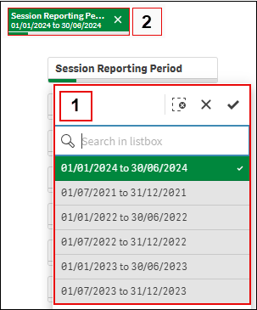
Each time you add a filter this will be added to the Filter ribbon at the top of the screen.
For example, in this image (Figure 7) three filters have been applied. The report will show the results for:

Figure 7 – Multiple filters displayed in the Filter applied area
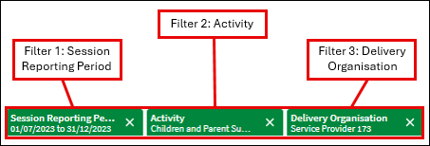
Graph and pie chart visualisations can be further filtered.
Go to the relevant sheet and select the required item to filter. Figure 10 highlights the Individual Client by Age Group filter selection of 40 to 44.
Figure 10 – Visualisation filter applied
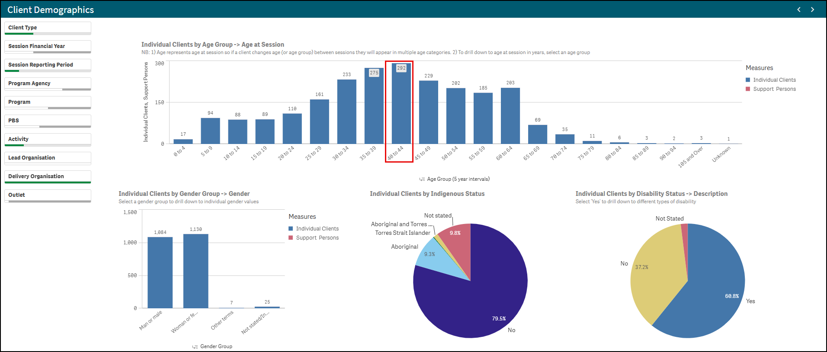
The data on the sheet will reflect the filter selected.
Figure 11 – Data reflects the filter selected
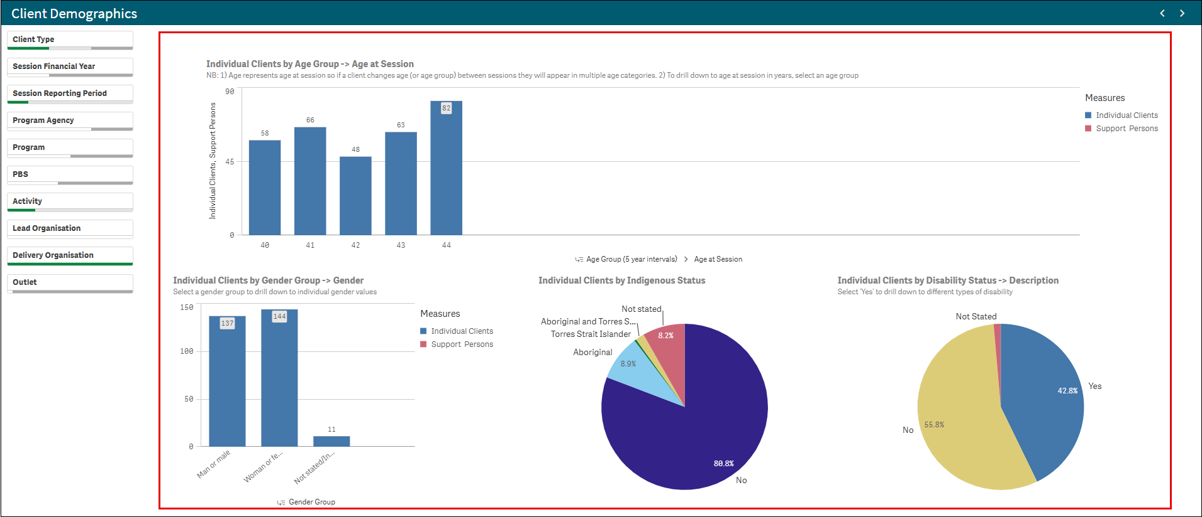

Selections
Qlik reports have been designed to initially display a standard set of data fields. At times, you may wish to add different data to your report. These additional filters are available from the Selections tool.
To open the additional filters, click the selections button in the top right of the sheet panel.
Figure 12 – Selections tool at top right of screen of chosen report sheet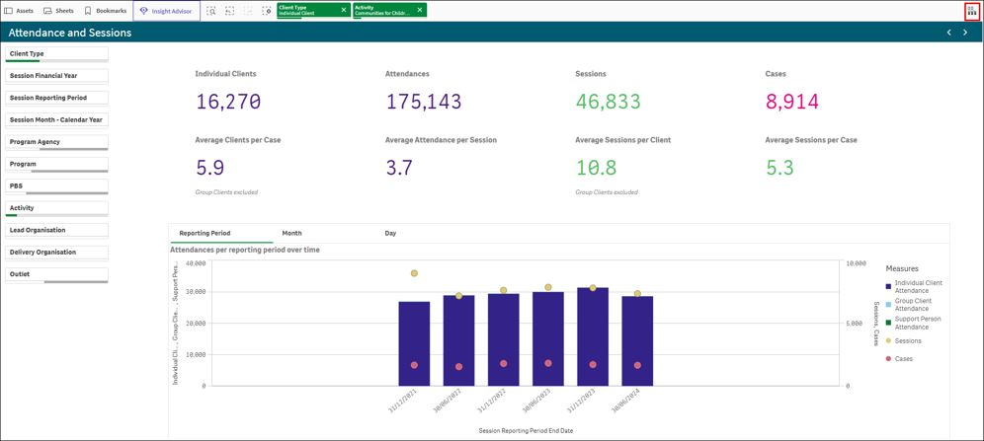
The selections screen will appear. In the top half of the screen, any filters that have already been applied will appear. Additional filters will be displayed in the bottom half of the screen.
The initial dimensions displayed are those that are available on the main sheet display. To display all of the dimensions available in the report, select the Show Fields tick box.

Figure 13 – Selections screen showing applied filters
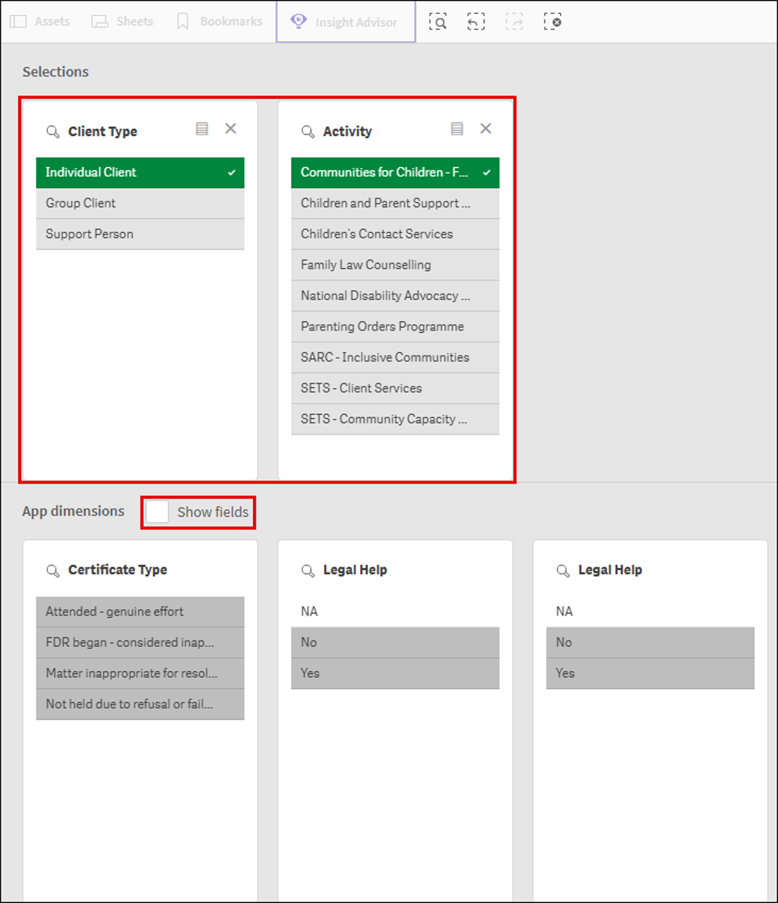
Once the show fields option is selected (1), all App dimensions available will be displayed. You can type in a word to search by in the Search dimensions and field box (2) to narrow the options down or use the Slide bar (3) at the bottom of the screen to move through the options.
Figure 14 – Selections screen displaying available dimensions and search field box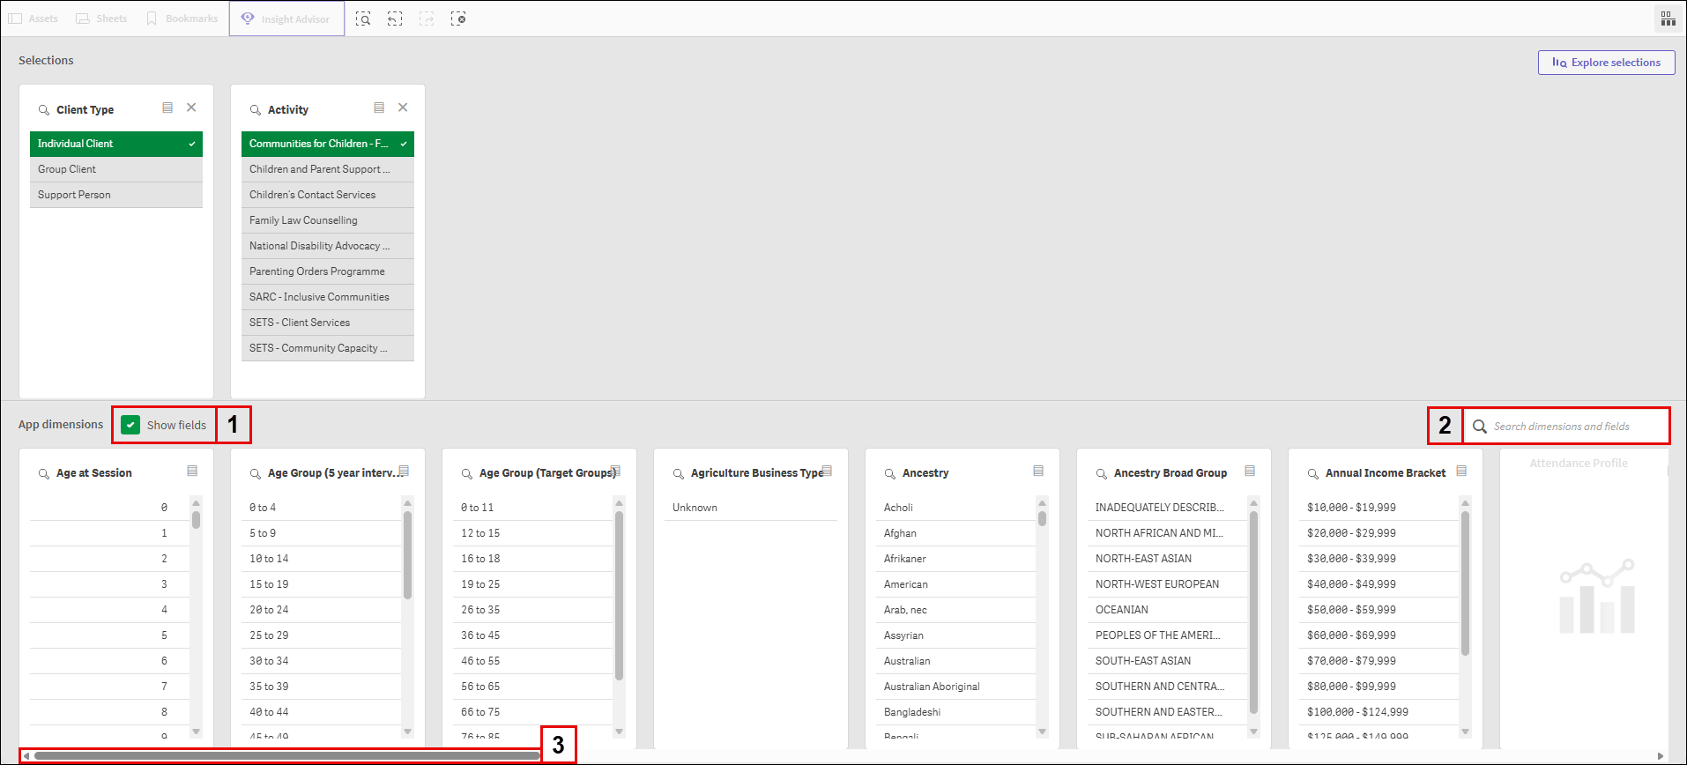
To select the dimension that you wish to filter the sheets with, select one of the data points in the dimension you wish to use.
This will move the dimension to the Selections area of the screen. In this example selections from Age Group and Ancestry dimensions have been selected.
Figure 15 – Selections screen displaying selections made 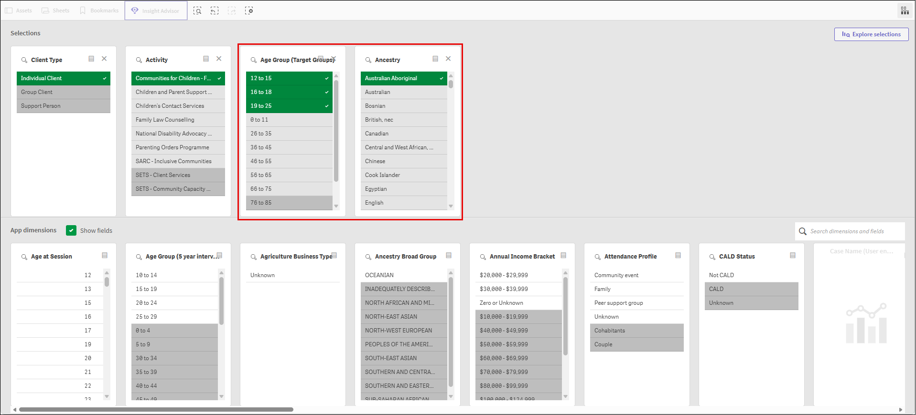
To return to the report, click the Selections button again.
The data will now include the dimension selections as filters at the top of the screen. You can select these filters and add or remove filters for this field as needed.
Figure 16 – chosen report sheet displaying data with filters and selections applied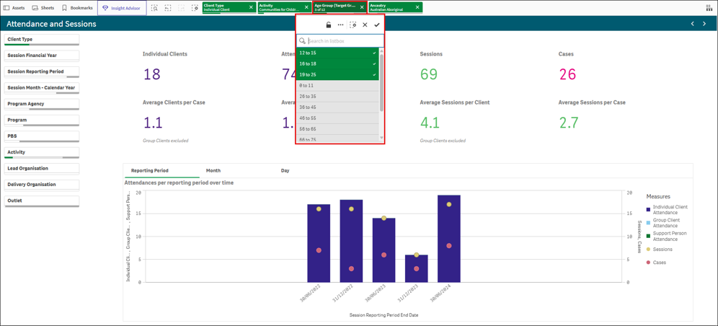

Exploration Menu
The appearance of a visualisation can be edited to improve design and enhance understanding.
To open the Exploration Menu on a chart, right-click the chart and select the exploration  icon.
Figure 17 – Exploration Menu icon on a chart
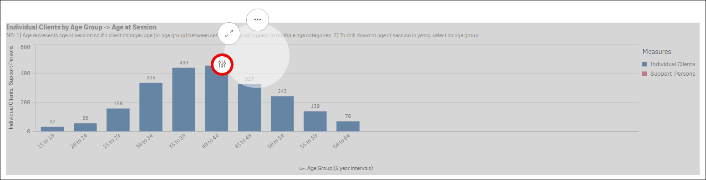
To open the Exploration Menu on a container, right-click the container and select Combo chart (Figure 18). Then select Exploration menu (Figure 19)
Figure 18 – Combo chart highlighted 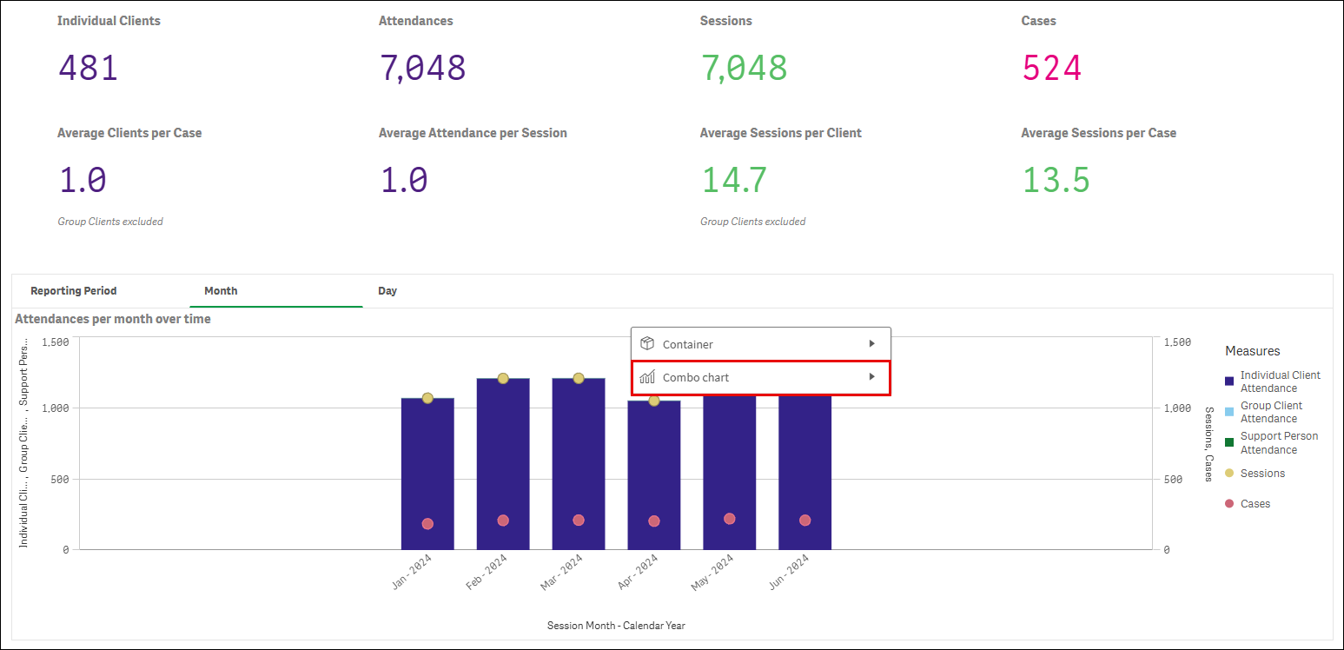

Figure 19 – Exploration menu highlighted
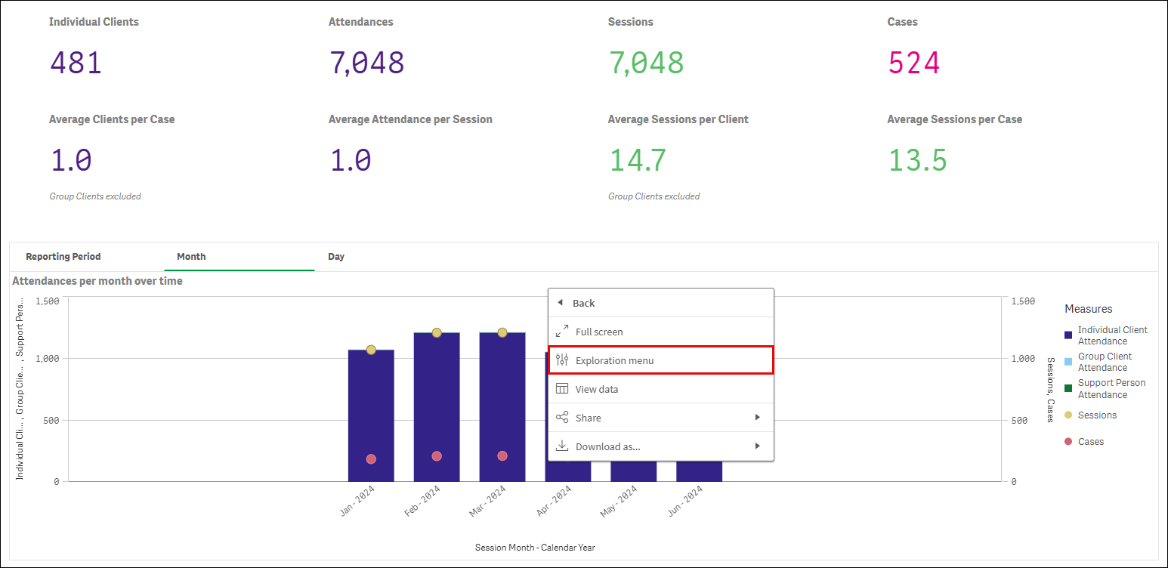
The visualisation will expand, and a menu will appear on the right side of the screen. At the top, the data fields that relate to this visualisation will be listed. At the bottom of the menu are the actions you can perform.
Figure 20 – Exploration menu and options
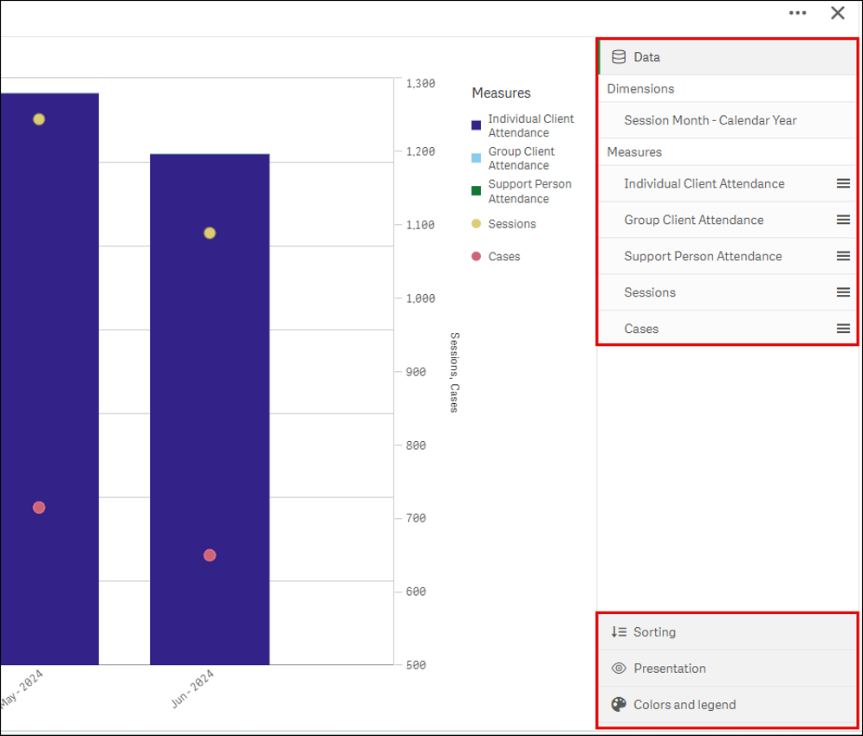
These options provide a number of ways to adjust the appearance of the visualisations.
Sorting: Allows you to sort the data in different ways.
Select the field/s that you want to move and drag up or down. This will change the visualisation to the new order.
Figure 21 – Sorting options
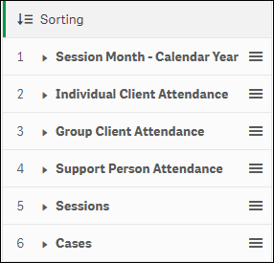
Presentation: Different visualisations have different options that can be adjusted to enhance the display of data.
For example, you can set bars in a bar chart to display as grouped or stacked, as well as vertically or horizontally.
Figure 22 – Presentation options
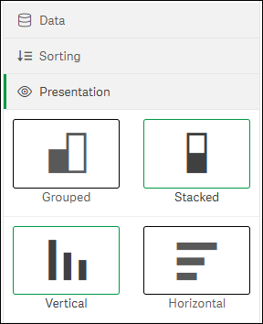

Colours and legend: Colouring is one of the best ways to highlight values in your visualisations. Qlik Sense provides a range of different colouring options.
Figure 23 – Colours and legend options
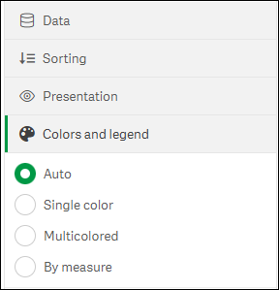
For example, if you select the “By measure” option, a variety of colour options are available.
Figure 24 – Colours and legend ‘By measure’ option selected
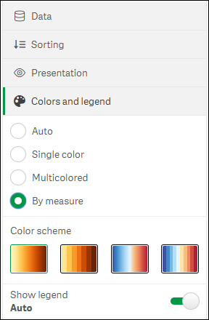
In the example at Figure 25, we have changed the presentation style to “Grouped” and the colours and legend to “Multi-coloured”.
To return to the main report sheet, select the small X in the top right corner of the visualisation. To return to the original layout, select the Discard button in the bottom right corner.
Figure 25 – Sheet with presentation and colours and legend applied
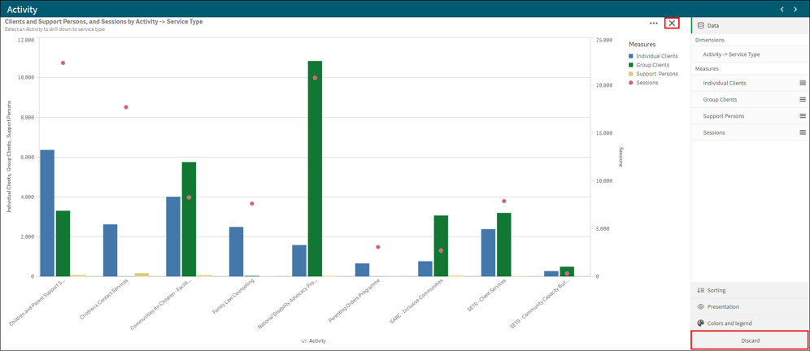
Note: Any changes made will only apply to the current session. Once you leave the report, the default settings will be applied next time you return to the report.

Bookmarks
Bookmarks can be created for reports you access on a regular basis. Bookmarks are saved against individual reports.
To create a bookmark, open a report and select the desired sheet. Make your selections by adding the filters you require.
Figure 26 – Selected sheet with filters applied
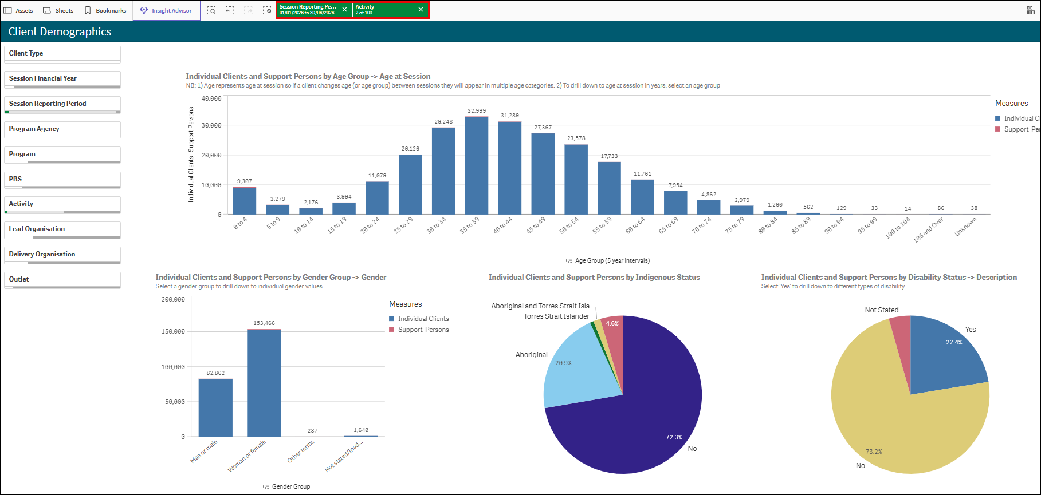
Select the bookmark icon located in the top left-hand corner to open the bookmarks menu. Select ‘Create new bookmark’.
Figure 25 – Bookmarks tile
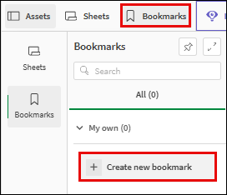

Enter a Title and Description of the bookmark. Click ‘Create’ to save the bookmark.
Figure 25 – Bookmark title and description boxes
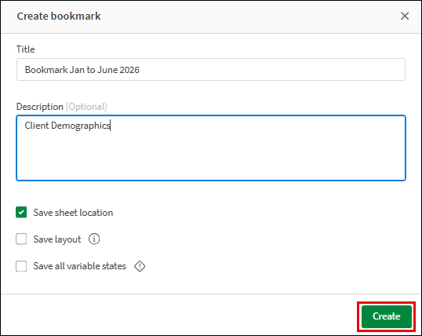
Your saved bookmark will now appear in the bookmarks menu screen.
Figure 25 – Saved bookmark
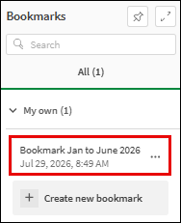
To access your saved bookmarks, navigate to the report where the bookmark was saved. Click on the Bookmarks icon underneath the report information.

Figure 25 – Bookmarks menu showing saved bookmark
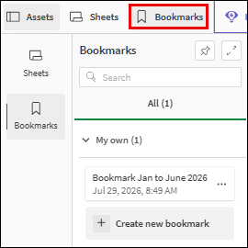
For a detailed description of how you can download the data you have selected from your report, please refer to the Data Exchange Reports Story task card.
You can find more information on reporting requirements in the Data Exchange Protocols. For further information on reports functionality, please visit the Training tab of the Data Exchange website.
For system support, email the Data Exchange Helpdesk use our online contact form.

