Data Exchange Reports - Story

Task card
What is a story? 1
1 Add items to a story 2
2 Add a sheet (page) to the story 3
2.1 Method 1 – Insert a blank sheet to a story 4
2.2 Method 2 - Insert a live data Base sheet from a report 5
3 Add text to the story 6
4 Add animations to a story 9
5 Add snapshots to a story 13
5.1 Take a snapshot 14
5.2 Add a snapshot to your story 15
5.3 Arrange a snapshot 16
5.4 Add comments to a snapshot 16
5.5 Edit a snapshot 17
5.6 Replace a snapshot 18
6 Add shapes to the story 19
7 Preview the story 20
8 Export the story 22
8.1 Export story to PowerPoint 23
8.2 Export story to PDF 24

What is a story?
The Data Exchange reports allow you to create presentations, called Stories, based on the Data Exchange (DEX) data you can access. You create Stories by incorporating elements of the Data Exchange report, such as taking a snapshot of a table or chart, and adding them in your presentation to tell a “story” about the data your organisation is working with. You can also create animations and add shapes to make your Story more engaging.
To start, choose a report that interests you. On the report page, you can access your stories by clicking on the Stories tab of the report, as per Figure 1 below.
Figure 1 – Stories tab
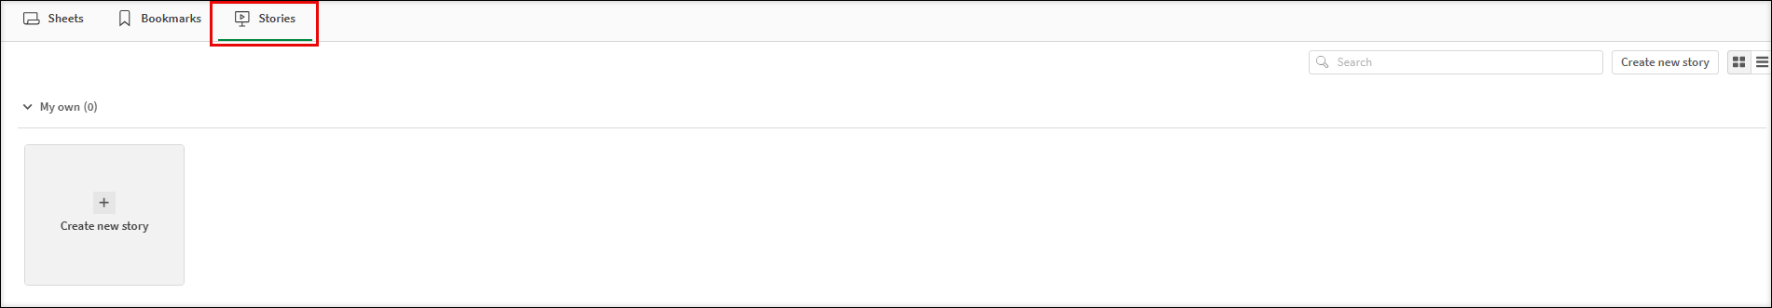
You can also access the Stories from the drop-down box at Figure 2 from other selected sheets. (insert new figure screenshot)
Figure 2 – Stories drop-down box
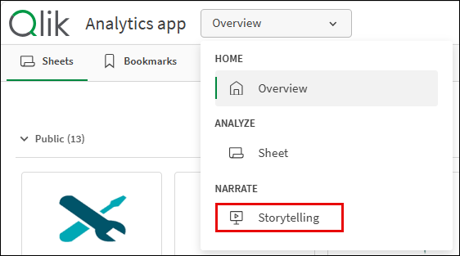
You can find more information on how to use Data Exchange reports at the Tutorials page on the Qlik website.

Add items to a Story
Table 1 – Add a new My story navigation icons
ITEM | DESCRIPTION
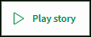 | Select the Play button to play your story.
 | Select the Camera icon to select an image from your snapshots to insert into your story.
 | Select the Add text icon to insert text into your story.
 | Select the Shapes icon to select different shapes to insert into your story.
 | Select the Animation icon to animate your shape or image in your story.
 | Select the Media icon to select media objects to insert into your story.
 | Select the Add slide button to add a new slide to your story.
 | Select the Cut icon to remove an item from your story slide.
 | Select the Copy icon to copy an item from your story slide.
 | Select the Paste icon to paste an item onto your story slide.
 | Select the Delete icon to delete an item from your story slide.
On the Stories page of the report you are interested to use, choose the Story you want to work with, or create a new one. You can have multiple Stories.
Figure 3 – Stories pop tab
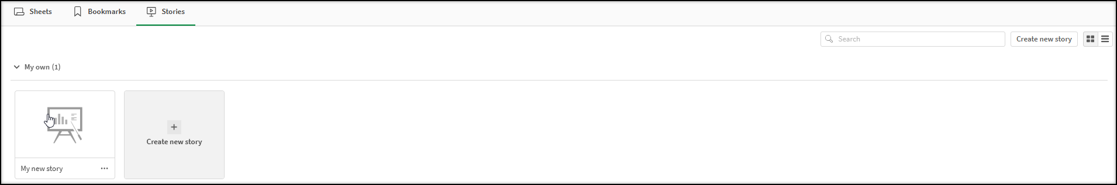
The Story page will display.
Figure 4 – Story page 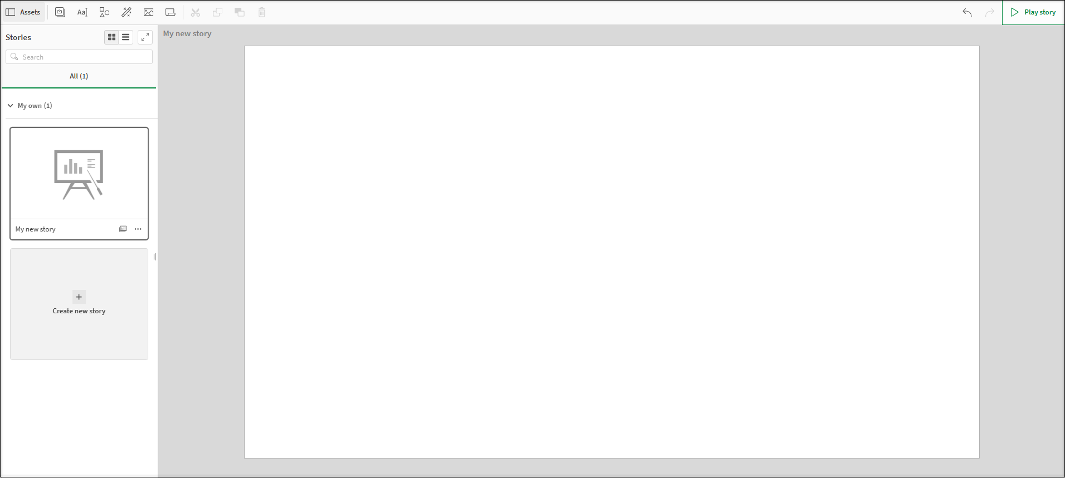
The DEX reports allow you to add different items to a story. This can include animations, media, shapes, sheets (pages), snapshots and text.
Within your Story page, add items to the story, as required, by selecting the appropriate icon.
Figure 5 – Add items icons (Refer Table 1)
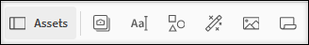

Add a sheet (page) to the story
Table 2 – Add a page navigation items
ITEM | DESCRIPTION
 | Select the sheet icon to insert a new sheet into the story.
 | Select the sheet left-aligned icon to insert the image on the left-hand side and add text on the right-hand side.
 | Select the sheet centre-aligned icon to insert the image on the centre of the sheet.
 | Select the sheet right-aligned icon to insert the image on the right-hand side and add text on the left-hand side.
 | Select the Add new slide icon to insert a blank sheet.
Within your Story page, you can add sheets (pages) to your Story. There are 2 different methods in order to do that.

Method 1 – Insert a blank sheet to a story
Select the Add new slide icon on the bottom left of the story page.
Figure 6 – Add a blank sheet to the story icon
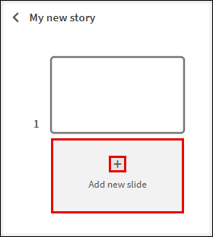
The additional slide will display in the side panel.
Figure 7 – Add an additional slide
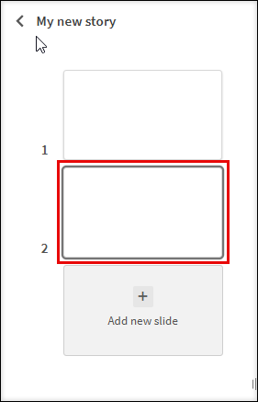

Method 2 - Insert a live data Base sheet from a report
Select the Sheet icon from the functions bar found on the right-hand side of the Story page.
Figure 8 – Insert Items panel
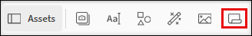
The Select sheet pop up box will display with the available Base sheets for the report.
Figure 9 – Select sheet pop up box
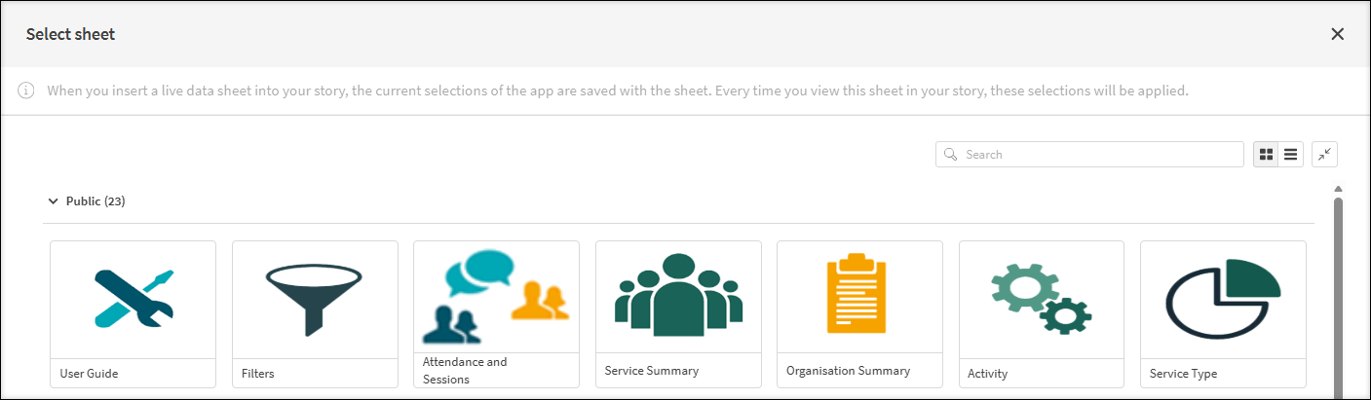
Select the required Base sheet.

The selected sheet will be inserted into the Story and the Live Data sheet pop up box will display.
Figure 10 - Selected Base sheet with Embedded sheet pop up box
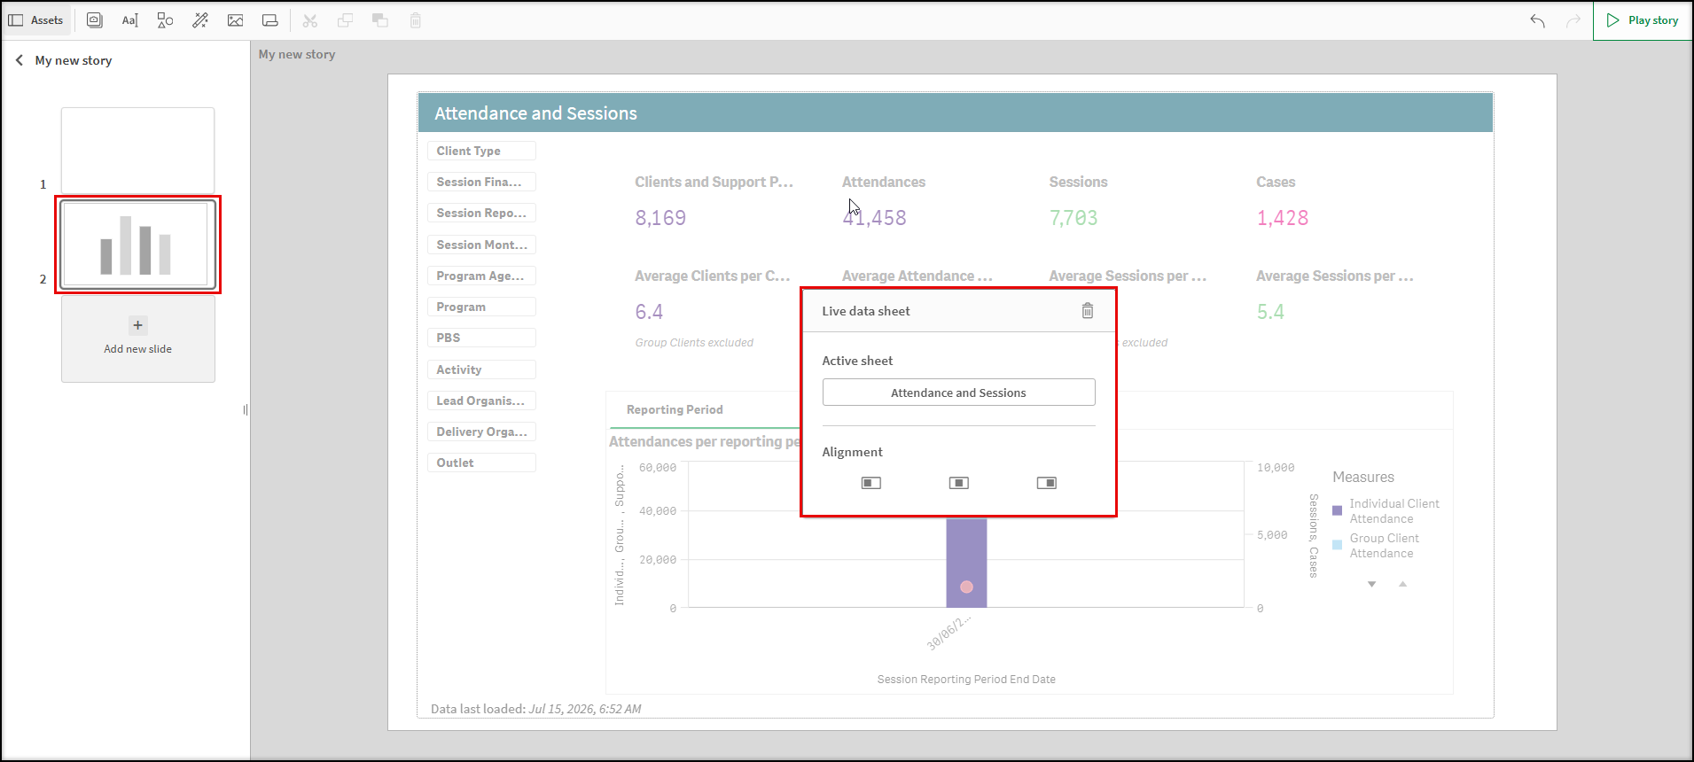
Select the appropriate Alignment icon for the inserted live data Base sheet.
Figure 11 - Embedded sheet pop up box
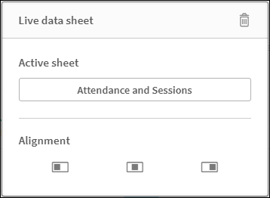
The current selections of the report are saved with the selected Base sheet. Every time you view this sheet in your story, the selections at that saved point of time will be applied.

Add text to the story
In your Story, you can add text by using the Text objects selections.
Table 3 – Title and Paragraph boxes navigation items
Item | Description
 | Select the edit icon to display the different edit options available.
 | Within the Title box, select the drop-down arrow near the colour box to choose the font colour.
 | Select B, I or U to make the text bold, italic or underlined.
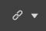 | Select the hyperlink icon to link a URL to the text.
 | Select the handles on the corner of the text box to resize the text box.
 | Within the Paragraph box, you can perform the functions available in the Title box. You can also select the alignment options to change the alignment of the text.
 | Select the font size drop down arrow to change the size of the text.
After selecting the Story, you would like to work on, you will land on the story page (Figure 3). You can then add text to the story page by selecting the Add text icon within the item functions bar found on the right-hand side of the Story page.
The Text objects pop up box will display.
Figure 12 – Text objects pop up box
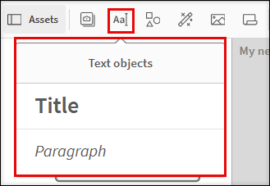
Double click on the displayed options to add either a Title or a Paragraph text box.
Example of Title box:
Figure 13 – Example of a Title box
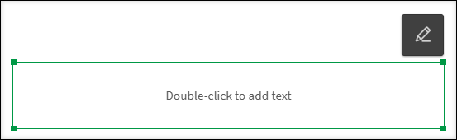
Select the Edit icon to display the Edit options.
Use the handles to resize or move the image anywhere on the page.

Click and drag the text box where ever you want on the page.

Highlight the required text to amend the font size, style, colour or to add a hyperlink.
Figure 14 – Amending the text icons
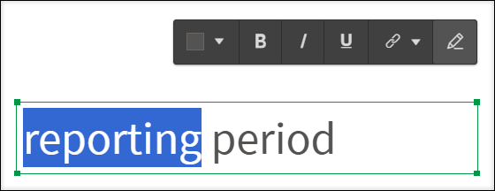
Example of Paragraph box:
Figure 15 – Example of a Paragraph box
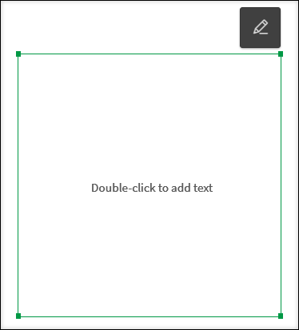
Select the Edit icon to display the Edit options.
Use the handles to resize or move the image anywhere on the page.
Click and drag the text box where ever you want on the page.
Highlight the required text to amend the font size, style, colour, positioning or to add a hyperlink.
Figure 16 – Amending the paragraph icons
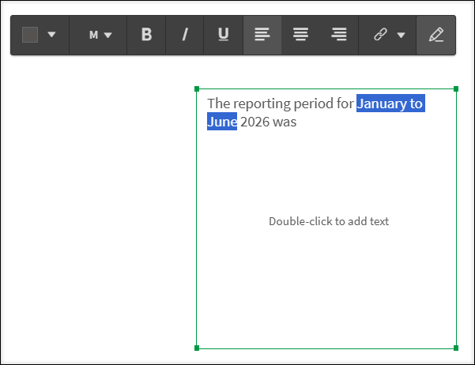

Select the drop-down arrow 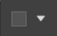 to choose the font colour.

Add animations to a story
You are able to add animations to your story by using the Effects library. These visual effects can only be used on bar charts, line charts and pie charts.
Table 4 – Effects library navigation items
Item | Description
 | Select the Highest value icon effect will make the highest value stand out by adding a label to the highest value and dimming the other values. For visualizations with grouped values, the highest value in each group will be highlighted
 | Select the Lowest value icon effect will make the lowest value stand out by adding a label to the lowest value and dimming the other values. For visualizations with grouped values, the lowest value in each group will be highlighted.
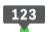 | Select the Any value icon effect will make a value, that you select manually, stand out by adding a label to the selected value and dimming the other values. For visualizations with grouped values, you can choose to highlight either a measure or a dimension. The selected measure or dimension will be highlighted in all the groups where it occurs.
 | Select to replace the image with another snapshot item in your Stories library.
 | Select to edit the image.
 | Select lock to prevent any changes being made to the snapshot.
 | Select to go to the originating sheet source of the snapshot.

Choose the Story that interests you. Figure 16 shows an example Story, ‘Clients for Program A’.
Figure 17 – Stories tab and My stories tile
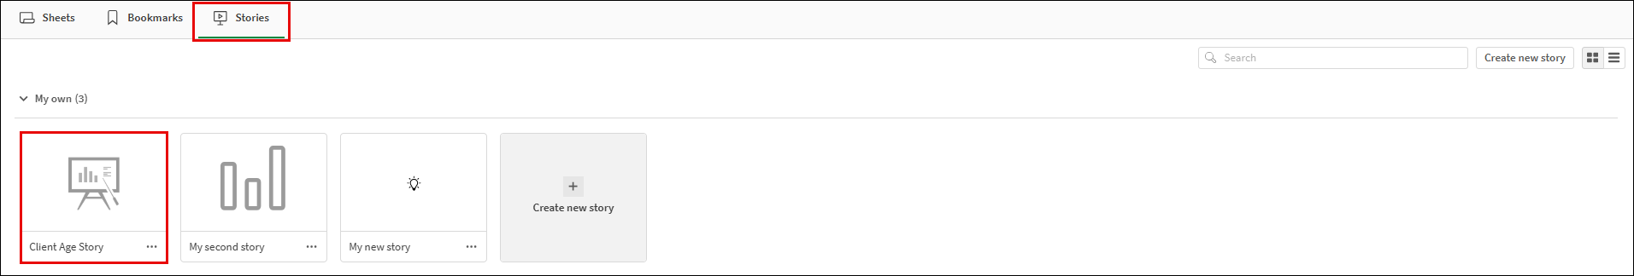
The Story page will then display.
Figure 18 – Story sheet with snapshot
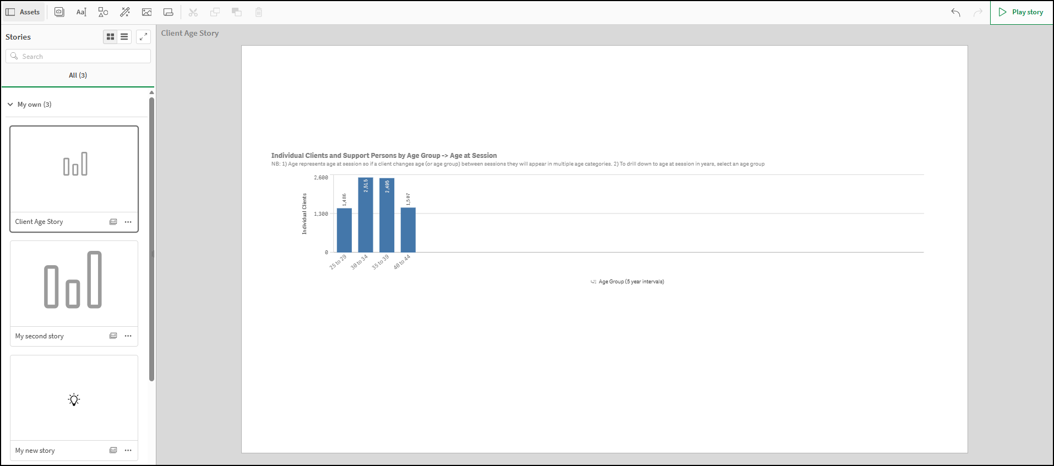
Select the Animation icon on the right of the Story page.
The Effects library pop up box will display.
Figure 19 – Effects library pop up box
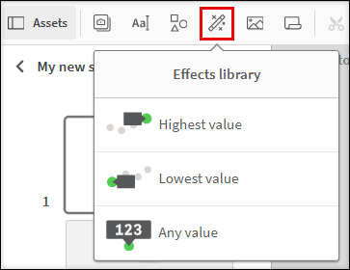
Click and drag the selected effect onto the snapshot.
The snapshot will display with the effect applied.
- Highest value effect applied - The column with the highest value will be highlighted and labelled. All other values will become dim.
Figure 20 – Highest value effects applied to snapshot
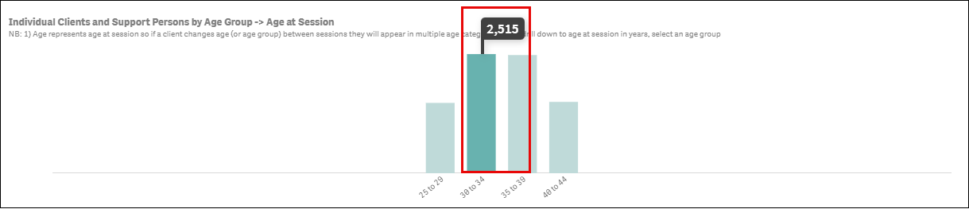
- Lowest value effect applied - The column with the lowest value will be highlighted and labelled. All other values will become dim.
Figure 21 – Lowest value effects applied to snapshot
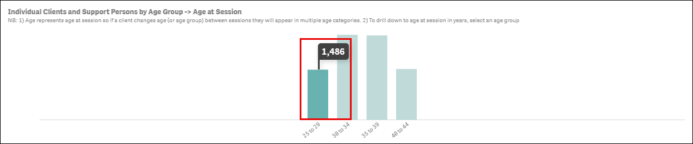
- Any value effect applied – The selected column will be highlighted and labelled. All other values will become dim.
Figure 22 – Any value effects applied to snapshot
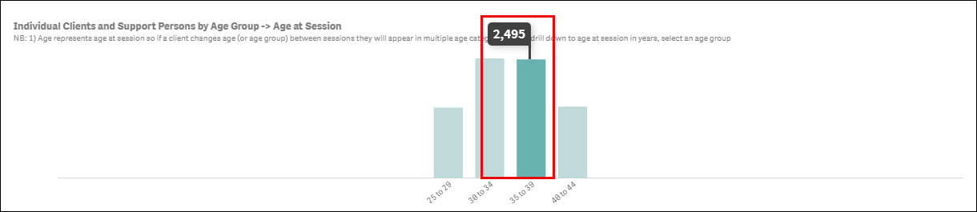
Click on the image to change the data item highlighted.
The Select data point pop up box will display.
Select the drop-down arrow in the Select data point pop up box to change the value selection.
Figure 23 – Select data point pop up box
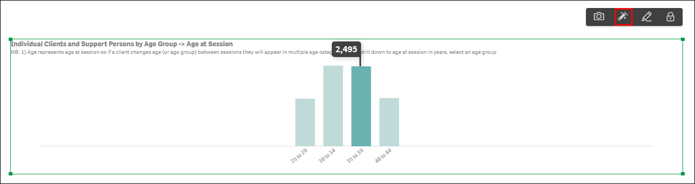
A pop-up box will display with the items available in the image that can be selected.
Figure 24 – Select data point pop up box
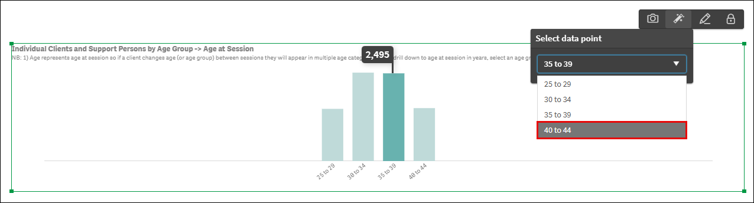
Select the required data point item, and the item will automatically update.
Figure 25 – Select data point pop up box
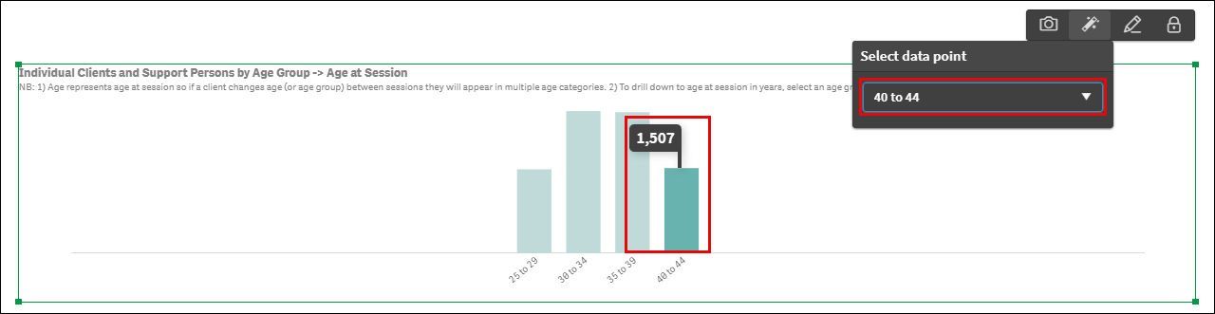

Add snapshots to a story
You can add snapshots of graphs, pie charts, and line charts found in the reports, to your story.
Table 5 – Snapshot navigation items
Item | Description
 | Select to add an image to the Snapshot library.
 | Select to add or find a story in the report.
 | Select the handles on the corner of the image to resize the snapshot item.
 | Select to replace the image with another snapshot item in your Stories library.
 | Select to edit the image.
 | Select lock to prevent any changes being made to the snapshot.
 | Select to go to the originating sheet source of the snapshot.
 | Select to send the item to the back of the image layers.
 | Select to send the item to the front of the image layers
 | Select to send the item back one layer of the image layers.
 | Select to send the item front one layer of the image layers.
 | Select to return to the sheet the image was taken from.
 | Select to remove the image from the story.

Take a snapshot
Access a report of interest and select the item that you would like to add to the Snapshot library.
Select Bar chart.
Figure 26 - Item selection for Snapshot library
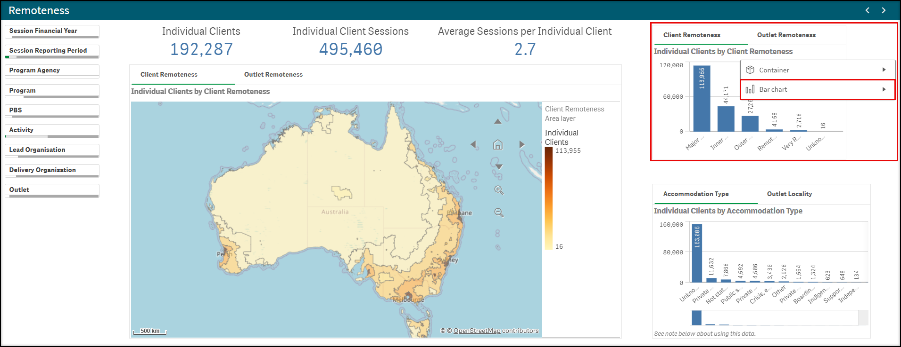
Select Storytelling snapshots from the pop-up box.
Figure 27 - Item selection for Snapshot library
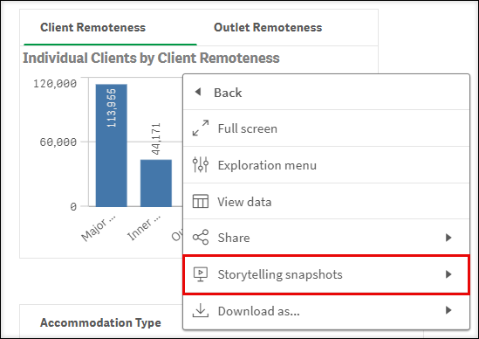
Next, select Take snapshot from the pop-up box.
Figure 28 - Item selection for Snapshot library
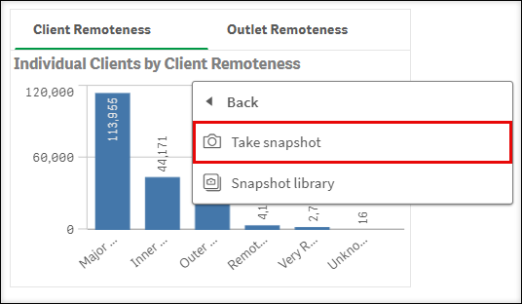
You can add a description in the Snapshot annotation pop up box.
Figure 29 - Snapshot annotation pop up box
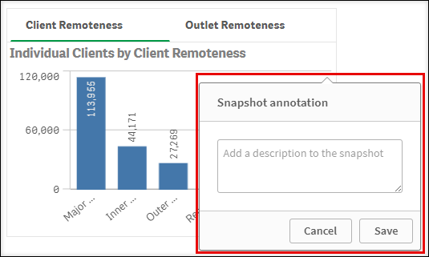
Enter a description of the snapshot and select Save. The item will display in the Snapshot library.

Add a snapshot to your story
On the Story page (Figure 4), select the Camera icon and the Snapshot library pop up box will display with a listing of the snapshot items that have been saved for that report.
Figure 30 - Snapshot library items
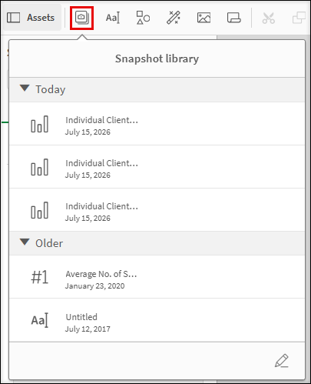
Click and drag the selected item onto the story sheet.
Figure 31 - Snapshot selection on the story sheet
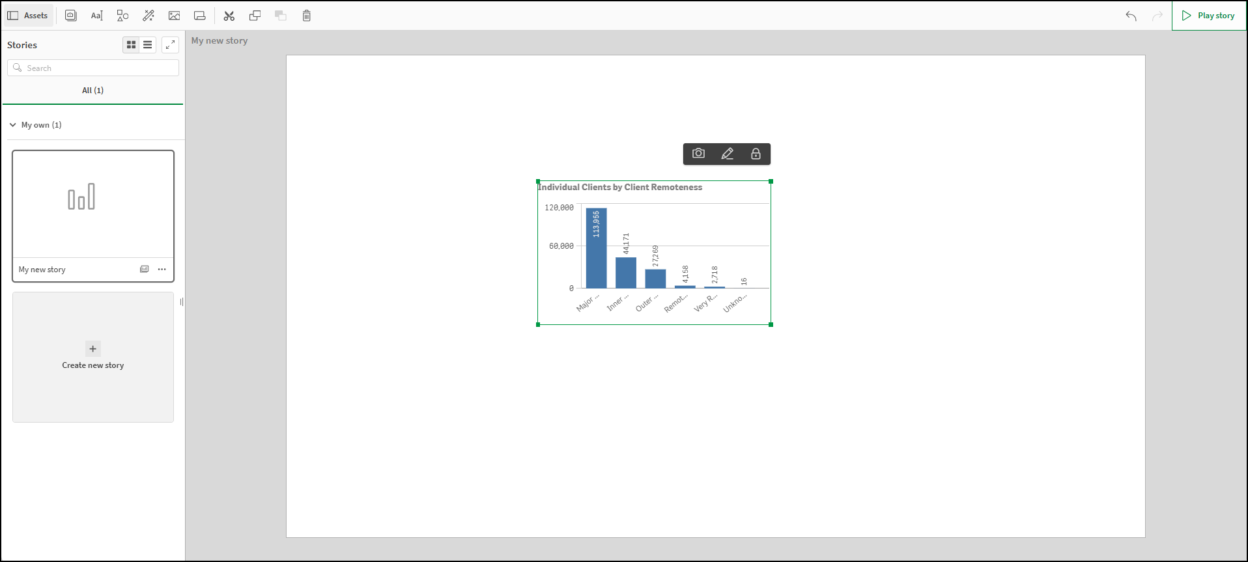
Use the handles to resize or move the image anywhere on the page.

You can click and drag the snapshot wherever you want on the page.

Arrange a snapshot
You can also:
- Change the position of the image
- Delete the image, or
- Return to the sheet where the image originated from.
If you right click on the snapshot image, an options pop-up box will display.
Figure 32 – Options pop up box
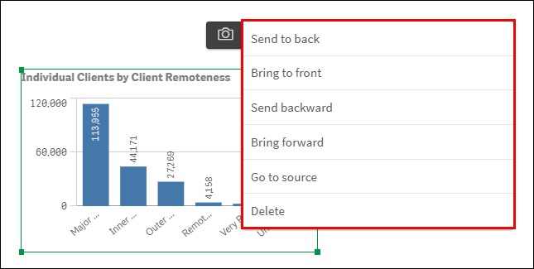

Add comments to a snapshot
You cannot change the title of a snapshot item. However, you can add comments to describe the snapshot item.
- Select the camera icon to open the Snapshot library.
- Select the pencil icon to open the comment fields.
- Select the snapshot item and type the details in the comments field.
Figure 33 – Snapshot library with comments field open
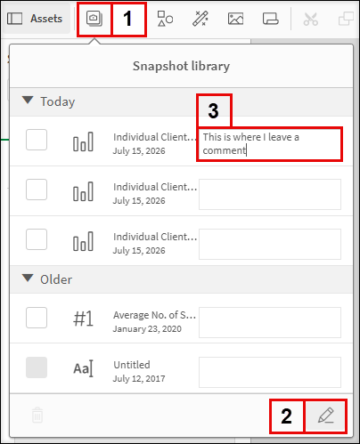
The comments will automatically save.
Figure 34 – Comments field for snapshot item updated
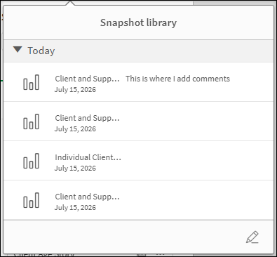

Edit a snapshot
Select Edit to edit the snapshot.
An edit pop up box will display, and you can amend titles, grid lines and labels.
Figure 35 – Edit options for snapshot
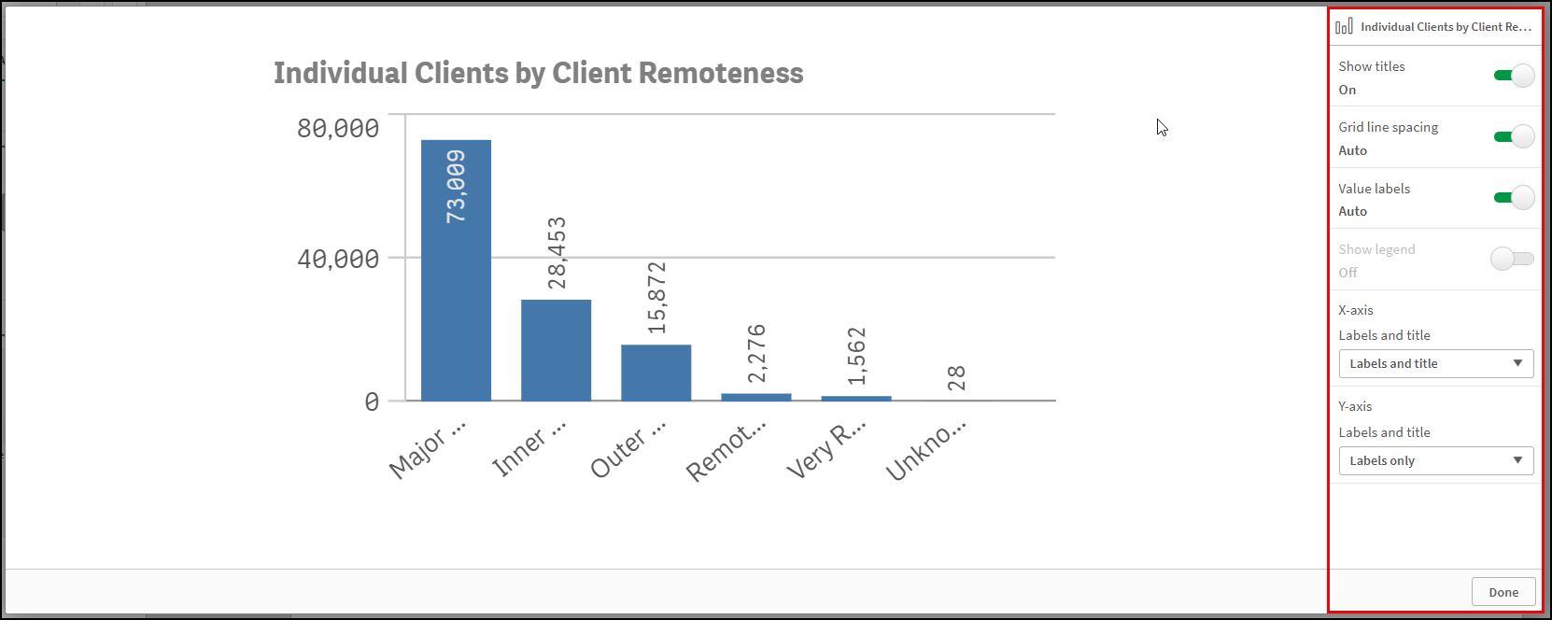
Select Done to save the amendments.

Replace a snapshot
Select the Camera icon to replace the snapshot.
The Replace snapshot pop-up box will display with the image that has been selected to be replaced.
Figure 36 – Replace snapshot pop-up box
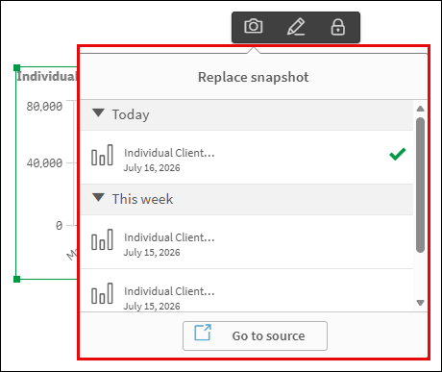
Select Go to source to choose another snapshot from the originating sheet source.
The originating sheet will display with a line around the original snapshot.
Figure 37 – Originating sheet for snapshot
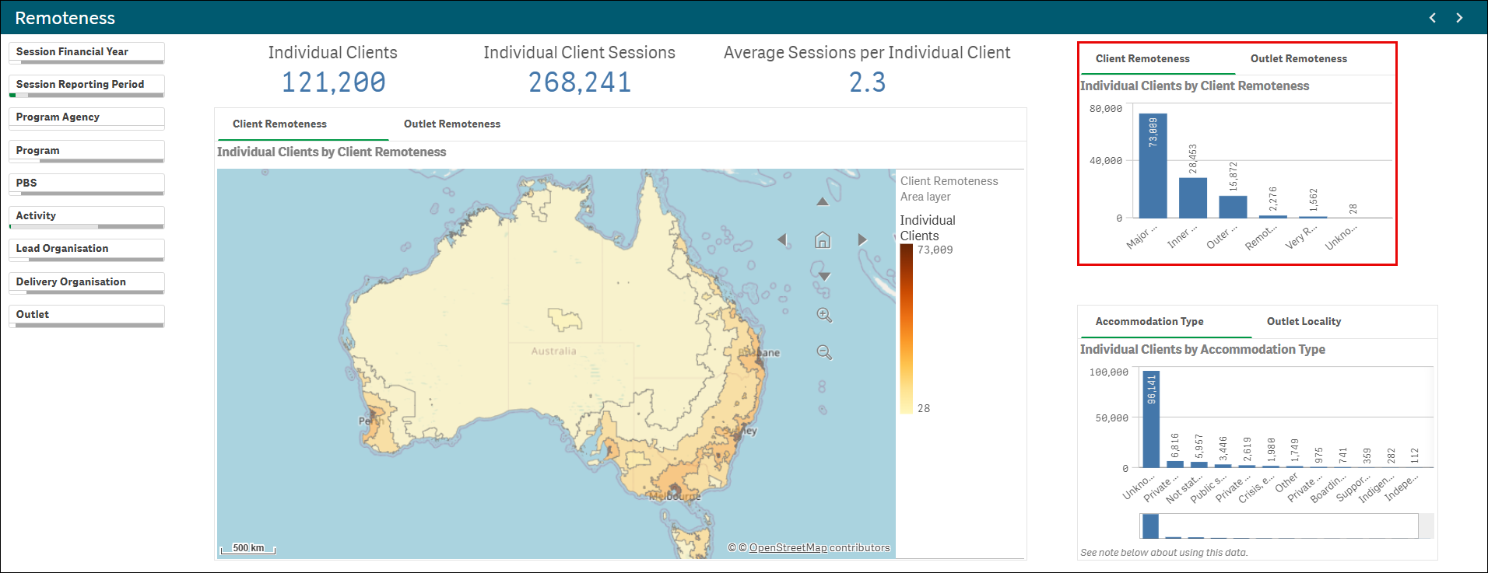
Select a different item to add to the Snapshot library.

Add shapes to the story
You can add shapes to the story page by selecting the Shapes icon within the functions bar found on the right-hand side of the story page.
The Shapes library pop up box will display.
Figure 38- Shapes library pop up box
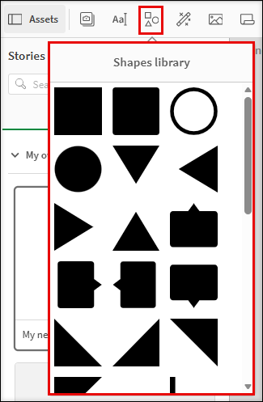
Click and drag, or double click on the desired shape, to add it to the Story page.

Use the handles to resize or move the shape anywhere on the page.
Select the drop-down arrow to edit the colour of the shape.
The icon confirms your colour selection.
Figure 39 – Edit the shape colour menu
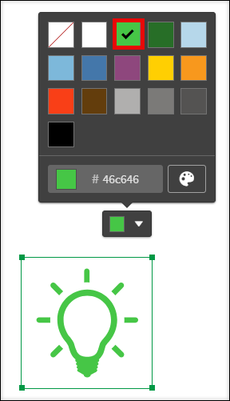

Preview the story
You can preview your Story before exporting it.
Table 1 – Preview story navigation items
ITEM | DESCRIPTION
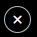 | Select the Close button to close the preview.
 | Select the Actions button for options to move back and forward and export.
 | Select the Back button to go to the previous slide in the story.
 | Select the Forward button to go to the next slide in the story.
 | Select the Export button to export the story to PDF or PowerPoint.
 | Select the Play button to play the story.
To preview your story, choose the Story you are working on. On the Story page, select Play on the top right of the screen.
Figure 40 – Play your story button
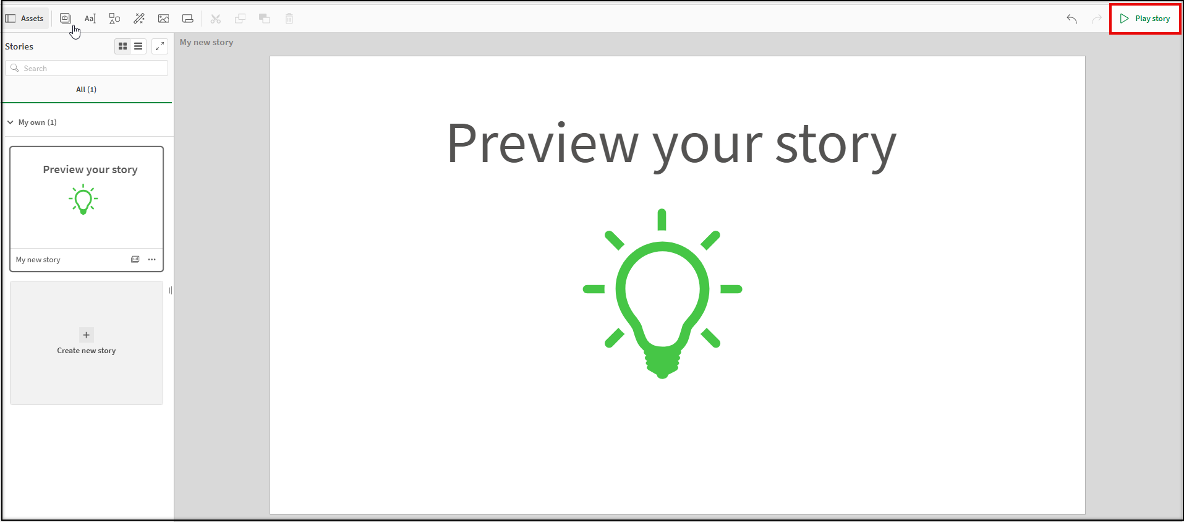
The Story will display in preview mode.
Figure 41 – Play your story screen
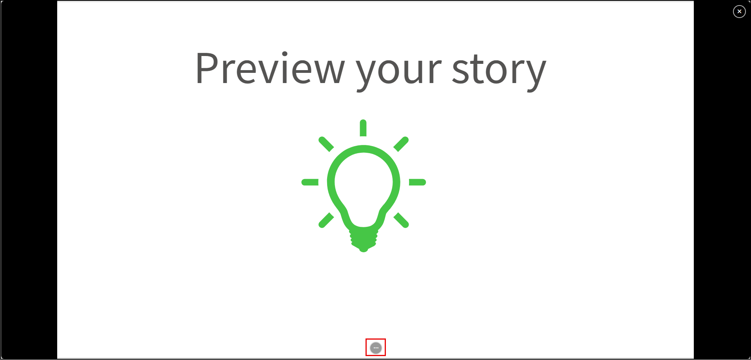
If you select Actions button at the bottom of the screen, the sheet navigation buttons will display.
Figure 42 – Play your story sheet navigation buttons
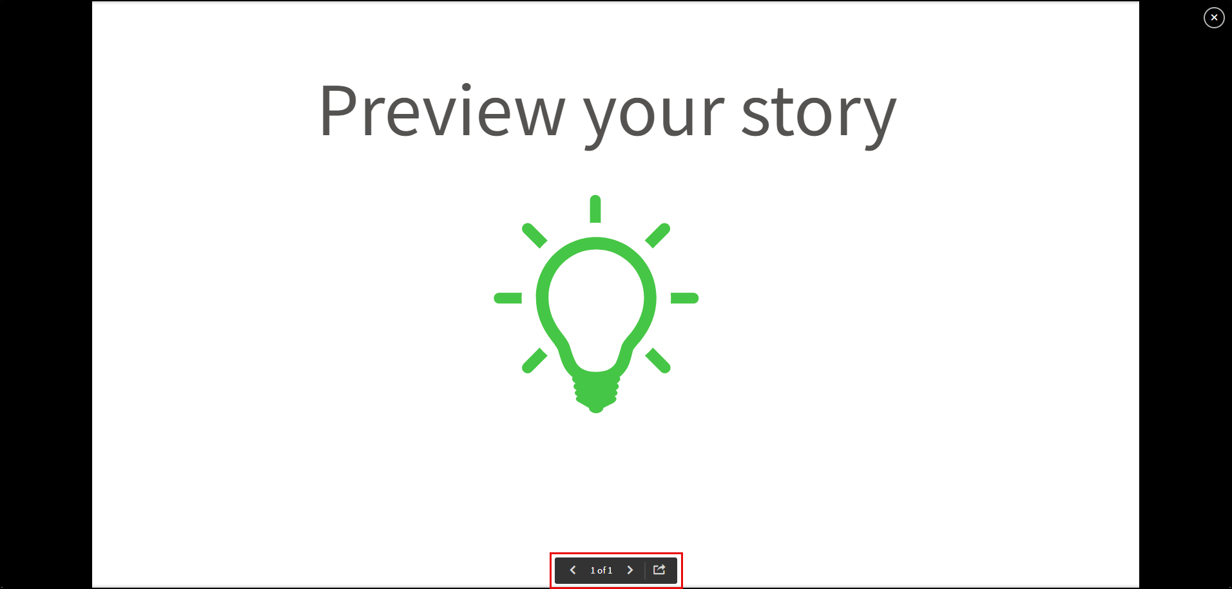

These buttons will allow you to move back and forward through the preview.
Select the Export button to export the story to PowerPoint or PDF.
Select the Close button to exit the preview.

Export the story
If you want to print or play the story outside of the Data Exchange Application, you will need to export the Story beforehand.
Table 1 –Export options navigation items
Item | Description
 | Select the Export story to PowerPoint button to send the story to PowerPoint.
 | Select the Export story to PDF button to send the story to PDF.
 | Select the Duplicate story button to make a copy of the original story.
 | Select the Delete story button to remove the story.
 | Select the Details button to edit the details of the story.
 | Select the Rename button to rename the story.
 | Select the Menu icon to export the story.
On the Story page, select the Menu icon at the bottom right of screen to export the story to PDF or PowerPoint.
Figure 43 – Menu icon selection to export story
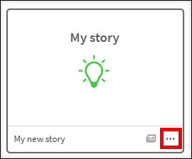
The Export Story pop up box will display.
Figure 44 – Export story pop up box
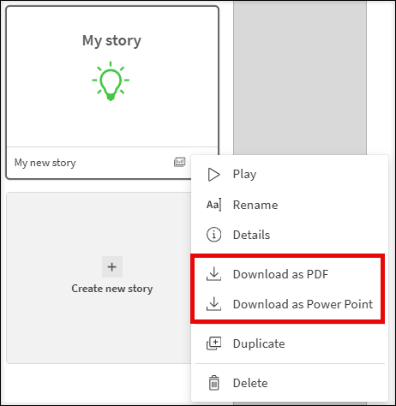
You can export your story as a PowerPoint or PDF.

Export story to PowerPoint
Make the appropriate changes to the PowerPoint settings then select Export .
Figure 45 – PowerPoint settings pop up box
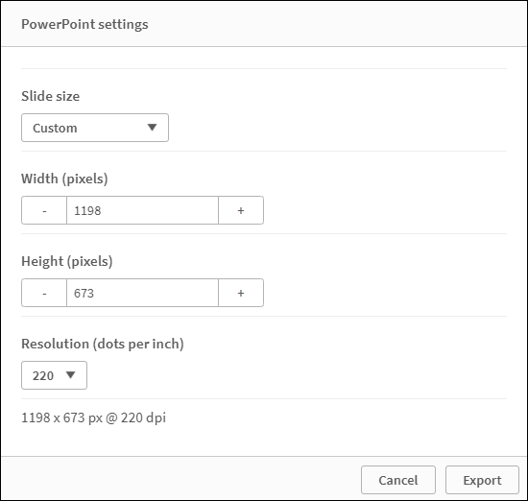

Select the PowerPoint hyperlink that displays.
Figure 46 – Click to download PowerPoint hyperlink
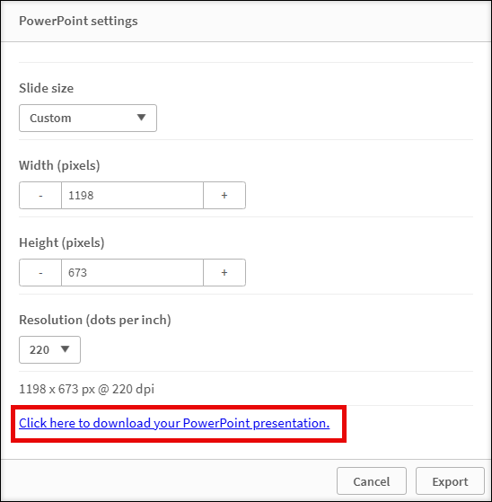

Export story to PDF
Make the appropriate changes to the PDF settings then select Export .
Figure 47 – PDF settings pop up box
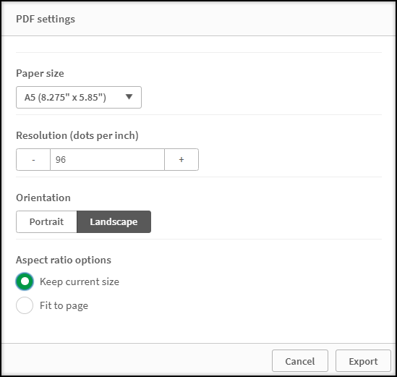

Select the PDF hyperlink that displays.
Figure 48– Click to download PDF hyperlink
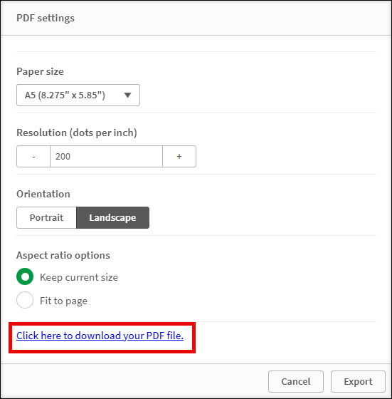
If required, select Cancel to stop the download.
You can find more information on reporting requirements in the Data Exchange Protocols. For further information on reports functionality, please visit the Training tab of the Data Exchange website.
For system support, email the Data Exchange Helpdesk use our online contact form.

