Find and edit a client

Task card
This task card discusses the following:
- Find a client record
  - Method 1 – Client icon button
  - Method 2 – Go to search box
- Edit a client
  - The Client profile screen
  - Edit Client details screen

KEY HIGHLIGHTS
- Do not add any personal information into the Client ID and Tag fields.
- Do not enter a client's full address if it is a sensitive location such as a refuge or shelter.
- Client and consent information is visible to the entire organisation and can be updated at any time.
- If a client does not provide consent, staff will only see the Client ID and no other identifying information such as name, date of birth and address details will be visible.
- Searching for a client can be completed by using either full or partial client information.
- Refer to the Data Exchange Protocols to confirm which conditions, disabilities and impairments fall into which categories.

Find a client record
There are two methods to find clients from the Data Exchange home page. Refer Figure 1.
- Select the Find client icon 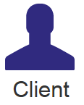 under the Find menu; or
- Type the client’s name or Client ID in the Go to search box at the top of the screen
Figure 1 – Data Exchange home page
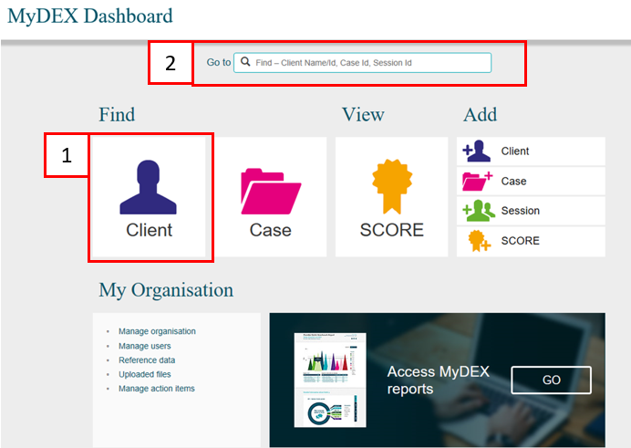

Method 1 – Client icon button
If you select the Client Icon button, the Find a client screen will display. Refer Figure 2.

Figure 2 – Find a client screen
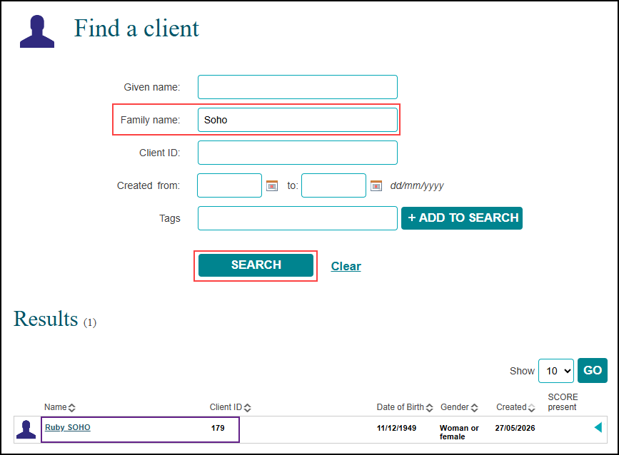

Type in the client details that you know, such as a surname or select the client name from the list of clients at the bottom of the page.
Select SEARCH and the matching records will display under the Results section.
Select the client’s name hyperlink and the Client profile screen will display. Refer Figure 4.
Searching can also be done by using either full or partial information. Partial searching allows you to search for a client by only using part of a name or client ID instead of the exact details.
You can search for a client by one of the following:
- Given name
- Family name
- Client ID
- The date period the client record was created between, and/or
- Tags.

Method 2 – Go to search box
In the Go To box at the top of the screen, start typing the details that you know such as the client’s surname. As you type, the list of clients will narrow down. Refer Figure 3.
You can search by first name, surname or client ID.
Figure 3 – Go to search option

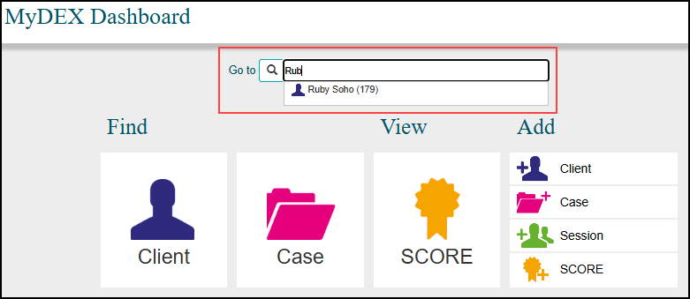

Edit a client

The Client profile screen
The Client profile screen contains the following information / functionality. Refer Figure 4.
- The client’s details
- Select the MORE v button to see the clients consent, residential address, demographic and extended demographic details
- Edit a client’s details
- Cases the client has been attached to
- A list of sessions the client has attended across all cases
- View client SCOREs
- Delete client – Can only be deleted if the client is not associated with a case.
Figure 4 – Client Profile screen
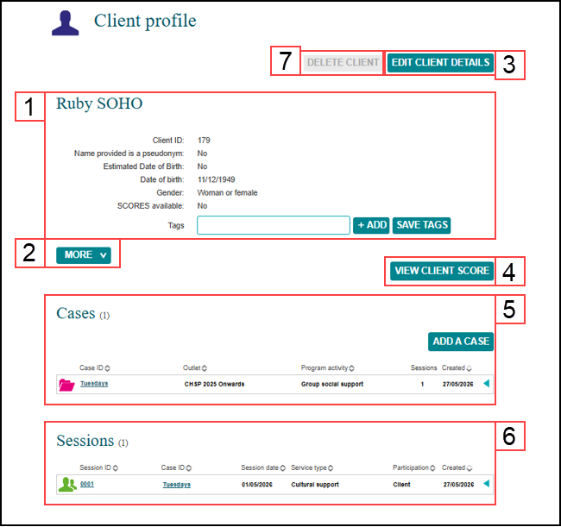

Edit client details screen
Select EDIT CLIENT DETAILS (refer Figure 4) to update client information including consent, residential address, demographic and extended demographic details.
The Edit client details screen will display. Refer Figure 5.
Figure 5 – Edit client details screen
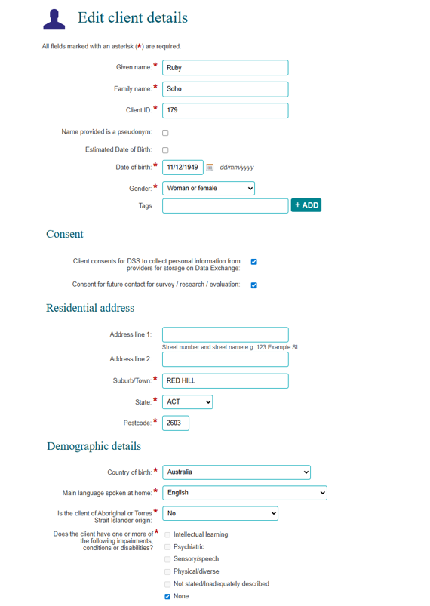
Figure 5 – Edit client details screen (continued)
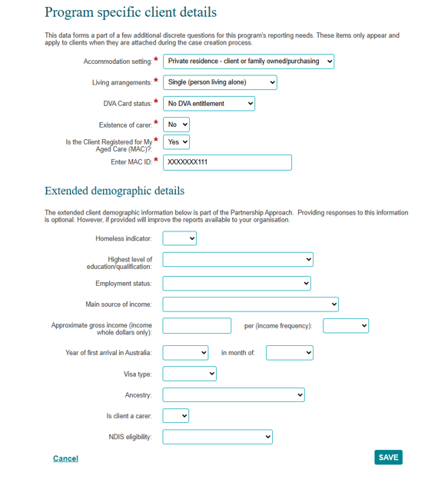

Update the client’s information as required.
Select SAVE when complete.
The Client profile screen will re-display.
Refer to the Add a case task card to add the client to a case.
Refer to the Add a session task card to add the client to a session.
Refer to the Add a SCORE assessment task card to record a SCORE assessment for the client.

You can find more information on outlets, clients, cases, and sessions on the Data Exchange Protocols and the Training page.
For system support, email the Data Exchange Helpdesk use our online contact form.

