
The Data Exchange Protocols

Part 2

Using the Data Exchange

An Easy Read guide


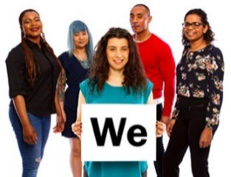 | The Australian Government Department of Social Services (DSS) wrote this guide. When you see the word ‘we’, it means DSS.
 | We have written this guide in an easy to read way.  We use pictures to explain some ideas.
 | We have written some words in bold. This means the letters are:  - thicker  - darker.
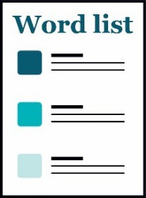 | We explain what these words mean.  There is a list of all these words on page 42.
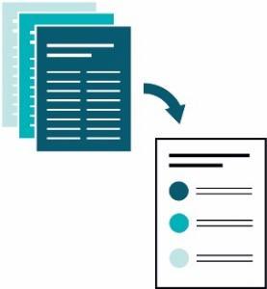 | This Easy Read guide is a summary of another document.  This means it only includes the most important ideas.
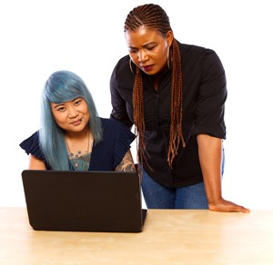 | You can find the other document on our website at dex.dss.gov.au/

How to use this guide
 | You can ask for help to read this guide.  A friend, family member or support person may be able to help you.
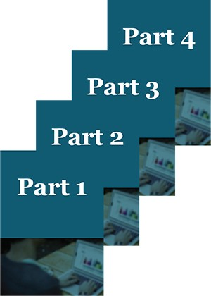 | This guide has 4 parts:  - Part 1 – What is the Data Exchange?  - Part 2 – Using the Data Exchange  - Part 3 – The Partnership Approach  - Part 4 – Recording client outcomes in the Data Exchange.
 | This is Part 2 – What is the Data Exchange?
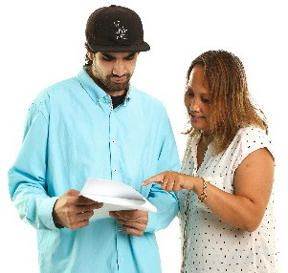 | You might like to read 1 part at a time.
 | You also might like to read parts of this guide while you look at the Data Exchange online.
 | If you have any questions, you can contact us. Our contact details are on page 40.

What’s in this guide?
Words we use in the Data Exchange 5
Using the Data Exchange 6
Entering data 13
Creating a client record 19
Keeping client records safe 25
Entering data about programs and activities 32
Recording extra data 34
Getting help to use the Data Exchange 39
Word list 41
The DSS Standard Notification 45

 | There are certain words we use in the Data Exchange.
 | Your organisation might use different words
 | It’s important to use our words when you use the Data Exchange.
 | We talk about all these words in Part 1 – What is the Data Exchange?
 | You’ll also find a list of all these words on page 41.

Words we use in the Data Exchange

Using the Data Exchange
 |  | If your organisation gets a grant to help people and communities, you will be asked to use the Data Exchange.
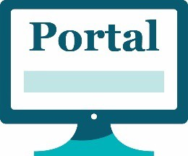 |  | We have a web-based portal for organisations to use.
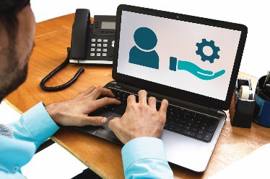 |  | You can use the web-based portal to:  - create client records  - look at your client records  - manage the services your clients use.
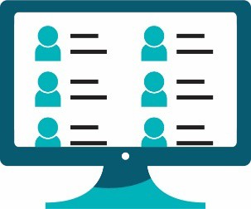 |  | Some organisations even decide to use the Data Exchange as their client records system.
 |  |  | A client records system is a system an organisation uses to collect and store personal information about their clients.  They might use software.  Their system might be online.
 | 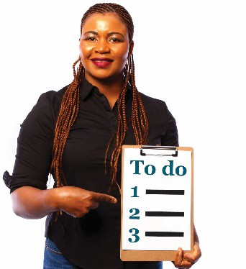 |  | There are things your organisation must do before you can start using the Data Exchange.
 | 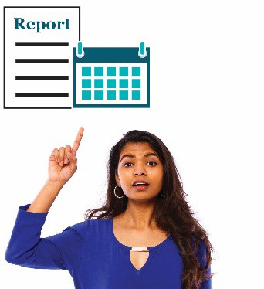 |  | You should do them as early as possible in the reporting period.
Did you know?
The Data Exchange has a training area where you can learn how to use the system. There are videos online to help you learn. We explain this in more detail on page 40.

 | To get started, your organisation must follow these 7 steps.

Step 1: Digital Identity
 | You need a Digital Identity to use the Data Exchange.
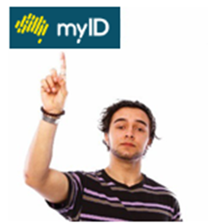 | myID is the Australian Government’s Digital Identity.
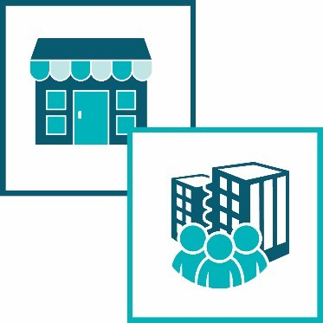 | myID is the tool the government uses to identify:  - businesses  - organisations
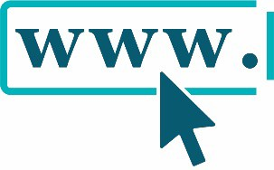 | You can apply for it online at  www.myID.gov.au/
 | Once you have a myID, you can use a software tool called a Relationship Authorisation Manager (RAM).
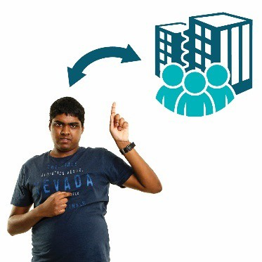 | RAM links you to:  - your organisation  - the Government systems your organisation uses.

Step 2: Ask for access to the system
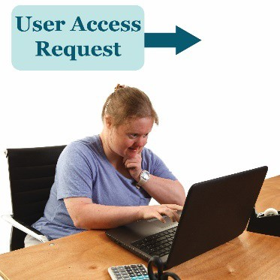 | Send a User Access Request to the Data Exchange Helpdesk.
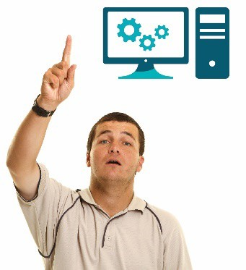 | A User Access Request is how you ask us if you can become a Data Exchange user.

Step 3: Enter your details
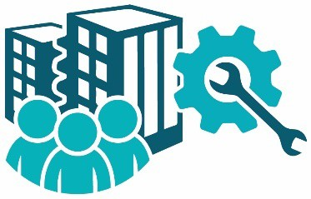 | Go into the Data Exchange and set up your organisation.

Step 4: Tell us about your outlets
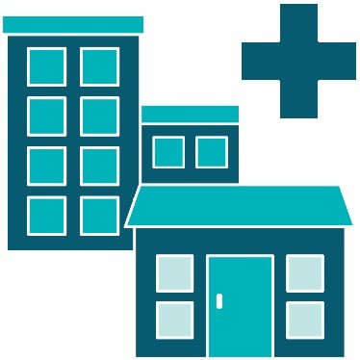 | Create any outlets – the places clients go to use your organisation’s services.

Step 5: Tell us about the activities you do
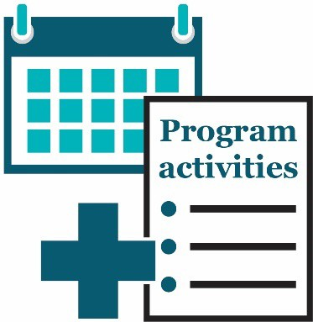 | Add program activities to the outlets you have created.
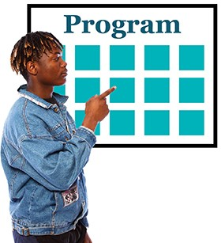 | Program activities are all the services:  - your organisation offers  - clients can choose from.

Step 6: Tell us about any other organisations you work with
 | Add the details for any delivery partners you need to add.
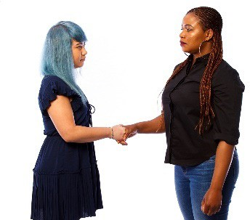 | Delivery partners are other organisations you work with to provide help and services for your clients.

Step 7: Create extra users if you need to
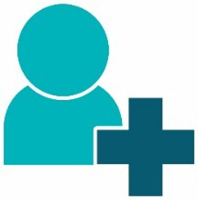 | Create any extra users you need to add.
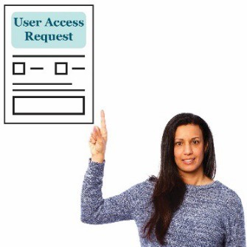 | At least 1 person from each organisation will need to complete and submit a Data Exchange User Access Request Form.
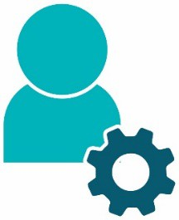 | This person will have Administrator access to the Data Exchange.
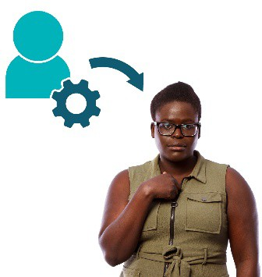 | This person might leave your organisation 1 day.  You must give someone else Administrator access to the Data Exchange
 | The form is on the Data Exchange website.
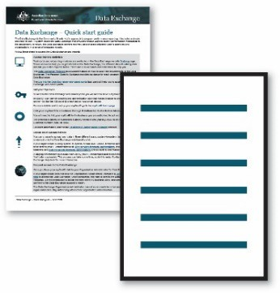 | You can find helpful information on our website, including:  - a Quick Start Guide  - training materials.
 | dex.dss.gov.au/

Entering data
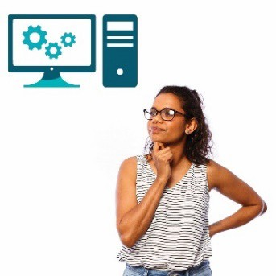 | There are different ways to record data in the Data Exchange.
 | We explain these ways in more detail on the following pages.
 | You should:  - choose the way that works best for your organisation  - use that way each time if you can.
 | There is more information about each of these ways on our website.
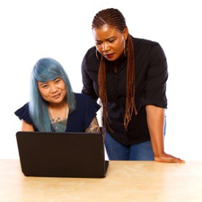 | dex.dss.gov.au/

Transfer data from one system to another
 | 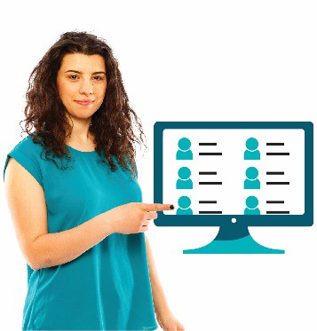 |  | Some organisations have a client management system.
 | 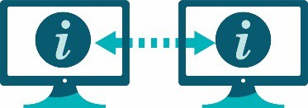 |  | If you have a client management system, you might be able to share the data with us.
 | 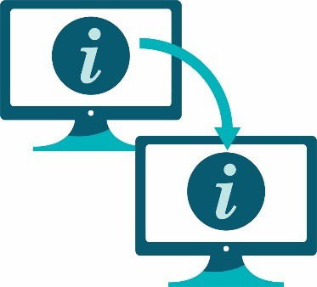 |  | You might be able to transfer data from 1 system to another.
 | 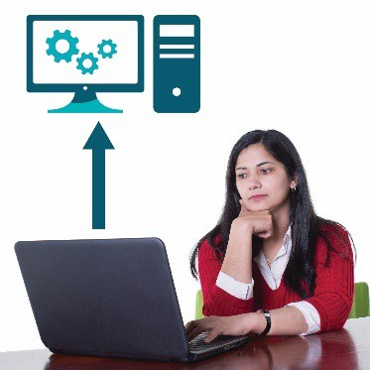 |  | This means you might be able to move your data over to the Data Exchange.
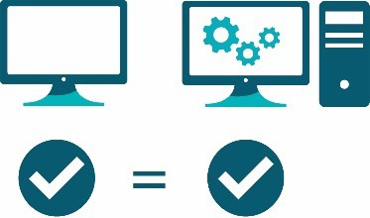 |  | Your system needs to match what the Data Exchange needs.
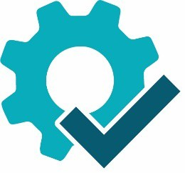 |  | We call this our technical specifications.
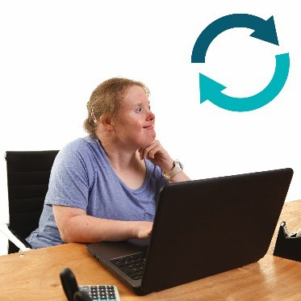 |  | You might need to make some small changes so the system works.
 |  | But you should only need to do this once.
There is information about the Data Exchange’s technical specifications on our website.
dex.dss.gov.au/

Upload a lot of files at 1 time
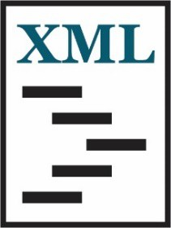 | Some organisations might use a type of file called XML.
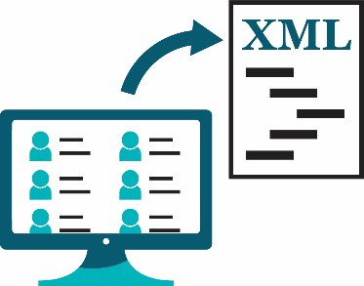 | The client management system may export this type of file.
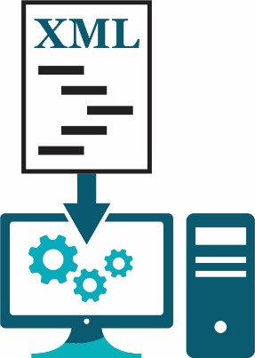 | This means that your organisation might be able to send XML files to the Data Exchange.
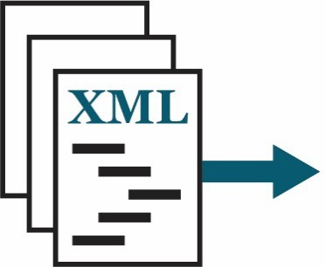 | If you can do this, you might be able to send us a lot of files at 1 time.
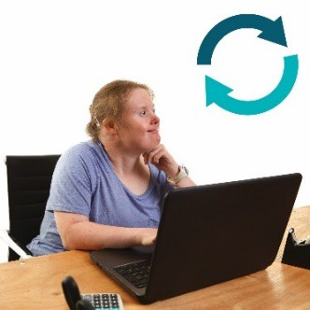 | You might need to make some small changes so the system works.
 | But you should only need to do this once.
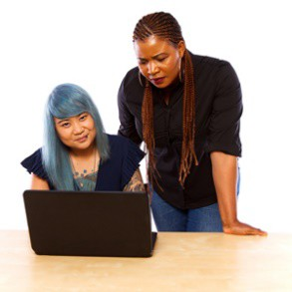 | There is information about the Data Exchange’s technical specifications on our website.  dex.dss.gov.au/

Use the web-based portal to enter data
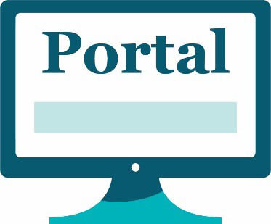 | Some organisations will use the web-based portal to enter data.
 | We explain what the web-based portal is on page 6.
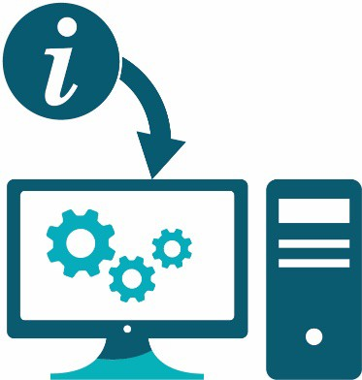 | If you use the web-based portal, you can put data straight into the Data Exchange.
 | You can type the data straight in during an open reporting period.

Creating a client record
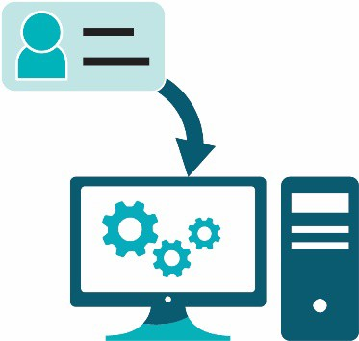 | Client level data is the information about clients that we put into the Data Exchange.
 | The client level data we collect includes the person’s:
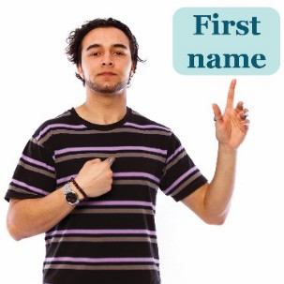 | - first or given name
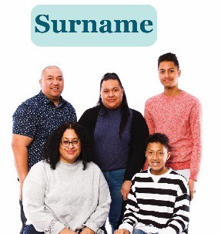 | - family name or surname
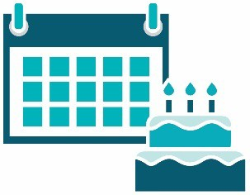 | - date of birth
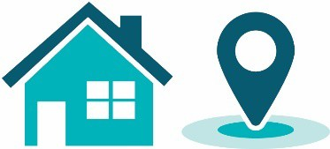 | - suburb, state and postcode.
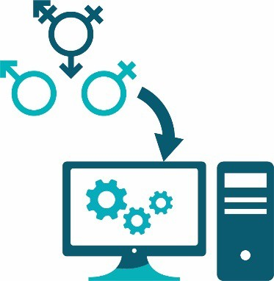 | We also collect data about a client’s gender in the Data Exchange.
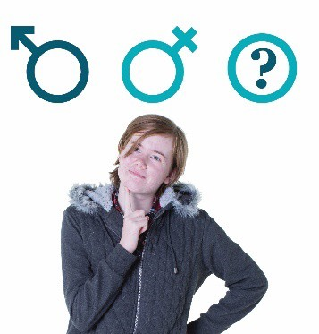 | You can tell us if they:  - are male or female  - identify in another way.
 | We also collect data about whether a client is from:
 | - an Aboriginal or Torres Strait Islander community
 | - a culturally and linguistically diverse (CALD) community.
 | If a client is from a CALD community, you can also record the:  - country they were born in  - language they speak at home.
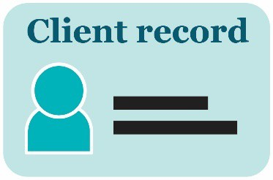 | Once you enter all this data for a client, it creates a client record.
 | You only need to create a client record once.
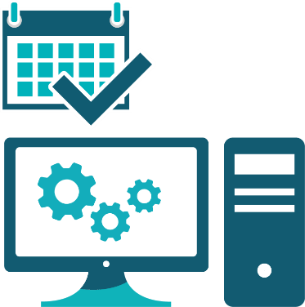 | You can go into the Data Exchange and update it at any time.

Clients with disability
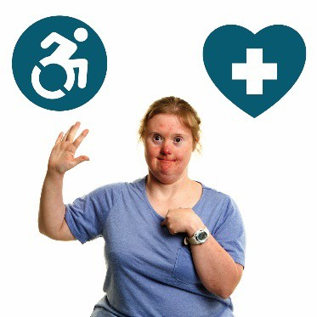 | It’s important for organisations and funding agencies to know if clients who use their services have:  - a disability or an impairment  - a health condition.
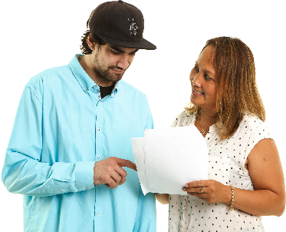 | It’s important to know if clients have a disability so we can make sure they get the help and services they need.
 | You must ask your clients if they have a:  - disability  - impairment  - health condition.
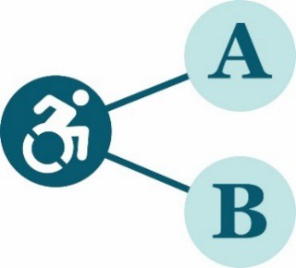 | In the Data Exchange, we group disabilities and impairments into broad categories.
 | We explain the types of disability and impairments that belong to each category on the following pages.
 | Your clients might have a disability or impairment from more than 1 category.

Intellectual or learning disability
 | If you have an intellectual or learning disability, it can affect the way you:  - think  - learn new skills  - understand new ideas.  .

Psychiatric disability
 | If you have a psychiatric disability, it can affect your mental health.
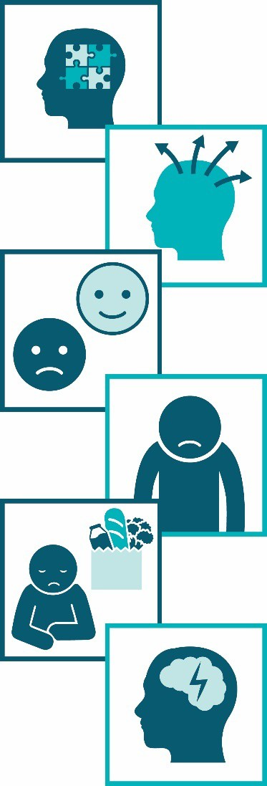 | A psychiatric disability might include:  - Autism Spectrum Disorder  - attention deficit hyperactivity disorder (ADHD)  - bipolar – your mood changes in a big way  - depression – you feel bad all the time and like it will not end  - eating disorders – you have problems with food, eating and the way you see your own body  - epilepsy – there are changes to electrical activity inside your brain.

Sensory or speech disability
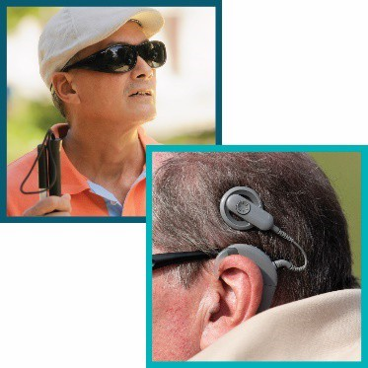 | If you have a sensory disability or impairment, it affects one or more of your senses, such as your:  - sight  - hearing
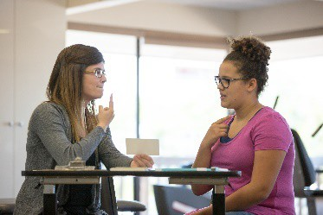 | If you have a speech disability, it affects how well you can:  - speak  - communicate.

Physical disability
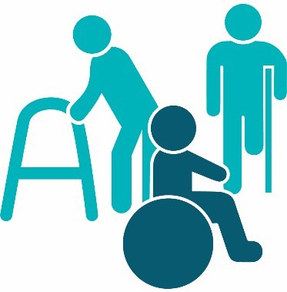 | If you have a physical disability or impairment, it affects how well you can:  - use parts of your body  - move  - get around.

Keeping client records safe
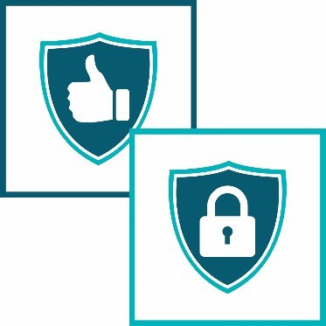 | The Data Exchange was designed to make sure a client’s personal information will be:  - safe  - protected.
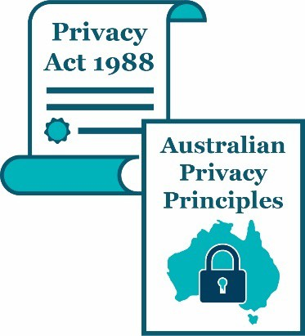 | The Data Exchange follows the rules in the:  - law that applies – the Privacy Act 1988  - Australian Privacy Principles.
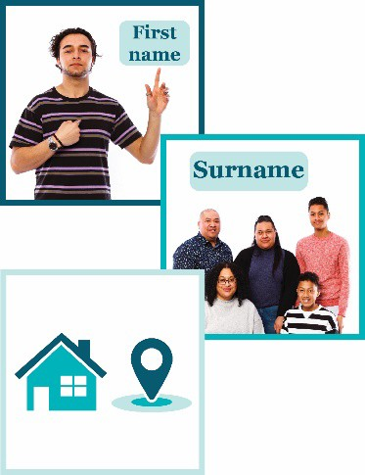 | Personal information is a client’s:  - First name  - Last name  - First and second lines of their street address
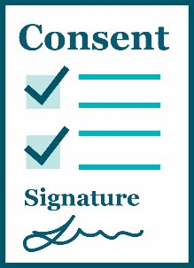 | You must get consent from your clients to collect and store their personal information in the Data Exchange.
 | If someone gives you their consent, they say it is ok for you to do something.
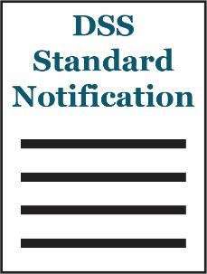 | If you want to use the Data Exchange to store personal information on a client’s record, you need to include the DSS Standard Notification when you get their consent.
 | You can find the DSS Standard Notification on page 46.
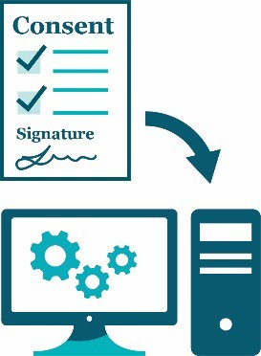 | You must record whether you have their consent in the Data Exchange.
 | If you don’t want to include the DSS Standard Notification, the consent form you use must tell your clients that:
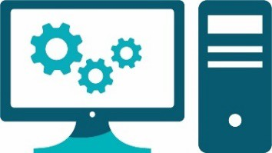 | - the Data Exchange is a computer system used by DSS
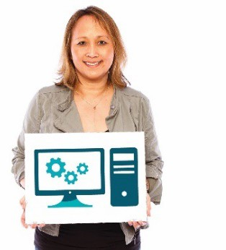 | - your organisation uses the Data Exchange to collect and store information about their clients
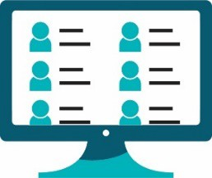 | - you will store your client’s personal information in the Data Exchange
 | - only your organisation will be able to see your clients’ personal information
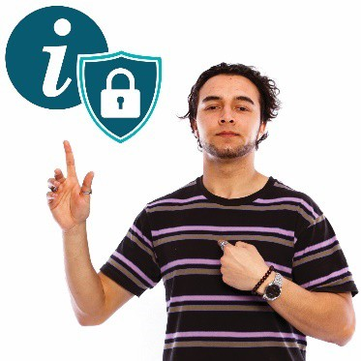 | - your clients’ personal information will be protected
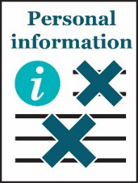 | - DSS uses data from the Data Exchange in reports but takes out personal details about clients when they do this
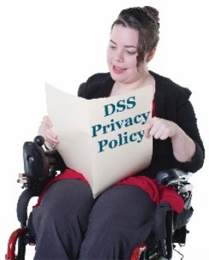 | - they can read the DSS Privacy Policy for more information.

Using data in the Data Exchange
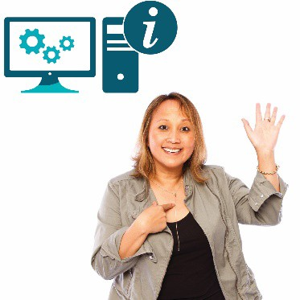 | Only your organisation can use data about your clients from the Data Exchange.
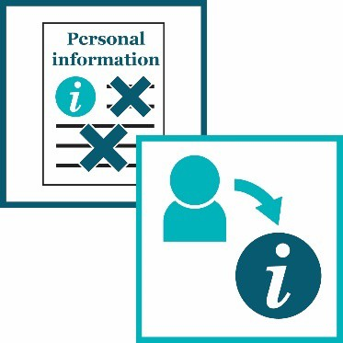 | If we are going to use the data in any way, we make sure it doesn’t:  - show any information that can identify a person  - link them to the data.
 | This is called de-identifying information.
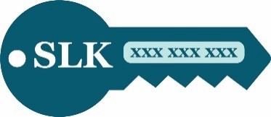 | We use Statistical Linkage Keys (SLK) to de-identify personal information.
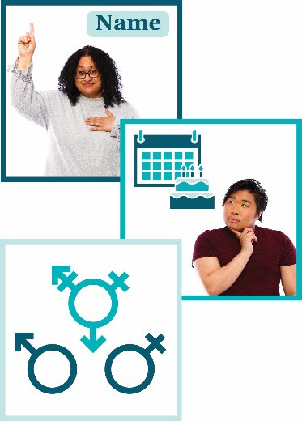 | An SLK is a code made up of:  - letters from a client’s name  - numbers from the client’s date of birth  - the client’s gender.
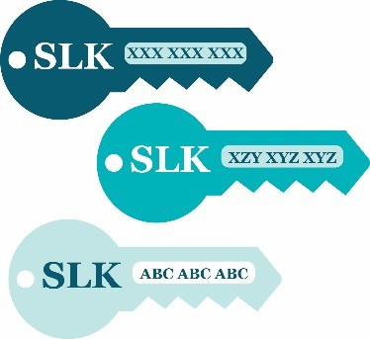 | The Data Exchange gives each client record its own identification code.  No other client record will have the same code.
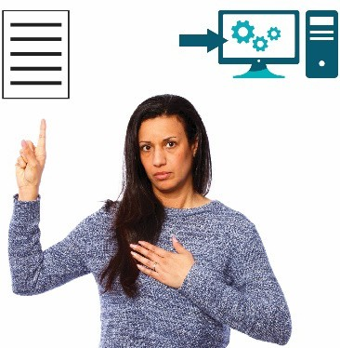 | We use the SLK codes.  Organisations only use SLK codes when they are submitting data as 1 large file or sending the data directly from their system into the Data Exchange.
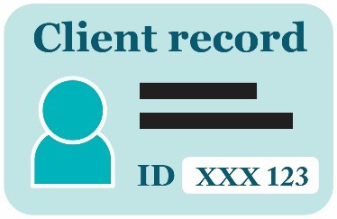 | The Data Exchange gives each client record a unique ID.  It can only have:  - letters  - numbers.
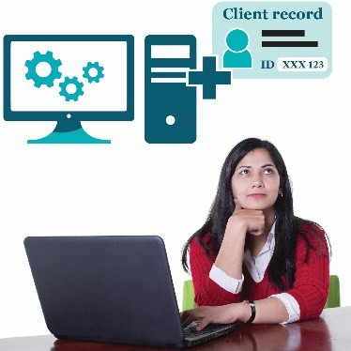 | You can enter an ID for each client record.  Or the Data Exchange can create an ID for your client records.
 | The ID should:
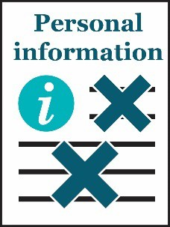 | - not include any personal information about the client
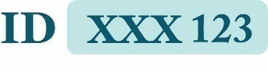 | - Just be a code made up of  - numbers  - letters.

Data you must collect
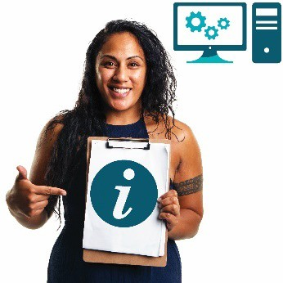 | There is some data you must:  - collect  - record in the Data Exchange.
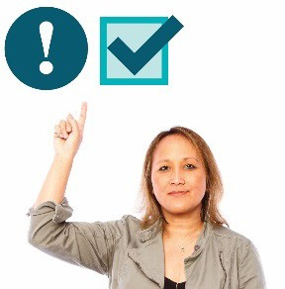 | We call this data priority requirements.
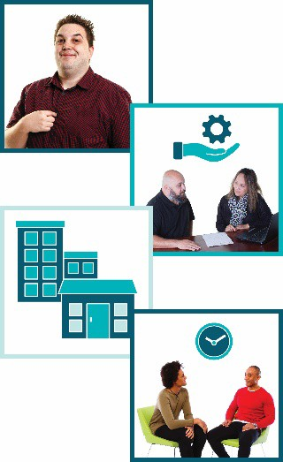 | Our priority requirements include data about:  - clients  - services  - outlets  - sessions.

Entering data about programs and activities
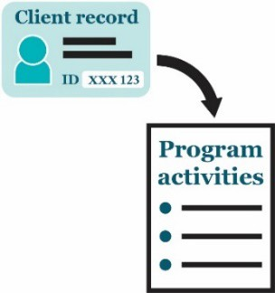 |  | Once you have created a client record, you must link it to the programs and activities the client takes part in.
 |  | The first step is to enter the case details, which include:
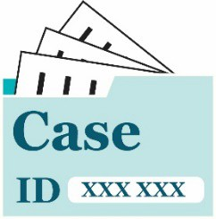 |  | - a case ID – a special code just for that case
 |  | It is important the case ID does not include any personal information about the client.
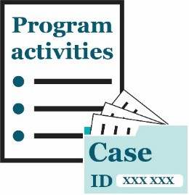 |  | - the activity the case is part of
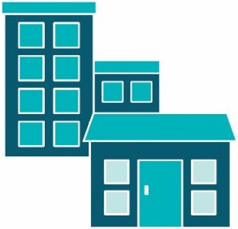 |  | - the outlet – the place where organisations deliver services to clients.
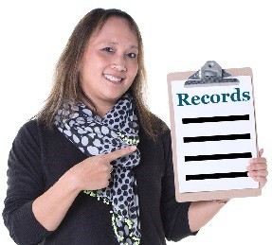 |  | - records for 1 or more clients who took part.
 |  |  | The next step is to enter the session details, which include:
 | 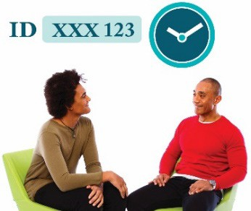 |  | - a session ID – a special code just for that session
 |  |  | It is important the session ID does not include any personal information about the client.
 |  |  | - the date of the session
 |  |  | - the type of service
 |  |  | - which clients took part
 |  |  | - how many clients took part.

Recording extra data
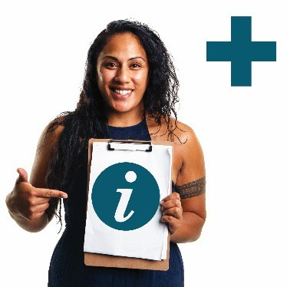 | Some programs require organisations to collect extra data. We call this the Partnership Approach data.
 | There are examples of programs that organisations need to collect extra data for on the following pages.

Commonwealth Home Support Programme
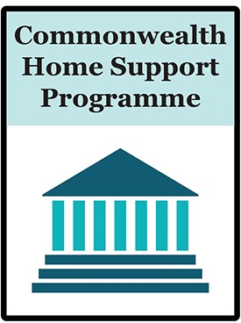 |  | The Commonwealth Home Support Programme is funded by the government.
 |  | It allows older people to receive care at home.
 |  |  | If a client uses this funding, the extra data you need to include is:
 | 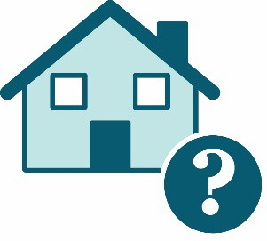 |  | - the type of home the client lives in
 | 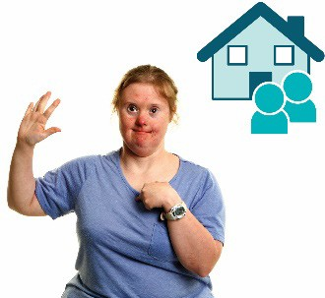 |  | - who the client lives with
 | 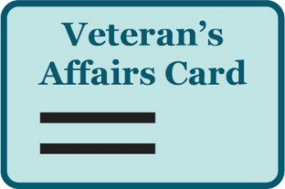 |  | - if the client has a Veteran’s Affairs card – a card for people who have worked for Australia’s defence forces
 |  |  | - if the client has a carer
 |  |  | - how much support the client uses
 |  |  | - what fees the clients were charged.

Family Law Services
 | 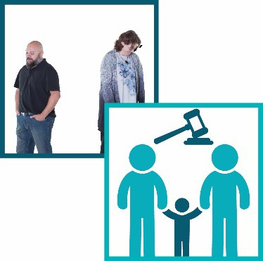 |  |  |  | Some people use the family law system if:  - they are getting a divorce  - the court is deciding who will look after their children.
 |  |  |  |  | If a client is using family law services, the extra data you can include is:
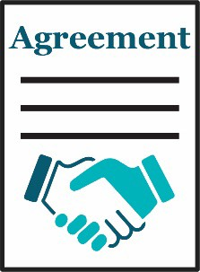 |  |  |  | - if there is an agreement between the parents about looking after the children
 |  |  |  | - what date the agreement was reached
 |  |  |  | - if someone who knows and understands the law helped with the agreement
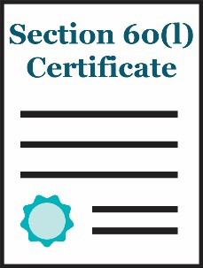 |  |  |  | - if there is a Section 60(l) certificate about the family’s work to fix the problems they are having
 |  |  | - the date the Section 60(l) certificate was issued
 |  |  | - what fees the clients were charged.

Financial Wellbeing and Capability
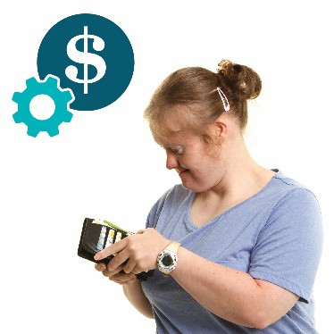 | The Financial Wellbeing and Capability program teaches people skills to manage their money better.
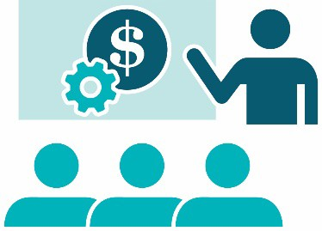 | If a client uses this program, you need to include  data about the training they have had in managing their money.

National Disability Advocacy Program
 | The National Disability Advocacy Program (NDAP) gives people with a disability support to speak  up about:  - their rights  - the issues that are important to them.
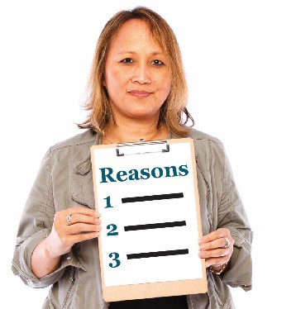 | If a client uses this program, you need to include the reason they use the advocacy service.

Getting help to use the Data Exchange
You can find training materials for the Data Exchange on our website.
dex.dss.gov.au/
 |  | The training is self-guided – you do it on your own.
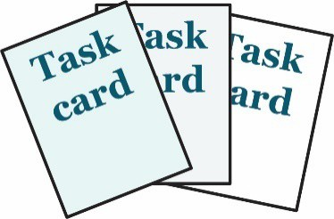 |  | We have task cards.
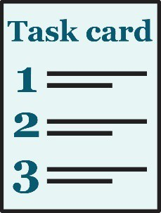 |  | The task cards take you through things you need to do in the web-portal step by step.
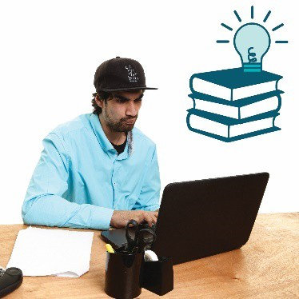 |  | We also have e-Learning modules.
 |  |  | e-Learning modules are training videos you can watch.
 | 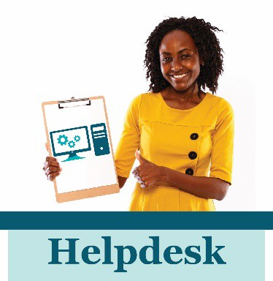 |  | The Data Exchange Helpdesk can give you technical support.
 |  |  | You can contact the Data Exchange Helpdesk by:
 |  |  | - email  dssdataexchange.helpdesk@dss.gov.au  or use our online contact form

Word list
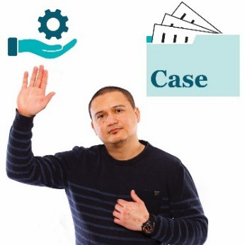 | Case  When a client takes part in 1 or more sessions of the same service, we call it a case.  We also call it a case when a group of clients use the same service.
 | Client  A client is a person who uses a service.  They use the service so they can reach a goal.
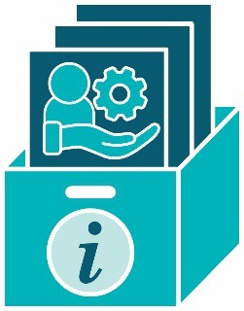 | Client level data  Client level data is the information organisations collect about each client.
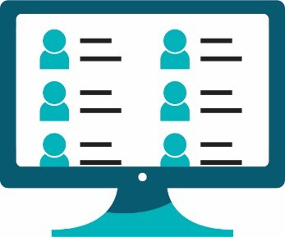 | Client records system  A client records system is a system an organisation uses to collect and store personal information about their clients.  They might use software.  Their system might be online.
 | Consent  If someone gives you their consent, they say it is ok for you to do something.
 | Delivery partners  Delivery partners are other organisations you work with to provide supports and services to your clients.
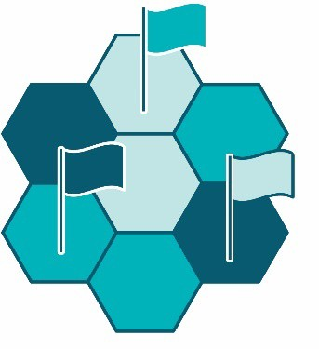 | Domains  Domains are important areas that are all related to the main topic.
 | Grant  A grant is a payment from the government or a funding agency for important work that can help others.
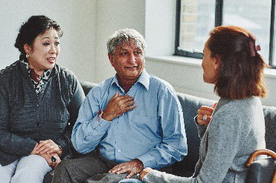 | Interpreter  An interpreter is someone who:  - speaks the language you speak  - can help you understand what someone says when they speak a different language.
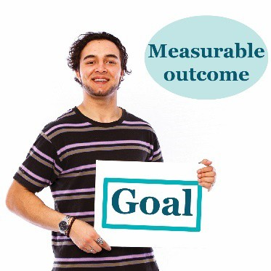 | Measurable outcome  In the Data Exchange, we measure if a client reaches their goals.  We call this a measurable outcome.
Outlet
An outlet is the place where organisations deliver services to clients.
Priority requirements
There is some data you must:
- collect
- record in the Data Exchange.
Program activities
Program activities are all the services:
- your organisation offers
- clients can choose from.
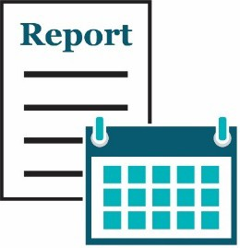 | Reporting period  We make reports about a reporting period. There are 2 reporting periods each year:  - 1 January – 30 June  - 1 July – 31 December.  Both reporting periods last for 6 months.
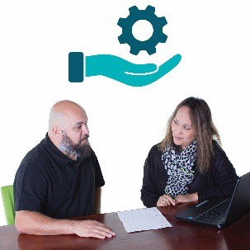 | Service  We call it a service when a client gets support from an organisation.
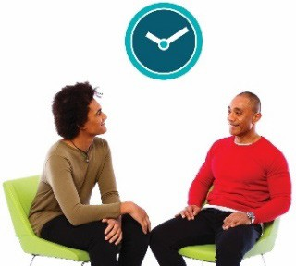 | Session  Each time a client uses a service, we call it a session.
User Access Request
A User Access Request is how you ask us if you can become a Data Exchange user.

The DSS Standard Notification
 | The DSS Standard Notification says:
 | “The information that we collect from you on this form includes your personal information. Your personal information is protected by law, including by the Commonwealth Privacy Act
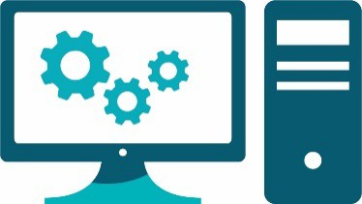 | Our use of the Data Exchange (DEX)  The client record system that we are using is an IT system called the ‘Data Exchange’. This system is hosted by the Australian Government Department of Social Services (DSS). Your personal information that is stored by DSS on the Data Exchange will only be disclosed to us for the purposes of managing your case.  DSS will only collect your personal information with your consent  Your client record can be set up to include your name and address. This assists us to manage your record, but will require DSS to collect personal information about you.  You are not required to provide your name and address to DSS. If you do not consent to the collection of your personal information, this will not affect the services provided to you. You can ask for this information to be removed by DSS at any time.
How DSS uses and discloses personal information in DEX
DSS uses your information in the Data Exchange to produce information for policy development, grants program administration, and research and evaluation purposes. DSS also shares data with organisations and agencies for reporting and research purposes. DSS de-identifies all data before use or disclosure so that it cannot be used to re-identify you.
.
 | Further information  For more information about how DSS will manage your personal information, including how you can request access or correction of your personal information or make a privacy complaint, see the privacy policy published on the DSS website.”
 | The Information Access Group created this Easy Read document using stock photography and custom images. The images may not be reused without permission. For any enquiries about the images, please visit www.informationaccessgroup.com. Quote job number 3490.

