Create and manage outlets

Task card
This task card discusses the following:
- What is an outlet?
- How to manage your outlets
- Access the ‘Manage organisation’ screen
- Add an outlet
- Add a program activity
- Start and end date information
- Bulk upload of outlets
- Editing and maintaining outlets
- How to manually update program activity start and end dates
- Step 1 – Check the start and end dates
- Step 2 – Select the outlet
- Step 3 – Amend the start and end dates
- Step 4 – Ready for approval

KEY HIGHLIGHTS
- Any sensitive information, such as a person’s home address or a protected location such as a refuge should not be recorded or included in an outlet’s name or address.
- You cannot create a new outlet that has an identical name and locality as an existing outlet or edit an outlet to mirror an existing outlet’s name and locality.
- You must assign each outlet the program activity(s) that it delivers.
- Program activities are pre-loaded from your grant agreement. You cannot select a program activity your organisation is not funded to deliver.
- Your program activity start and end date is pre-loaded from your grant agreement.
- Creation of outlet requests should occur before the close of a reporting period.
- The Data Exchange helpdesk may take up to 10 business days to approve an outlet.
- The use of * & % # @ should not be included in the outlet free text fields.

What is an outlet?
The Data Exchange Protocols describe an outlet as “the physical location from where a service is primarily being delivered”.
An outlet identifies the location where a service took place, or where staff travelled from to deliver a service. Each outlet can have different staff, service information and contact details.

Post office boxes cannot be used as an outlet address in place of a physical location.
Where a service is mobile in nature, delivered at a client’s home or sensitive location (such as a refuge), record the outlet as the nearest administrative premises where staff are based.

How to manage your outlets

Access the Manage organisation screen
From the Data Exchange web-based portal home page, select Manage organisation found in the
My Organisation menu. Refer to Figure 1.
Figure 1 - Data Exchange home page
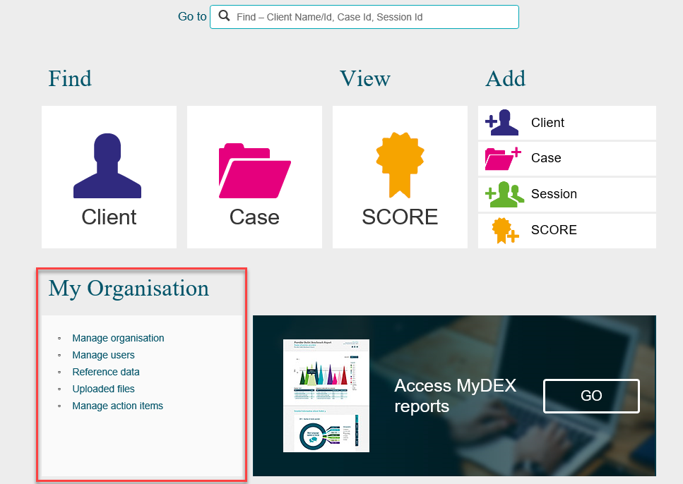
The Manage organisation screen will display with the following information. Refer to Figure 2:
- Your Organisation Details, which are pre-loaded from your grant agreement.
- Your organisation’s current Partnership Approach status.
- Outlets you have created. If this is the first time you have accessed the web-based portal, no outlets will be listed until you create them. Refer to the Add an outlet section in this document for guidance.
- Program activities your organisation is funded to deliver, which are pre-loaded from your grant agreement. This section includes the following columns:
- Start date
- End date
- Status: The default for status is Active.
- Active – the program activity is a current grant and can be reported on
- Expired – the program activity is not a current grant and can’t be reported on (tick the Show all box to display)
- Ended by lead (only visible to delivery partners) – the program activity has been ended by the lead organisation and can’t be reported on (tick the Show all box to display).
- Notification – a notification bell icon will display if a handshake request is submitted
You are able to search for and filter your outlets using the Name, Address, State, and Program activity name fields, as referred to in Figure 2 item 3.
Figure 2 - Manage organisation screen
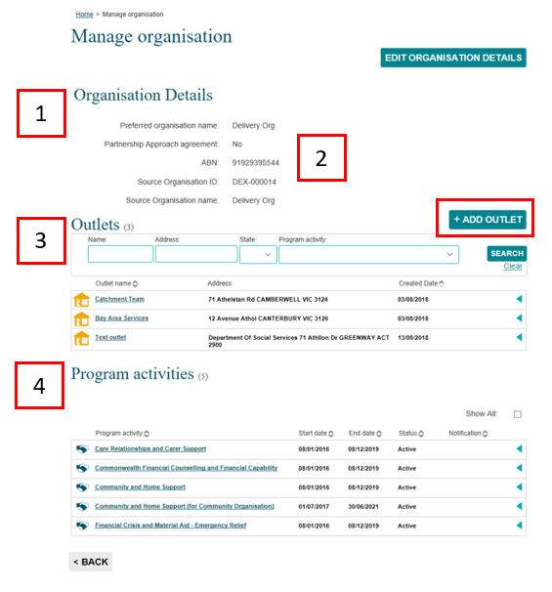

Add an outlet
At the Manage organisation screen, select +ADD OUTLET. Refer to Figure 2.

When creating an outlet name and address, DO NOT include any sensitive information such as a person’s home address or a protected location like a refuge. If you deliver services to clients' homes, use the staff’s administrative office address as the outlet.

To create an outlet for a refuge, record the record the outlet as the nearest administrative premises where staff are based, or use an address of a non-identifiable public place nearby, such as a post office, police station of shopping centre.

The Add outlet – (Organisation name) screen will display. Refer to Figure 3.
Figure 3 - Data Exchange Add outlet – (Organisation name) screen
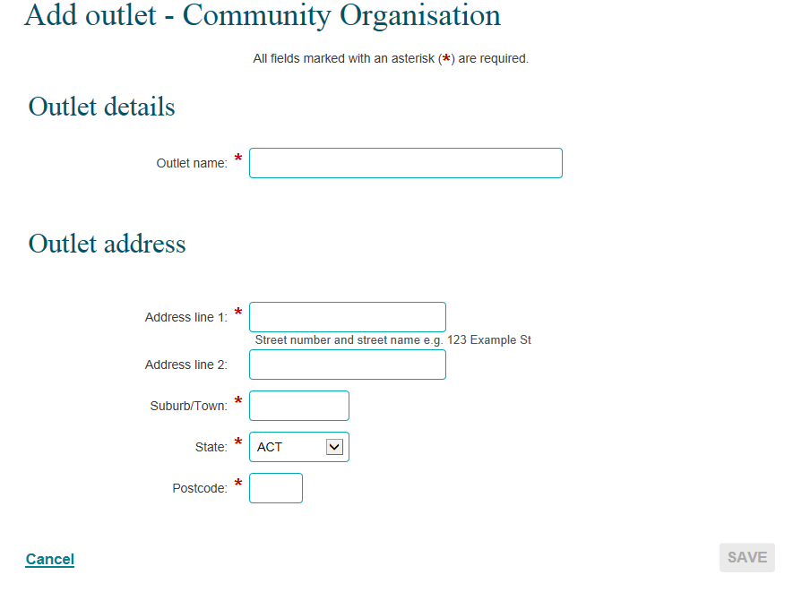
* Mandatory Field
Enter the name and address of your outlet. This name will be displayed when creating cases and within your reports.
NOTE: The use of special characters such as * & % # @ should not be included in the free text fields.

Refer to the Program Specific Guidance for outlet naming conventions for your program activity.
The Data Exchange uses third-party software to validate the outlet address. If the details do not match, select a valid address from the list that will display.
Complete all the required fields, then select SAVE.

You should not create duplicate outlets that have an identical name and address (suburb, state, postcode combination) as an existing outlet for your organisation.

If you create or edit an outlet using an existing name and address, an error will display advising you to modify the outlet name or address before you complete the outlet creation or update process.

Requests for the creation of outlet(s) must be submitted at least 10 days before the close of a reporting period. Delays in creating outlets will impact your ability to upload data.
Organisation Administrators outlets must be attached to a program activity before they are submitted to the Data Exchange helpdesk for approval.

Add a program activity
Each outlet must be assigned the program activity(s) that it delivers. You will not be able to record data at the case and session level until this step is completed.
To add a program activity, select the outlet name hyperlink found in the Manage organisation screen located under the Outlets heading. Refer to figure 4.
Figure 4 - Manage organisation screen
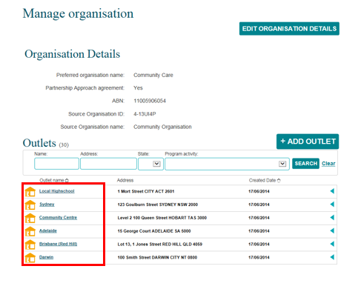
The Outlet details screen will display. Refer to figure 5.
Figure 5 - Outlet details screen
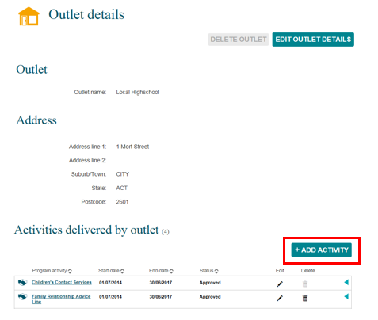
Select ADD ACTIVITY.
The Add activity screen will display. Refer to figure 6.
Figure 6 - Add activity screen
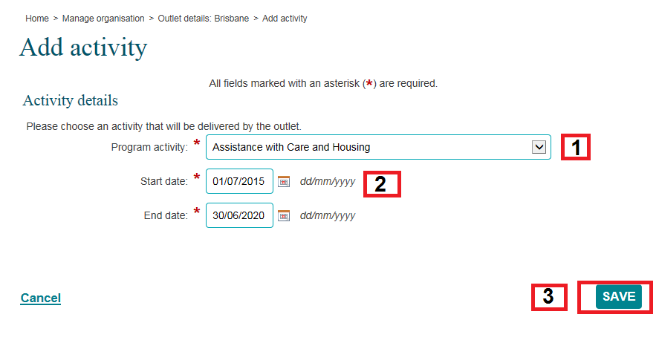

- Select a program activity from the drop-down box.
Program activities are pre-loaded from your grant agreement. You can’t select a program your organisation is not funded to deliver.
- Review and edit (if required) the start and end date.
- Select SAVE.

Start and end date information
The end date for a program activity is automatically populated with the end date value from your grant agreement you have been funded to deliver.
The Data Exchange is able to identify any date changes to your organisation’s program activity and automatically apply the updates to your outlet activity date. This automated process means Organisation Administrators will not have to manually change outlet dates when an extension to funding is granted. For example, if a program activity was extended for six months, the date would automatically update both the organisation and outlet dates for that program.
At times, you may need to amend the end date against an outlet. For example, an outlet may only operate for a short time and you want to ensure that no data can be entered against that outlet once it is no longer active. You would manually amend the end date to stop any data reported against that outlet after the set date.
More information is in the How to manually update program activity start and end dates section in this document.
Date changes will only automatically take effect on outlets that already have a matching end date to the program activity. For example, if the program activity ends on 21/12/2025, but the outlet activity end date is 30/11/2025, the outlet date will not change after an extension to the program funding. However, if the outlet and activity end date matches the program end date at 31/12/2025, then the outlet end date will automatically update to reflect the extension to program funding.

Once saved, the outlet and program activity(s) will be automatically forwarded to the Data Exchange helpdesk for approval within 10 business days. The Data Exchange helpdesk will notify you when approval occurs.
Once approved, the outlet and its program activities will display in the appropriate drop-down menus in the Data Exchange web-based portal: creating cases.
Repeat these steps for any other program activities delivered from the same outlet. Notification will be sent to the Data Exchange helpdesk for approval each time a program activity is matched to an outlet.
Repeat these steps for each outlet location you create.

Bulk upload of outlets
Organisations can create their outlets via a bulk upload process. Information on how to do this is available in the Reference Data learning module on the website. The reference data file is downloadable within the web-based portal under ‘My Organisation’. Go to the Upload methods task card for more information.
Approval of outlet creation requests via bulk uploads can be delayed by the size of the upload and larger uploads may take longer than 10 business days to approve.

Editing and maintaining outlets
An outlet name and address can be edited across any reporting period. These changes trigger the re-approval process for an outlet, which the Data Exchange helpdesk will approve within 10 business days.
Date changes will only automatically apply to outlets that have a matching end date to the program activity.
To update an outlet’s name or address:
Go to the Outlet Details screen and select EDIT OUTLET DETAILS.
The Edit Outlet Details screen will display. Refer to figure 7.
Figure 7 – Edit Outlet details screen
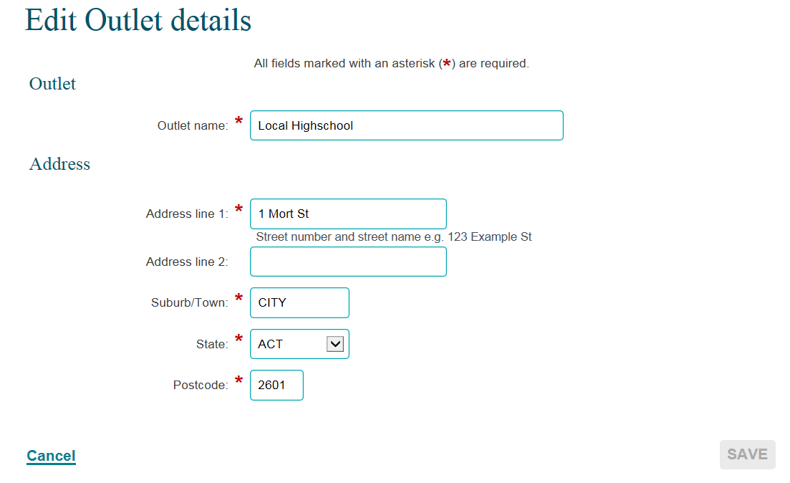
* Mandatory Fields
Amend the Outlet name and / or address details as required, then select SAVE.
NOTE: The use of * & % # @ should not be used in the free text fields.
An outlet cannot be deleted once it has data recorded against it in any reporting period.

How to manually update program activity start and end dates
If you need to update the program activity start and end dates for a particular outlet, an Organisation Administrator must update the outlet information within the Data Exchange web-based portal before you can continue entering data.
Please note: you cannot amend the program activity outlet end date beyond the end date specified in your grant agreement.

Step 1 – Check the start and end date
Your program activity start and end date is pre-populated from your grant agreement. Check that these dates match your organisation's signed grant agreement. Refer to figure 8.
Figure 8 – Start and End dates
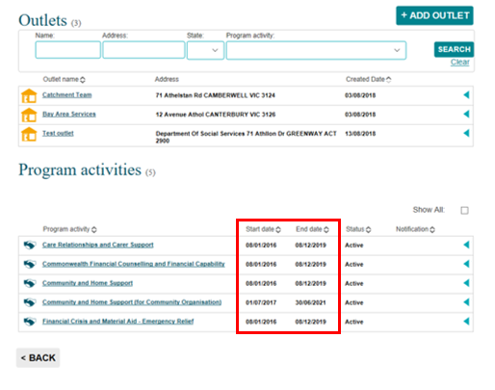

Step 2 – Select the outlet
Select the hyperlink of the outlet that needs to be updated. This example below highlights the outlet at Sydney. Refer to figure 9.
Figure 9 – Select the required outlet
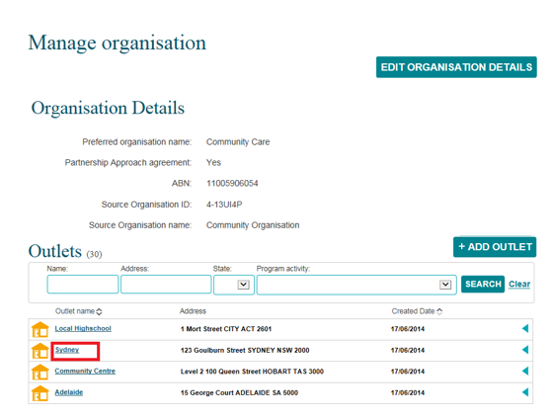
The Outlet details screen will display. Refer to figure 10.
Figure 10 – Outlet details screen
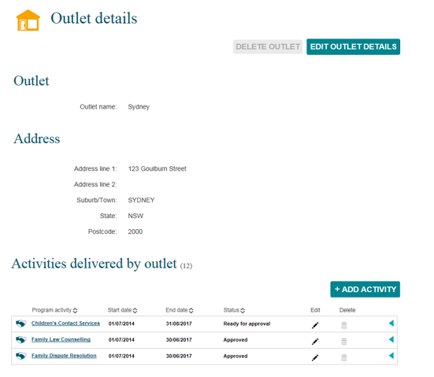

Step 3 – Amend the start and end dates
To edit the start and end dates, select found under the Activities delivered by outlet heading for the relevant program activity. Refer to figure 11.
Figure 11 – Activities delivered by outlet section
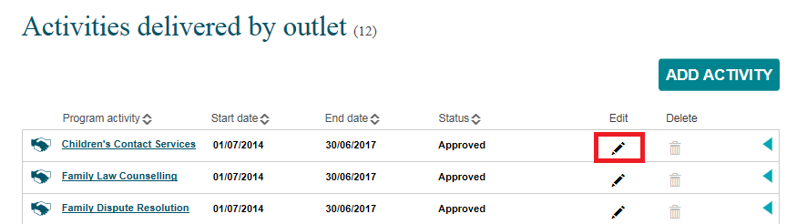

The Edit activity screen will display. Refer to figure 12.
Amend the start and end dates as required, then select SAVE.
Figure 12 – Edit activity screen
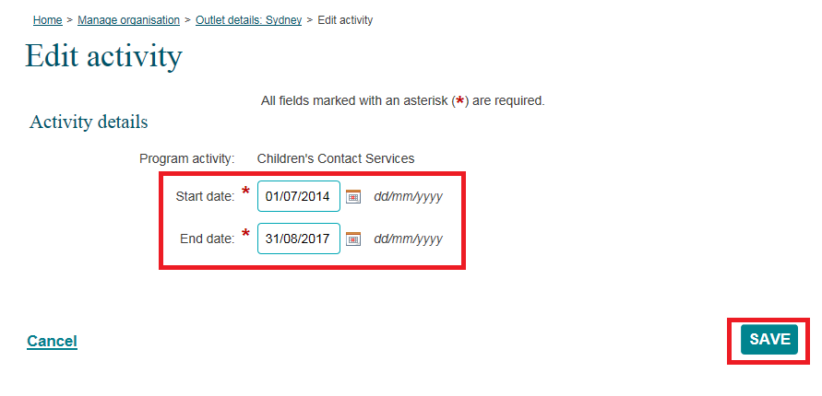
The outlet Status will now display as Ready for approval. Refer to figure 13.
Figure 13 – Ready for approval status
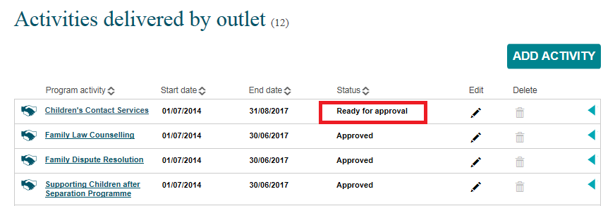

Step 4 – Ready for approval
Amending your start and/or end dates triggers an automated approval request to the Data Exchange helpdesk. Please note that this approval process is subject to normal Data Exchange helpdesk processing times.
Once approved, you will be able to continue entering data against the program activities that are updated.

You can find more information on outlets, clients, cases, and sessions on the Data Exchange Protocols, and the Training page on the website.
For system support, email the Data Exchange helpdesk or use our online contact form.

