Data Exchange – Digital Identity
As part of your Grant Agreement, you will be using Data Exchange (DEX) to report your organisation’s client data and information about your service delivery. Data Exchange helps you and your funding agency improve outcomes for individuals, families and communities. For more information about Data Exchange, please go to https://dex.dss.gov.au/what-dex.
We strongly recommend you start the process to get access as early as possible before your reporting deadlines, as it can take up to a few weeks to complete all steps.
There are three key steps you need to follow to get access to Data Exchange:

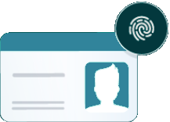 Step 1: Create your Digital Identity
Every staff member in your organisation who needs access to the Data Exchange needs to have a Digital Identity.
Download the myGovID app on your smart phone through Apple Store or Google Play and follow the steps to set up your Digital Identity.

Need help? Visit https://www.mygovid.gov.au Call 1300 287 539 (option 2)

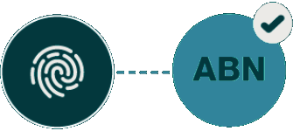 Step 2: Link your Digital Identity to your Organisation
Relationship Authorisation Manager (RAM) is the Australian Government’s authorisation service that allows you to act on behalf of an organisation. How you do this depends on your role in the organisation.
If you are the Principal Authority (generally the CEO or Director), you must link your Digital Identity to your organisation’s ABN in RAM. Once linked, you can access online services on behalf of the business and authorise others to do the same.
If you are another user, the Principal Authority or authorisation administrator needs to authorise you to act on behalf of the organisation. When you are authorised, you will receive an email from RAM to link your Digital Identity to your organisation.
Visit: https://info.authorisationmanager.gov.au/get-started
Need help? Visit https://info.authorisationmanager.gov.au Call 1300 287 539 (option 3)

Step 3: Request access to the Data Exchange
Once your Digital Identity is created and linked to your organisation in RAM, you can request access to the Data Exchange.
Complete and submit a Data Exchange Access Request: https://dex.dss.gov.au/dex-user-access-request-form.
Need help? Visit https://dex.dss.gov.au Call 1800 020 283 (option 3) Email dssdataexchange.helpdesk@dss.gov.au

What comes next?
- Setting up additional DEX users - https://dex.dss.gov.au/document/286
- Setting up outlets - https://dex.dss.gov.au/document/271
- Setting up if you have a Delivery Partner/s - https://dex.dss.gov.au/document/136

