Program Specific Guidance for the National Indigenous Australians Agency programs in the Data Exchange
Version dated 1 December 2023

Introduction
The Program Specific Guidance
The Program Specific Guidance assists service providers on entering data into the Data Exchange in a consistent way that best reflects the program activity being delivered.
Purpose of this document
This document provides policy guidance on entering data into the Data Exchange for activities funded by the National Indigenous Australians Agency (NIAA).
These guidelines should be read in conjunction with:
- Data Exchange Protocols
- Your funding agreement
- Your program guidelines
- The task cards and e-Learning modules available on the Data Exchange website.
Intended Use
This Program Specific Guidance is intended to provide practical information for managers and front-line staff to better understand the data expected for their program. It also assists them in integrating Standard Client/Community Outcome Reporting (SCORE) outcomes and partnership data collection into existing service and administrative practices.
Additionally this guide aims to provide consistency on how program data is interpreted within program activities, and support a consistent interpretation of the Data Exchange protocols across commonly funded organisations.
This document will be periodically updated to provide more detailed guidance on questions as they arise and as new programs come on board to the Data Exchange. Users of this document are encouraged to provide feedback where further guidance related to their program activity is needed.
All resources associated with the Data Exchange are available on the Data Exchange website.
The Program Specific Guidance for Commonwealth-funded programs was formerly published as:
- Protocols – Appendix B
- Program Specific Guidance for Commonwealth Agencies in the Data Exchange.

Contents
Introduction 2
DEPARTMENT OF NATIONAL INDIGENOUS AUSTRALIANS AGENCY 4
Indigenous Skills and Employment Programs 4
Indigenous Skills and Employment Program 5
Version History 9

NATIONAL INDIGENOUS AUSTRALIANS AGENCY

Indigenous Skills and Employment Program
The following program activities are included:
- Indigenous Skills and Employment Program (ISEP)

Indigenous Skills and Employment Program
Description
The Indigenous Skills and Employment Program (ISEP) will contribute to closing the gap in employment by supporting pathways to meaningful and sustainable employment for First Nations peoples, through flexible, place-based investment. ISEP projects are designed by providers in consultation with communities and key stakeholders.
Who is the primary client?
The primary clients are ISEP participants who identify as Aboriginal and/or Torres Strait Islander and are 15 years or older.
What are the key client characteristics?
As ISEP is a place-based, flexible program, the key client characteristics may vary depending on the aims of the project in each region. A core feature of the ISEP is purposeful investment based on the key priorities (outlined in the ISEP Grant Opportunity Guidelines) in the 11 NIAA regions – Arnhem Land and Groote Eylandt, Top End and Tiwi Islands, Central Australia, North Queensland, South Queensland, Western New South Wales, Eastern New South Wales, Victoria and Tasmania, South Australia, Greater Western Australia and Kimberley.
ISEP project activities align with the Regional Priorities including the identified Aboriginal and/or Torres Strait Islander cohort in each region. Clients can have local barriers to employment, aspire to acquire skills, seek employment or to advance in their careers.
Who might be considered ‘support persons’?
Recording support persons is voluntary; staff can record support persons if they feel it is relevant. Instructions on how to record them in the web-based portal can be found on the Data Exchange website.
How should cases be set up?
Cases include a free text Case ID field where the case may be given a unique name. Cases will be created at the start of the project and be outlined in the Project Monitoring Plan (PMP).
Additional cases must not be created unless approved by the NIAA.
As ISEP projects vary between regions, providers can create a case name based on the aims of their project, as shown by examples in the table below.
Examples of ISEP Project aims | Number of Cases & Case Names
A project to support 20 School-based Trainees each calendar year to gain casual work during Years 10-12. | 4 cases: 2023 / 2024 / 2025 / 2026
A project to deliver pre-employment training and employment for 100 new employees and career advancement guidance and mentoring for 150 existing staff to upgrade critical infrastructure and roadworks. | 2 cases: Existing Employees / New Employees
Once a participant is entered into a case they should never be removed, unless created in error. To protect client privacy, family names or other identifying information should not be recorded in the case ID field.

The partnership approach
Providers are not required to participate in the partnership approach and will not be required to enter any Standard Client Outcome Reporting (SCORE) data. If ISEP providers chose to use SCORE, this should be stated in their PMP.
Collecting extended data
Providers are not required to collect any extra data for cases or sessions, but certain projects may require providers to collect and record extra data fields relevant to their ISEP project. For example, if the provider’s ISEP project aims to support First Nations unemployed youth with a Certificate to find full-time employment, the provider can collect data on participants’ highest level of education/qualification and employment status to monitor progress in this activity. Extended data options include:
Client Level Data
- Homeless indicator
- Household composition
- Highest level of education / qualification
- Employment status
- Main source of income
- Income (approximate gross income and frequency)
- Is client a carer?
- NDIS eligibility
For this program activity, when should each service type be used?
When a session of service is delivered, it must be using one of the 15 service types below, which have been grouped by project aim. It is expected that not all service types will be relevant to all projects.
Service | Service type | Descriptions
PRE-EMPLOYMENT SUPPORT | Pre-employment Support Commenced | Use this service type when an ISEP participant starts with an ISEP provider with the aim of securing employment, but employment has not yet started.
 | Pre-employment Support Exit | Use this service type when an ISEP participant ceases pre-employment support activities.
EMPLOYMENT | Employment Commenced | Use this service type to record when the participant starts paid employment.
 | Employment Engagement | Use this service type when an ISEP provider interacts with an ISEP participant regarding their employment placement.  Do not use for the first and last session.
 | Employment Exit | Use this service type when an ISEP participant ceases working with an ISEP provider for employment.
TRAINING | Training Commenced | Use this service type when an ISEP participant starts with an ISEP provider with the goal to secure formal training or a qualification.
 | Training Engagement | Use this service type when an ISEP provider interacts with an ISEP participant during their training or education placement.  Do not use for the first and last session.
 | Training Outcome Achieved | Use this service type when the participant has achieved the certificate/diploma/formal training outcome.  You can use this multiple times if several training outcomes are achieved during the service period.
 | Training Exit | Use this service type when an ISEP participant ceases working with an ISEP provider for training support.
MENTORING | Mentoring Commenced | Use this service type when an ISEP participant enters into a mentoring arrangement OR as defined in the provider’s PMP.
 | Mentoring Engagement | Use this service type when an ISEP provider interacts with an ISEP participant regarding their mentoring. This might include matching a participant to a mentor, the mentoring sessions themselves, or check-ins to discuss how mentoring is going.  Do not use for the first and last session.
 | Mentoring Exit | Use this service type when an ISEP participant ceases their mentoring service.
CAREER ADVANCEMENT | Career Advance Commenced | Use this service type when an ISEP participant begins a career advancement service OR as defined in the provider’s PMP.
 | Career Advance Engagement | Use this service type when the ISEP provider interacts with an ISEP participant during their career advancement service.  Do not use for the first and last session.
 | Career Advance Exit | Use this service type when an ISEP participant ceases their career advancement service.
Using the ISEP service types
- Commenced - this service type is used at the start of the participant’s journey in each of the project streams (Pre-employment Support, Employment, Training, Mentoring, and Career Advancement). Providers should only use this once they have started working with a participant.
- Pre-employment Support Commenced - used when a provider starts delivering pre-employment support services to a participant with the aim of achieving employment, and includes job-readiness activities.
- Pre-employment Support Exit - this would typically be when a participant secures employment or when ISEP provider ceases offering support.
- Employment Commenced - used when the participant starts in a paid job.
- Engagement - used to record a session when there is meaningful contact between the provider and the participant during the activity, not including the start and finish.
- Training Outcome Achieved - used when a participant successfully completes a formal training outcome they were working towards, such as a certificate.
- Training Exit - usually entered on the same day a participant successfully completes formal training, unless the participant is still working towards another training outcome; then the provider enters this service type once all training outcomes are achieved.
- Exit – this service type is used at the end of the participant’s journey in each of the 5 project streams. Providers should only use this once they have finished working with the participant in that stream. This could be because the participant no longer needs ongoing support, or because they have disengaged with the provider for another reason. Providers should never remove participants from a case after they have received any services, even after they have ceased working with the provider.
A participant may receive services for multiple projects streams. It is important to use the correct service type for the relevant project stream. For example, if a participant is working with a provider on both training and employment, they will have a session of both Training Commenced and Employment Commenced and then ongoing sessions of Training Engagement and Employment Engagement, and eventually Training Exit and Employment Exit.

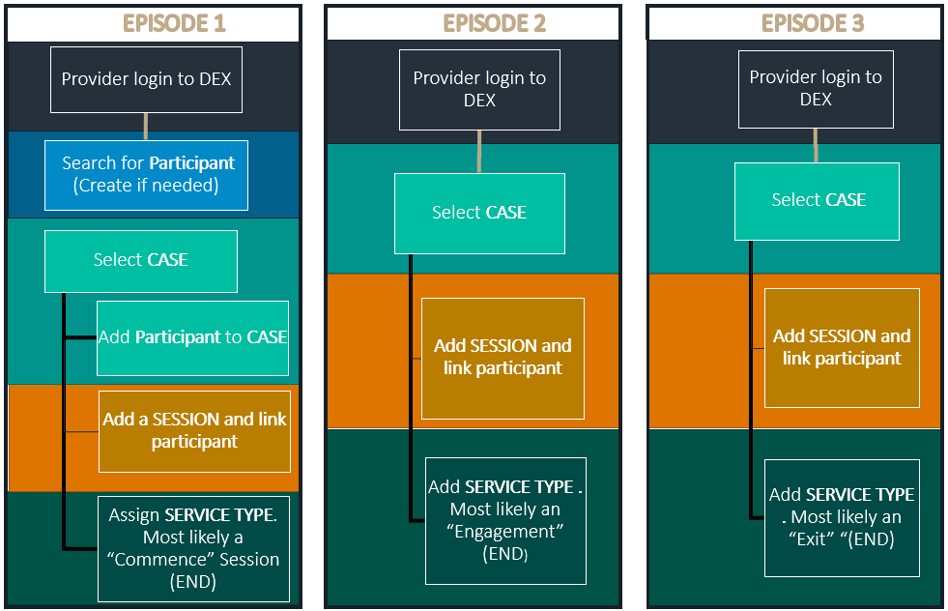

Version History

Version 1, December 2023
First publication and release of document.

