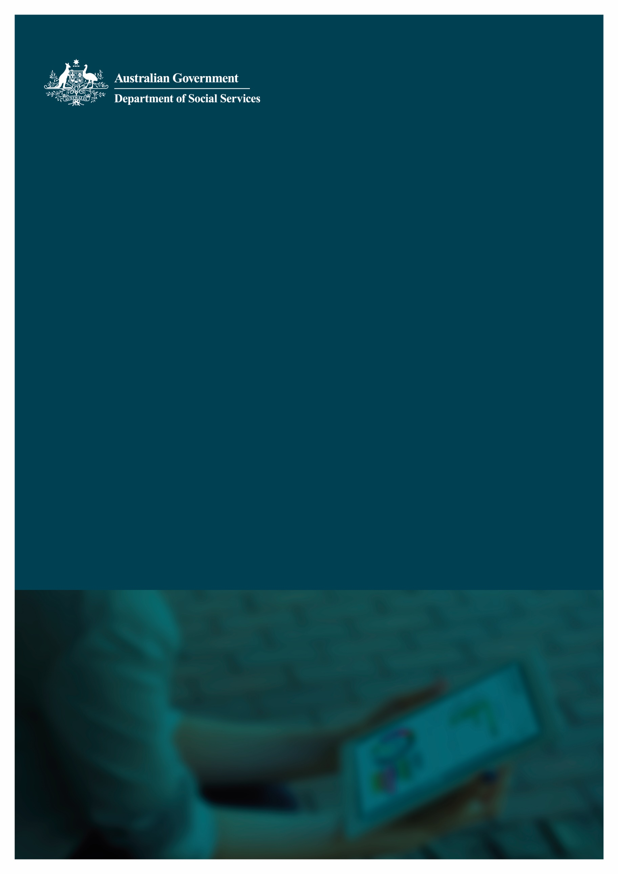
Data Exchange System
Bulk XML upload errors and explanations
Version Number: 1
Publication Date: June 2023

Bulk XML upload errors and explanations
Summary
This document outlines the most common errors a system user can encounter when they try to upload an XML file to the Data Exchange (DEX).
List of error messages
Service Type Id ____ does not exist or you do not have access to it 3
Outlet Activity Id ____ does not exist or you do not have access to it 4
Outlet Activity Id cannot be updated as the case has sessions attached to it 5
Cannot detach clients from a case until the clients have been removed from all associated sessions 5
Errors related to client and outlet addresses: 7
Address details are invalid. Please ensure the address details are correct 7
Suburb/Town, State and Postcode are valid, however, Address Line 1 and/or 2 cannot be verified 7
Invalid SLK. SLK must meet the department’s SLK generation rules 8
Client Id _____ not found 9
Client Id ____ is not associated with the case 9
Case Id ____ not found 10
The element ____ has invalid child element ____. List of possible elements expected: _ 10

Service Type Id ____ does not exist or you do not have access to it
This error message appears when a session record has a service type Id attached that is not available for that program activity.
When a program activity is added to the Data Exchange, a list of service types is allocated based on the activities being delivered. When you create a case, linked to a program activity, the allocated list of service types attaches to the case. This means all sessions linked to the case can only use the service types available.
The example at Figure 1 shows all available service type Ids (ServiceTypeId) for the ‘Children’s Contact Services’ program activity.
Figure 1
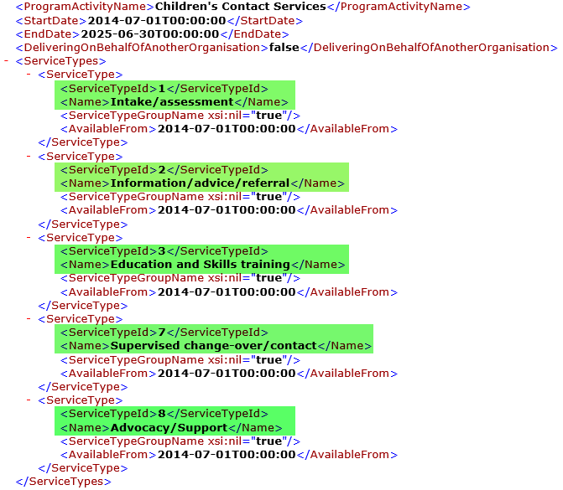
When you create a session for this program activity, DEX will only accept one of the five service types listed above. This is because not all service types are available for all sessions.
All available service types, service type Id’s, and each corresponding outlet activity for your organisation, are specified in your ‘Organisation activity and outlet data’ XML file. This file can be download from the ‘Reference data’ page of your DEX portal.

Outlet Activity Id ____ does not exist or you do not have access to it
This error message appears when an outlet activity Id has been used that is not listed as an available one for your organisation.
An outlet activity Id is created when you assign a program activity to an outlet. Once the Helpdesk approves the outlet action item, the outlet activity Id will appear in your ‘Organisation activity and outlet data’ file.
Every outlet activity Id in the Data Exchange is unique. The outlet activity Id is used at the case node to specify which outlet, and which program activity to record the case against.
The example at Figure 2 shows how the outlet activity Id (OutletActivityId) links an outlet (OutletName) and program activity (ActivityName).
Figure 2
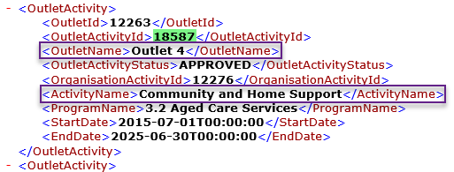
If you create a case that is delivered from ‘Outlet 4’ (the outlet name) for program activity ‘Community and Home Support’, then you need to use OutletActivityId ‘18587’ in your XML.
You can only use OutletActivityId for your organisation when uploading cases. All available outlet activities (including outlet activity ids) for your organisation are specified in your ‘Organisation activity and outlet data’ XML file which you can download from the ‘Reference data’ page of your DEX portal.

Outlet Activity Id cannot be updated as the case has sessions attached to it
This error appears when you are attempting to modify the outlet activity details for an existing case that has at least one session record under it.
You cannot modify the outlet activity once a case has a session created within it. This is to avoid inaccurate reporting.
If you wish to modify the outlet activity information for an existing case, you will need to ensure you remove any sessions associated with that case prior to doing so.
This error message will also appear if you are attempting to create a new case with an existing case Id.
Within your organisation, every case record must have a unique case Id. If you attempt to create a new case with an existing case Id, then the system attempts to update the previous case with the new details.

Cannot detach clients from a case until the clients have been removed from all associated sessions
When this error message appears there are two possible causes depending on the action you are trying to perform:
- Did you intend to remove / detach a client from a case?
You will receive this message when you are attempting to remove a client from a case record, without first removing them from a session record within that case.
If it is your intention to remove the client entirely (from session and case), then you can do so by removing them from all sessions underneath the case first. Once the client does not belong to any sessions under that case, you can then detach them from the case as well, and you will not receive this error.
- Did you not intend to remove / detach a Client from a Case?
Figure 3 shows a scenario where you have an existing DEX case (with case clients) and sessions (also with those clients as attendees).
Figure 3
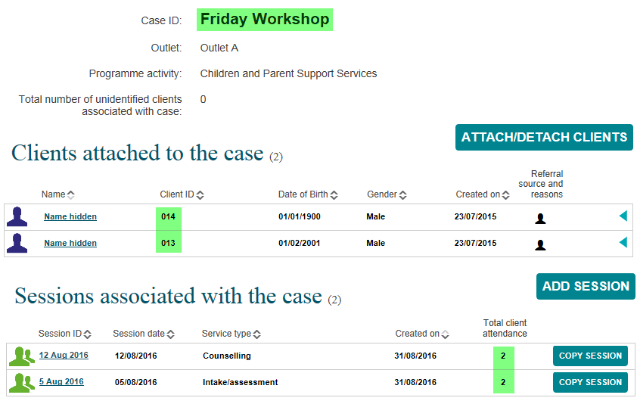
Figure 4 shows the correct node structure of adding a client to a case that has existing clients in it:
Figure 4
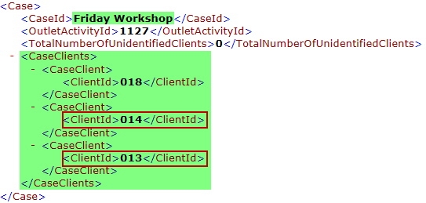
Figure 5 shows the incorrect node structure:
Figure 5
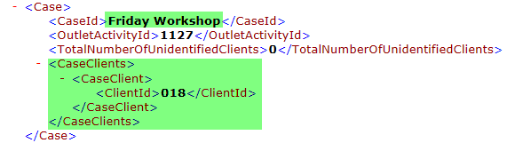
If you do not include the existing / previous clients against a case record when modifying it, the system is being instructed to add the new clients and remove all others from the record.
To avoid this error message appearing, all existing clients must be included when modifying a case.

Errors related to client and outlet addresses:
All client and outlet addresses provided to the Data Exchange are verified to ensure they are valid.
DEX uses a third party address validation tool to match address data to a Geocoded National Address File (GNAF). As part of this process, a deterministic matching method is used to offer alternatives to the DEX addresses if there is not a direct match.
Where the tool cannot validate the address information provided, it will fall back on the suburb, state, postcode (mandatory items) and validate using those mandatory data items only.
Please Note:
The GNAF is updated at regular intervals per calendar year.
This is why new and / or rezoned addresses may not be accepted at time of data submission.
The 2 most common errors are:
- Address details are invalid. Please ensure the address details are correct
- Suburb/Town, state and postcode are valid, however, address line 1 and/or 2 cannot be verified

Address details are invalid. Please ensure the address details are correct
Receiving this error message for a client address means the address validation tool could not validate the address, and no alternative was found using the information provided.
Possible reasons for triggering this error include:
- Incomplete or vague information
- Mismatch between suburb, state and postcode
If you are receiving this error, check the address you are trying to send, ensuring it is complete and correct.

Suburb/Town, State and Postcode are valid, however, Address Line 1 and/or 2 cannot be verified
For client records, you may receive a message stating:
‘Suburb/Town, State and Postcode are valid, however, Address Line 1 and/or 2 cannot be verified. Only Suburb/Town, State and Postcode have been saved. Closest matched address:___’
This is an Information message only.
You may wish to amend the street-level address, however the client profile has been created successfully.
For outlet records, you may receive a message stating:
‘Suburb/Town, State and Postcode are valid, however, Address Line 1 and/or 2 cannot be verified. No information was saved. Closest matched address:___’
This is an error message.
You will have to amend the outlet address and resubmit the file in order for the outlet to be created successfully.

Invalid SLK. SLK must meet the department’s SLK generation rules
DEX de-identifies client data using Statistical Linkage Keys (SLK), an algorithm developed by the Australian Institute of Health and Welfare (AIHW). The SLK is a method that allows DSS to link clients with the service they received through a unique key, enabling two or more records belonging to the same individual to be linked. DEX uses SLK 581 as the unique client identifier.
The SLK is a 14 digit alphanumeric code consisting of the second, third and fifth characters of a person‘s family name, the second and third letters of the person‘s given name, the day, month and year when the person was born and the gender of the person.
For example John Smith, a male born on 14th February 1971 has an SLK of: MIHOH140219711
You can access the full set of business rules for the SLK in the Bulk file upload technical specifications.
The error message ‘Invalid SLK. SLK must meet the department’s SLK generation rules’ means the SLK you are providing is not meeting the SLK rules that are summarised above and in detail in the specifications.
The SLK also needs to match any of the contributing components in your Client record on your XML file, as shown in the example at Figure 6.
Figure 6
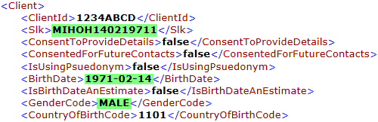
If you provide an SLK of ‘MIHOH140219711’, it tells us the client was born on ‘14th February 1971’ and is ‘male’. This information also needs to match the BirthDate and GenderCode fields provided for this client in your XML file.
If there is a mismatch between the client details and the SLK, as shown at Figure 7, this will result in the ‘Invalid SLK’ error message.
Figure 7
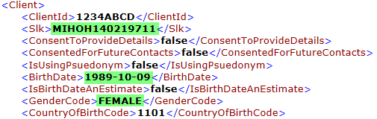
Ensuring the SLK code you are providing matches the information provided on the client record will resolve this error.

Client Id _____ not found
This error message means you are attempting to attach a client Id that does not exist to a case record.
A client must first exist in DEX before you attach them to a case.
In some instances, if you are uploading client and case nodes within the one XML, and a client record being uploaded failed to create (for one or more errors); The error message ‘Client Id ____ not found’ may be a ‘flow on’ effect from that client error.
In these instances, resolving the issue at the client record, should then in-turn resolve the case error without any further amendments.

Client Id ____ is not associated with the case
This error message means you are attempting to attach a client Id that is not yet attached to a case, to a session record.
In some instances, if you are uploading client, case, and session nodes within one XML, and a client record being uploaded fails to create (for one or more errors). The error message ‘Client Id ____ is not associated with the case’ may be a ‘flow on’ effect from that client error.
To attach a client to a session you must first attach the client to the case record that the session belongs under. If the client Id does not exist in DEX, then you cannot subsequently attach it to the case. Resolving the issue at the client record should, in-turn resolve the issues at the case and session records without any further amendments.

Case Id ____ not found
This error message means you are attempting to create a session record in a case that does not exist.
In some instances, if you are uploading case and session nodes within the one XML, and a case record being uploaded failed to create (for one or more errors); The error message ‘Case Id ____ not found’ may be a ‘flow on’ effect from that case error.
In order to create a session, a case record must first exist. In these instances, resolving the issue at the case record should, in-turn resolve the session error without any further amendments.

The element ____ has invalid child element ____. List of possible elements expected: ____
This error message appears immediately after attempting to upload an invalid or malformed XML file to DEX. As a result DEX rejected the file for processing.
This means an issue with the structure of your XML file itself exists, rather than the information that you have provided within it.
The error message will be different depending on the location within the XML file. It is important to note that DEX was unable to continue processing the XML code past this point.
For example:
‘The element Client1 has invalid child element GivenName2. List of possible elements expected: IsUsingPsuedonym3.’
1 This is the node where the error is occurring, i.e. client, case, session.
2 This is the element (field) that DEX has deemed to be incorrect or unexpected.
3 This is the field that DEX expected to see next in sequence.
The XML structure for DEX clients requires the elements to be in the following order:
<GivenName>John</GivenName>
<FamilyName>Smith</FamilyName>
<IsUsingPsuedonym>false</IsUsingPsuedonym>
Uploading in the following incorrect order would result in the error message above:
<FamilyName>Smith</FamilyName>
<GivenName>John</GivenName>
<IsUsingPsuedonym>false</IsUsingPsuedonym>
After processing the element FamilyName, DEX expects to read IsUsingPsuedonym as the next element in the sequence3. Instead, it read GivenName2 which is structurally incorrect and has resulted in the error.
The descriptive terms at ‘element__/child element__’ will point you to where in your file the issue is located. Some common examples of causes you can check are listed below:
- Incorrect order of tags
For example:
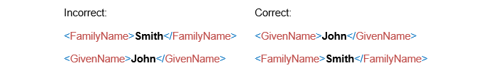
- Missing one (or more) mandatory elements
For example:
<ClientId>, <BirthDate>, <SessionId>, etc.
- Incorrectly defined parent/child nodes
For example:
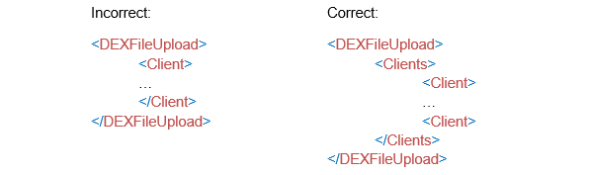If you are receiving these errors, you will need to review your XML file and ensure the XML structure is correct.
Appendix A of the Bulk File Upload Technical Specifications, provides a Sample XML for all DEX nodes (Clients, Cases, Outlets, Sessions, SessionAssessments, and ClientAssessments) and all their applicable child nodes.
You can use this sample to verify your tags are in the correct order, and that all mandatory items are included.
You can download the schema file from the ‘Reference data’ page on the Data Exchange web portal. These can help you identify if there are any structural issues in your XML file that need resolving.
If you built / generated your file from a client management system, or another third party application, it is strongly recommended that you speak to the appropriate support personnel for the system / application you are using, to help identify the issue.
Once the structure of your XML is valid, you will be able to upload your file for processing.
You can find more information on outlets, clients, cases, and sessions on the Data Exchange Protocols, and Training page.
For technical support: contact the Data Exchange Helpdesk by email at dssdataexchange.helpdesk@dss.gov.au or on 1800 020 283.

