The Data Exchange Protocols
Part 4
Recording client outcomes in the Data Exchange An Easy Read guide

 | The Australian Government Department of Social Services (DSS) wrote this guide. When you see the word ‘we’, it means DSS.
We have written this guide in an easy to read way.
We use pictures to explain some ideas.
We have written some words in bold. This means the letters are:
- thicker
- darker.
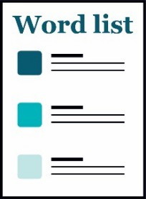 | We explain what these words mean.  There is a list of all these words on page 28.
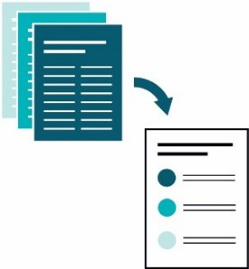 | This Easy Read guide is a summary of another document.  This means it only includes the most important ideas.
 | You can find the other document on our website at dex.dss.gov.au/
How to use this guide
You can ask for help to read this guide.
A friend, family member or support person may be able to help you.
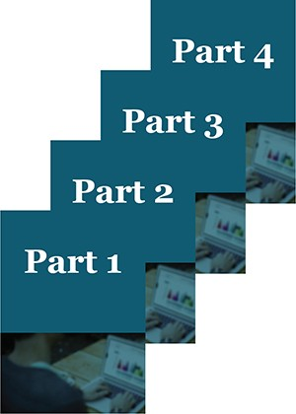 | This guide has 4 parts:  - Part 1 – What is the Data Exchange?  - Part 2 – Using the Data Exchange  - Part 3 – The Partnership Approach  - Part 4 – Recording client outcomes in the Data Exchange.
 | This is Part 4 – What is the Data Exchange?
 | You might like to read 1 part at a time.
 | You also might like to read parts of this guide while you look at the Data Exchange online.
 | If you have any questions, you can contact us. Our contact details are on page 26.
What’s in this guide?
Words we use in the Data Exchange 5
Recording SCOREs 6
Reporting from the Data Exchange 24
Getting help to use the Data Exchange 26
Word list 28

There are certain words we use in the Data Exchange.
Your organisation might use different words
It’s important to use our words when you use the Data Exchange.
We talk about all these words in Part 1 – What is the Data Exchange?
You’ll also find a list of all these words on page 28.

Words we use in the Data Exchange

Recording SCOREs
We use Standard Client Outcomes Reporting in the Data Exchange.
We call it SCORE.
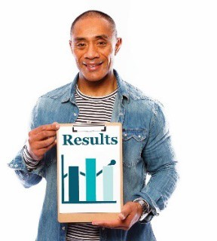 | SCORE captures the results, or outcomes, for clients during, and after, they have received a service.
 | The main reasons we use SCORE are:
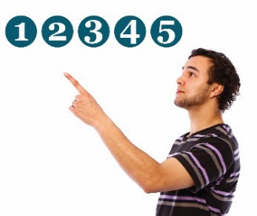 | - it has a 5-point rating scale – this means there are 5 choices
 | - many organisations already collect data just like the data we need for SCORE
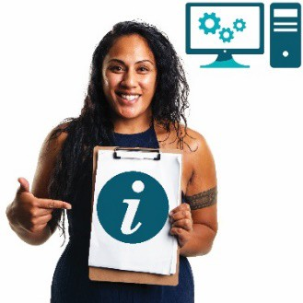 | - organisations can put their data into the Data Exchange even if they do things in different ways
 | - it gives organisations an easy way to report on what clients achieve based on the services they use.
 | If an organisation doesn’t already have a good way to record data, they can use SCORE directly with the client.
A SCORE is recorded at least twice:
- once when a client starts using a service
- 1 or more times during or after the service has been delivered.
 | SCORE measures 4 different types of outcomes:
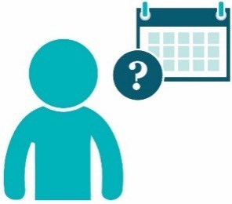 | - circumstances – what a client’s life is like now and how it changes over time
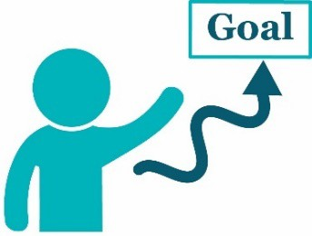 | - goals – what the person wants to achieve
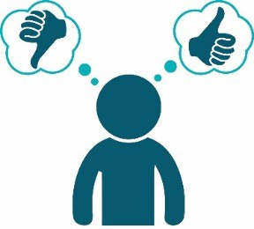 | - satisfaction – how the client felt about the service
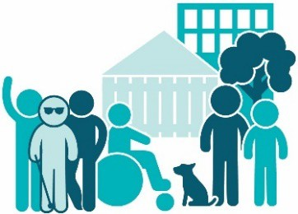 | - community – measures changes for large groups, organisations or community groups.
 | We talk about the 4 different types of outcomes on the following pages.

Circumstances
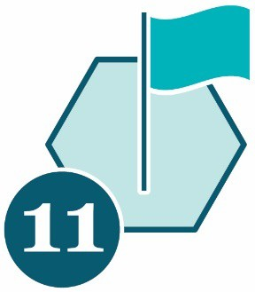 | Organisations who take part in the partnership approach might be asked to record a circumstances SCORE:  - more than 1 time  - for at least 50% of their clients.
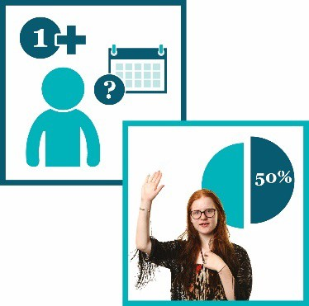 | The circumstances SCORE links to 11 domains.

The 11 circumstances domains are:
 | - physical health | 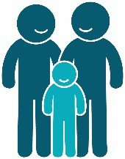 | - family functioning
 | - mental health, wellbeing and self-care | 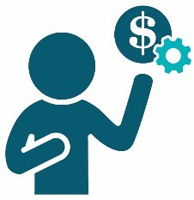 | - financial resilience
 | - personal and family safety |  | - employment
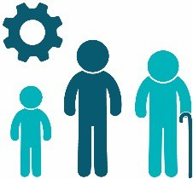 | - age-appropriate development |  | - education and skills training
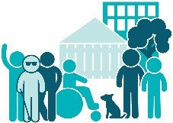 | - community participation and networks |  | - material wellbeing and basic necessities.
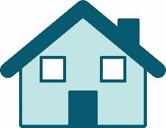 | - housing
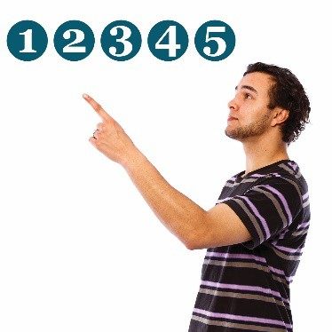 | You need to record a rating between 1 and 5 for each domain.
 | 1 – A client’s circumstances are having a very bad effect on them.
 | 2 – A client’s circumstances are having a bad effect on them.
 | 3 – A client’s circumstances are not having a big effect on them.
 | 4 – A client’s circumstances are okay for now.
 | 5 – A client’s circumstances are very good for now.
Goals
 |  | 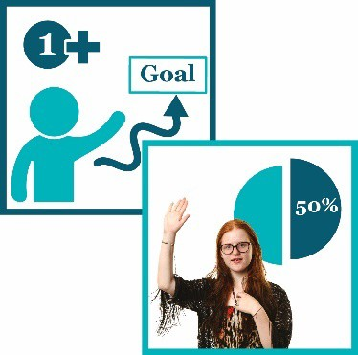 |  |  | Organisations who take part in the partnership approach might be asked to record a goals SCORE:  - more than 1 time  - for at least 50% of their clients.
 |  | 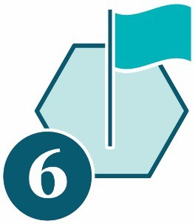 |  |  | The goals SCORE links to 6 domains.
 |  |  |  |  | The 6 goals domains are:
 |  | 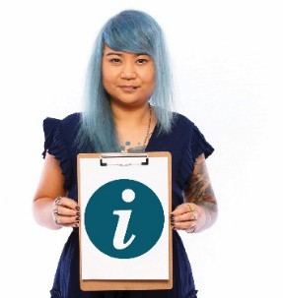 |  |  | - changed knowledge and access to information
This domain is about ways an activity helps a client find out more so they can:
- do more for themselves
- take part in their community.
 | 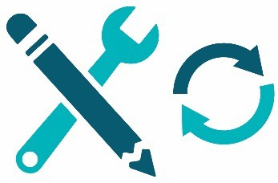 |  |  | - changed skills
This domain is about ways an activity helps a client learn new skills so they can:
- do more for themselves
- take part in their community
- be safe, happy and well.
 | 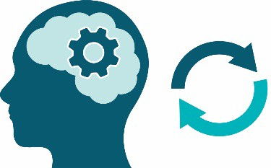 |  |  | - changed behaviours
This domain is about ways an activity helps a client change how they do things so they can:
- do more for themselves
- take part in their community
- be safe, happy and well.
 |  |  |  | - empowerment, choice and control to make own decisions
This domain is about ways an activity can help a client:
- be more confident
- have more choice and control
- make their own decisions.
 |  |  |  | - engagement with relevant support services
This domain is about ways an activity helps a client find and use services they need so they can:
- do more for themselves
- take part in their community
- be safe, happy and well.
 |  |  |  | - changed impact of immediate crisis.
This domain is about ways an activity helps a client when things go wrong so they can find better ways to:
- do more for themselves
- take part in their community
- be safe, happy and well.
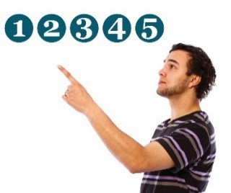 |  |  | You also need to record a rating between 1 and 5 for each domain.
 |  |  | 1 – A client hasn’t made any progress towards reaching their goals.
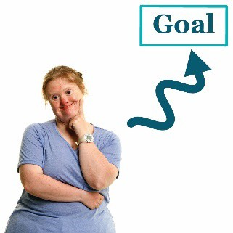 |  |  | 2 – A client has only made a little bit of progress towards reaching their goals.
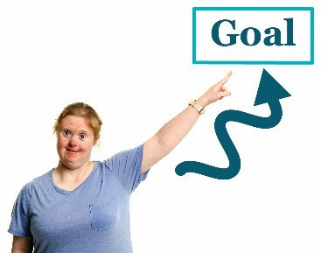 |  |  | 3 – A client has made some progress towards reaching their goals.
 |  |  | 4 – A client has made good progress towards reaching their goals.
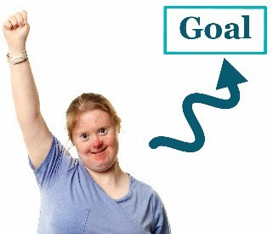 |  |  | 5 – A client has reached their goals.
Satisfaction
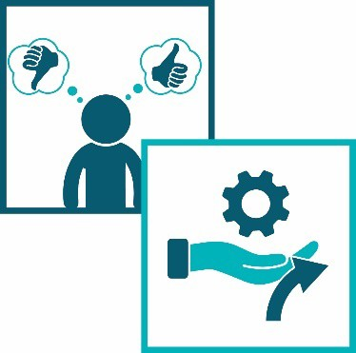 |  | Organisations who take part in the partnership approach might be asked to record a satisfaction SCORE:  - once  - when the service ends.
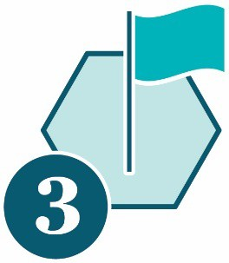 |  | The satisfaction SCORE links to 3 domains.
 |  | Each domain is a statement a client could make about the service they have used.
 |  |  | The 3 satisfaction domains are:
- The service:
  - listened to me
  - understood my issues.
 |  |  | - I am satisfied with the service I got.
 | 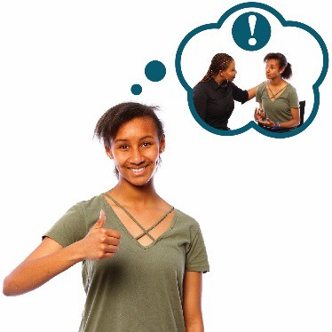 |  | - Now I am better at dealing with the issues I need support with.
You also need to record a rating between 1 and 5 for each domain.
1 – The client strongly disagrees with the statement.
2 – The client disagrees with the statement.
3 – The client neither agrees or disagrees with the statement.
4 – The client agrees with the statement.
5 – The client strongly agrees with the statement.
It is important to collect data about client satisfaction in a way that makes clients feel:
- safe
- comfortable
- they can choose if they want to take part.
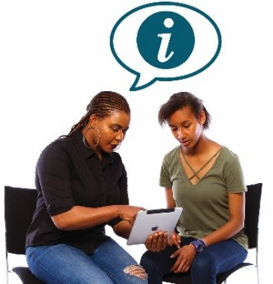 | You must make sure clients understand that you need the information so you can make your services better.
 | Clients should be able to tell you what they think without you knowing who they are.
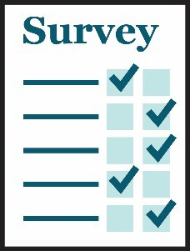 | Surveys are a good way to do this.
Community
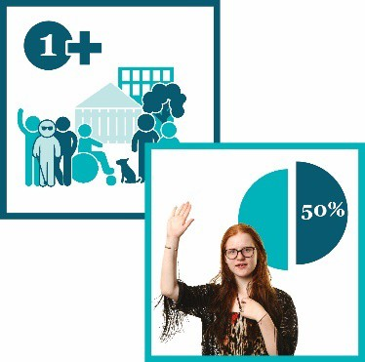 |  | Organisations who take part in the partnership approach might be asked to record a community SCORE:  - more than 1 time  - for at least 50% of their clients.
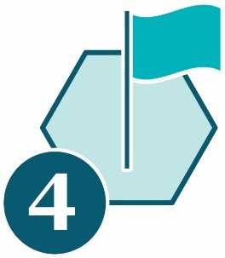 |  | The community SCORE links to 4 domains.
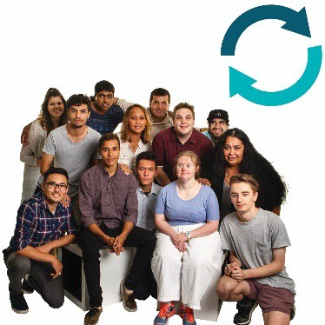 |  | Each domain is about changes that a group or the whole community can experience.
 |  | The domains are not about each client’s experience.
 |  |  | The 4 community domains are:
 | 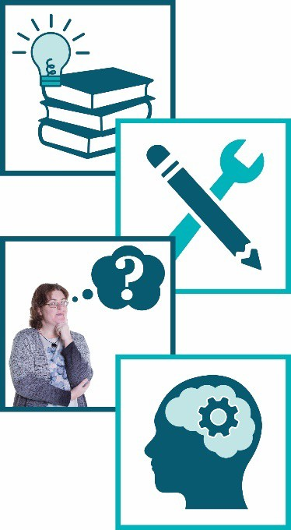 |  | - Changes in groups or communities’:  - knowledge  - skills  - attitudes – what people think and believe  - behaviours – what people do
 |  |  | - The organisation knows more and does things in better ways so they can better meet the community’s needs.
- The community is strong and connected so it can better meet the needs of:
  - clients
  - the whole community.
 |  |  | - The community works together and everyone gets along.
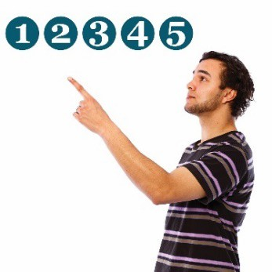 | You also need to record a rating between 1 and 5 for each domain.
1 – The community has made no change in how well they can meet the needs of:
- clients
- the community.
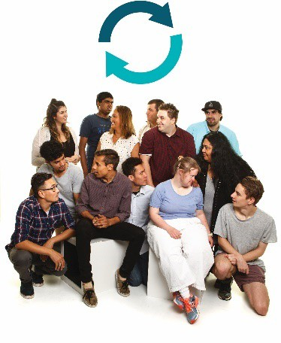 | 2 – The community has made very few changes in how well they can meet the needs of:  - clients  - the community.  The community is showing signs that they might be able to deal with the issues.
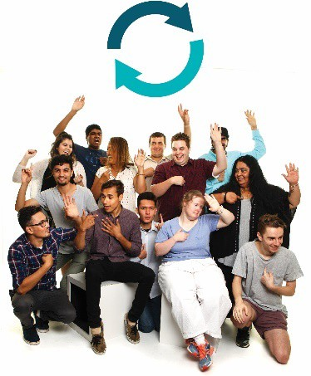 | 3 – The community has made some changes in how well they can meet the needs of:  - clients  - the community.  The community is showing signs that they can deal with the issues.
4 – The community has made many changes in how well they can meet the needs of:
- clients
- the community.
5 – The community has made a lot of good changes in how well they can meet the needs of:
- clients
- the community.

 | Your organisation might already have a good way to record client outcomes.
 | If so, you can keep using the system you have.
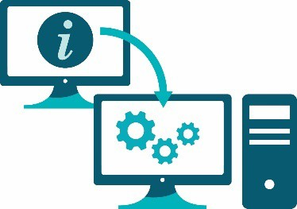 | We have a tool that can help you transfer your outcomes data onto the Data Exchange.
 | It’s called a Translation Matrix.
You can find it on the Data Exchange website.
dex.dss.gov.au/

Reporting from the Data Exchange
 | You can access reports based on the data you record in the Data Exchange.
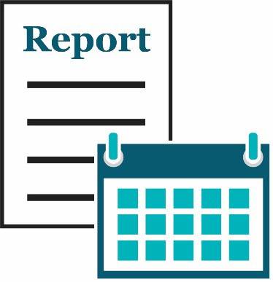 | These reports can be about each reporting period.
 | The reports update every 24 hours.
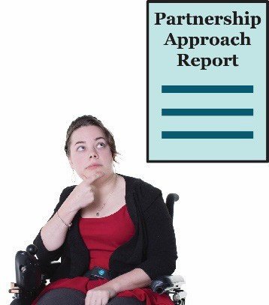 | You can also access partnership approach reports if you enter partnership approach data.
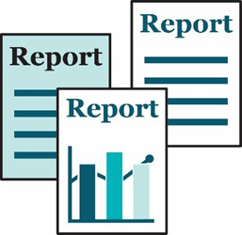 | Organisations that take part in the partnership approach can access a range of detailed reports.
These reports can give you important information about:
- service delivery
- client outcomes.

Getting help to use the Data Exchange
You can find training materials for the Data Exchange on our website.
dex.dss.gov.au/
 |  | The training is self-guided – you do it on your own.
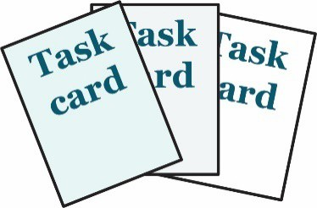 |  | We have task cards.
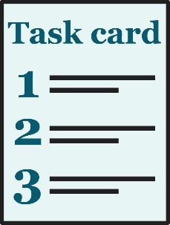 |  | The task cards take you through things you need to do in the web-portal step by step.
 |  | We also have e-Learning modules.
 |  |  | e-Learning modules are training videos you can watch.
 |  |  | The Data Exchange Helpdesk can give you technical support.
 |  |  | You can contact the Data Exchange Helpdesk by:
- email
dssdataexchange.helpdesk@dss.gov.au
- by phone
1800 020 283.

Word list
Case
When a client takes part in 1 or more sessions of the same service, we call it a case.
We also call it a case when a group of clients use the same service.
Client
A client is a person who uses a service.
They use the service so they can reach a goal.
 | 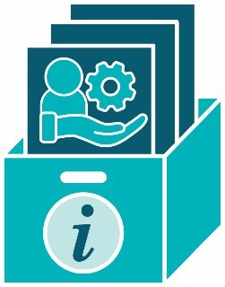 |  | Client level data  Client level data is the information organisations collect about each client.
 | 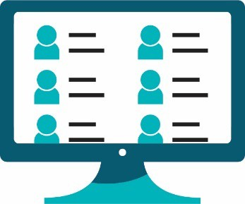 |  | Client records system  A client records system is a system an organisation uses to collect and store personal information about their clients.  They might use software. Their system might be online.
Consent
If someone gives you their consent, they say it is ok for you to do something.
Delivery partners
Delivery partners are other organisations you work with to provide supports and services to your clients.
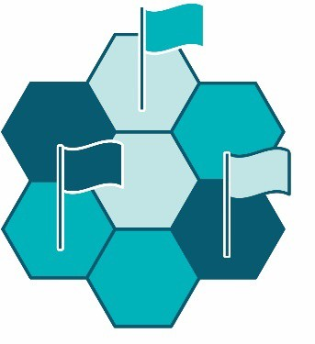 |  | Domains  Domains are important areas that are all related to the main topic.
Grant
A grant is a payment from the government or a funding agency for important work that can help others.
Interpreter
An interpreter is someone who:
- speaks the language you speak
- can help you understand what someone says when they speak a different language.
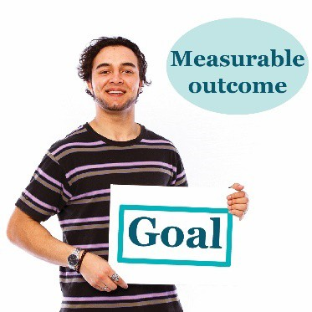 |  | Measurable outcome  In the Data Exchange, we measure if a client reaches their goals.  We call this a measurable outcome.
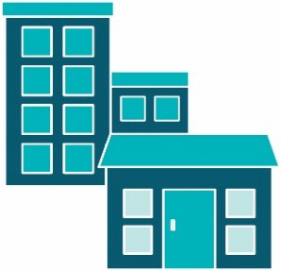 |  | Outlet  An outlet is the place where organisations deliver services to clients.
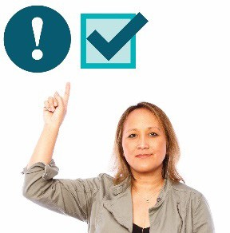 |  | Priority requirements  There is some data you must:  - collect  - record in the Data Exchange.
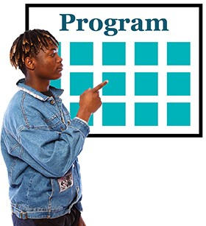 |  | Program activities  Program activities are all the services:  - your organisation offers  - clients can choose from.
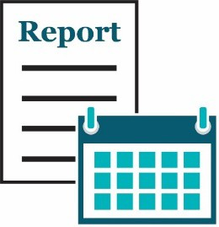 |  | Reporting period  We make reports about a reporting period. There are 2 reporting periods each year:  - 1 January – 30 June  - 1 July – 31 December.  Both reporting periods last for 6 months.
Service
We call it a service when a client gets support from an organisation.
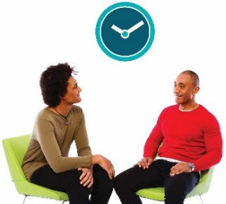 |  | Session  Each time a client uses a service, we call it a session.
User Access Request
A User Access Request is how you ask us if you can become a Data Exchange user.
The Information Access Group created this Easy Read document using stock photography and custom images. The images may not be reused without permission. For any enquiries about the images, please visit www.informationaccessgroup.com. Quote job number 3490.

