The Data Exchange Protocols
Part 3
The Partnership Approach An Easy Read guide

 | The Australian Government Department of Social Services (DSS) wrote this guide. When you see the word ‘we’, it means DSS.
We have written this guide in an easy to read way.
We use pictures to explain some ideas.
We have written some words in bold. This means the letters are:
- thicker
- darker.
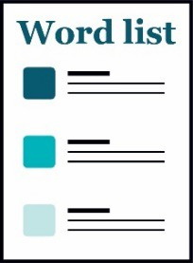 | We explain what these words mean.  There is a list of all these words on page 20.
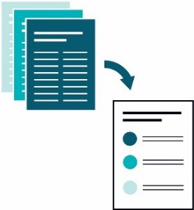 | This Easy Read guide is a summary of another document.  This means it only includes the most important ideas.
 | You can find the other document on our website at dex.dss.gov.au/
How to use this guide
You can ask for help to read this guide.
A friend, family member or support person may be able to help you.
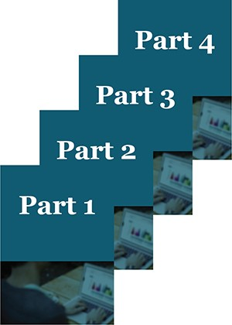 | This guide has 4 parts:  - Part 1 – What is the Data Exchange?  - Part 2 – Using the Data Exchange  - Part 3 – The Partnership Approach  - Part 4 – Recording client outcomes in the Data Exchange.
 | This is Part 3 – What is the Data Exchange?
 | You might like to read 1 part at a time.
 | You also might like to read parts of this guide while you look at the Data Exchange online.
 | If you have any questions, you can contact us. Our contact details are on page 18.
What’s in this guide?
Words we use in the Data Exchange 5
Taking part in the partnership approach 6
Collecting partnership approach data 7
Getting help to use the Data Exchange 18
Word list 20

Words we use in the Data Exchange
There are certain words we use in the Data Exchange.
Your organisation might use different words
It’s important to use our words when you use the Data Exchange.
We talk about all these words in Part 1 – What is the Data Exchange?
You’ll also find a list of all these words on page 20.

Taking part in the partnership approach
The partnership approach includes more sections you can work through with your clients that relate to the funded activity you are delivering.
If organisations share data, we can all learn more about how and why programs get good results.
To make sure this data is useful, organisations need to record data in the same way for all their activities.

Collecting partnership approach data
 | For the partnership approach, you can record data about the reasons why clients need support.
 | The extra data you can include is about whether the client is trying to:
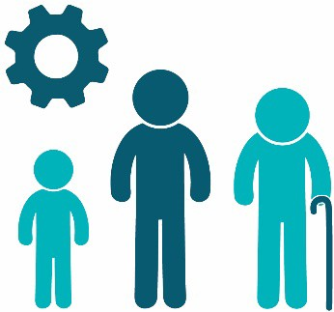 | - reach a level of development closer to their age – we call this age-appropriate development
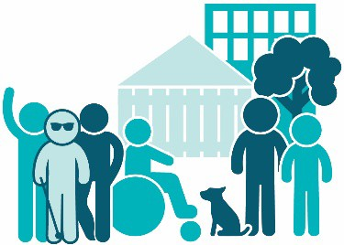 | - take part in their community and connect with other people – we call this community participation and networks
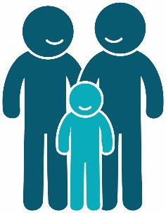 | - fit in well with their family – we call this family functioning
 | - learn how to look after their money – we call this financial resilience
 | - find work or get a job – we call this employment
 | - learn and develop new skills – we call this education and skills training
 | - make it easier to get the things they need in their daily life – we call this material wellbeing and basic necessities
 | - live in a home where they are safe and happy – we call this housing
 | - look after their mental health – we call this mental health, wellbeing and self-care
 | - stay safe – we call this personal and family safety
 | - become fit and healthy – we call this physical health.
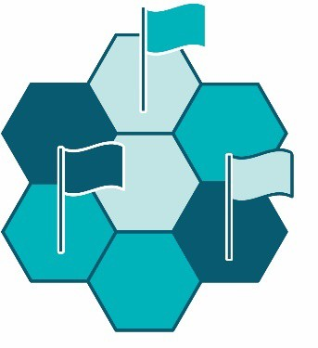 | We call these areas domains.
 | For the partnership approach, you can record data about the main reasons a client needs support.
The Data Exchange gives you a list of 10 reasons to choose from.
1 of these will be the primary reason for seeking assistance.
You can also record 1 or more other reasons the client needs support.
We call these secondary reasons for seeking assistance.
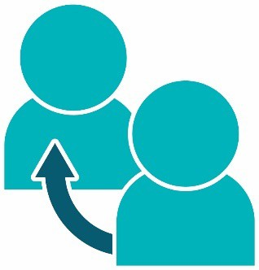 | For the partnership approach, you can record data about the way a client found about your organisation.  We call this the referral source.
 | This data helps us:
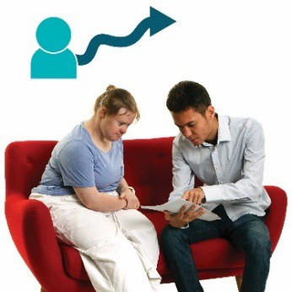 | - understand the paths clients follow when they need a service
 | - find good ways to connect clients with activities that meet their needs.
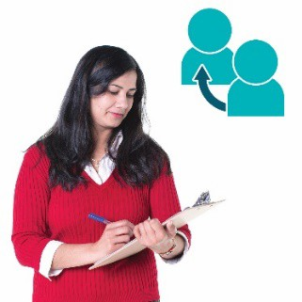 | For the partnership approach, you can record data about times when you have sent a client to get support from another organisation.  We call these referrals to other services.
 | You can record whether the client went to:
 | - another service your organisation offers
 | - a different organisation to get the service they need.
 | You can also include the reason you made referrals to other services, such as the client needed to get better results in 1 or more of the domains from the list above.

Extra data for the partnership approach
 | You can include extra data for the partnership approach, such as:
 | if they are a carer for another person.
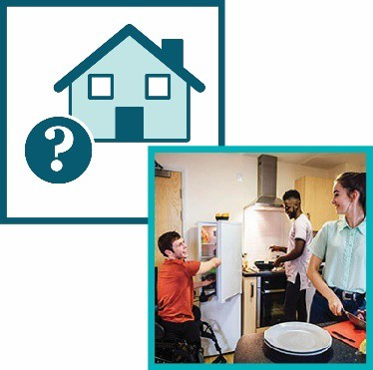 | - the type of home a client lives in and who a client lives with
 | - what level of education a client has reached
 | - if a client works or has a job
 | - how a client gets or earns money
 | - how much a client earns
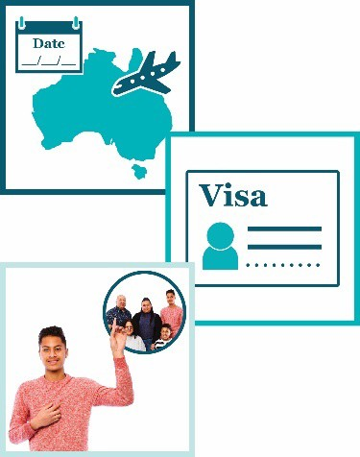 | - details about their CALD background, such as:  - the date they first arrived in Australia  - what type of visa they have  - their family background.
You can include extra data about:
- a client’s housing situation
- if a client is at risk of becoming homeless.
 | A client may be at risk of becoming homeless if the home they live in now:
 | - is not safe for them
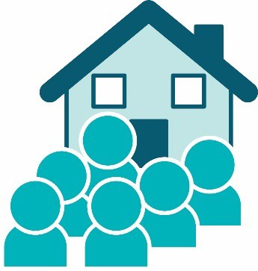 | - has too many people living in it
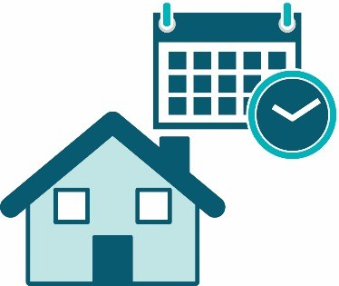 | - is only meant to be their home for a short time.
When you enter the data, the options you can choose from are:
- Yes
- No
- At risk.
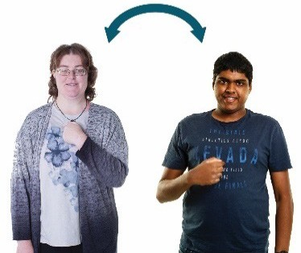 | You can include extra data in your cases about how different clients are connected to each other.
 | The options you can choose from are:
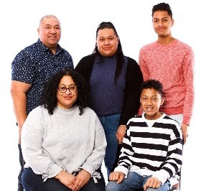 | - family – they are part of the same family
 | - community event – they did the same activity
 | - peer support group – they use the same services
 | - couple – they are a romantic couple or married
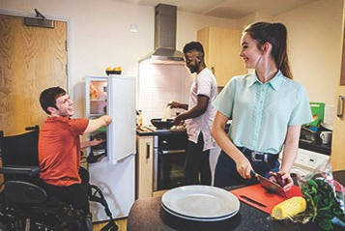 | - cohabitant – they live in the same home.
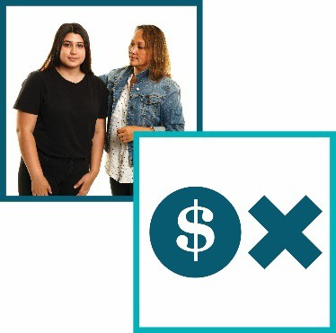 | You can include extra data about clients who:  - provide care and support to a family member or friend with a disability or health problem  - don’t get paid for the care and support they provide.
 | You can also include extra data about clients who:
 | - take part in the NDIS
 | - don’t speak English and might need an interpreter.
An interpreter is someone who:
- speaks the language you speak
- can help you understand what someone says when they speak a different language.

Service settings
 | You can also include extra data about the place where clients goes to receive their service.
 | The options you can choose from are:
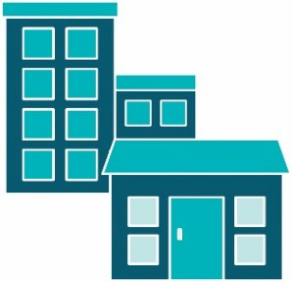 | - your organisation’s office or outlet
 | - the client’s home
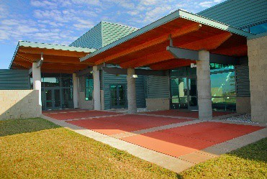 | - a community venue – a place or space in the community for anyone to use
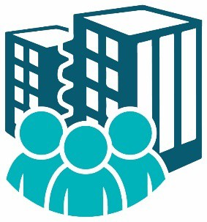 | - another organisation’s office or outlet
 | - a healthcare facility – a doctor’s office, hospital, mental health or aged care facility
 | - an education facility – a school or university
 | - a justice facility – a prison or jail, a police station or a court of law
 | - telephone – over the phone or voice chat
 | - video – a video interaction with another person
 | - online service – a virtual service, such as webinars, online training, or online chat.

Getting help to use the Data Exchange
You can find training materials for the Data Exchange on our website.
dex.dss.gov.au/
 | The training is self-guided – you do it on your own.
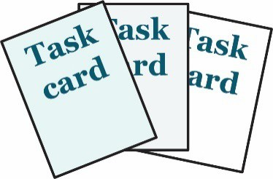 | We have task cards.
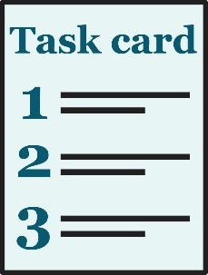 | The task cards take you through things you need to do in the web-portal step by step.
 | We also have e-Learning modules.
 | e-Learning modules are training videos you can watch.
 | The Data Exchange Helpdesk can give you technical support.
 | You can contact the Data Exchange Helpdesk by:
- email
dssdataexchange.helpdesk@dss.gov.au
- by phone
1800 020 283.

Word list
Case
When a client takes part in 1 or more sessions of the same service, we call it a case.
We also call it a case when a group of clients use the same service.
Client
A client is a person who uses a service.
They use the service so they can reach a goal.
 | 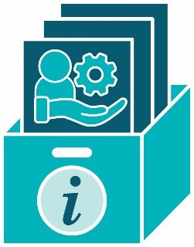 |  | Client level data  Client level data is the information organisations collect about each client.
 | 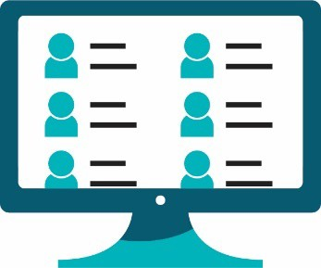 |  | Client records system  A client records system is a system an organisation uses to collect and store personal information about their clients.  They might use software. Their system might be online.
Consent
If someone gives you their consent, they say it is ok for you to do something.
Delivery partners
Delivery partners are other organisations you work with to provide supports and services to your clients.
Domains
Domains are important areas that are all related to the main topic.
Grant
A grant is a payment from the government or a funding agency for important work that can help others.
Interpreter
An interpreter is someone who:
- speaks the language you speak
- can help you understand what someone says when they speak a different language.
 | 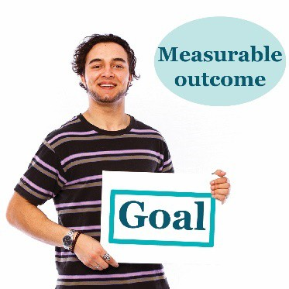 |  | Measurable outcome  In the Data Exchange, we measure if a client reaches their goals.  We call this a measurable outcome.
Outlet
An outlet is the place where organisations deliver services to clients.
 | 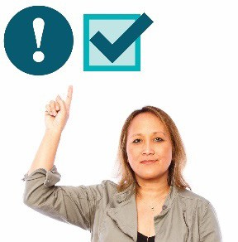 |  | Priority requirements  There is some data you must:  - collect  - record in the Data Exchange.
 | 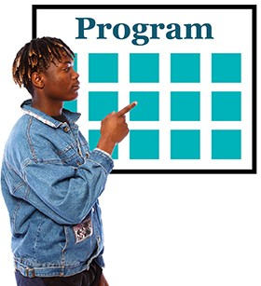 |  | Program activities  Program activities are all the services:  - your organisation offers  - clients can choose from.
 | 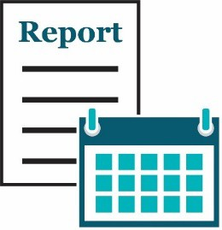 |  | Reporting period  We make reports about a reporting period. There are 2 reporting periods each year:  - 1 January – 30 June  - 1 July – 31 December.  Both reporting periods last for 6 months.
Service
We call it a service when a client gets support from an organisation.
Session
Each time a client uses a service, we call it a session.
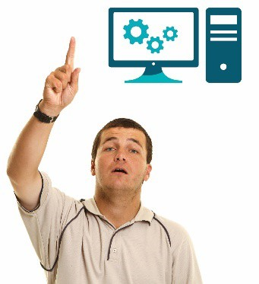 |  | User Access Request  A User Access Request is how you ask us if you can become a Data Exchange user.
The Information Access Group created this Easy Read document using stock photography and custom images. The images may not be reused without permission. For any enquiries about the images, please visit www.informationaccessgroup.com. Quote job number 3490.

