The Data Exchange Protocols
Part 1
What is the Data Exchange? An Easy Read guide

 | The Australian Government Department of Social Services (DSS) wrote this guide. When you see the word ‘we’, it means DSS.
We have written this guide in an easy to read way.
We use pictures to explain some ideas.
We have written some words in bold. This means the letters are:
- thicker
- darker.
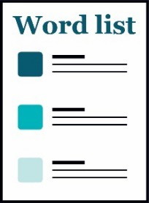 | We explain what these words mean.  There is a list of all these words on page 18.
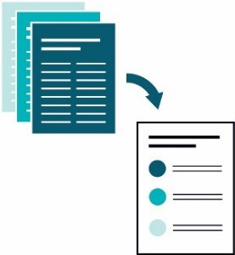 | This Easy Read guide is a summary of another document.  This means it only includes the most important ideas.
 | You can find the other document on our website at dex.dss.gov.au/
How to use this guide
You can ask for help to read this guide.
A friend, family member or support person may be able to help you.
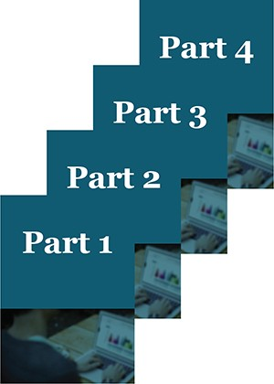 | This guide has 4 parts:  - Part 1 – What is the Data Exchange?  - Part 2 – Using the Data Exchange  - Part 3 – The Partnership Approach  - Part 4 – Recording client outcomes in the Data Exchange.
 | This is Part 1 – What is the Data Exchange?
 | You might like to read 1 part at a time.
 | You also might like to read parts of this guide while you look at the Data Exchange online.
 | If you have any questions, you can contact us. Our contact details are on page 16.
What’s in this guide?
What is the Data Exchange? 5
What is the Data Exchange Framework? 8
The Data Exchange Protocols 9
Words we use in the Data Exchange 10
Getting help to use the Data Exchange 16
Word list 18

What is the Data Exchange?
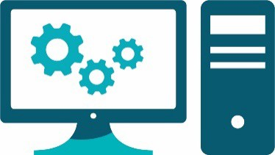 | The Data Exchange is a computer system.
 | We use it to share data and information.
 | It is managed by the Australian Government Department of Social Services (DSS).
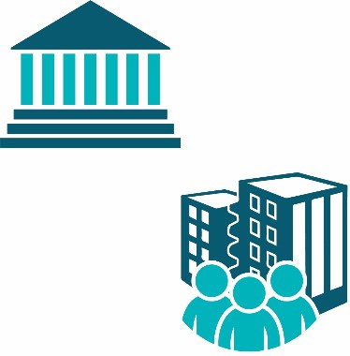 | It is used by:  - government departments and agencies  - community organisations.
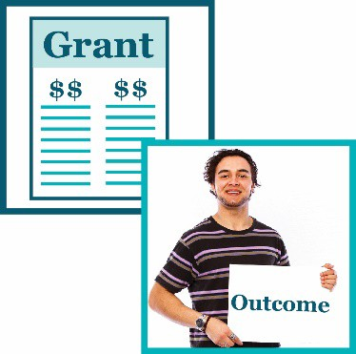 | They use it to share information about:  - grants  - client outcomes.
 | A grant is a payment from the government or a funding agency for important work that can help others.
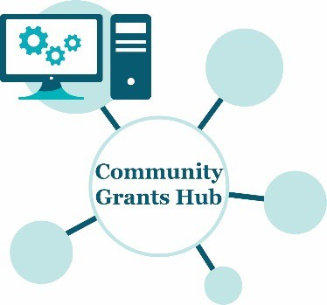 | The Data Exchange is part of the Community Grants Hub.
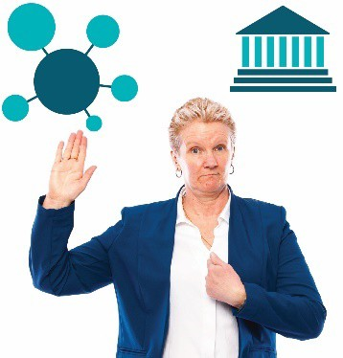 | The Community Grants Hub is an online system run by the government.  Organisations go onto the Hub to apply for grants.
 | If an organisation receives a grant to help people and communities, we ask them to use the Data Exchange.
 | They use the Data Exchange to:
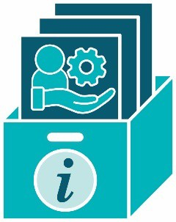 | - store information about the clients who use their supports and services
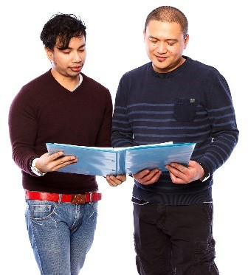 | - show the government or funding agencies how clients use their supports and services.
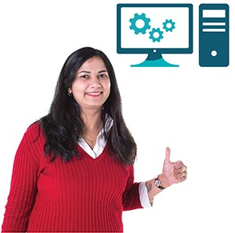 | The Data Exchange is:  - an online system  - simple  - easy to use.

What is the Data Exchange Framework?
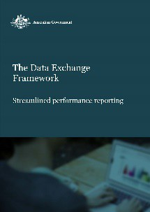 | The Data Exchange Framework is a document that explains:
 | - the goals of the Data Exchange
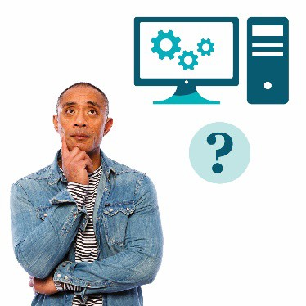 | - how the Data Exchange works
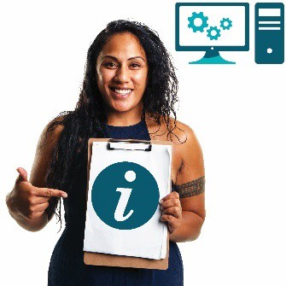 | - what information can be in the Data Exchange.
You can find the Data Exchange Framework on the Data Exchange website.
dex.dss.gov.au/

The Data Exchange Protocols
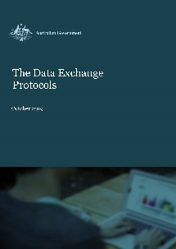 | We have written a document for people who use the Data Exchange called The Data Exchange Protocols.  In this guide we call them the Protocols.
 | The Protocols explain:
 | - words we use in the Data Exchange
 | - what information we put into the Data Exchange
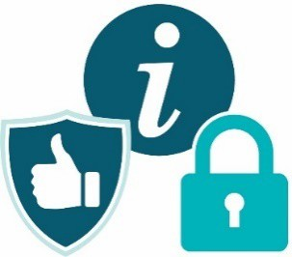 | - how we keep all the information in the Data Exchange:  - safe  - private
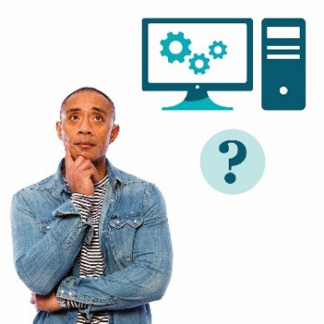 | - how to use the Data Exchange
 | - how the Data Exchange can work side- by-side with systems that organisations already use.

Words we use in the Data Exchange
 | There are certain words we use in the Data Exchange.
 | Your organisation might use different words.
 | It’s important to use our words when you use the Data Exchange.
 | We talk about these words on the following pages.
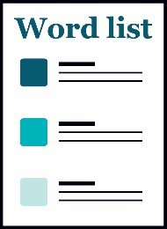 | You’ll also find a list of all these words on page 18.
 |  | When we say client, we are talking about 1 person.
 |  | A client is a person who uses a service.
 |  | We call it a service when a client gets support from an organisation.
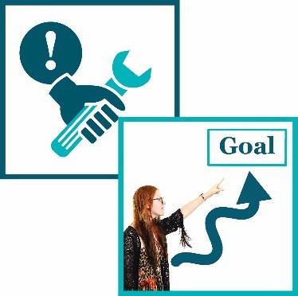 |  | A client uses a service so they can:  - solve a problem  - reach a goal.
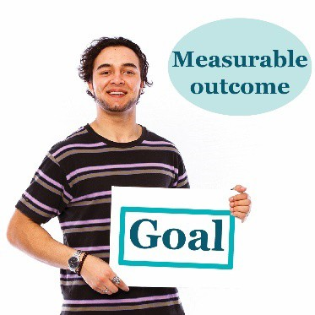 |  | In the Data Exchange, we measure if a client reaches their goals.  We call this a measurable outcome.
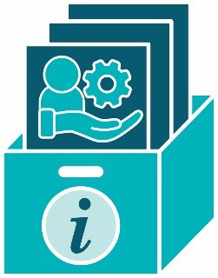 | Client level data is the information organisations collect about each client.
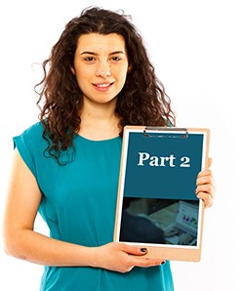 | We talk about client level data in more detail in Part 2 – Using the Data Exchange.
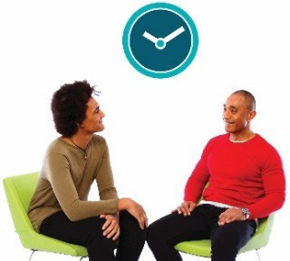 | Each time a client uses a service, we call it a session.
 | When 3 or more clients take part in a session together, we call it a group session.
 | A client might bring a support person to a session, such as a family member or carer.
 | The support person doesn’t take part in the session. They are just there to give the client support.
 | When a client takes part in 1 or more sessions of the same service, we call it a case.
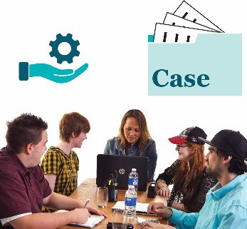 | We also call it a case when a group of clients take part in 1 or more sessions of the same service.
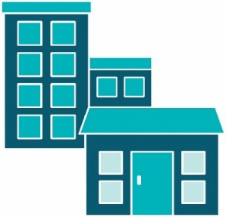 | An outlet is the place where organisations deliver services to clients.
 | We can make reports from the information collected in the Data Exchange.
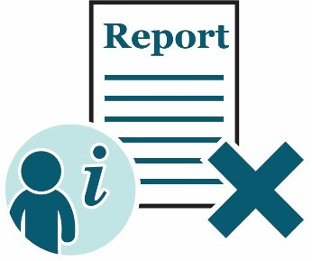 | Reports do not include any personal information about clients.
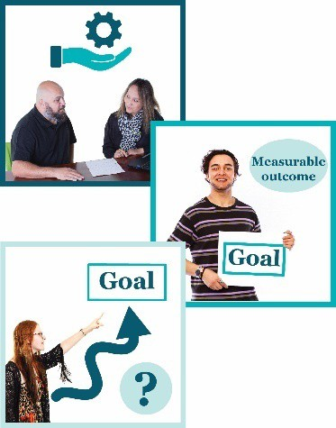 | Reports are usually about:  - the services clients have used  - measurable outcomes  - if clients have reached their goals by using the services.
The paperwork about your grant will explain:
- what you need to tell us
- when you need to tell us.
This is called reporting.
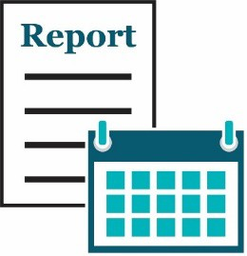 | We make reports about a reporting period.
 | This is the period of time that we are looking at.
 | There are 2 reporting periods each year:
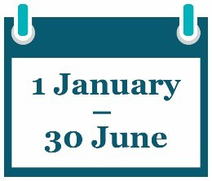 | - 1 January – 30 June
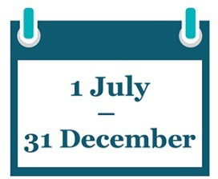 | - 1 July – 31 December.
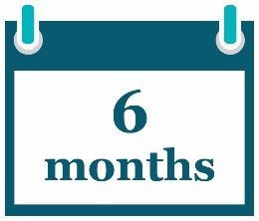 | Both reporting periods last for 6 months.
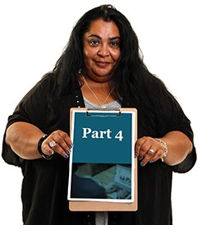 | We talk about reporting in Part 4 – Recording client outcomes in the Data Exchange.

Getting help to use the Data Exchange
You can find training materials for the Data Exchange on our website.
dex.dss.gov.au/
 | The training is self-guided – you do it on your own.
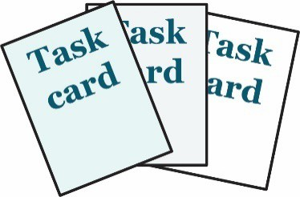 | We have task cards.
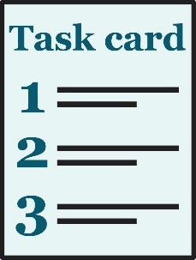 | The task cards take you through things you need to do in the web-portal step by step.
 | We also have e-Learning modules.
e-Learning modules are training videos you can watch.
The Data Exchange Helpdesk can give you technical support.
You can contact the Data Exchange Helpdesk by:
- email
dssdataexchange.helpdesk@dss.gov.au
- by phone
1800 020 283.

Word list
Case
When a client takes part in 1 or more sessions of the same service, we call it a case.
We also call it a case when a group of clients use the same service.
Client
A client is a person who uses a service.
They use the service so they can reach a goal.
Client level data
Client level data is the information organisations collect about each client.
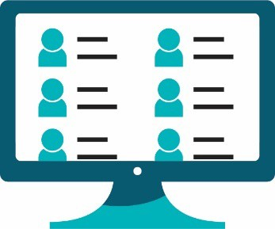 | Client records system  A client records system is a system an organisation uses to collect and store personal information about their clients.  They might use software.  Their system might be online.
Consent
If someone gives you their consent, they say it is ok for you to do something.
Delivery partners
Delivery partners are other organisations you work with to provide supports and services to your clients.
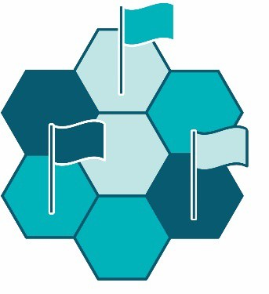 |  | Domains  Domains are important areas that are all related to the main topic.
Grant
A grant is a payment from the government or a funding agency for important work that can help others.
Interpreter
An interpreter is someone who:
- speaks the language you speak
- can help you understand what someone says when they speak a different language.
Measurable outcome
In the Data Exchange, we measure if a client reaches their goals.
We call this a measurable outcome.
Outlet
An outlet is the place where organisations deliver services to clients.
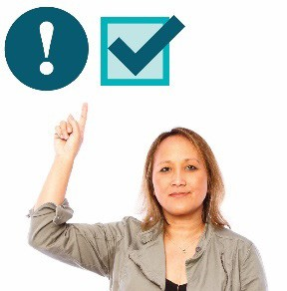 | Priority requirements  There is some data you must:  - collect  - record in the Data Exchange.
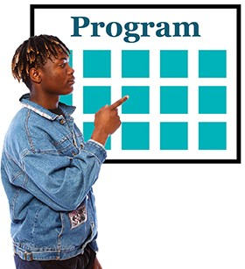 | Program activities  Program activities are all the services:  - your organisation offers  - clients can choose from.
Reporting period
We make reports about a reporting period. There are 2 reporting periods each year:
- 1 January – 30 June
- 1 July – 31 December.
Both reporting periods last for 6 months.
Service
We call it a service when a client gets support from an organisation.
Session
Each time a client uses a service, we call it a session.
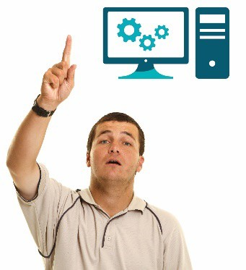 | User Access Request  A User Access Request is how you ask us if you can become a Data Exchange user.
 | The Information Access Group created this Easy Read document using stock photography and custom images. The images may not be reused without permission. For any enquiries about the images, please visit www.informationaccessgroup.com. Quote job number 3490.

