# System re-opening request form

## Task card

### For organisations

**Step 1.** On the Data Exchange home page, select the **IT access and portal support** drop-down arrow.

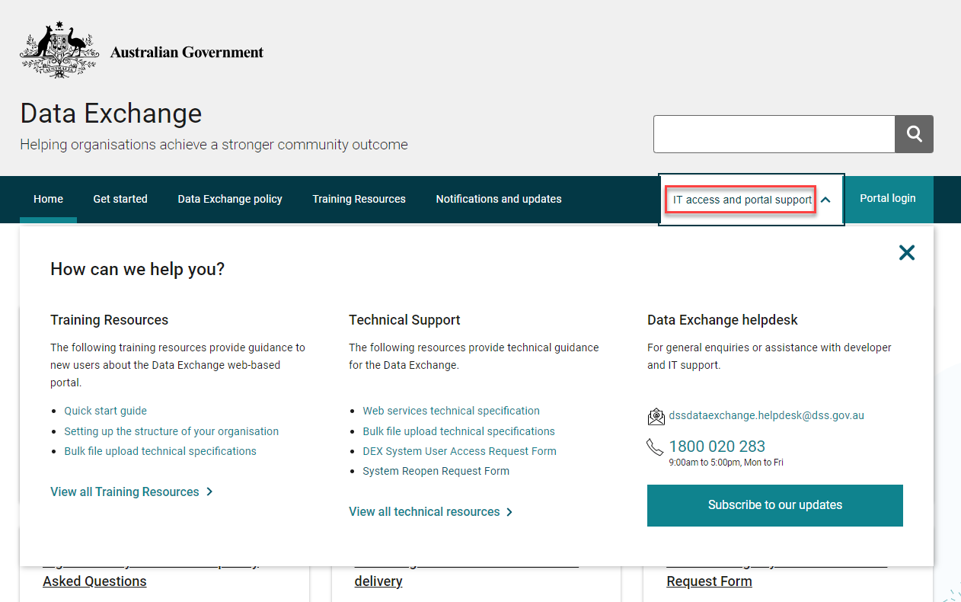

**Step 2.** Select the **System Reopen Request Form** option.

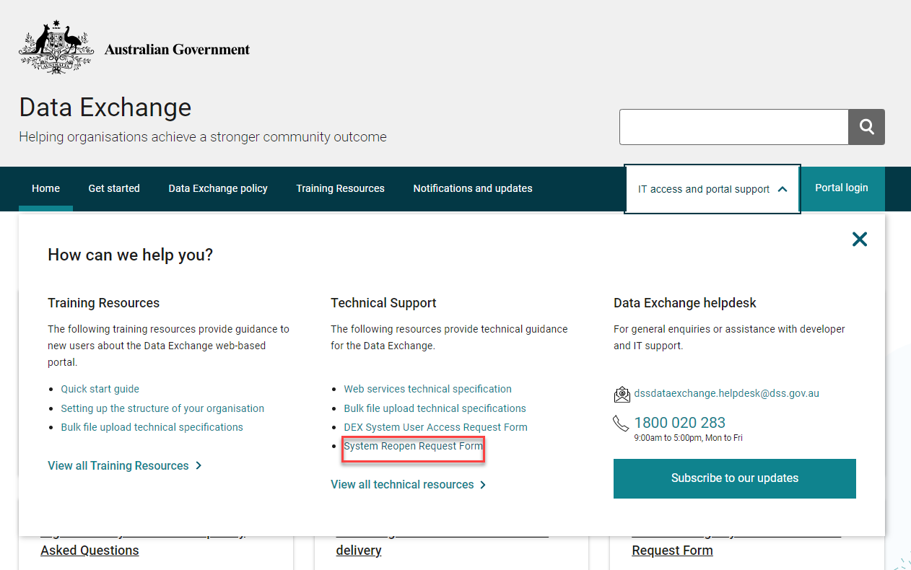

**Step 3.** A new window will appear.

1. Select **Complete Form** for new requests.
2. Select **Open Saved Form** to open a saved form.

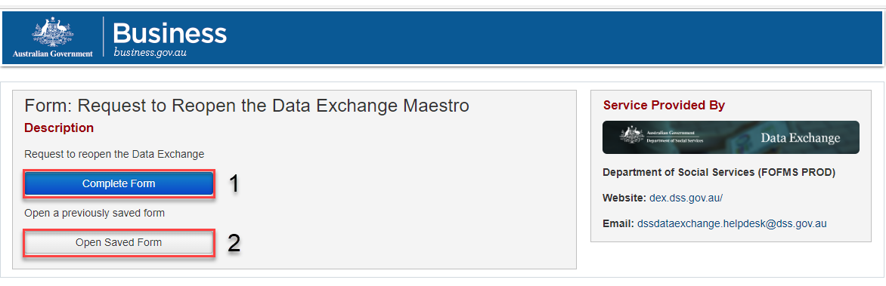

If you choose to open a saved form, you will be asked to enter your **Submission Reference** and **Access Code**.

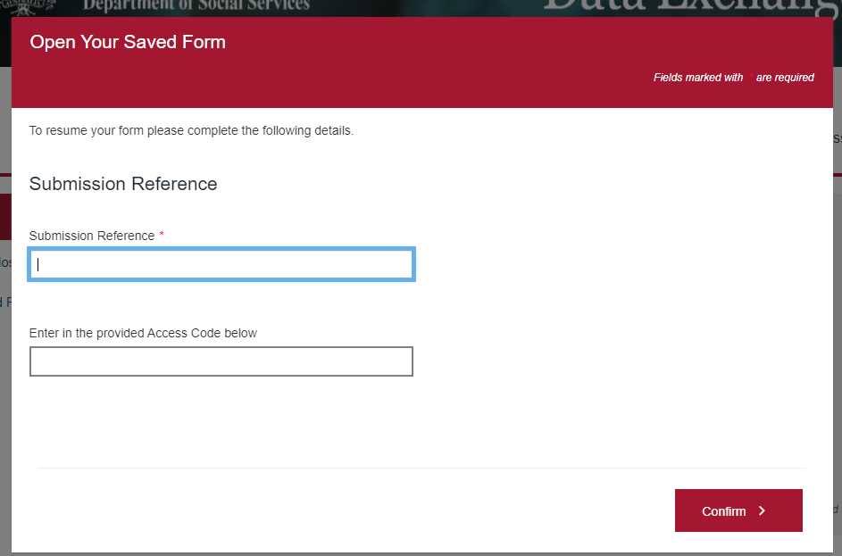

The interface for completing a new or existing form is the same. Refer to **Steps 4-7**.

**Step 4.** Completing the form.

Please Note:

* The reasons that are **not** considered “exceptional circumstances”.
* Delivery and community partners will need to complete their own extension requests.

Screenshot of the main page in the 'Request to reopen the Data Exchange' form.Highlighted are the four reasons that will not be considered exception circumstances. Those are:
"Inability to obtain a Digital identity". "staff unavailable to provide the data", "not being aware of the reporting requirements". "delay caused by a third party vendor".

**Step 5.** Complete all fields marked with a red asterisk throughout the form.

You can find the **Organisation Legal Name** and **Organisation** **ID** in the Manage organisation page, under **Source Organisation name** and **Source Organisation ID**. You can access that page through the MyDEX Dashboard.

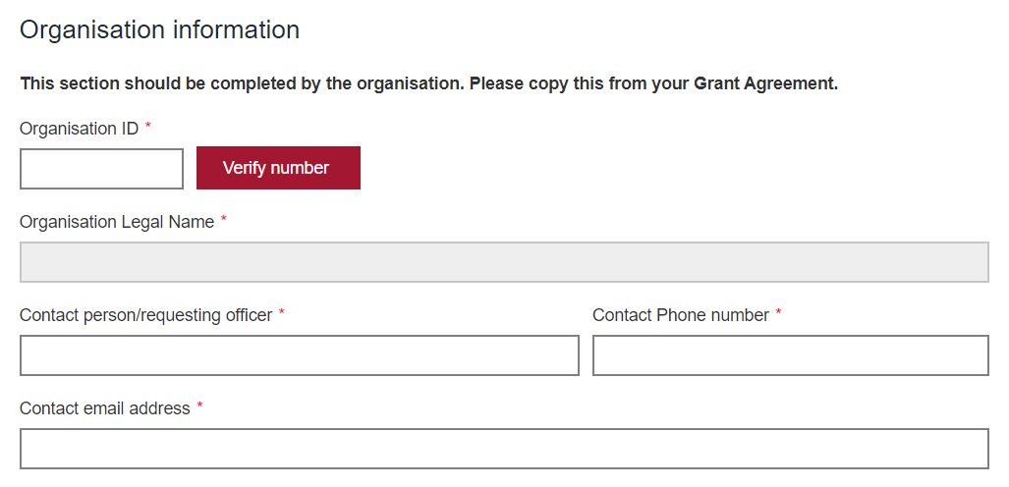

**Step 6.** **Answer the questions –**

* For the first question, select **No** if this is the first reporting period in the Data Exchange for the program requiring the extension.
* Selecting **Yes** will ask if you have requested an extension for a previous period.

You can now select the program activities you are seeking the extension for by scrolling through the list on the left column. By ticking the box on the left of the activity name, the activity will display in the List of chosen activities box.

If you have made a mistake, untick the box of the incorrect selection. You cannot exceed more than 15 activities.

A screenshot with three Yes / no questions:
"Has your organisation used the Data Exchange for previous reporting periods?", "Has your organisation already requested an extension for this reporting period?". "Has your organisation requested an extension for a previous reporting period?".
A list of available program activities is displayed below, with the 'Be Connected', and the 'Building Employer Confidence in Inclusion and Disability' options ticked. Those options appear on the right-hand side list, reading 'List of chosen program activities (Max 15 per form).

**Step 7.** **Submitting your data:** Click the drop-down arrow to select your method for submitting data.

A screenshot of the page with a title reading "Background Information", and a Yes / noquestion under it reading: "Do you, or another user in your organisation, have a Digital Identity that has been linked to your business in RAM?".
Under that, another question "How are you submitting data?". This has the drop-down option of 'Web-based portal (manual entry) chosen, which is highlighted. Under that two additional questions: "How are you submitting data?" and "How many sessions still need inputting?"

If you select **System to system** or **Bulk XML** additional Yes / No questions will appear for you to answer.

This screenshot has the same content as Picture 8, the picture before, with the exception of the 'System-to-system' drop-down option chosen, instead of the 'Web-based portal (manual entry' option. This prompted two additional yes / no questions.
"Has your organisation successfully submitted data for this reporting period?" and "Have you tested your upload in the staging environment?"

**Adding a reason for the request**

* Click the drop-down to select a reason from the list provided. Below is a text box to provide further details.
* Attach supporting documentation if you wish to do so. Attachments must not include identifiable client information. Select the Click to Upload button
* Please ensure the Funding Arrangement Manager email address ends with @dss.gov.au

A screenshot of the page with a title reading "Reason for request". A 'Reason for request' drop-down arrow is highlighted. Under that there is a free text field to provide the reasons for the request and a summary of contact with the Data Exchange Helpdesk to resolve technical matters.
A button that reads "Upload File" is highlighted, and above it it states all the acceptable formats.
Under it, a text reads "By selecting the Email Funding Arrangement Manager button, you confirm that the information contained is true and correct."
A free-text field asking for the Funding Arrangement Manager's email and a date appear on the bottom. Under those, a button reading "Email Funding Arrangement Manager".


The Helpdesk is available to provide system support to users of the Data Exchange.

You can contact the Data Exchange Helpdesk by email at [dssdataexchange.helpdesk@dss.gov.au](mailto:dssdataexchange.helpdesk@dss.gov.au) or on 1800 020 283.