Using Selections (additional filters)

Introduction
Qlik reports have been designed to initially display a standard set of data fields. At times, you may wish to add different data to your report. These additional filters are available from the Selections tool.

Opening Selections
Step | Action
To open the additional filters, click the “Selections” button in the top right of the sheet panel.
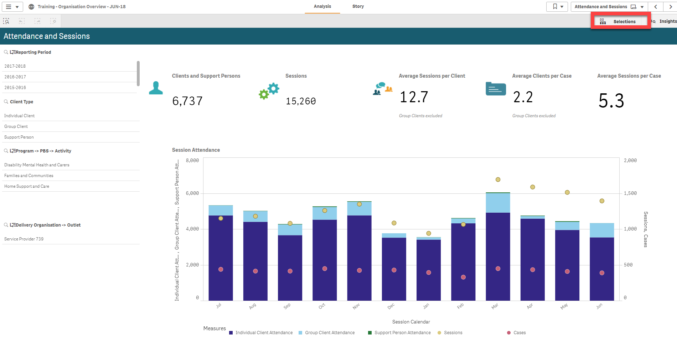
The selections screen will appear. In the top half of the screen, any filters that have already been applied will appear. Additional filters will be displayed in the bottom half of the screen
The initial dimensions displayed are those that are available on the main sheet display. To display all of the dimensions available in the report, select the Show Fields tick box.
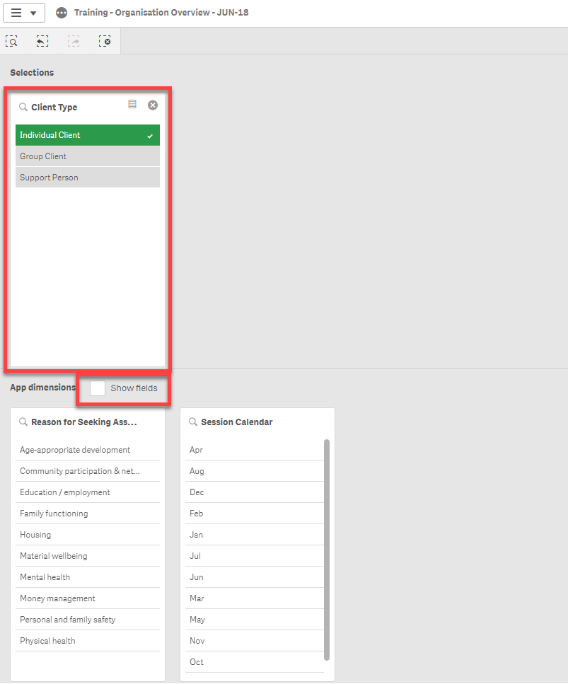
Once the show fields option is selected (1), all App dimensions available will be displayed. You can type in a word to search by in the Search dimensions and field box (2) to narrow the options down or use the Slide bar (3) at the bottom of the screen to move through the options.

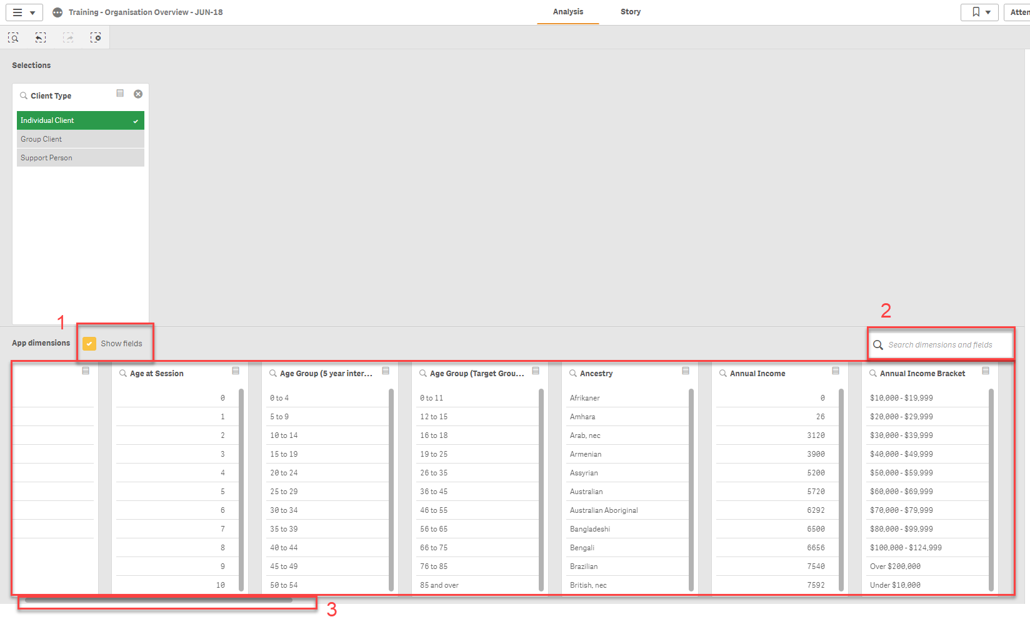

To select the dimension that you wish to filter the sheets with, select one of the data points in the dimension you wish to use.

This will move the dimension to the Selections area of the screen. In this example the Reason for Seeking Assistance dimension has been selected.

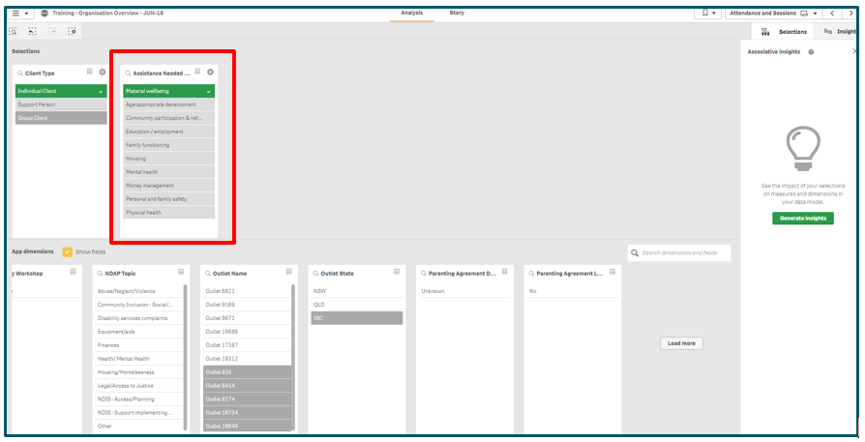

To return to the report, click the Selections button again.

The data will now include the Reason for seeking assistance filter at the top of the screen. You can select this filter and add or remove filters for this field as needed. 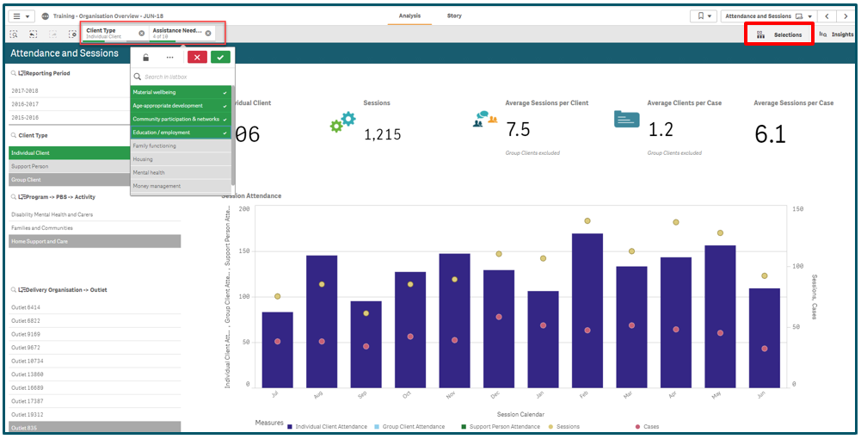

Supported browsers
In order to access the Data Exchange reports your computer needs to meet certain requirements. Select this link to view the list of supported browsers.

You can find more information on reporting requirements in the Data Exchange Protocols. For further information on reports functionality, please visit the Training tab of the Data Exchange website.
For system support, contact the Data Exchange Helpdesk by email at dssdataexchange.helpdesk@dss.gov.au or on 1800 020 283.

