Setting up the structure of your organisation

Task card
This task card explains the following:
- Organisation set-up options
  - Single entity set-up
  - Multi-entity set-up
- Delivery partners
  - Option 1 set-up details
  - Option 2 set-up details
- Adding a delivery partner if using Option 1

KEY HIGHLIGHTS
- An individual account holder must have their own Digital Identity prior to requesting a Data Exchange account.
- The recommended option is to set-up a delivery partner as their own entity with their own access to the Data Exchange.
- Contact DSSDataExchange.Helpdesk@dss.gov.au if your required delivery partner does not appear in the drop down listing.
- The use of special characters such as * & % # @ should not be included in the free text fields as they are used as search functions in the Data Exchange.

Option 1 is the recommended option for multi-entity set-ups.
Organisations should set-up a delivery partner as their own entity with their own access to the Data Exchange.

Organisation set-up options
There are a number of ways to structure your organisation. These can be as either single or multi-entity organisation configurations. This flexibility is designed to give organisations a choice on how they enter their data and reflects the diversity of organisational structures.

Single entity set-up
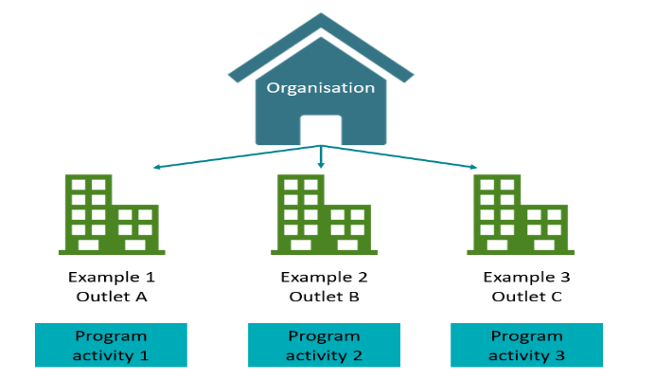
In Figure 1 the organisation delivers different program activities from each of it’s outlets.
This is a stand-alone organisation funded by the Department.
There are no delivery partners, consortia or sub-contractor arrangements.
An organisation can have a number of outlets from where in-scope program activities are delivered.

Figure 1 – Example of single entity organisation set-up

Table 1 – Single entity description
SINGLE ENTITY | DESCRIPTION
Set-up | For the majority of organisations this is the recommended configuration within the Data Exchange.  It is suitable where all users belong to a single organisation and all program activities are delivered by the one organisation.  This set-up also works where the organisation's users are entering data for consortia or sub-contracted agencies. In this instance the consortia or sub-contracted agencies should ensure consent is provided by their client’s for a third-party to enter and view their personal information.
Digital Identity | Your Digital Identity is a safe, secure and convenient way for you to prove who you are when accessing government online services.  myGovID is the Australian Government’s Digital Identity app. To access the DEX Portal you will need at least a <Basic/ Standard/Strong> identity strength. More information about Digital identity can be found here.  More information about myGovID can be found here.
Relationship Authorisation Manager (RAM) | Link your Digital Identity to a business using RAM  To access the DEX portal on behalf of a business, you will need to link your Digital Identity to the business in RAM.  How you link depends on your role:  - Principal authority – person responsible for the business  - Authorised user or administrator - someone who acts on behalf of the business.  For more information, refer to the Relationship Authorisation Manager website.
Visibility of client records | Each user will need a Data Exchange account within their organisation.  All users within the organisation will be able to view any client record against the organisation.
Visibility of cases and sessions | Data Exchange Organisation (Org) Administrators will have visibility of all outlets, program activities, and can access, add and edit details for all cases and outlets in the organisation.  Editor access users can add and edit cases and sessions within the web-based portal only against the outlets and program activities they have been granted access to by their Data Exchange Org Administrator.  View only access users can only view cases and sessions within the web-based portal against the outlets and program activities they have been attached to by their Data Exchange Organisation administrator.

Multi entity set-up
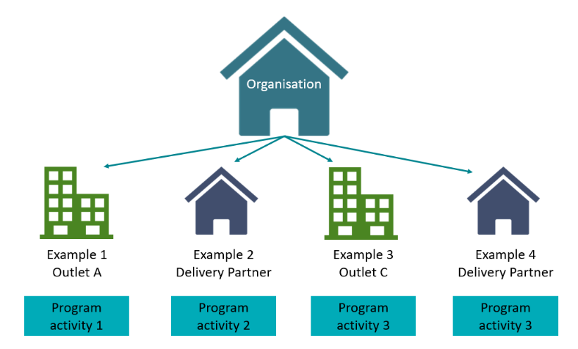
A multi entity structure has a lead organisation that is funded by the Department.
Figure 2 – Example of multi-entity organisation Set-up
The lead organisation funds delivery partners, consortia or has sub-contractor arrangements in place to deliver in-scope programs for the lead organisation.
Below are explanations of the examples found in Figure 2:
- Example 1 – Lead organisation has its own outlet that delivers program activity 1.
- Example 2 – Lead organisation has a delivery partner that delivers program activity 2.
- Example 3 – Lead organisation has its own outlet that delivers program activity 3.
- Example 4 – Lead organisation has a delivery partner that delivers program activity 3.

Table 2 – Multi - entity descriptions
MULTI- ENTITY | DESCRIPTION
Set-up | This configuration can be considered where an organisation is operating a consortia or has a sub-contract arrangement and have consortia members who have their own organisation ABN.  It allows the creation of delivery partners* who create and manage their own client, case and session records that are then attributed to the lead organisation funded by the Department.  This set-up is suitable if an organisation or delivery partner does not want their multi-agency partners to have access to their lead organisation client records.  *Refer to the Adding a delivery partner section within this document
Digital Identity | Your Digital Identity is a safe, secure and convenient way for you to prove who you are when accessing government online services.  myGovID is the Australian Government’s Digital Identity app. To access the DEX Portal you will need at least a <Basic/ Standard/Strong> identity strength.  More information about Digital identity can be found here.  More information about myGovID can be found here.
Relationship Authorisation Manager (RAM) | Link your Digital Identity to a business using RAM  To access the DEX portal on behalf of a business, you will need to link your Digital Identity to the business in RAM.  How you link depends on your role:  - Principal authority – person responsible for the business  - Authorised user or administrator - someone who acts on behalf of the business.  For more information, refer to the Relationship Authorisation Manager website.
Visibility of client records | Each user will need a Data Exchange account within their organisation.  Visibility of client data is dependent on the lead organisation model.  If each delivery partner enters their own data, they will only be able to see their own client data. The lead organisation cannot see the delivery partner’s client level data. This ensures total client privacy.  All users will be able to view any client record created with their organisation, with appropriate access permissions.  Client records are not visible to other consortia/sub-contract members.  Where a client attends program activities across multiple agencies a client record is created by each organisation.  Consortia / sub-contract organisations will be able to provide lead organisations aggregate reports of their clients and the services delivered via the handshake functionality. Refer to the Handshake – Create, accept or revoke task card for more information.
Visibility of cases and sessions | Data Exchange Organisation Administrators will have visibility of all data and can access and edit details including outlet, program and user details for their organisation.  Editor access users can add and edit cases and sessions within the web-based portal against the outlets and program activities they have been granted access to by the administrator of their organisation.  View only access users can only view cases and sessions within the web-based portal against the outlets and program activities they have been attached to by their administrator.

Delivery partners
When an organisation sub-contracts their services to be delivered by another entity, this entity would act as a delivery partner. Some organisations may refer to delivery partners as community partners, consortia members, sub-contractors or brokers.
There are two options available for setting up delivery partners. Delivery partners can be set up as a separate entity (refer table 3) or as an outlet of the lead organisation (facilitating partner) (refer table 4).
Table 3 – Option 1 set-up details
ITEM |  | OPTION 1  Delivery partner is set up as an entity with their own access to the Data Exchange and enter their own information.
This is the recommended set-up option.
Initial request | ABN required | An ABN is required.
 | Digital Identity required | Each staff member of the delivery partner who is required to access the Data Exchange will need to create their own Digital Identity. myGovID is the Australian Government digital identity app.  Refer to the myGovID website for how to set up your Digital Identity.
 | Relationship Authorisation Manager (RAM) | To access the DEX portal on behalf of the delivery partner, staff members will need to link their Digital Identity to the business in RAM.  How they link depends on their role:  - Principal authority – person responsible for the delivery partner  - Authorised user or administrator - someone who acts on behalf of the delivery partner.  Refer to the Relationship Authorisation Manager website for more information.
 | User access form required | The delivery organisation will require a Data Exchange organisation administrator to create outlets and users.
Set-up | Data Exchange Organisation administrator required | The first person seeking access to the Data Exchange for the organisation will need to complete a User access request form.
 | Data Exchange Editor and View only required | The organisation administrator can create new users in the Data Exchange and will set the level of access for each user.
 | Attaching program activities to the delivery partner | The organisation administrator for the lead organisation assigns program activities to the relevant delivery partner.
 | Set-up of outlets | The organisation administrator for the delivery partner creates the outlets.
 | Partnership Approach Flag | If required by the lead organisation, the Partnership Approach flag must be checked in the Manage organisation area in the Data Exchange web based portal.
Data input | Data entry | The delivery partner inputs their own cases, clients, sessions and outcomes for the services they deliver.
 | Client level data visibility | The delivery partner will only have visibility of the clients, cases and sessions they have entered.
 | Capturing Outcomes | If required, the delivery partner may be required to capture client outcomes.
Reports | Lead organisation access to reports | The lead organisation can request to view delivery partner reports by submitting a ‘Handshake’ request. The Handshake – Create, accept or revoke task card provides further information.
 | Delivery partner access to reports | They can access reports for their programs, outlets and sessions only.
Privacy | Lead organisation / delivery partner | The delivery partner will only be able to enter and view their own client data. The lead organisation can view aggregate data in reports if a Handshake agreement is in place. The lead organisation cannot view client level data.

Table 4 – Option 2 set-up details
ITEM |  | OPTION 2  Lead organisation sets up the delivery partner as an outlet and enters the data into the Data Exchange for the delivery partner.
Initial request | ABN required | Only required by lead organisation.
 | Digital Identity required | Each staff member of the delivery partner who is required to access the Data Exchange will need to create their own Digital Identity. myGovID is the Australian Government digital identity app.  Refer to the myGovID website for how to set up your Digital Identity.
 | Relationship Authorisation Manager (RAM) | To access the DEX portal on behalf of the delivery partner, staff members will need to link their Digital Identity to the business in RAM.  How they link depends on their role:  - Principal authority – person responsible for the delivery partner  - Authorised user or administrator - someone who acts on behalf of the delivery partner.  Refer to the Relationship Authorisation Manager website for more information.
 | User access form required | The lead organisation will require this as they will enter information into the Data Exchange on behalf of the delivery partner.
Set-up | Data Exchange Organisation administrator required | The lead organisation will require this as they will enter information into the Data Exchange. Not required by the delivery partner.
 | Data Exchange Editor and View only required | The lead organisation will require this, as they will enter information into the Data Exchange. Not required by the delivery partner.
 | Attaching program activities to the delivery partner | The lead organisation will attach program activities.
 | Set-up of outlets | The lead organisation will set-up and create outlets.
Data input | Data entry | The lead organisation will enter information into the Data on behalf of the delivery partner.
 | Client level data visibility | The lead organisation will have visibility to all client, case and session data.
Reports | Lead organisation access to reports | The lead organisation has access to reports.
 | Delivery partner access to reports | Only the lead organisation has access to reports. No Handshake solution is available in this set-up.
Privacy | Lead organisation / delivery partner | Consent from a delivery partner’s clients is required for their personal information to be entered into the Data Exchange by the lead organisation.

Adding a delivery partner for Option 1
Select Manage organisation in the My Organisation menu from the Data Exchange home screen. Refer Figure 3.

Figure 3 – Manage organisation option
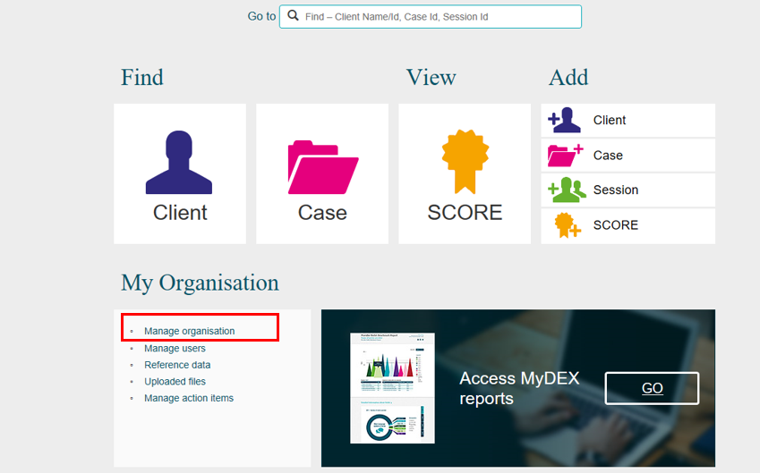

The Manage organisation screen will display with the following sections. Refer Figure 4.
- Organisation Details
- Outlets
- Program activities
Figure 4 - Manage organisation screen
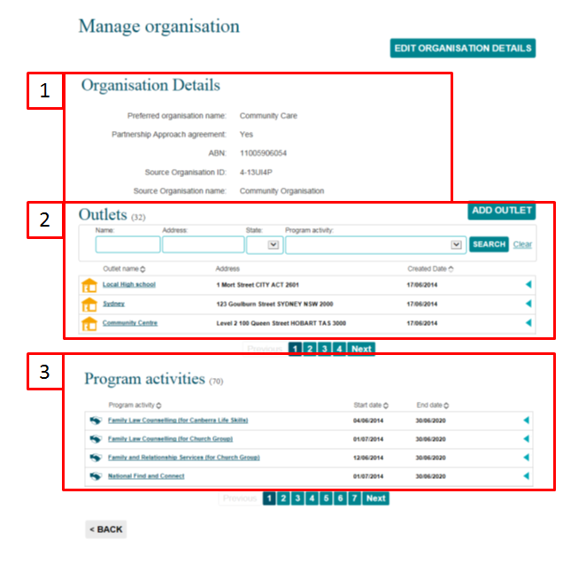

The list of program activities (3) will be the same as those listed in your Grant Agreement.
Select a program activity hyperlink from the Program activities section that you wish to assign a delivery partner.

For this example we will select the National Find and Connect Program activity. Refer Figure 5.
Figure 5 – National Find and Connect example
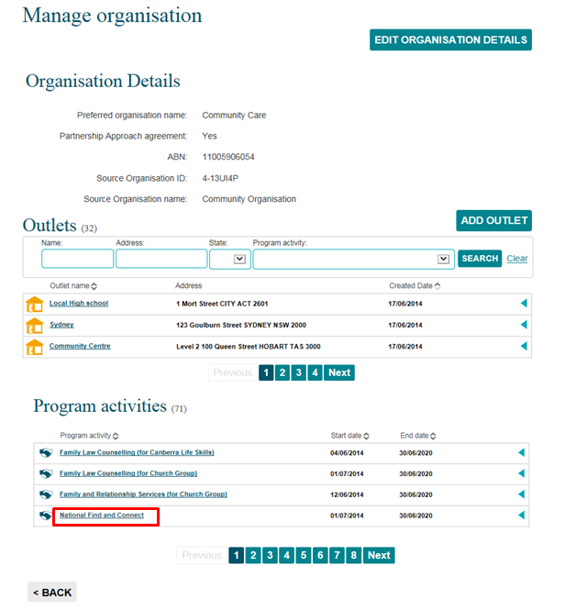
The selected Program activity screen will display. Refer Figure 6.
Select ADD DELIVERY PARTNER .
Figure 6 - Program activity screen
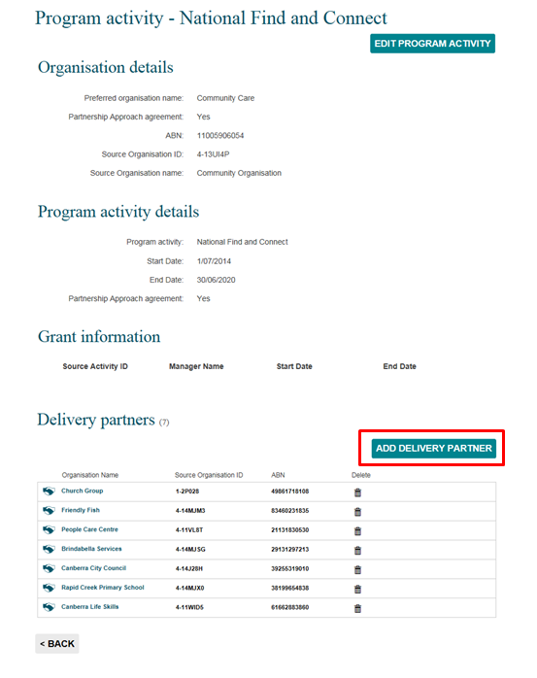

The Add delivery partner screen will display. Refer Figure 7.

Figure 7 - Add a delivery partner screen
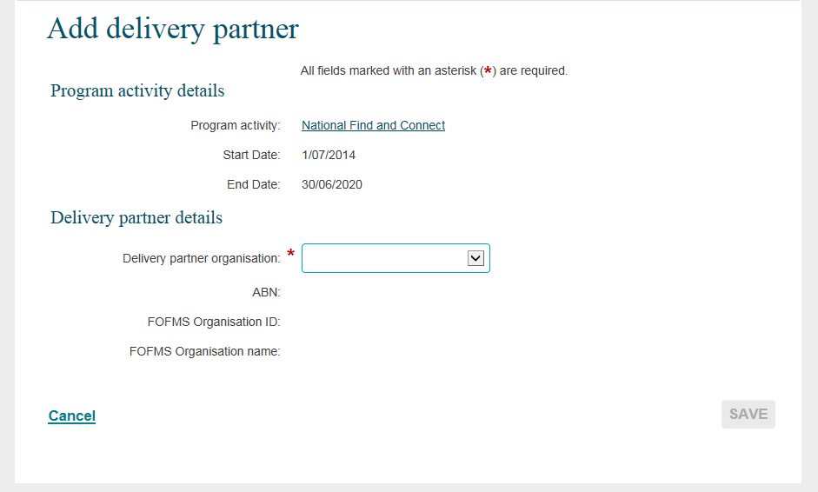
Select the delivery partner either by using the drop down arrow or typing the first few letters of their organisation at the Delivery partner organisation field. Refer Figure 8.
The details of the delivery partner will auto populate the fields.
There is also a Send ‘Handshake’ Request section. Refer to the Handshake – Create, accept or revoke task card for more information.
Figure 8 – Delivery partner details section
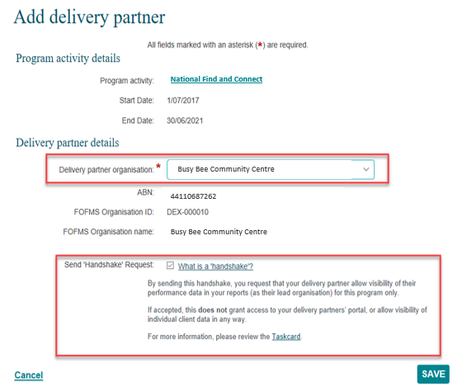

Select SAVE .

The Program activity screen will display with the selected delivery partner now attached to the program. Refer Figure 9.
Figure 9 – Program activity screen
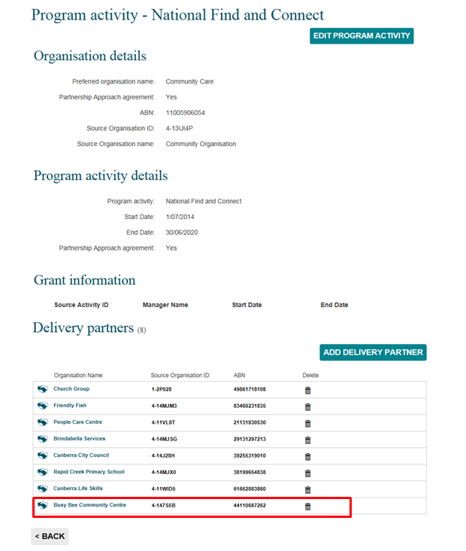

If the delivery partner's name does not display on the listing, this could mean that they have already been added as a delivery partner, they have changed their name, or have never been funded by the Department before.
Contact the Data Exchange Helpdesk who will be able to either inform you of the organisation's name in the Data Exchange, or request a new organisation record be created.
You will need to provide the following information about the delivery partner:
- Organisation Legal Name
- ABN
- Street address
- Contact name and number
Forward these details to dssdataexchange.helpdesk@dss.gov.au for inclusion in the Data Exchange organisation listing. The Data Exchange Helpdesk will endeavour to action the request within five (5) business days

You can find more information on outlets, clients, cases, and sessions on the Data Exchange Protocols and the Training page.
For system support, contact the Data Exchange Helpdesk by email dssdataexchange.helpdesk@dss.gov.au or on 1800 020 283.

