Overview of the My Organisation section

Task card
This task card discusses the following:
- Access to ‘My Organisation’
- Manage organisation
- Manage users
- Reference data
- Uploaded files
- Manage action items

KEY HIGHLIGHTS
- All functions under the My Organisation section are accessible to the organisation’s Data Exchange Organisation Administrator.
- The Reference data and Uploaded file sections are only relevant for those organisations that perform bulk file uploads into the Data Exchange.

Access to My Organisation
Access to the My Organisation section of the Data Exchange can be located on the home page. Refer Figure 1.
Figure 1- The Data Exchange home page
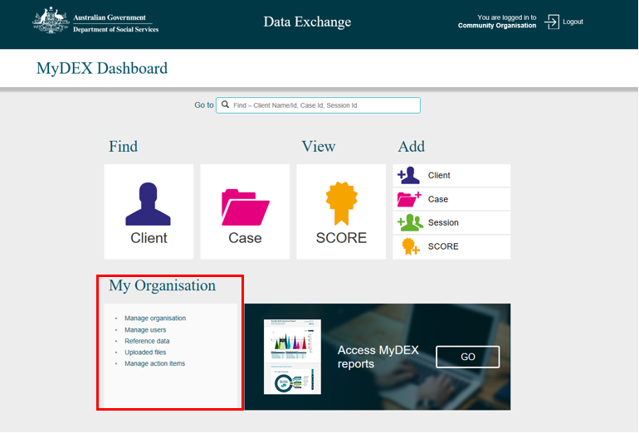
There are five links in the My Organisation section that a Data Exchange Org Administrator can select.
- Manage organisation
- Manage users
- Reference data
- Uploaded files
- Manage action items

Manage organisation
Select Manage organisation under the My Organisation heading. Refer Figure 2.
Figure 2 - Manage organisation link
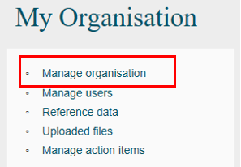
The Manage organisation screen will display detailing the following information to Data Exchange Organisation Administrators. Refer Figure 3:
- Edit organisation details button
- Organisation details section
- Outlets listing
- Add outlet button
- Pagination function
- Program activities listing
- Notifications area
Figure 3 - Manage organisation screen
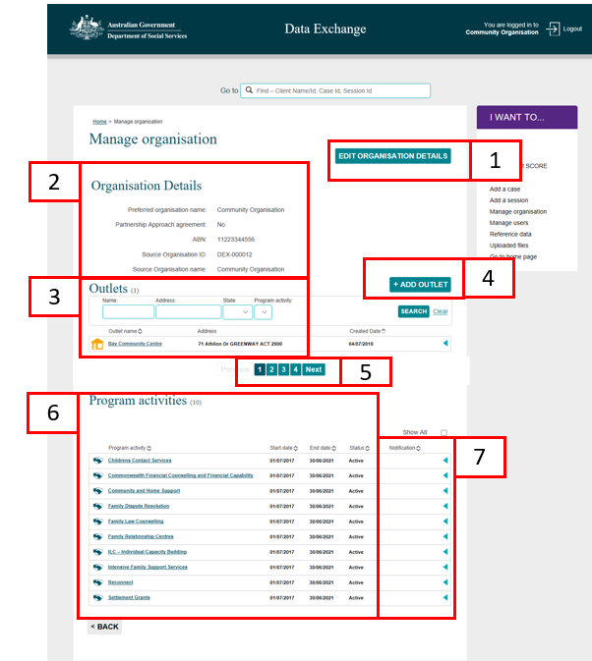
Table 1 - Field descriptions for the Manage organisations screen (Refer Figure 3)
FIELD | DESCRIPTION
Edit Organisation Details | Select this button if you need to update your organisations details, including preferred name and participation in the partnership approach. Refer to the Create and manage outlets task card for more information.
Organisation Details | This area displays a general overview of your organisation including your preferred name, source name, ABN and source Identifier.
Outlets | This area lists all outlets associated with your organisation. If you are a first time user, no outlets will be listed. You will need to add your outlets.
Add Outlet | Select this button if you need to add an outlet.  For instructions on how to add an outlet, please access the Create and manage outlets task card.
Pagination function | Should your organisation have multiple outlets and/or program activities, the information will automatically paginate. Use the numbered pages or Next button to move through the pagination function.
Program activities | This area lists all program activities that your organisation has been funded to deliver, and to be reported against in the Data Exchange.
Notifications area | This area will display a bell icon to advise that a handshake request has been issued / received. This area is for Lead and Delivery organisations. Refer to the Handshake – Create, accept or revoke task card for more information.

Manage Users
Select Manage users under the My Organisation heading. Refer Figure 4.
Figure 4 – Manage users link
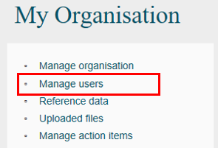

The Manage users screen will display. Refer Figure 5.
Figure 5 - Manage users screen
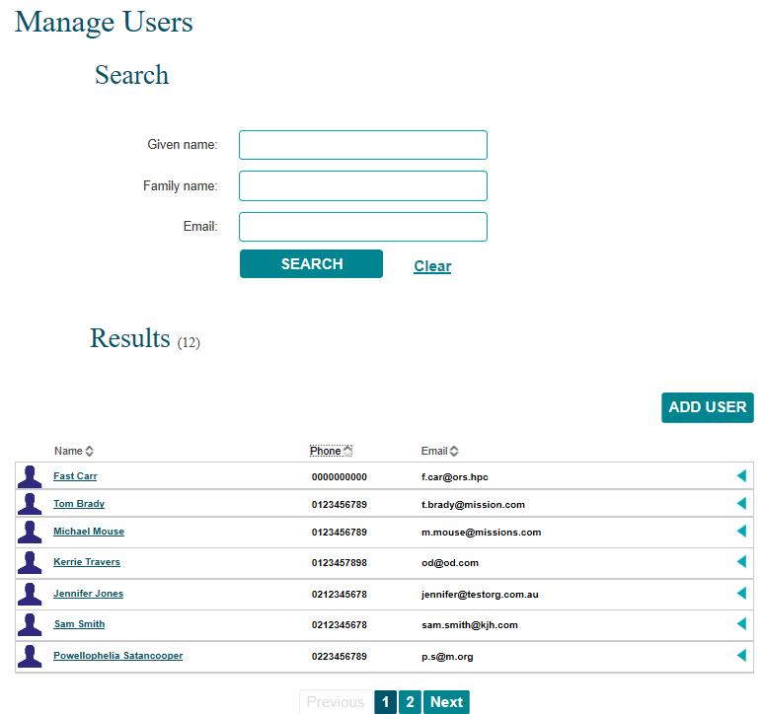
Table 2 - Field descriptions for the Manage users screen (Refer Figure 5)
FIELD | DESCRIPTION
Search | Search for existing users. This is especially useful for organisations that have large numbers of users.
Results | This area will display a list of already registered existing users within your organisation. Click on the blue ‘expand row’ arrow to display the user’s access type.
Add User | Select this button if you need to add a new user.  Refer to the Add and edit a user task card for instructions on how to add a new user.

Reference Data
The Reference data section is for those organisations that perform bulk uploads into the Data Exchange. Files that contain all the Data Exchange codes can be downloaded through Reference data.
Select Reference data under the My Organisation heading. Refer Figure 6.
Figure 6 - Reference data link
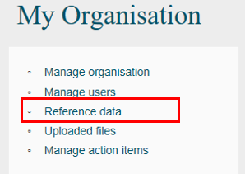
The Reference data screen will display. Refer Figure 7.
From this screen, you can download the XML schema, Reference data, and Organisation Activity data. We recommend these files be downloaded at least every three months to ensure you have access to the most recent reference data.
Figure 7 - Reference data screen
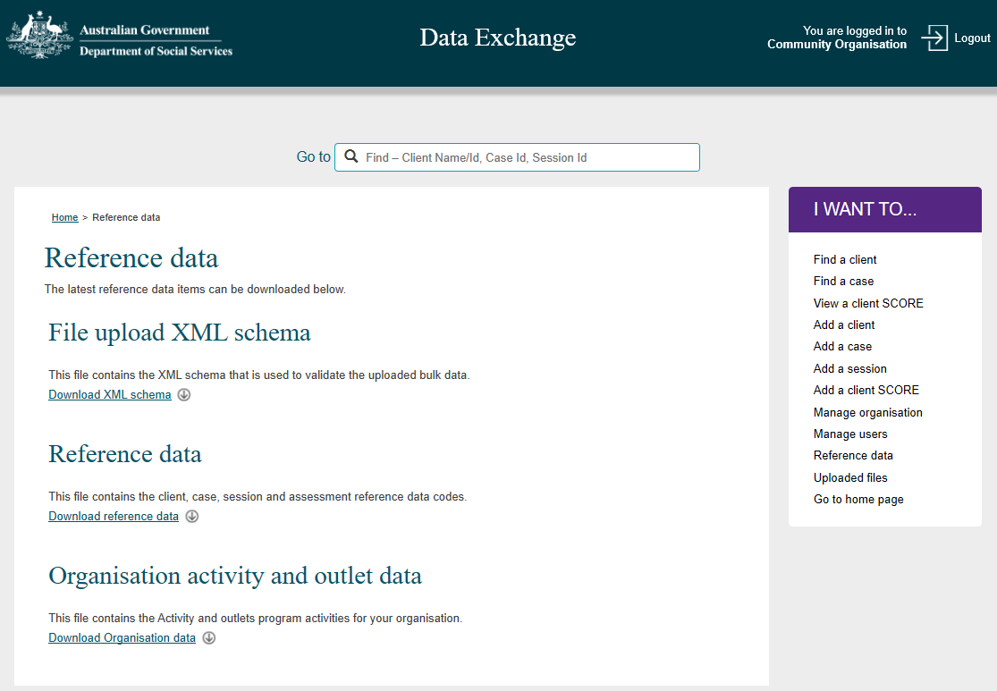

Uploaded files
The Uploaded files section is only for those organisations that perform bulk uploads into the Data Exchange. Select Uploaded files under the My organisation heading. Refer Figure 8.
Figure 8 - Uploaded files link
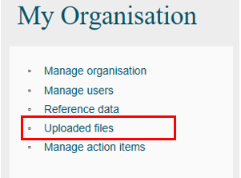
The Uploaded files screen will display. Refer Figure 9.
Figure 9 - Uploaded files screen
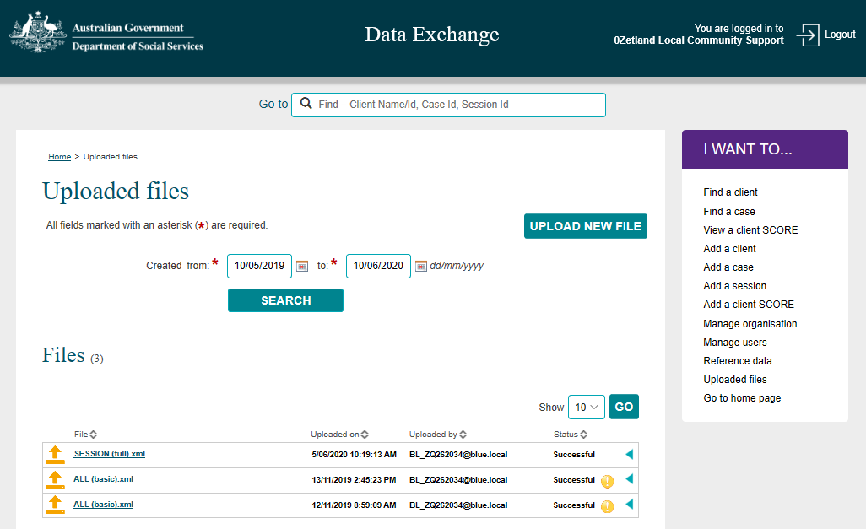
Table 3 - Field descriptions for the Uploaded files screen (Refer Figure 9)
FIELD | DESCRIPTION
Upload new file | Select this button to upload an XML file containing bulk client, case and session data.
Search | Search for files that have previously been uploaded. Use the calendar function to enter the dates.
Files | This section will display the files that have been located using the Search functionality on this page.  Click on the blue ‘expand row’ arrow to display additional comments about the upload file. Click on the file name hyperlink to view details about the files contents and upload status.

Manage action items
Select Manage action items under the My Organisation heading. Refer Figure 10.
Figure 10 – Manage action items link
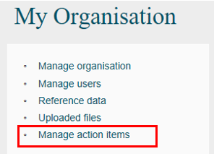

The Manage action items section will alert an organisation if a handshake request has been received and requires actioning. Refer Figure 11.
Figure 11 – Manage action items link
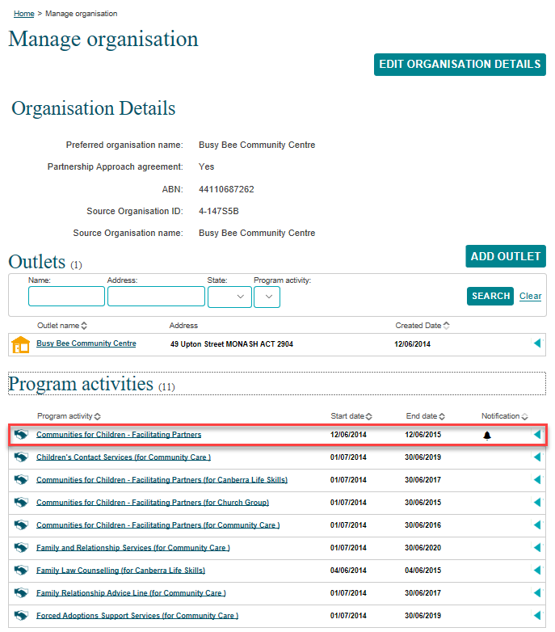

More information on handshakes can be found in the Handshake - Create, accept or revoke task card.

You can find more information on outlets, clients, cases, and sessions on the Data Exchange Protocols and the Training page.
For system support, contact the Data Exchange Helpdesk by email dssdataexchange.helpdesk@dss.gov.au or on 1800 020 283.

