Introduction and access
More information on how to use Qlik can be found at Tutorials - Qlik Sense

Introduction
The Data Exchange is an innovative and intuitive suite of applications (reports) which display data reported in the Data Exchange.
Refer to the Data Exchange translator below to find out more about the terms used in Data Exchange.
Table 1 – Qlik translator
QLIK TERM | DESCRIPTION
App | Is the report name.
Drill | Click to drill down into the selected item.
Hub | When Qlik starts up, you arrive at the hub. The hub is where you find all the apps you have access rights to use.
Sheet | Is a page or screen.
Snapshot | Is a screenshot of a graph or image.
Story | Is a presentation.
Visualization | Is a chart or table that presents data in an easy to read way.

Access and Log in
From the Data Exchange web-site portal, select located in the Access MyDEX reports box.
Figure 1 - The Data Exchange web-site portal
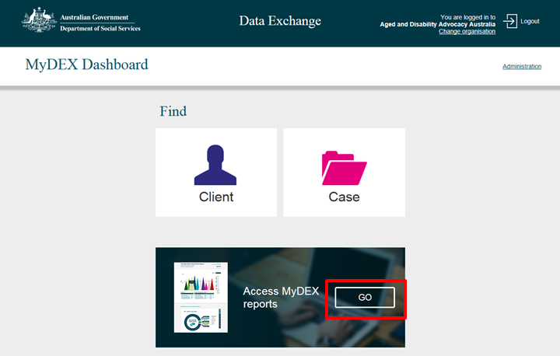
The Reports screen will display.
Figure 2 – The Reports screen
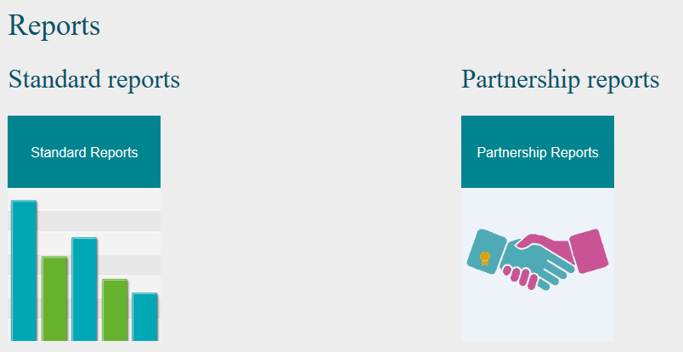
Select a Report tile.
Figure 3 – Standard reports tile
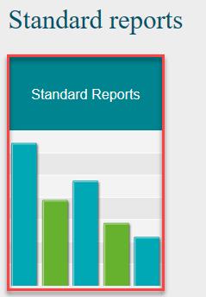
The Login screen will display.
Figure 4 – The Login screen
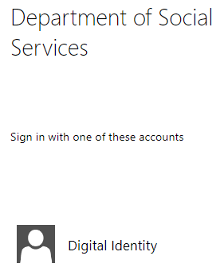
Login with your Digital Identity.

The Qlik Sense screen will display.
Figure 6 –The Qlik Sense screen
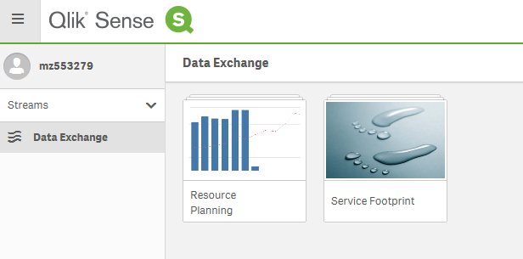
Select the required report.
Table 2 – Qlik navigation items
ITEM | DESCRIPTION
 | Select the Navigation icon to return you to the Open hub
 | Select the Menu icon to display Help and About.
 | Select the Bookmark icon to save the reference point in the sheet.
 | Select the Stories icon to access the stories already set up.
 | Select the Menu viewer to display the items in grid or list view.
 | Select the Sheets drop down arrow to view available report types.
 | Select the Back and Forward arrows to view the available report types.
 | Select the Magnifying glass to conduct a search.
 | Select the Menu icon to access Development Hub, Help and About.

Supported browsers
In order to access the Data Exchange reports your computer needs to meet certain requirements. Select this link to view the list of supported browsers.

You can find more information on reporting requirements in the Data Exchange Protocols. For further information on reports functionality, please visit the Training tab of the Data Exchange website.
For system support, contact the Data Exchange Helpdesk by email at dssdataexchange.helpdesk@dss.gov.au or on 1800 020 283.

