Handshake – Create, accept or revoke

Task card
This task card discusses the following:
- Background information
- Lead Organisation View – Request for Access to Delivery Partner data (Handshake)
- Delivery Partner View – Handshake request alert received
- Accepting/Declining a Handshake Request
- Lead Organisation View – Handshake request status
- Lead Organisation View – Revoking a handshake
- Delivery Partner View – Handshake revoked by lead organisation
- Delivery Partner View – Revoking a handshake
- Lead Organisation View – Handshake revoked by delivery partner

KEY HIGHLIGHTS
- Using the handshake arrangement, lead organisations can request to view data for the program a delivery partner is providing.
- A delivery partner has the option to accept or decline a handshake request.
- A handshake can be revoked at any time by either the lead organisation or delivery partner.
- It takes up to 24 hours for the handshake to become active and it can also take up to 24 hours for access to be removed.

Background information
What is a handshake?
The ‘handshake’ is a virtual agreement between a lead organisation and their delivery partner/s to allow a sharing of reports data (in the form of de-identified, aggregate information). Under a handshake, a lead organisation cannot access any data that is not otherwise available to the delivery partner.
For more information on how to set up an organisation as a lead organisation or a delivery partner, refer to the Setting up the structure of your organisation task card.
Who can initiate a handshake?
A Data Exchange Organisation Administrator of the lead organisation will initiate a request through the Data Exchange web-based portal. An Organisation Administrator of the delivery partner can then choose to accept or decline the request. An overview on how the handshake arrangement works with lead and delivery partners is shown in Figure 1.

Each agreement / relationship between a lead organisation and their delivery partner is unique; therefore, a separate handshake request is required for each delivery partner and each program.

Figure 1 – How the handshake arrangement works with lead and delivery partners
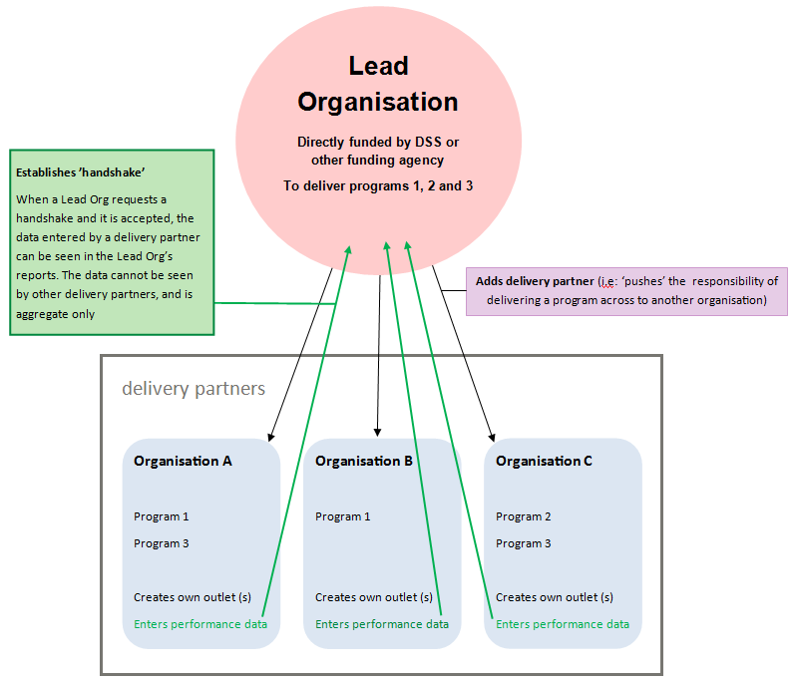

What data is visible between a lead organisation and their delivery partner?
If the request is accepted, the lead organisation will be able to view data in reports ONLY for the program the delivery partner is providing. This data is aggregate and includes outlet data relevant to that program.
If the delivery partner is directly funded, or delivers services for other organisations, performance data relevant to those agreements/relationships will not be visible to the requesting lead organisation.
Who can revoke a handshake?
A handshake can be revoked at any time, by either the lead organisation or the delivery partner. When revoked, visibility of the delivery partner’s data will be removed from the lead organisation’s reports. This includes visibility of historical data from a time when the handshake was active. The performance data will still be accessible for the delivery partner; it just will not be visible to the lead organisation.
It takes up to 24 hours for the handshake to become active, therefore when the handshake is revoked, it can also take up to 24 hours for access to be removed.

Lead Organisation View – Request for Access to Delivery Partner data (Handshake)
From the Data Exchange web-based portal home page, go to the My Organisation menu. Refer Figure 2.
Figure 2 – Data Exchange web-based portal home page
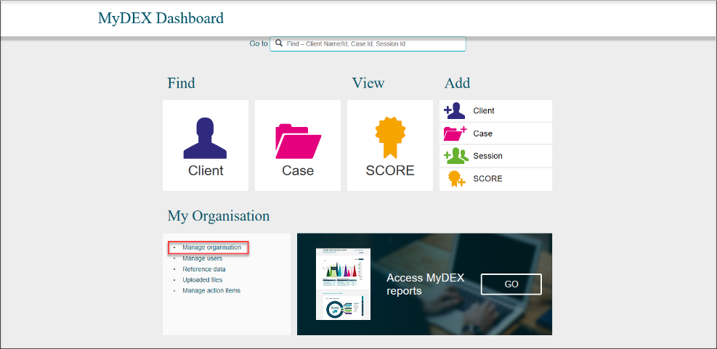
Select Manage organisation.
The Manage organisation screen will display. Refer Figure 3.
Select the appropriate program activity hyperlink.
Figure 3 – Manage organisation screen
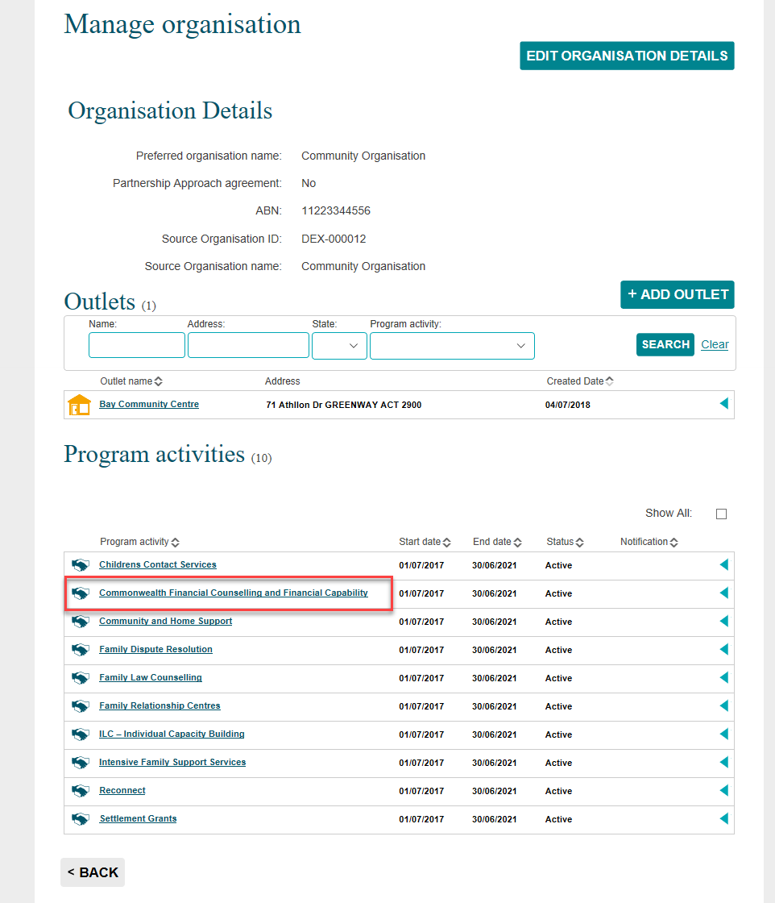

The Program activity screen will display. Refer Figure 4.
Figure 4 – Program activity screen
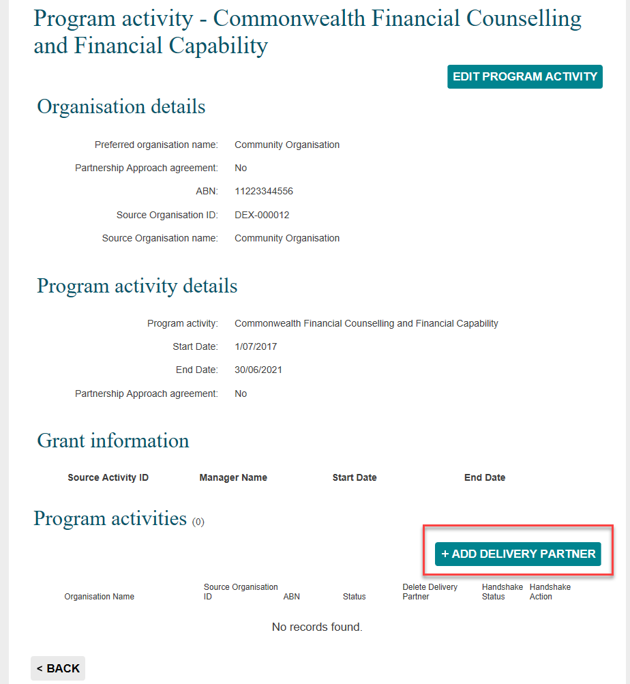
Select + ADD DELIVERY PARTNER
The Add delivery partner screen will display with the following. Refer Figure 5.
- An information icon will display advising if the organisation you wish to add as a delivery partner is not in the list, contact the Data Exchange Helpdesk
- Select the delivery partner by either using the drop down arrow or typing the first few letters of the organisation at the Delivery partner organisation field.
- The details of the delivery partner will auto populate the fields.
Figure 5 – Add delivery partner screen
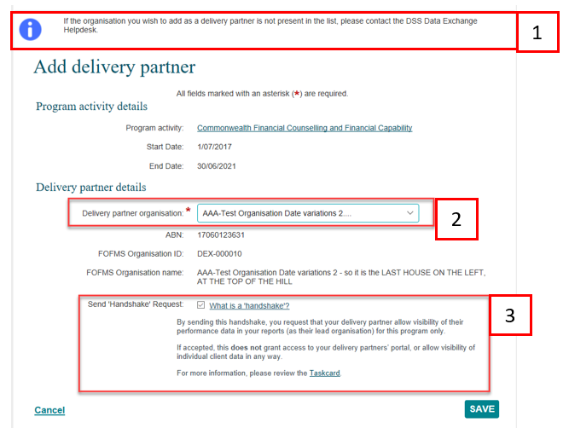
Select the Send ‘Handshake’ Request tick box then select SAVE.
The tick icon will indicate that your request has been successfully saved and sent to the delivery partner. Refer Figure 6.
Under Program activities, the Handshake Status will be updated to Requested.
Figure 6 – Program activity screen
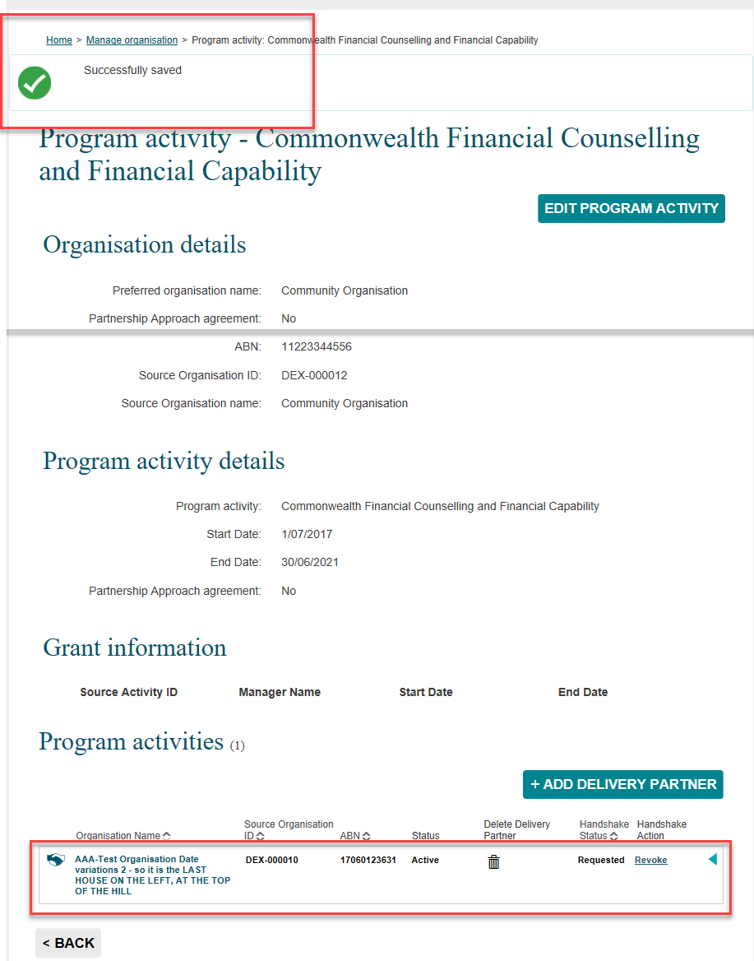

Delivery Partner View – Handshake request alert received
From the Data Exchange web-based portal home page the notifications icon will have displayed next to the Manage action items. Refer Figure 7.
Select Manage action items.
Figure 7 – Data Exchange web-based portal home page with notification icon
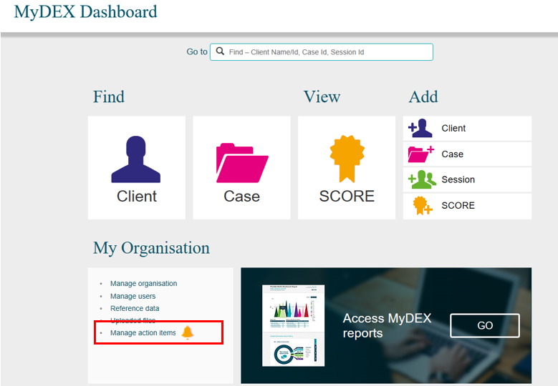
Please Note: The bell icon signifies a handshake request / agreement. A gold notification icon will display on the Data Exchange web-based portal home page and a black notification icon will display in the Manage organisation screen.
The Manage organisation screen will display. Refer Figure 8.
Figure 8 – Manage organisation screen with notification icon
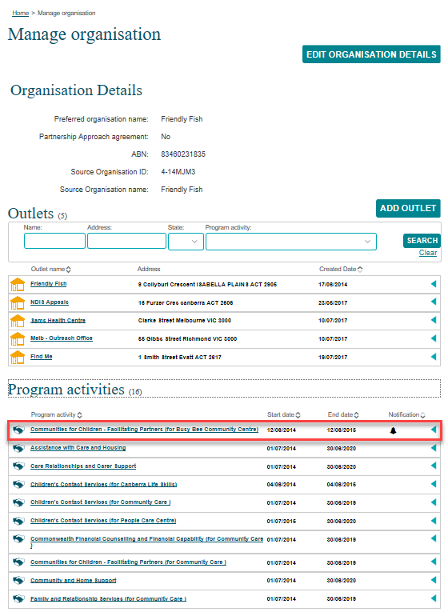
In the Program activities section, the notification icon will display next to the Program activity that has received a handshake request.
Select the Program activity hyperlink.

Accepting / declining a Handshake
The selected Program activity screen will display. Refer Figure 9.
On the Program activity screen, the information icon will indicate that a handshake was requested.
Select either ACCEPT HANDSHAKE or DECLINE HANDSHAKE .
Figure 9– Program activity screen
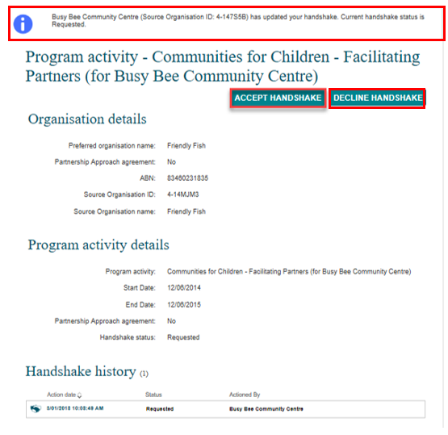
By selecting ACCEPT HANDSHAKE a pop-up message will display. Refer Figure 10.
Select OK
Figure 10 – Pop-up message: Accept handshake?
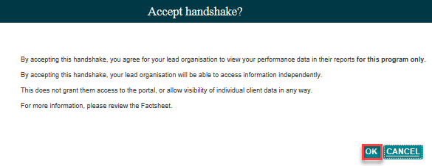

The Handshake history status will be updated to Accepted. Refer Figure 11.
Figure 11 – Program activity screen – Status update to Accepted
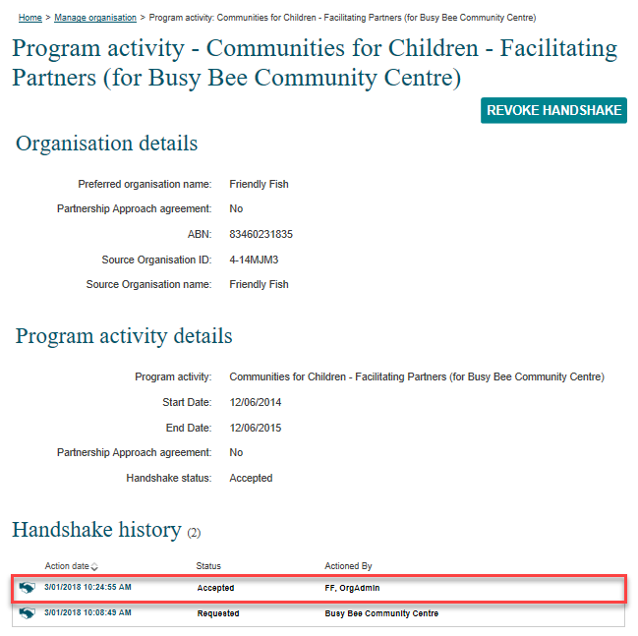

Please Note: It can take up to 24 hours for the handshake to become active.

Lead Organisation View – Handshake request status
From the Data Exchange web-based portal home page, go to the My Organisation menu. Refer Figure 12.
Select Manage action items.
Figure 12 – Data Exchange web-based portal home page
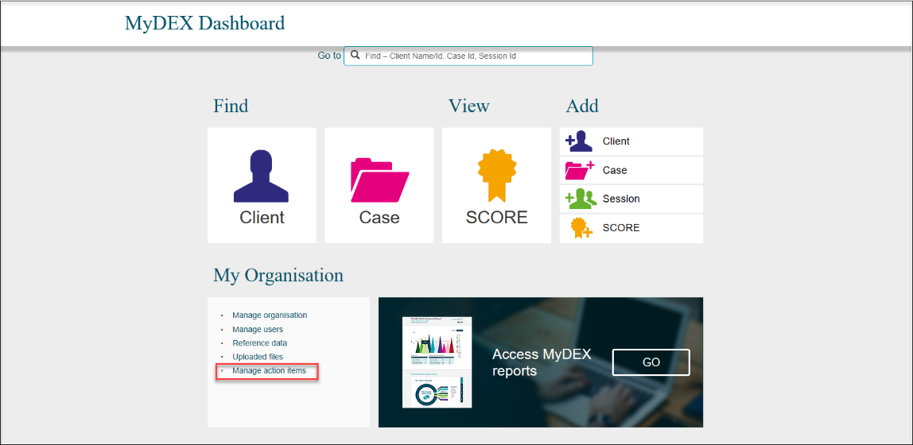

The Manage organisation screen will display. Refer Figure 13.
Figure 13 – Manage organisation screen
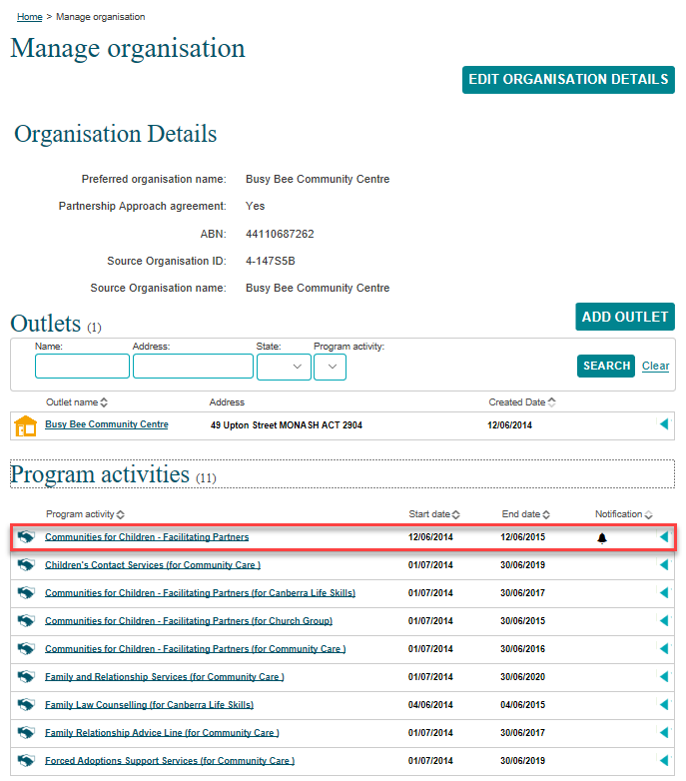
A notification icon will display next to the Program activity where a handshake request has been actioned.
Select the relevant Program activity hyperlink.
The Program activity screen will display with the following. Refer Figure 14.
- The information icon will indicate that your handshake request has been accepted.
- Under Program activities, the Handshake Status will display Accepted.
Figure 14 – Program activity screen
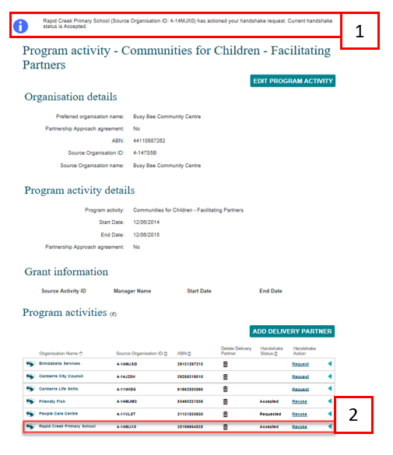

Lead Organisation View – Revoking a handshake
From the Data Exchange web-based portal home page, go to the My Organisation menu. Refer Figure 15.
Figure 15 – Data Exchange web-based portal home page
Select Manage organisation.
The Manage organisation screen will display. Refer Figure 16.
A notification icon will display next to the Program activity where a handshake request has been requested.
Select the relevant Program activity hyperlink.
Figure 16 – Manage organisation screen

The Program activity screen will display. Refer Figure 17.
Scroll down to the list of Program Activities.
Under the Handshake Action column, select the Revoke hyperlink.
Figure 17 – Program activity screen
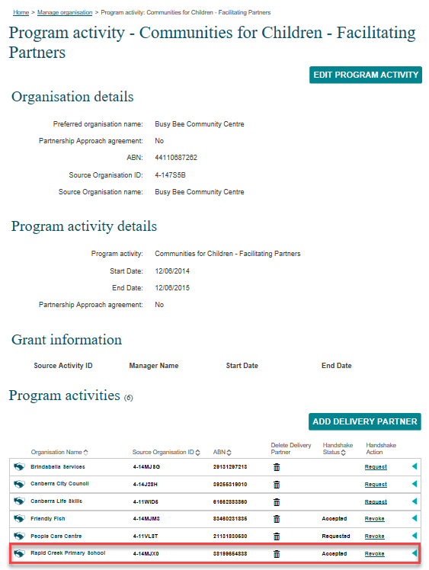
A Revoke handshake? pop-up box will display. Refer Figure 18.
Figure 18 –Revoke handshake? pop-up box
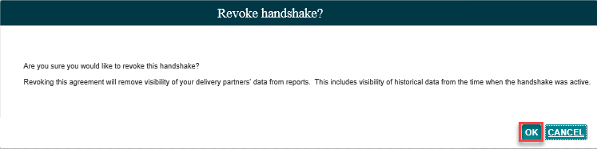
Select OK

The Handshake Status for the program activity will display Revoked by lead partner. Refer Figure 19.
Figure 19 – List of program activities
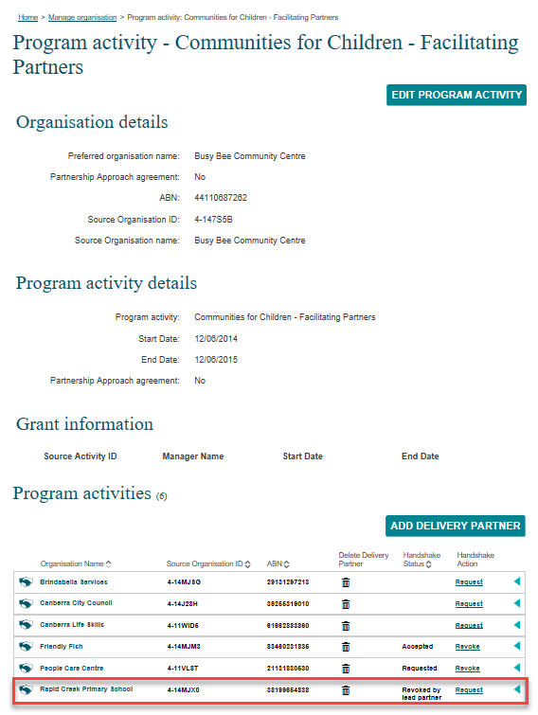

Please Note: It can take up to 24 hours for the handshake access to be removed.

Delivery Partner View – Handshake revoked by lead organisation
From the Data Exchange web-based portal home page, go to the My Organisation menu. Refer Figure 20.
Figure 20 – Data Exchange web-based portal home page
Select Manage action items.
The Manage organisation screen will display. Refer Figure 21.
Figure 21 – List of program activities
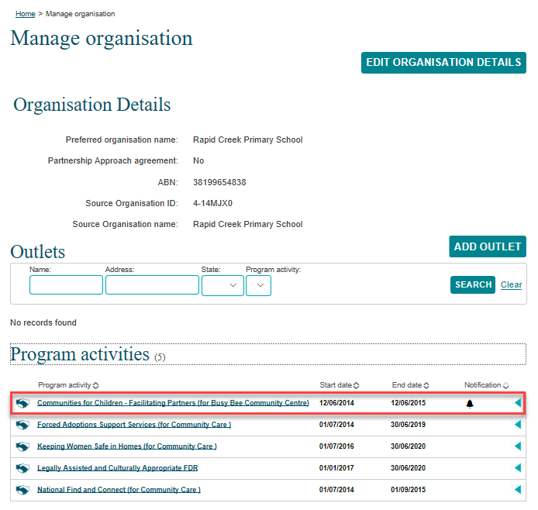
A notification icon will display next to the Program activity where a handshake request has been changed.
Select the relevant Program activity hyperlink.

The Program activity screen will display with the following. Refer Figure 22.
- The information icon will indicate that your handshake has been revoked.
- In the Handshake history section, the status will display Revoked by lead partner.
Figure 22 – Program activity screen
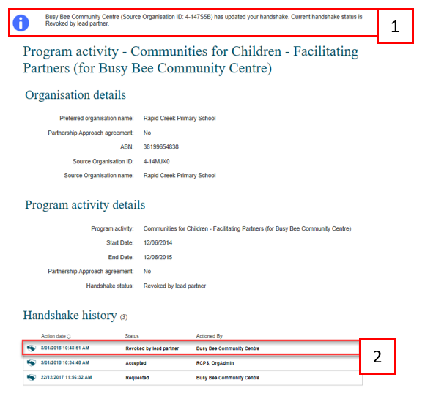

Delivery Partner View – Revoking a handshake
From the Data Exchange web-based portal home page, go to the My Organisation menu. Refer Figure 23.
Select Manage organisation.
Figure 23 – Data Exchange web-based portal home page

The Manage organisation screen will display. Refer Figure 24.
Figure 24 – Manage organisation screen
A notification icon will display next to the Program activity where a handshake request has been changed.
Select the relevant Program activity hyperlink.
The Program activity screen will display. Refer Figure 25.
Figure 25 – Program activity screen
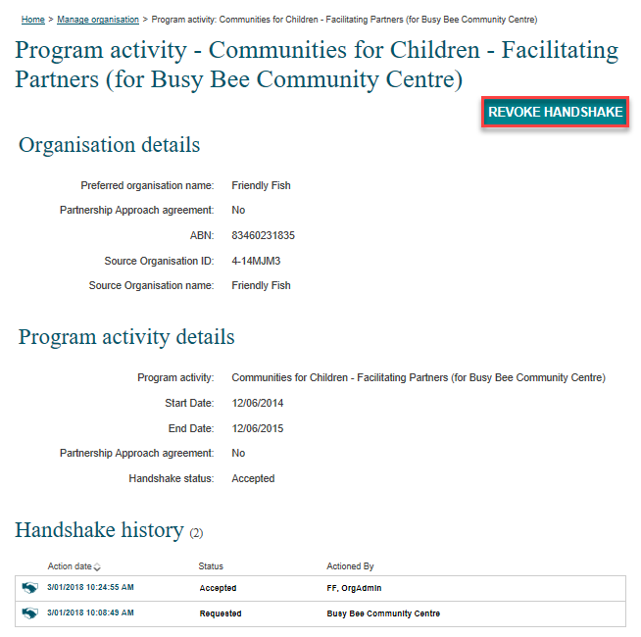
Select REVOKE HANDSHAKE

A Revoke handshake? pop-up box will display. Refer Figure 26.
Figure 26 –Revoke handshake? pop-up box
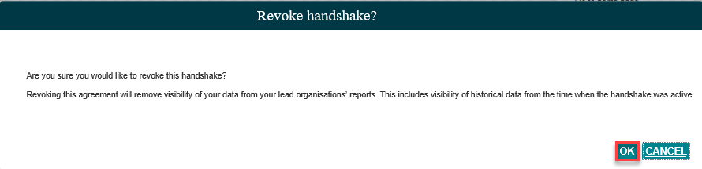
Select OK
The Handshake history status will be updated to Revoked by delivery partner. Refer Figure 27.
Figure 27 – Program activity screen
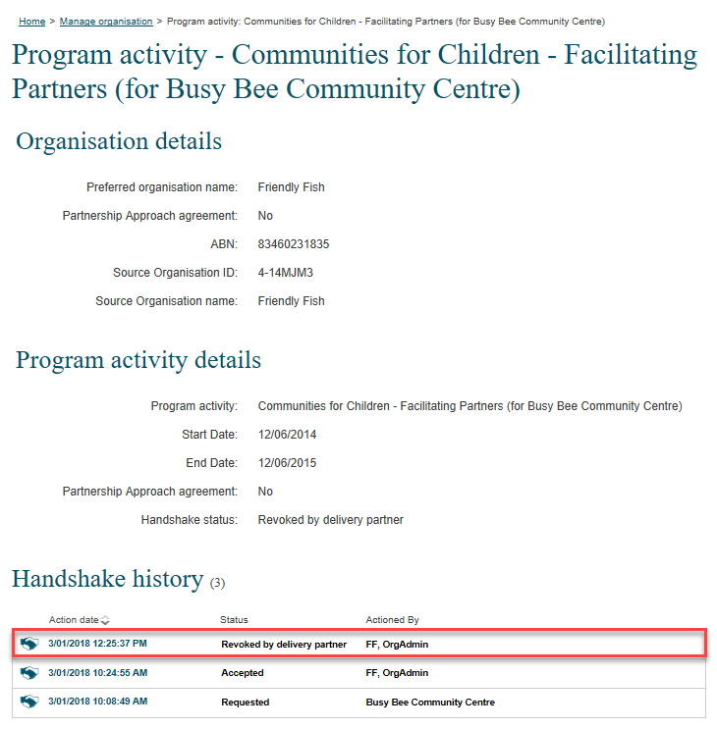

Lead Organisation View– Handshake revoked by delivery partner
From the Data Exchange web-based portal home page, go to the My Organisation menu. Refer Figure 28.
Select Manage action items.
Figure 28 – Data Exchange web-based portal
The Manage organisation screen will display. Refer Figure 29.
Figure 29 – Manage organisation screen with a list of program activities
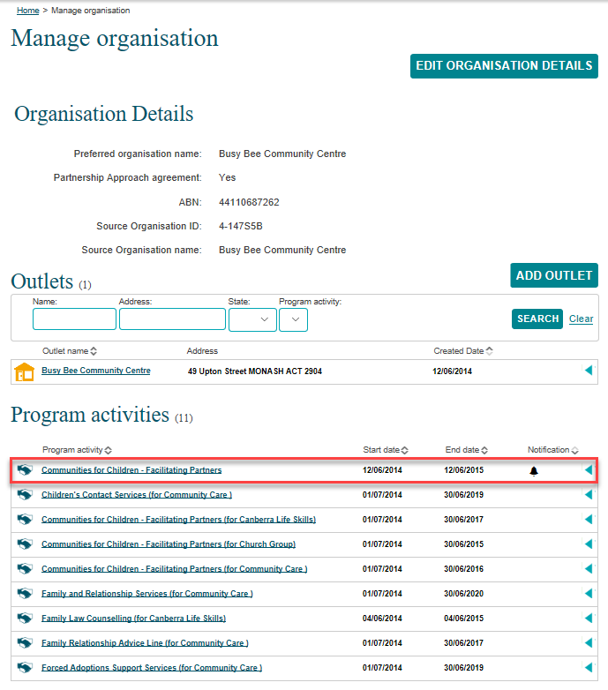
A notification icon will display next to the Program activity where a handshake request has been changed.
Select the Program activity hyperlink.
The Program activity screen will display with the following. Refer Figure 30.
- The information icon will indicate that your handshake has been revoked.
- The Handshake Status will display Revoked by delivery partner.
Figure 30 – Program activity screen
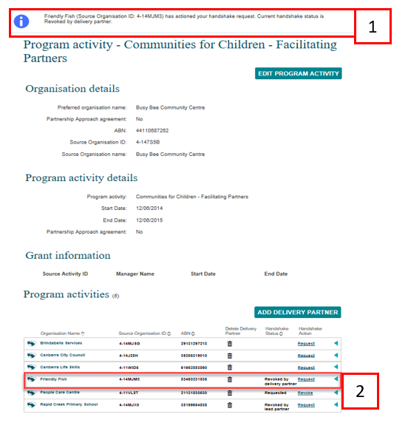

You can find more information on outlets, clients, cases, and sessions on the Data Exchange Protocols and the Training page.
For system support, contact the Data Exchange Helpdesk by email dssdataexchange.helpdesk@dss.gov.au or on 1800 020 283.

