Find and edit a session

Task card
This task card discusses the following:
- Information on updating sessions
- Find a Session
  - Method 1 – From the Go to field
  - Method 2 – From the Find Case button
- Results section
- Edit a Session

KEY HIGHLIGHTS
- At least one session must be recorded during a reporting period for the session and associated clients to be counted in reports.
- A session can be updated any time only during the relevant reporting period.
- The use of special characters such as * & % # @ should not be included in the free text fields as they are used as search functions in the Data Exchange.

Information on updating sessions
A session records what service was delivered on a particular date within a reporting period, the type of service delivered and which clients attended. Sessions are a critical part of the service record of a service provider and drive the reporting function of the Data Exchange.

At least one session must be recorded as occurring within a reporting period for the session and associated clients to be counted in reports.

Find a session
There are a number of ways to find an existing session. Refer to Figure 1.
Go to the Data Exchange home page and either:
- Enter information in the Go to field
- Select the Find Case action tile
Figure 1 - Data Exchange home page
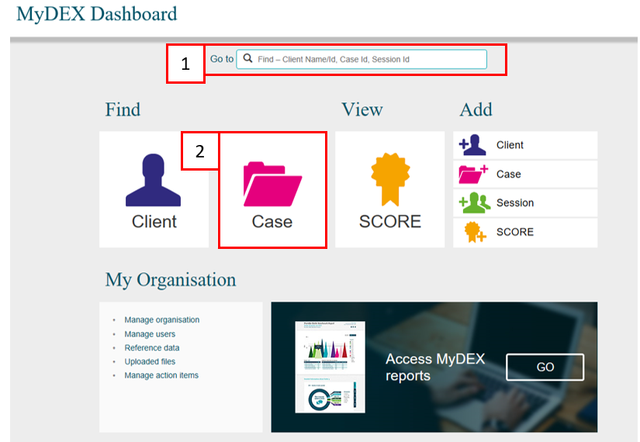

Method 1 – From the Go to field
Start typing the session ID (this could be numerical or alphabetical) in the Go to field
The field will provide a drop down list to select the required session. Refer to Figure 2.
Figure 2 – Data Exchange home page - Go to field
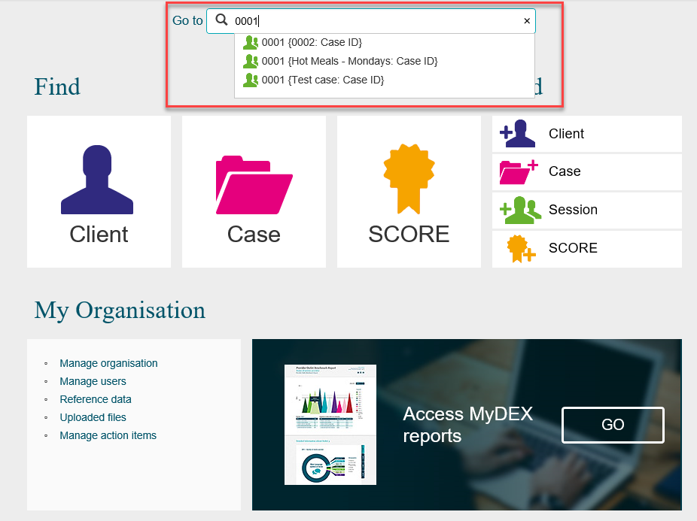

The Session details screen will display. Refer to Figure 3.
Figure 3 – Session details screen
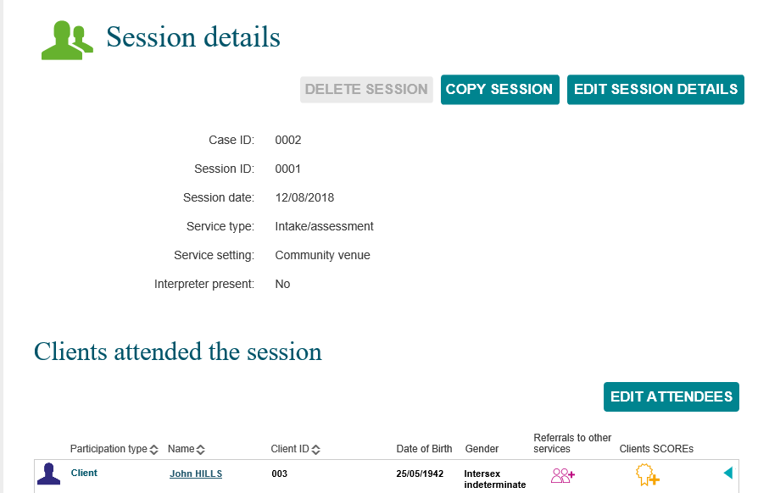

Refer to the Edit a session details in this task card for further instructions.

Method 2 – from the Find a Case button
The Find a case screen will display. Refer to Figure 4.
Find your session by selecting the corresponding case
Figure 4 – Find a case screen
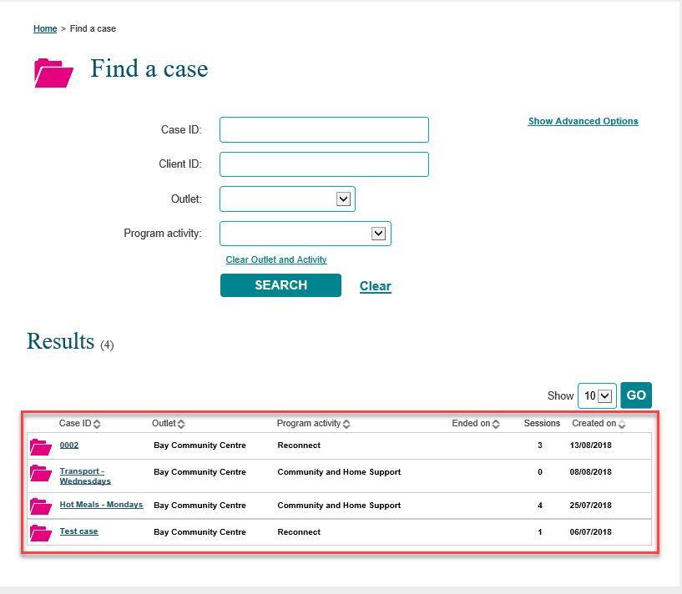

Results section
The most recently created cases will display in the Results section. Refer to Figure 5.
- Select GO to change the amount of records displayed on the screen. The options are 10, 20 and 50.
- Click on the heading hyperlinks of Case ID, Outlet, etc. to filter columns from ascending to descending order and visa-versa either alphabetically or numerically.
- Click on the case hyperlink to select the case.
Figure 5 – Results section
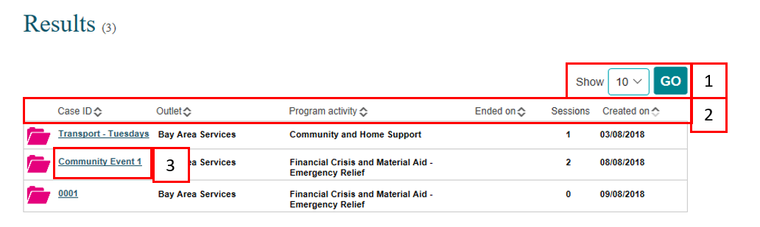

Select the relevant case hyperlink and the Case details screen will display. Refer to Figure 6.
Figure 6 – Case details screen
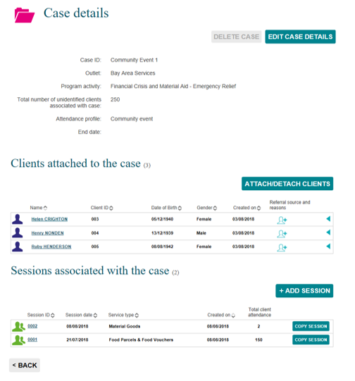

Select the relevant session hyperlink and session details will display. Refer to Figure 7.
Figure 7 – Session screen
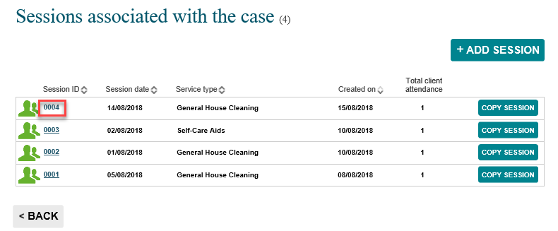

Refer to the Edit a session details in this task card for further instructions.

Edit a session
There are a number of ways to edit an existing session. Refer Figure 8.
- Delete a session
NOTE: you can only delete a session that is in the current reporting period.
- Copy a session
- Edit a session
NOTE: The use of Special characters such as * & % # @ should not be included in the free text fields as they are used as search functions in the Data Exchange.
- Edit Attendees

Figure 8 – Session details screen
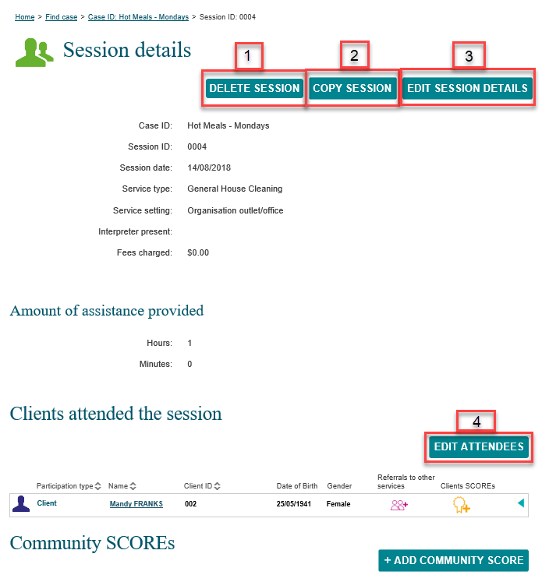

You can find more information on outlets, clients, cases, and sessions on the Data Exchange Protocols and the Training page.
For system support, contact the Data Exchange Helpdesk by email dssdataexchange.helpdesk@dss.gov.au or on 1800 020 283.

