Filters
More information on how to use Qlik can be found at Tutorials - Qlik Sense
The Data Exchange reports will allow you to filter data by selecting items from the available objects on the report sheet.
Filters can be applied to the following areas:
- Reporting Periods
- Activity
- Delivery Organisation
- Outlets
- Visualisations such as graphs and pie charts
- Maps

Navigation guide
Table 1 – Filter applied area navigation items
ITEM | DESCRIPTION
 | Select the step back function to undo the last selection.
 | Select the step forward function to redo a selection.
 | Select the clear selections function to clear all the filters selected.
 | Select the confirm button to confirm your filter selection.
 | Select the clear button to clear your filter selection.
 | Select the drill-down dimension button to display additional filters for that field.
Once you have accessed your report type (i.e. SA3 or LGA) you can select the required filter.

Filter display area
To see what filters you have applied to a report: refer to the filters applied area which is the ribbon located at the top left of the screen.
Figure 1 – Filter applied area
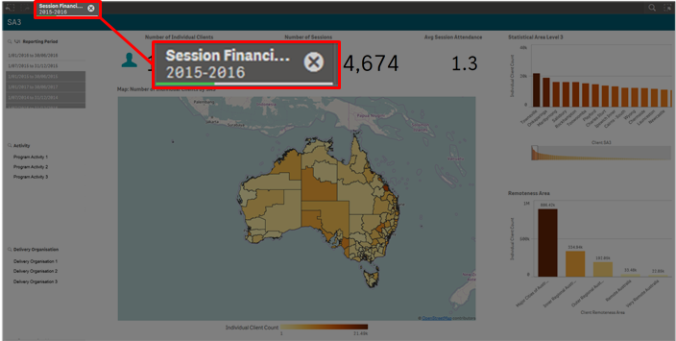

Applying filters

Apply a filter
Select the item that you wish to display:
Figure 2 –Confirm and Clear filter icons
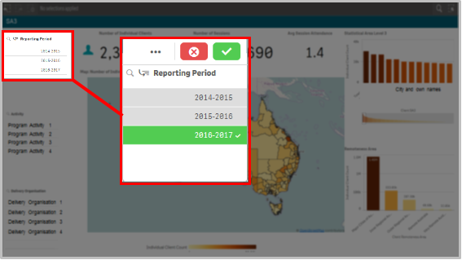
Select to confirm this filter.
Select to clear your selection.
The sheet will automatically update and display the filtered items.

Change a filter
To change the filter selection:
- Click on the previously chosen selection and the item will change from green to grey.
- Click on the new selection (if required).
- Select to confirm.
The sheet will update to reflect your selections.
Figure 3 – SA3 sheet highlighting the selection of one reporting period
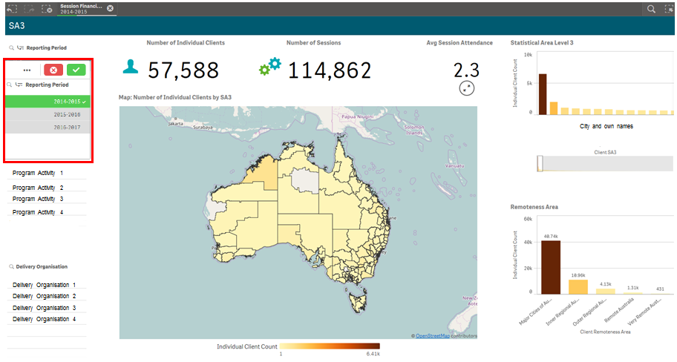
Select next to the filter you wish to remove.
Figure 4 – Clear filter button
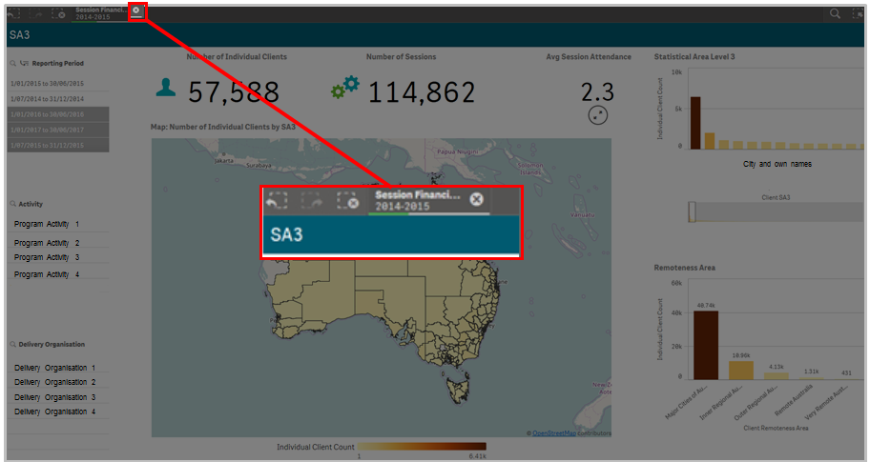

Example of filters
- No filters selected
The default is for no filters to be applied and is shown as No selections applied.
Figure 5 – Filter applied area displaying no selections applied
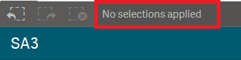
As you drill into the report additional filters can be applied.

Single filter
This image (Figure 6) shows:
- One reporting period selected (highlighted in green) even though three reporting periods are able to be selected.
- This filter is then applied for this sheet and the remainder of the sheets. This filter remains in the Filter ribbon at the top of the screen.
Figure 6 – Filter displaying reporting periods
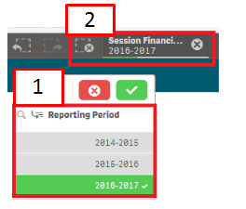

Multiple filters
Each time you add a filter this will be added to the Filter ribbon at the top of the screen.
For example, in this image (Figure 7) three filters have been applied. The report will show the results for:
Figure 7 – Multiple filters displayed in the Filter applied area
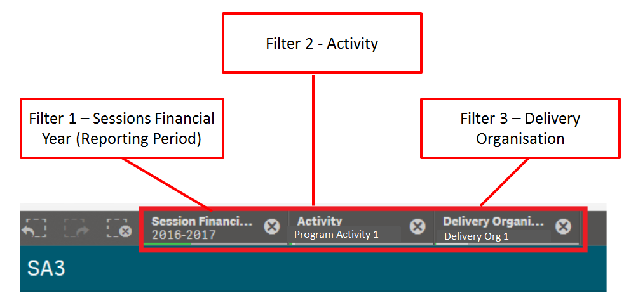

Drill-down dimension filters
Some filter options also have drill-down dimension filters where when selected another set of filter options display under the original filter heading.
Figure 8 - Drill-down filter option
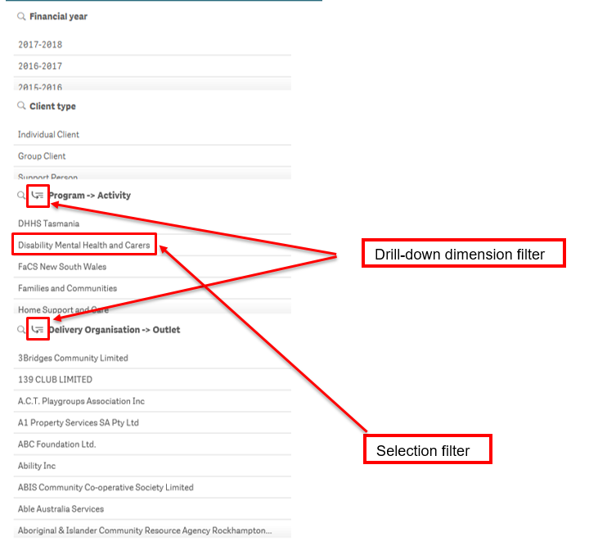

Select in the relevant filter field. The next layer of filters will now display.
Figure 9 – New filter options displayed when drill-down filter option selected
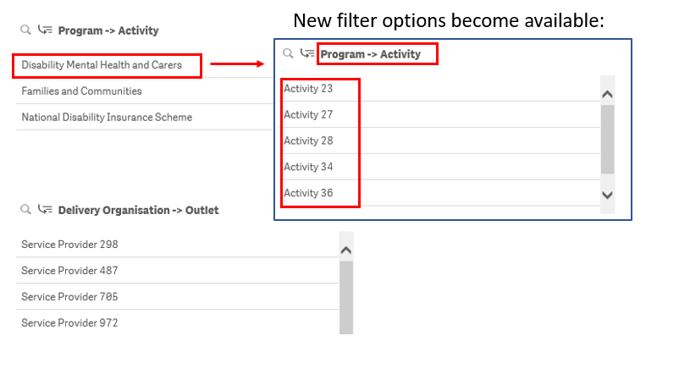

Visualisation filters
Graph and pie chart visualisations can be further filtered.
Go to the relevant sheet and select the required item to filter. Figure 10 highlights the Individual Client by Age Group filter selection of 45 to 49.
Figure 10 – Visualisation filter applied
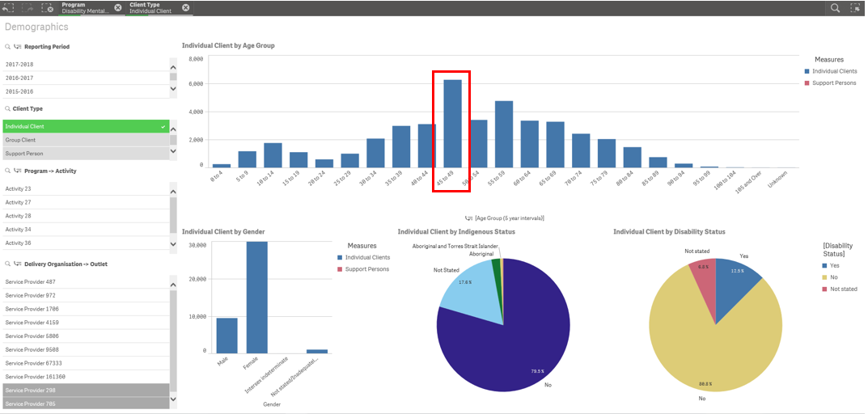
The data on the sheet will reflect the filter selected.
Figure 11 – Data reflects the filter selected
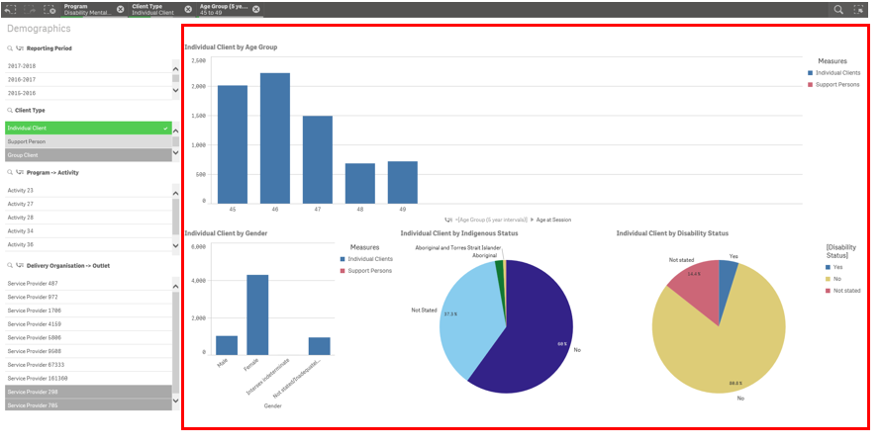

You can find more information on reporting requirements in the Data Exchange Protocols. For further information on reports functionality, please visit the Training tab of the Data Exchange website.
For system support, contact the Data Exchange Helpdesk by email at dssdataexchange.helpdesk@dss.gov.au or on 1800 020 283.

