Accessing the Data Exchange with Digital Identity (myGovID) and RAM – Frequently Asked Questions
This task card discusses frequently asked questions when accessing the Data Exchange through RAM with your myGovID.

Q. What is Digital Identity?
A. The DEX Portal uses the Australian Government Digital Identity System to verify users. Your Digital Identity is a safe, secure and convenient way for you to prove who you are when accessing government online services like the DEX Portal. More information about Digital identity can be found here.

Q. What is myGovID?
A. myGovID is the Australian Government’s Digital Identity app. Your myGovID is different to your myGov account.
Set up your myGovID in three easy steps. Download the myGovID app to your smart device, enter your details and verify your documents to your chosen identity strength. To access the DEX Portal, you will need at least a Basic identity strength. As it's your personal Digital Identity, you should set up your myGovID using a personal email address. It should not be a shared or work email address.
For help with myGovID, visit www.myGovID.gov.au/help

Q. Can you use myGovID as your Digital Identity?
A. Yes, myGovID is the Australian Government’s Digital Identity app and forms part of the wider Australian Government Digital Identity System. You’ll be given the option to select myGovID as your Digital Identity and asked to provide consent to share your information for the DEX Portal.

Q. What is Relationship Authorisation Manager (RAM)?
A. Relationship Authorisation Manager (RAM) is an authorisation service that allows you to act on behalf of an entity online when linked with your Digital Identity, like myGovID.
For more information, visit info.authorisationmanager.gov.au

Q. Can you link your Digital Identity to a business using RAM?
A. Yes, before you access the DEX portal on behalf of a business, you need to link your Digital Identity, like myGovID, to the business using RAM.
How you link depends on whether you’re a:
Principal authority – person responsible for the business or entity. A principal authority needs to link to the business in RAM first before others can be authorised to access government online services like the DEX Portal on behalf of the business. To link the business in RAM as a principal authority, you need a myGovID with a Standard or Strong identity strength.
- Authorised user or administrator - someone who acts on behalf of a business or entity. A principal authority or authorisation administrator needs to authorise you before you can access the DEX Portal on behalf of a business. You’ll use your myGovID to log into RAM and accept an authorisation request.

Q. I already have a myGov account, do I need a myGovID as well to access DEX?
A. Yes, because myGov and myGovID are different. The myGovID app lets you prove who you are and securely access participating government online services like the DEX Portal.
Your myGov account lets you, as an individual, link to government services online in one place, such as Medicare and Centrelink.
Each individual requires their own Digital Identity, such as myGovID, to access the Data Exchange portal.

Q. I put in my email address linked to my Data Exchange profile to receive the activation code but have not received it. What do I do?
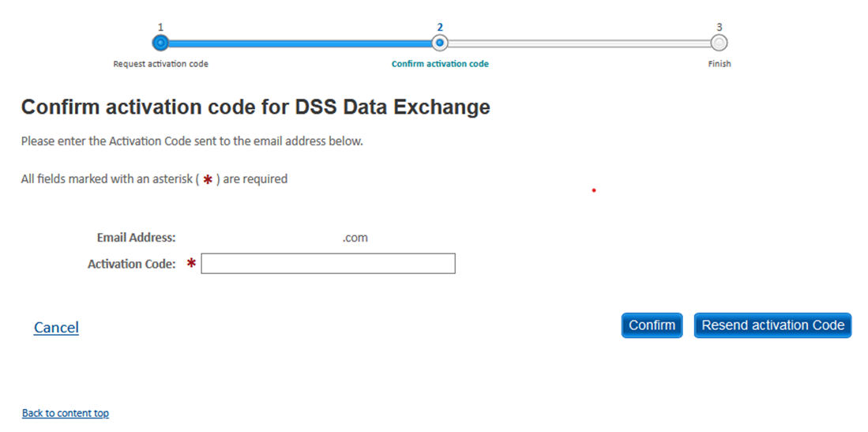
A. Please ensure that the spelling of your email address is correct and that you have checked your junk mail folder. Alternatively, the email may be blocked by your firewall/IT system. If the email with the activation code does not come through within 5 minutes, please talk to your IT administrator or phone the Data Exchange Helpdesk on 1800 020 283 for further assistance.

Q. I keep getting this error message ‘A user account has not been created for this email address within the Department of Social Services application. Please try again or contact the Data Exchange Helpdesk on 1800 020 283 or email dssdataexchange.helpdesk@dss.gov.au for assistance.’ – What do I do?
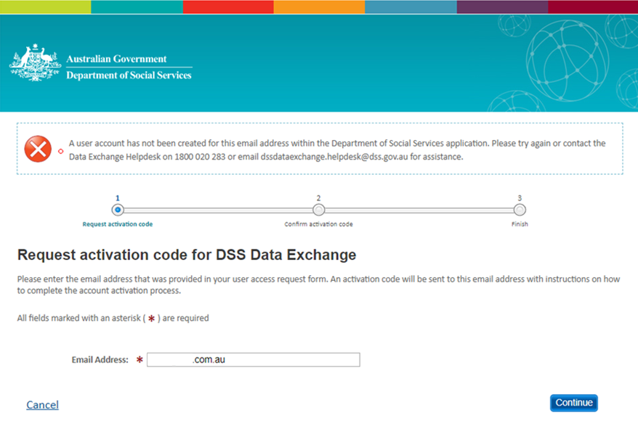
- This error message means you do not have access to the Data Exchange under the email address provided. This typically occurs for one of two reasons:
  - If you have input an email address registered with your myGovID (your personal email address) which is different to the email address registered on your Data Exchange user profile, the system will not pick up that you are an existing user. Please check what email address you used on your DEX access request form. The email address used to request an activation code needs to be the same as the email address on your Data Exchange user profile.
  - If you have never accessed the Data Exchange portal before, your Organisation Administrator can create your access or alternatively, you will need to complete a Data Exchange System User Access Request Form.

Q. I keep getting this error message when logging in for the first time ‘This email address is already taken for another user within the Department of Social Services application. Please try again or contact the Data Exchange Helpdesk on 1800 020 283 or email dssdataexchange.helpdesk@dss.gov.au for assistance.’ – How do I get around this?
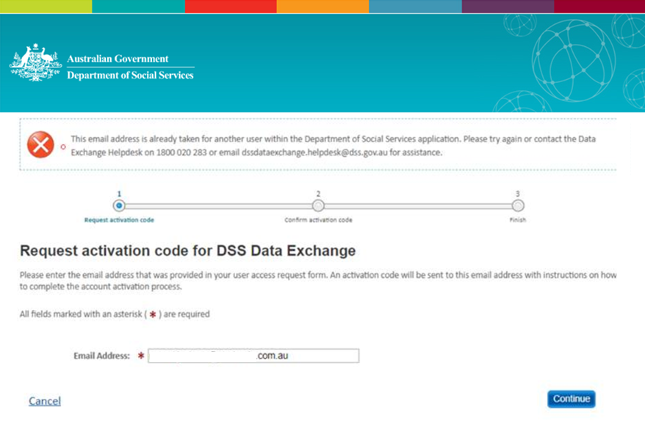
A. Another user within your organisation may have already authenticated with the email address you are using. Each user accessing the Data Exchange must have their own Digital Identity and Data Exchange account with a unique email address. We recommend completing a new Data Exchange System User Access Request Form. If this approach does not work, please contact the Data Exchange Helpdesk for assistance.

Q. I am continually getting stuck here with this error ‘011 – Please contact your application administrator.’ – What do I do?
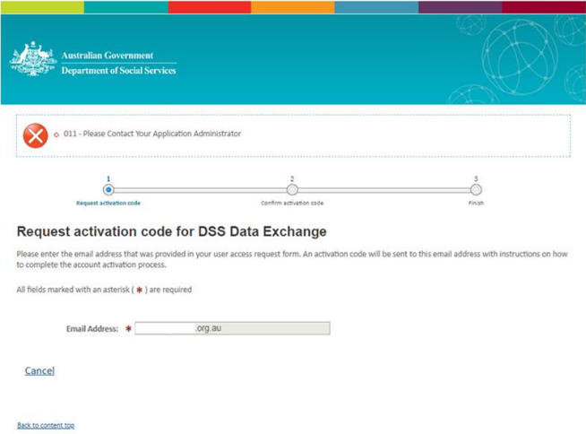
A. This error indicates that there is a mismatch between the ABN on your Data Exchange account and the ABN selected in RAM through the Digital Identity login process via myGovID. Please ensure the ABN you have been linked to in RAM is correct. If you continue to receive this error, please contact the Data Exchange Helpdesk for further investigation.

Q. When I attempt to log in to the Data Exchange Portal, I verify the four-digit code in myGovID but am then taken to this screen – what do I need to do in RAM?
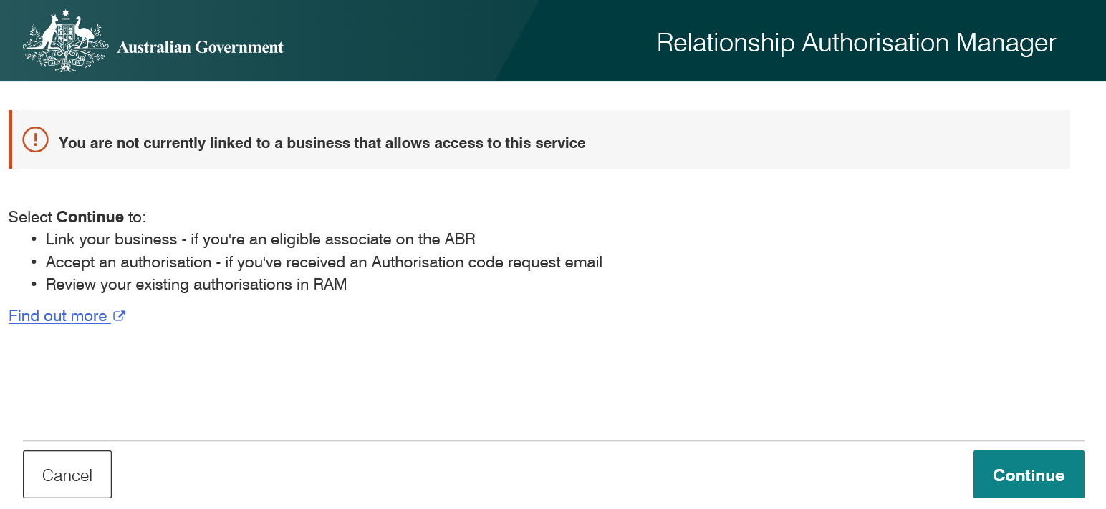
A. This indicates that you haven’t been authorised to act on behalf of the business in RAM. You will need to contact a principal authority or authorisation administrator to authorise you. Further information on this process can be found here.

Q. Can I have more than one myGovID?
A. No, your myGovID is your personal identity and unique to you. You should set up your myGovID using a personal email address. It should not be a shared or work email address. You can set up your myGovID on multiple devices. When installing the myGovID app on another device you’ll need to re-verify your identity with the same email address. You can use your myGovID for personal or business matters, or both.
For more information, visit myGovID.

Frequently Asked Questions
For information about myGovID, and for help with set up, please visit the myGovID website.
For information and support with RAM, please visit the Relationship Authorisation Manager website.
For information about Digital Identity, please visit the Digital Identity Website.

You can visit the myGovID and RAM websites for further information, or assistance.
For system support, contact the Data Exchange Helpdesk by email at dssdataexchange.helpdesk@dss.gov.au or on 1800 020 283.

