Add a session

Task card
This task card discusses the following:
- What is a session?
- Add a session
  - Method 1 – From Add a case
  - Method 2 – From Add a session
  - Method 3 – From Find a case
- Enter session details
- Add clients and support persons to the session
- Add a session – Finish
- Copy a session
- Record Referrals to other services
- Special data entry fields

KEY HIGHLIGHTS
- A session must be created within the relevant reporting period for it to be counted in reports.
- Attendees to a session can be either a client or a support person.
- Referrals to other services can only be added to a client during the relevant reporting period.
- The use of special characters such as * & % # @ should not be included in the free text fields.
- Some programs have special data entry fields that apply to sessions.

What is a session?
A session records:
- What service was delivered on a particular date within a reporting period
- The type of service delivered, and
- Which clients attended.
Sessions are a critical part of the service record of an organisation and drive the reporting function of the Data Exchange. They must be submitted in the reporting period they occurred. They cannot be reported in a different reporting period.

At least one session must be recorded as occurring within a reporting period for the case and associated clients to be counted in reports.

Add a session
There are three different methods to add a session.
- At the case creation point where a session is immediately added to a new case.
- From the home screen, Add a Session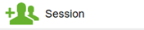.
- From the home screen, Find a Case 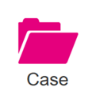.
Note: All three methods will direct you to the Add a session – session details screen. Refer to Figure 5.

Method 1 – From Add a new case
Add a new Case – refer to the Add a case taskcard.
Select Add a session to this case hyperlink under the What can you do now? heading. Refer to Figure 1.
Figure 1 – “What can you do now?”
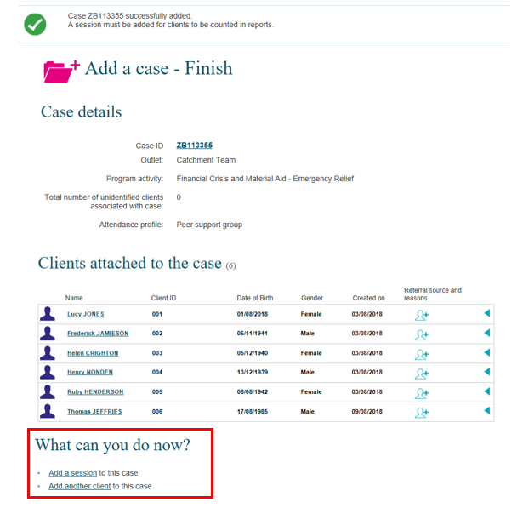

Method 2 – From Add a session
At the Data Exchange web-based portal home page select under the Add menu. Refer to Figure 2.
Figure 2 – The Data Exchange home page – Add a session action tile
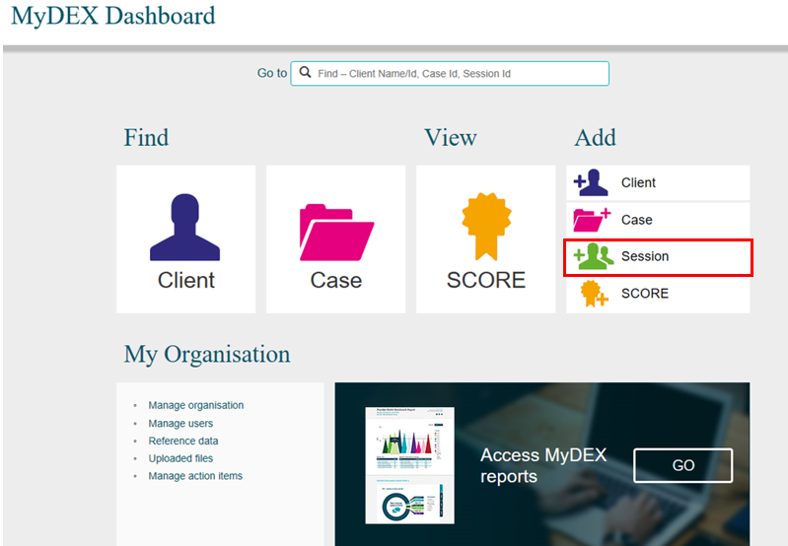

Method 3 – From Find a case
At the Data Exchange web-based portal home page select under the Find menu. Refer to Figure 3.
Figure 3 – The Data Exchange home page – Add a session action tile
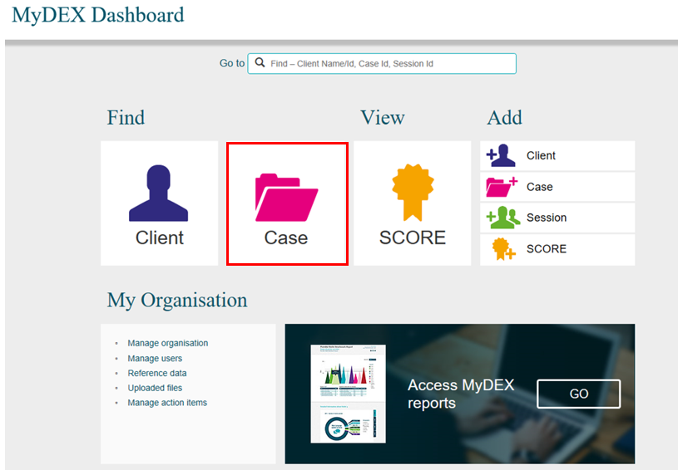
The Find a case screen will display. Refer to Figure 4.
Select the case hyperlink to add a session to the case.
Figure 4 – The Data Exchange home page – Add a session action tile
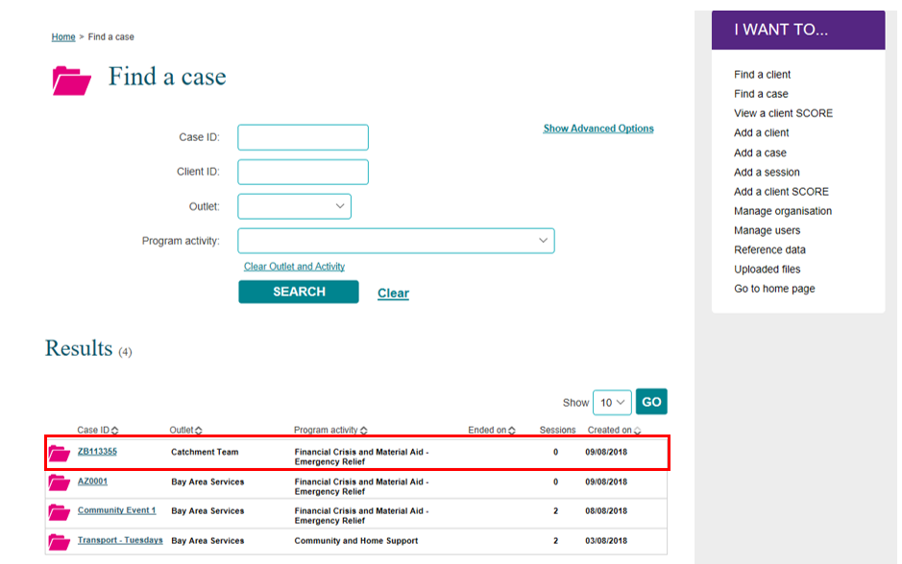

The Case details screen displays. Refer to Figure 5.
Select the +ADD SESSION button under Sessions associated with the case heading. Refer to Figure 5.
Figure 5 – Case details – Add session button
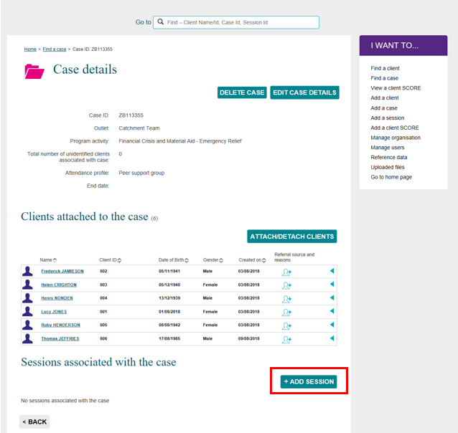

Enter Session details
The Add a Session – session details screen will display. Refer to Figure 6 and Table 1 for more information on the fields.
Figure 6 – Add a session – Session details screen
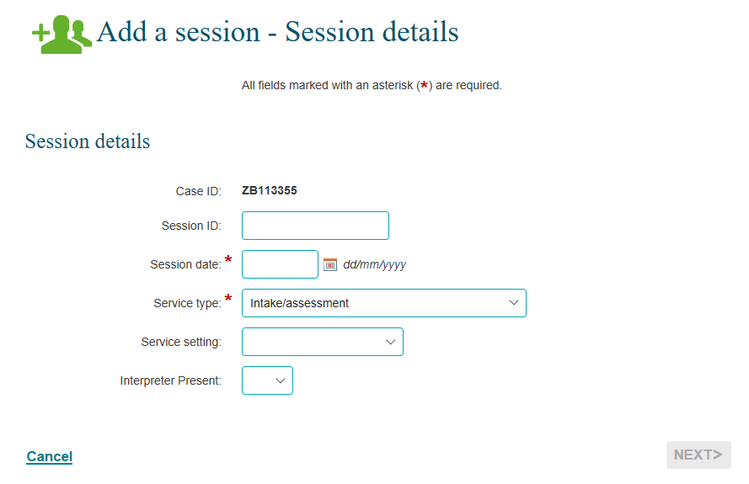

Table 1 – Session Details Field Descriptions (Refer Figure 6)
FIELD | DESCRIPTION
Case ID | This is the identifier (ID) of the case you are recording a session against.
Session ID | Enter the session ID if your organisation has a session ID system, or leave it blank for auto-generation.  Note: The use of special characters such as * & % # @ should not be included in the free text fields in the Data Exchange.
Session date* | Record the date the session occurred. Enter today’s date or a date in the past within the reporting period.  Note: Sessions cannot be entered for future dates or dates in a closed reporting period.
Service type* | Each session can only have one service type.  Select the service type that best reflects the intent of the session.  The service type choices are dependent on the program activity the case was created under and are to align with the program intent.  Go to the Data Exchange program specific guidance for more information on which service types apply to each program.
Service setting | Select where/how the session took place. The options are:  - Organisation outlet/office  - Client’s residence  - Community venue  - Partner organisation  - Telephone  - Digital  - Healthcare facility  - Education facility  - Justice facility
Interpreter Present | Enter Yes if an interpreter was present. This includes a professional interpreter, a bilingual support person or a bilingual staff member who interprets for a client. This also includes Auslan or other sign language interpreters for the hearing impaired.
* Mandatory Fields
Once completed, please select NEXT.
The Add a session – Client/support persons attended screen will display. Refer to Figure 7 for more information). Definitions of client and support persons are included in Table 2.
Figure 7 – Add a session – Clients/support persons attended screen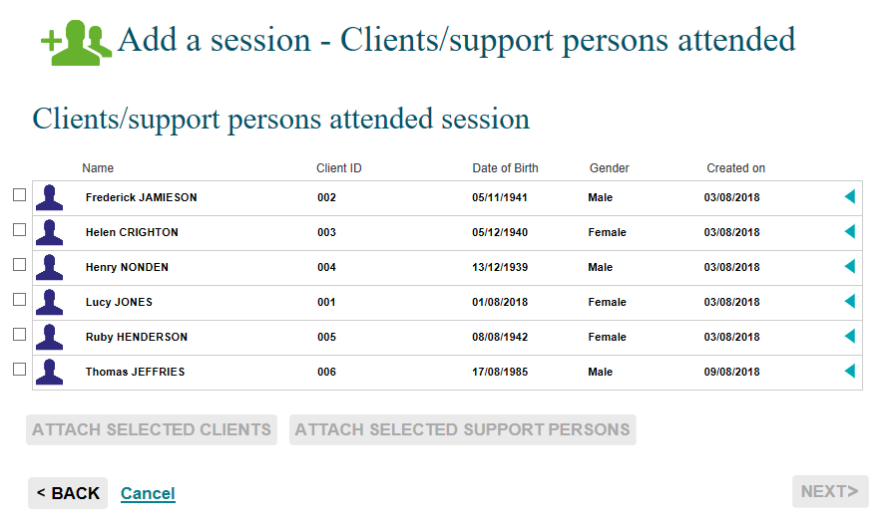

Add clients and support persons to the session
The Add a session – Client/support persons attended screen will display all the clients linked with the case.
When creating a session, only clients who attend the session are to be recorded.

Table 2 – Client and support persons definitions. Refer Figure 7.
TERM | DEFINITION
Client | Is an individual who receives a service as part of a funded activity that is expected to lead to a measurable outcome.
Support persons | Persons who may be present at a service who do not meet the definition of a client. These could include carers of clients and family members such as young children. There is no requirement to record the details of support persons, however you can record participants as ‘support persons’ to provide details of session attendees.

To add a support person, you must first create a client record in the Data Exchange and then add a support person at the session level.

Note: if you are creating a session for the Community and Home Support program you must complete the client details that display the icon before you can attach the client to a session. Refer to Figure 8.

Figure 8 – Case details highlighting the warning icon for client
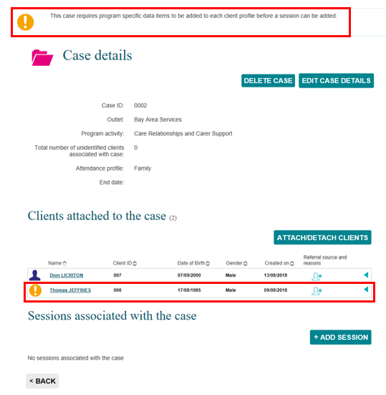
- Select client(s) you wish to add to the session using the tick box next to the client record
- Select the ATTACH SELECTED CLIENTS button. Refer to Figure 9.

Figure 9 – Add a session – Clients selected 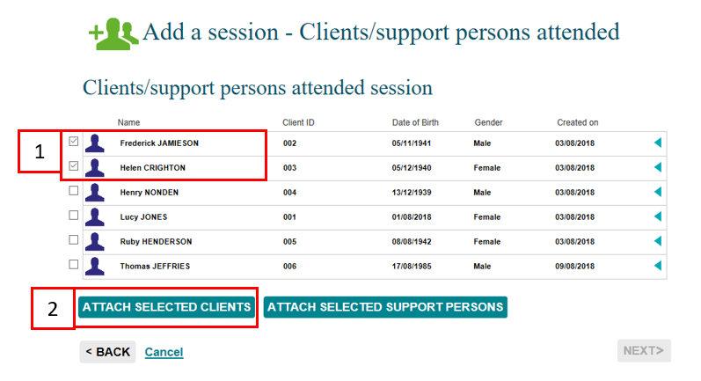

- Select support persons (if any) you wish to add to the session using the tick box to the session.
- Select ATTACH SELECTED CLIENTS. Refer to Figure 10.
Figure 10 – Add a session – Support persons selected 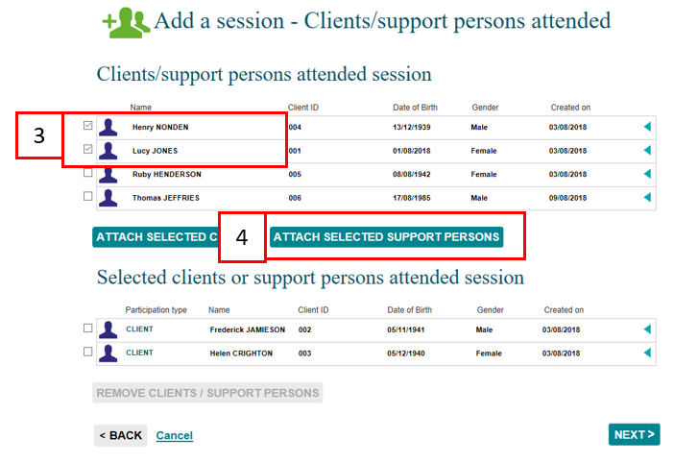
The client(s) and support person(s) selected will display under the Selected clients or support persons attended session heading with their relevant Participation type. Refer to Figure 11.
Figure 11 – Client participation type
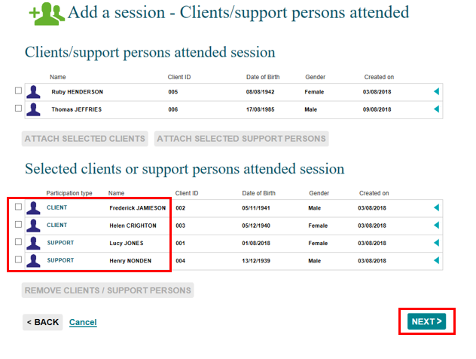
Select NEXT>
The Add a session – Review screen will display. Refer to Figure 12.

Figure 12 – Add a session – Review screen
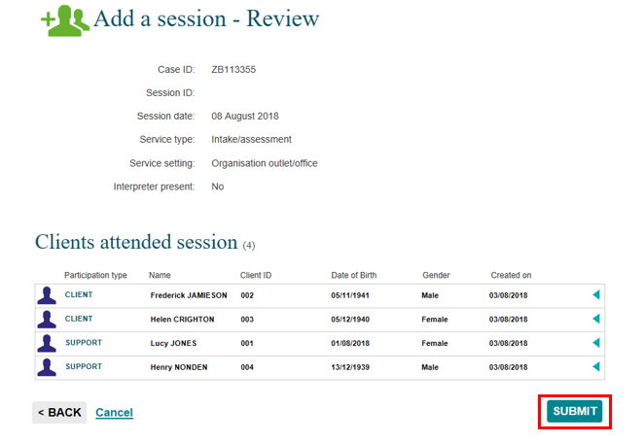
Select <BACK to edit the details or Cancel to stop the process and remove the case.
If the details are correct, select SUBMIT

Add a session – Finish
The Add a session – Finish screen will display with the following. Refer to Figure 13.
- A message box to advise the successful creation of the session.
- A summary of the session you have created. If you did not enter your own session ID, a Session ID will automatically be created.
- A listing of the clients attached to the session.
- What can you do now? section where you can Copy session, Add another session to the case and Add another session. Refer to Table 3.
- I want to… box where you can complete other tasks.
- Go to… search field where you can search for clients, cases and sessions.
Figure 13 – Add a session – Finish screen
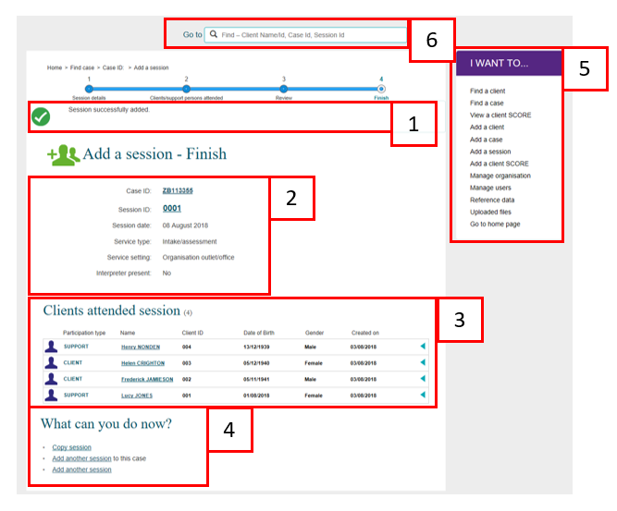

The What can you do now? field provides hyperlinks for you to copy and add more sessions. Refer to Figure 13 (No. 4). Table 3 provides descriptions of these options.

Table 3 – What can you do now? section (Refer Figure 13 item 4)
FIELD | DESCRIPTION
Copy a session | Select the hyperlink to copy the last session created for the case.
Add another session to the case | Select the hyperlink to add another session to the same case.
Add another session | Select the hyperlink to add a session to a different case.

Copy a session
There are a number of ways you can copy a session.
- Select the Copy session hyperlink found on the Add a session – Finish screen. Refer to Figure 14.
- Select the COPY SESSION button found on the Case details screen, after you have searched for your case. Refer to Figure 15.
Figure 14 – Copy session hyperlink
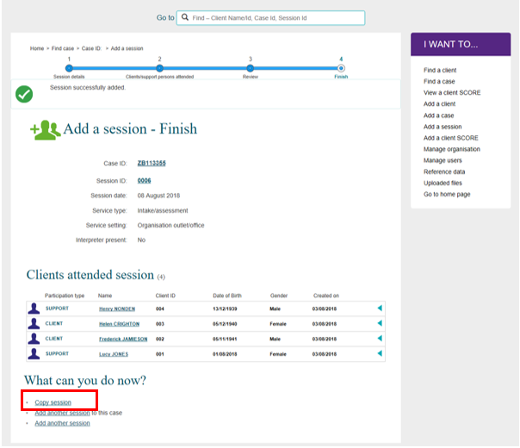

Figure 15 – Copy session button
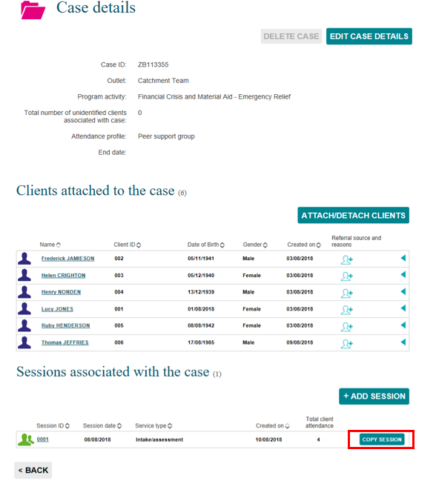
The Copy a session – Session details screen will display. Refer to Figure 16.
Figure 16 – Copy session – Session details screen
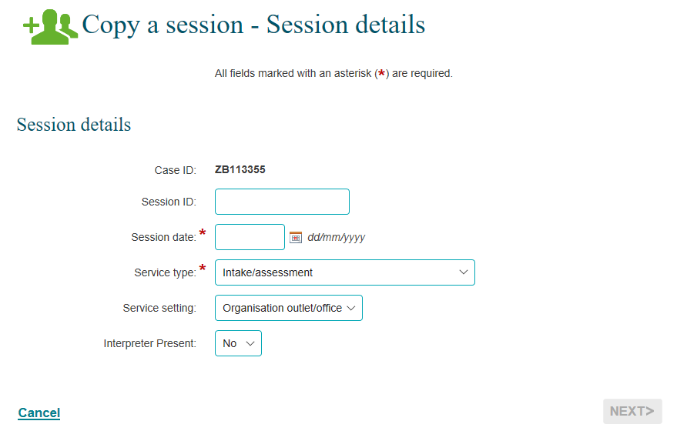
Complete the details as required.
Select NEXT> .
The Copy a session – Clients/support persons attended screen displays. Refer to Figure 17.
Figure 17 – Copy a session – Clients/support persons attended screen
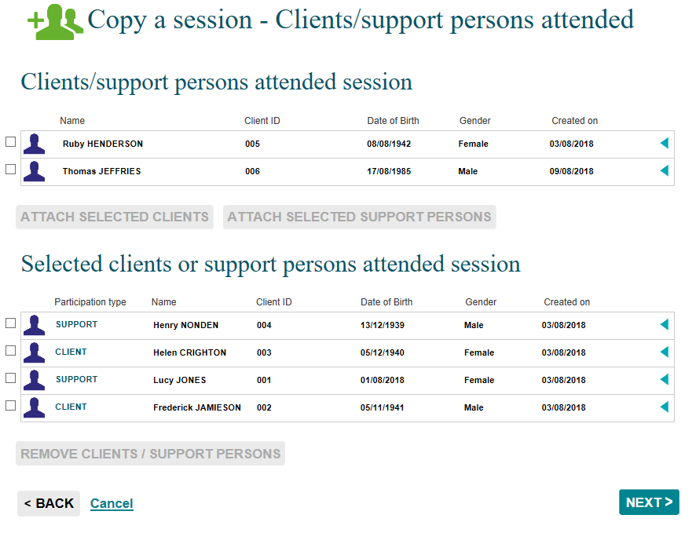
Select the clients that attended the session.
- If the same clients attended from the session you have copied, select NEXT>.
- Remove the clients that didn’t attend this new session by selecting the tick box next to their name. Refer to Figure 18.
Figure 18 – Selecting clients that did not attend the session
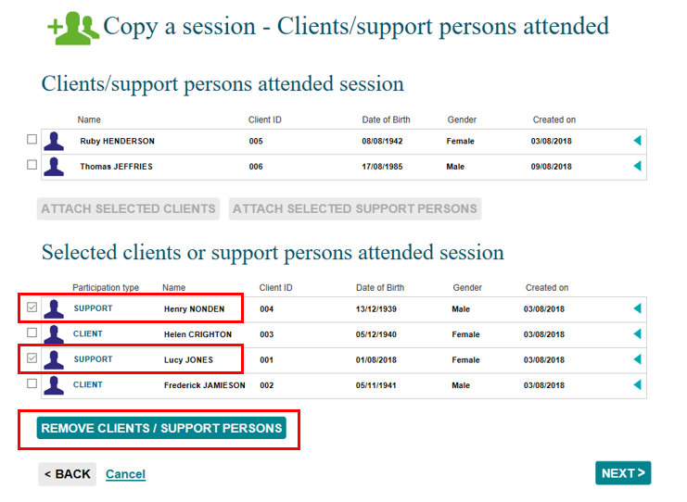
Select the REMOVE CLIENTS / SUPPORT PERSONS button.
The selected clients will move back to the Clients/support persons attended session heading. The clients that did attend the session will remain under the Selected clients or support persons attended session heading. Refer to Figure 19.
Figure 19 – Removal of clients from created session
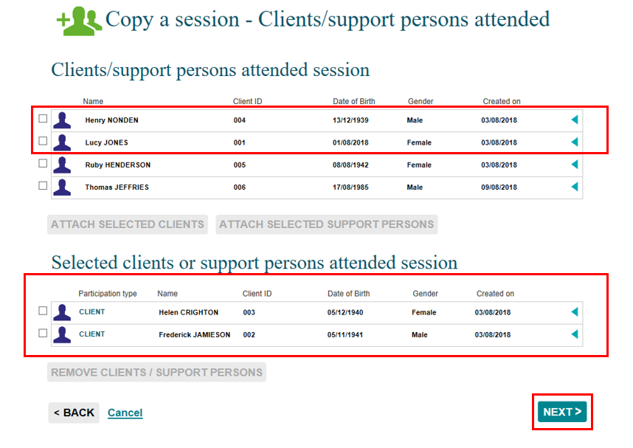
Select NEXT>.
The Copy a session – Review screen will display. Refer to Figure 20.
Figure 20 – Copy a session Review screen
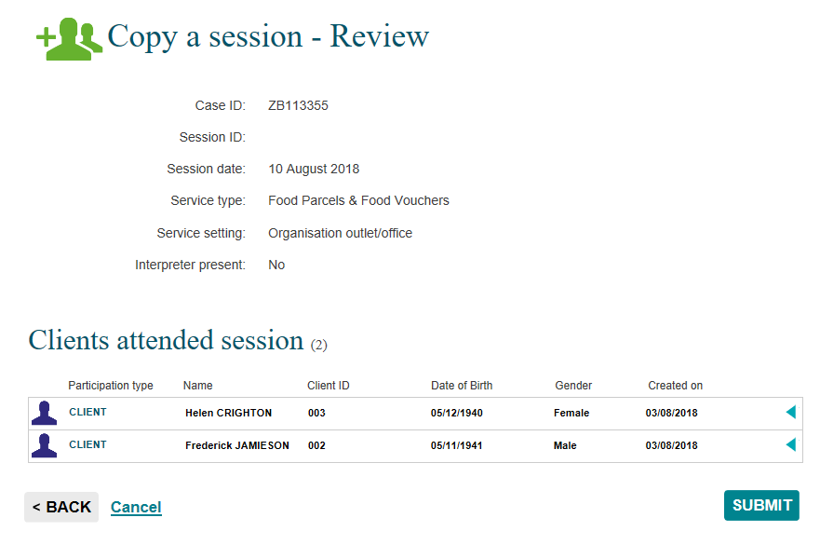
Select SUBMIT>.
The Add a session – Finish screen will display. Refer to Figure 21.
Figure 21 – Add a session – Finish screen
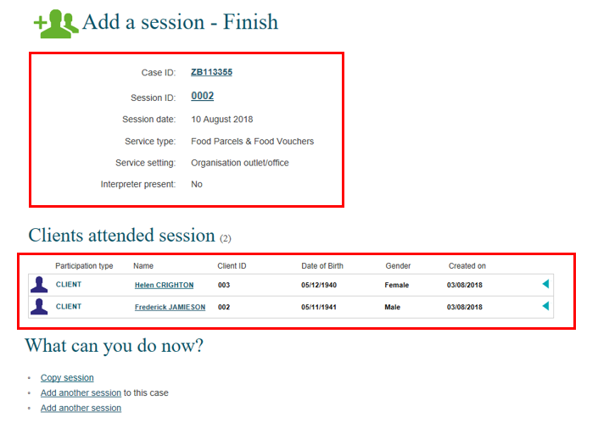

Record Referrals to other services
You can add Referrals to other services to the clients attached to this session.

There are a number of ways you can add Referrals to other services:
- Select the Session ID number hyperlink found in the Add a session – Finish screen after you have created a new session. Refer to Figure 22
- Select the Session ID number hyperlink found in the Case details screen after you have searched for the relevant case. Refer to Figure 23.
Figure 22 – Add a session – Finish screen Session ID link
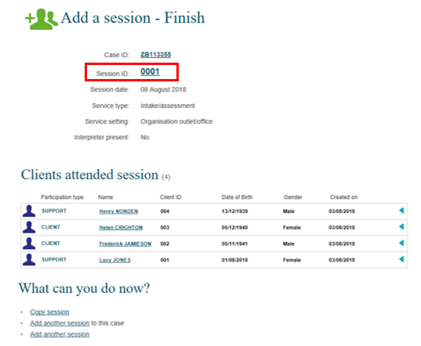

Figure 23 – Case details screen Session ID link
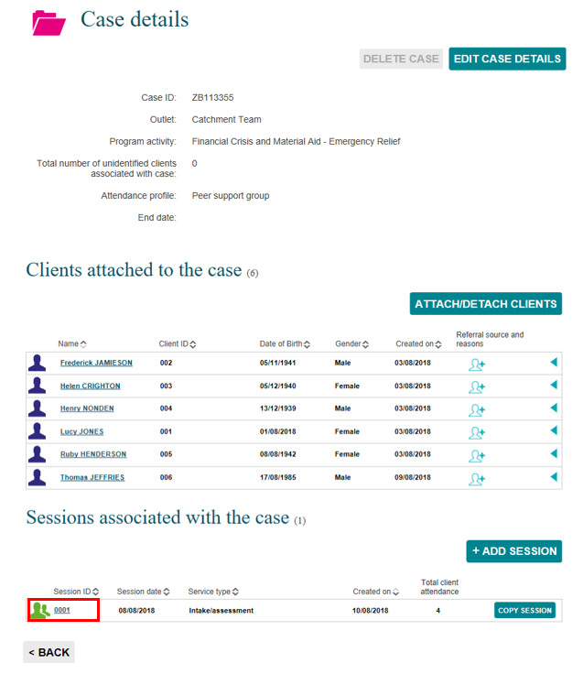

The Session details screen displays. Refer to Figure 24. Table 4 includes descriptions of the icons on this screen.
Select found next to the relevant client.
Figure 24 – Session details screen
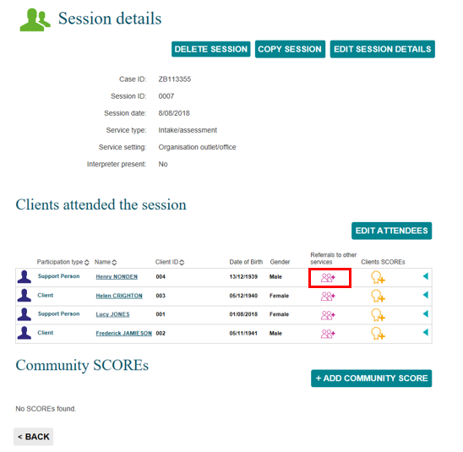
Table 4 – Icon descriptions for Referrals to other services (Refer Figure 24)
ICON | DESCRIPTION
 | This icon indicates a referral for other services can be added for this client for this case.
 | This icon indicates a referral for other services can be added for this client’s record summary attached to a session. One internal and one external referral type can be added per client, per session.
 | This icon indicates the full quota of referrals to other sources is added to a client's record summary, attached to a session.

The Add referral to other services screen displays. Refer to Figure 25.
Figure 25 – Add referral to other services screen
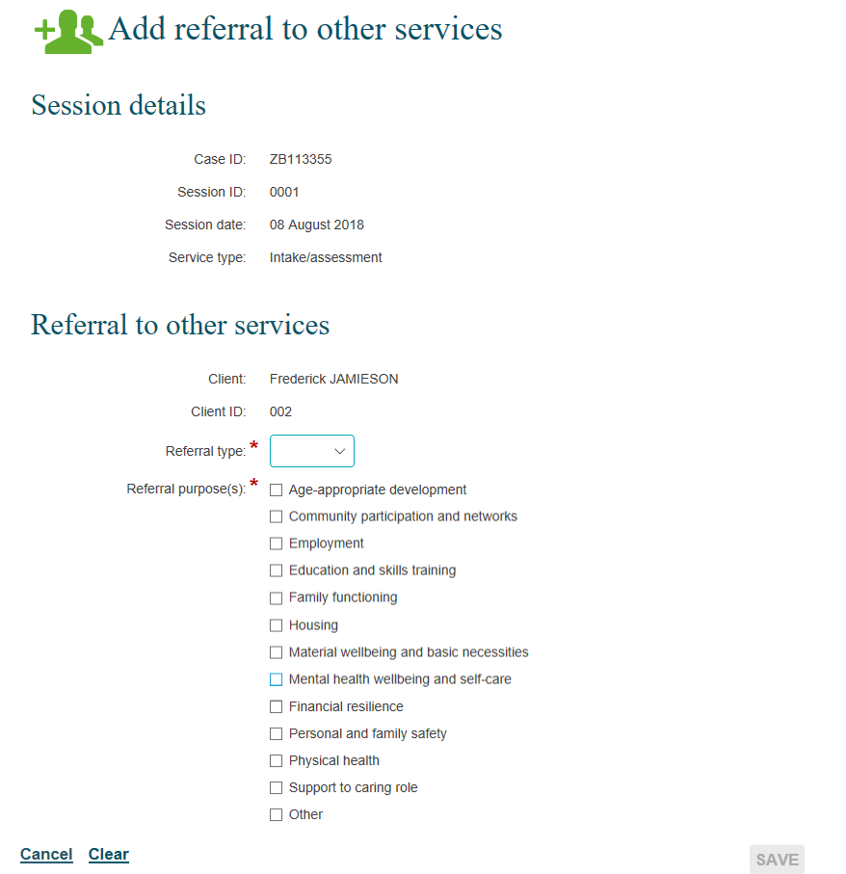

Select the relevant Referral type and Referral purpose(s). Refer to Figure 25. Table 5 has descriptions for the referral type and purpose.

Table 5 –Field descriptions for the Add referral to other services screen (Refer Figure 25)
FIELD | DESCRIPTION
Referral type | Select the appropriate referral type for the client. This can be internal or external.
Referral purpose(s) | Select the appropriate reason for referral to other services (including own services).  More than one can be selected.

Select SAVE.
The Session details screen will display.
The Referrals to other services icon will display as . Refer to Figure 26.
Figure 26 – Session details screen – Added referral to other services
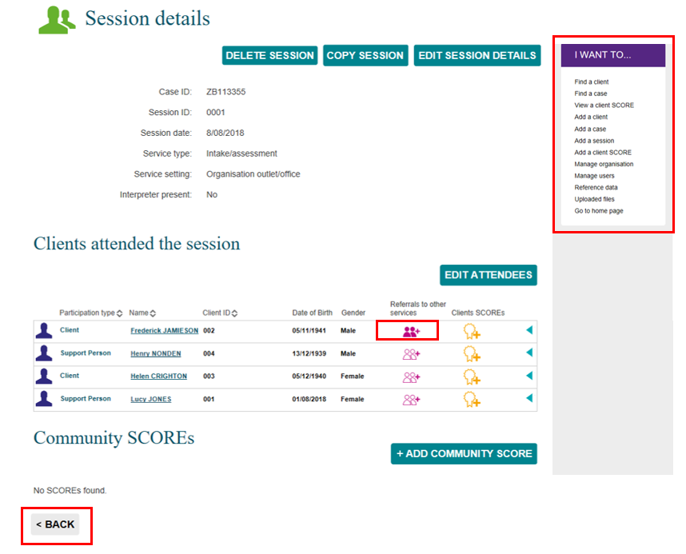

Select to view the referral(s) created for the client. Refer to Figure 27.
Figure 27 – Amending Referral to other services items
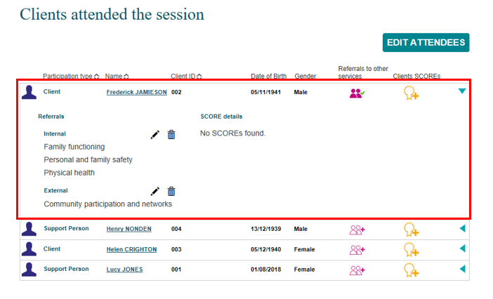
Select to edit the referral. Select to delete the referral. Select to collapse the field.
Select <BACK to go to the Case details screen, or the I want to… box where you can complete other tasks. Refer to Figure 26.

Special Data Entry fields

Some programs have special data entry fields display when a session is created for the program activity. Go to the Data Exchange Protocols, program specific guidelines and the Add a case task card, Special Data Entry Fields for more information.

Additional field for Family Law Services programs

Fees charged
This field applies to all Family Law Services programs from February 2020. Once a service type is selected for the session, the mandatory Fees charged field will appear. Refer to Figure 28.
Figure 28 – Selecting a Session type and Fees charged field appearing
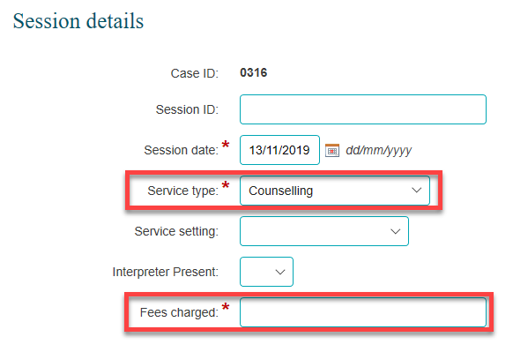
The Fees charged field is a numerical field. Fees charged can contain up to six digits before the decimal point and two digits after the decimal point. If no fee is charged, you need to enter a 0 (zero) amount in this field to be able to continue entering data. Refer to Figure 29.
Figure 29 – Populating the Fees charged field
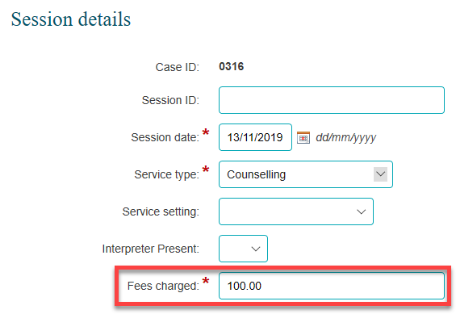

Once the field is completed the next button can be selected to move to the next screen. Refer to Figure 30.
Figure 30 – Select the next button
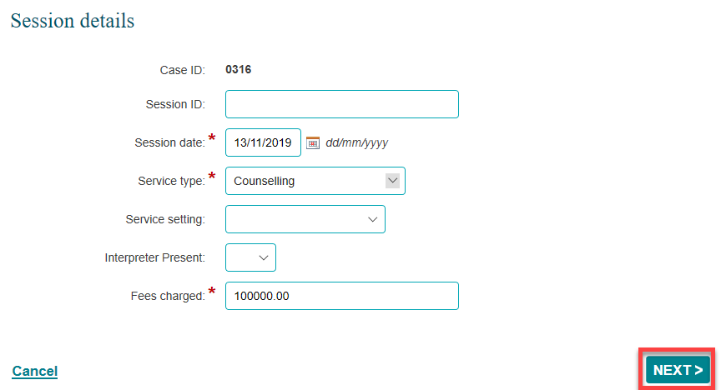

Additional fields for Commonwealth Home Support Program (CHSP) cases

Go to the Data Exchange website for Program Specific Guidance on the Commonwealth Home Support Programme (CHSP) counting rules in sessions. Further information on the CHSP can be found in the Commonwealth Home Support Programme Manual available on the Department of Health website.

You can find more information on outlets, clients, cases, and sessions on the Data Exchange Protocols and the Training page.
For system support, contact the Data Exchange Helpdesk by email dssdataexchange.helpdesk@dss.gov.au or on 1800 020 283.

