Add a case

Task card
This task card discusses the following:
- What is a case?
- Add a case – Case details
- Add a case – Attach clients
- Add a case – Review
- Add a case – Finish
- Referral and source reasons
- Special data entry fields

KEY HIGHLIGHTS
- The case identity (ID) should not contain any personal information, such as any part of a client’s first or last names, Customer Reference Numbers (CRN) or My Aged Care reference numbers.
- A case should be created for each outlet even if the case is delivered across multiple outlets.
- Primary and secondary referral source and reasons can be added to a client record at any time.
- The use of special characters such as * & % # @ should not be included in the free text fields.
- Some programs have special data entry fields apply to cases.

What is a case?
A case is the first step in recording service delivery information within the Data Exchange. A case reflects how you deliver a services. Depending on the nature of your program, a case may link to an individual, a couple, a family or a group of unrelated individuals.

A case captures:
- where the service was or will be delivered
- the program activity it is funded by, and
- the client(s) who have or will attend this service.

Add a case – Case details
From the Data Exchange home page, select under the Add menu. Refer to Figure 1.
Figure 1 – The Data Exchange home page
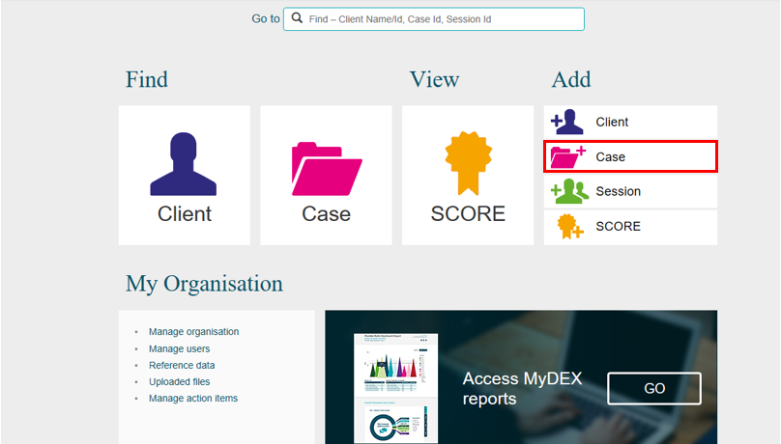
The Add a case – Case details screen will display. Refer to Figure 2.
Enter the case details.
Fields marked with an * are mandatory and must be completed before you can move to the next screen.
Figure 2 – Add a case – Case details screen
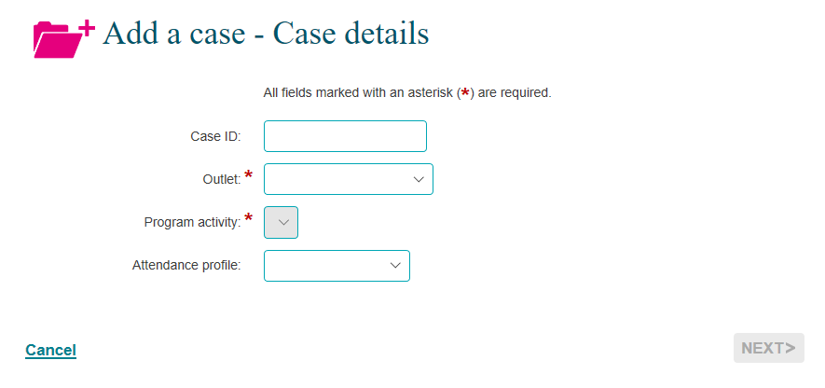
Note: The Total number of unidentified clients associated with case field will only display on the Add a case – Case details screen once a program activity is selected. Refer to Figure 3.
Figure 3 – Total number of unidentified clients associated with case field 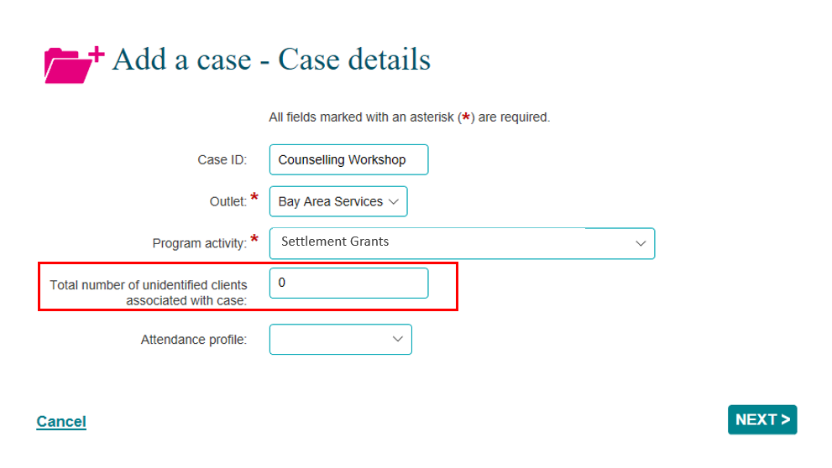

Do not enter any personal information into the Case ID field, such as first or last names, Customer Reference Numbers (CRN) or My Aged Care reference numbers.

Table 1 – Case details field descriptions (Refer Figures 2 and 3)
FIELD | DESCRIPTION
Case ID | Enter the Case ID or leave it blank for numerical auto-generation.  Note: The use of Special characters such as * & % # @ should not be included in the free text fields.
Outlet* | Select the Outlet where the service is delivered. If a case is delivered across multiple locations, a separate case should be created for each outlet.  You will only see outlets within your organisation to which your Data Exchange Organisation Administrator has provided you access.
Program activity* | Select the Program activity that the service is delivered under. If a client is receiving a service from multiple programs then separate cases will need to be created for each program activity.  Note: Refer to page 8 for additional details for sub-contractors and consortia arrangements.
Total number of unidentified clients associated with case | Organisations are strongly encouraged to create individual client records for as many of their clients as possible. If it is impractical to collect information about individual participants, for example in community outreach activities where many members of the general public may participate, the aggregate number of unidentified clients is recorded. For example, if you expect 150 people to attend the event over the life of the case you would enter 150 in this field.  The field should not be used to ‘bulk report’ services to individuals or small groups where it is possible to collect the details of each individual client.  For group activities where a combination of clients and unidentified persons are expected to attend, enter in the expected number of unidentified persons only. You can then add the clients that are recorded in the Data Exchange in the next page.  Note: If the number of actual attendees at the session is greater than the number of expected attendees recorded against the case, you must edit the case record and increase the number of clients expected to attend before recording the session.
Attendance profile | Select the relationship between the clients attached to the case. If there is only one client attached to the case then no option would be selected. The options are:  - Family  - Community event  - Peer support group  - Couple  - Cohabitants
Once completed, please select NEXT.

Add a case – Attach clients
The Add a case – Attach clients screen will display.
Attach the relevant client(s) to the case. Refer to Figure 4.
To do this use the:
- Search clients field at the top of the screen, or the
- Results section.
Figure 4 – Add a case – Attach clients screen
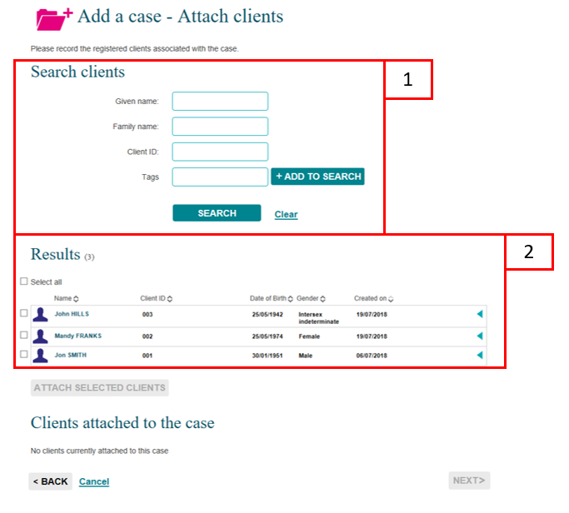

The order of the Results section can be changed by clicking on the relevant heading title such as Name, Client ID, Date of Birth, Gender or Created on.
The selected clients will display under the Clients attached to the case heading. Refer to Figure 5.

Figure 5 – Clients attached to the case field
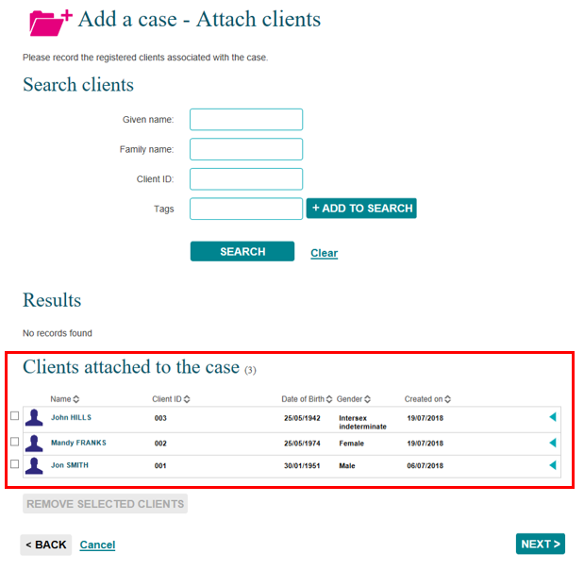

Associate clients with the case by selecting the tick box next to the relevant client’s name.
Select ATTACH SELECTED CLIENTS .
Select NEXT.

Add a case – Review
The Add a case – Review screen displays and allows you to review and edit the details of the case you have entered. Refer to Figure 6.
Figure 6 – Add a case – Review screen
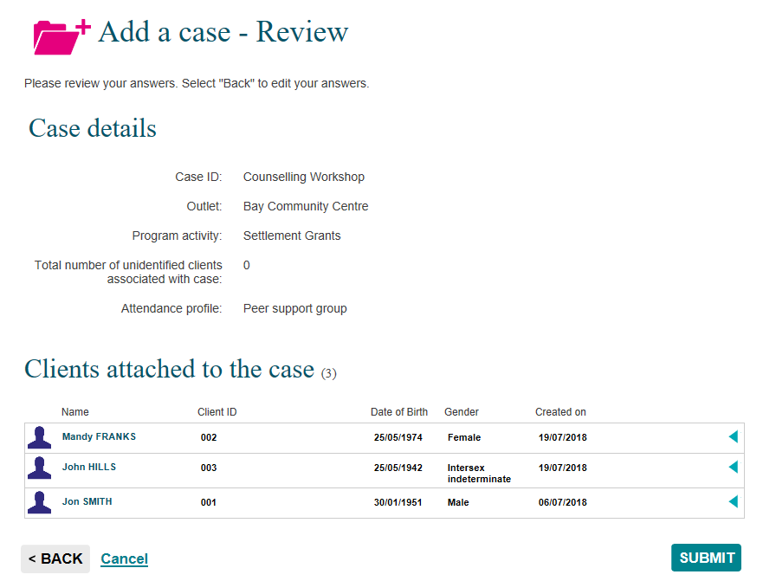
Select <BACK to edit the details or Cancel to stop the process and remove the case.
If the details are correct, select SUBMIT .

Add a case – Finish
The Add a case – Finish screen will display with the following. Refer to Figure 7.
- A message box to advise the successful creation of the case and that a session must be added for the clients to be counted in reports.
- A summary of the case you have created. If you did not enter your own case ID, a Case ID will automatically be created.
- A listing of the clients that are attached to the case.
- What can you do now? section where you can Add a session to the case of Add another client to the case.
- I want to… box where you can complete other tasks.
- Go to… search field where you can search for clients, cases and sessions.
Figure 7 – Add a case – Finish screen
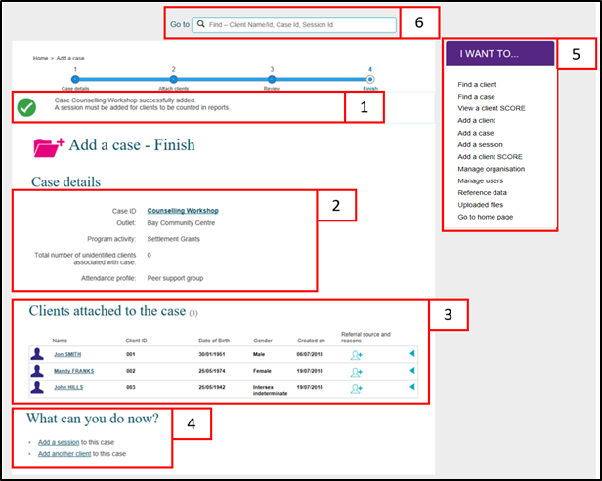

Referrals to other services
You can add Referral source and reasons to the clients attached to this case. Refer to Figures 7 and 10.
Table 2 – Icon descriptions for Referral source and reasons (Refer Figures 6 and 9)
ICON | DESCRIPTION
This icon indicates that a referral source and reasons can be added for this client for this case.
Note: Refer to page 9 for additional information for the Commonwealth Home Support Program (CHSP).
 | This icon indicates that no further referral source and reasons can be added for this client for this case.

Select found next to the relevant client.

The Edit referral source and reasons screen will display. Refer to Figure 8.
Figure 8 – Edit referral source and reasons screen
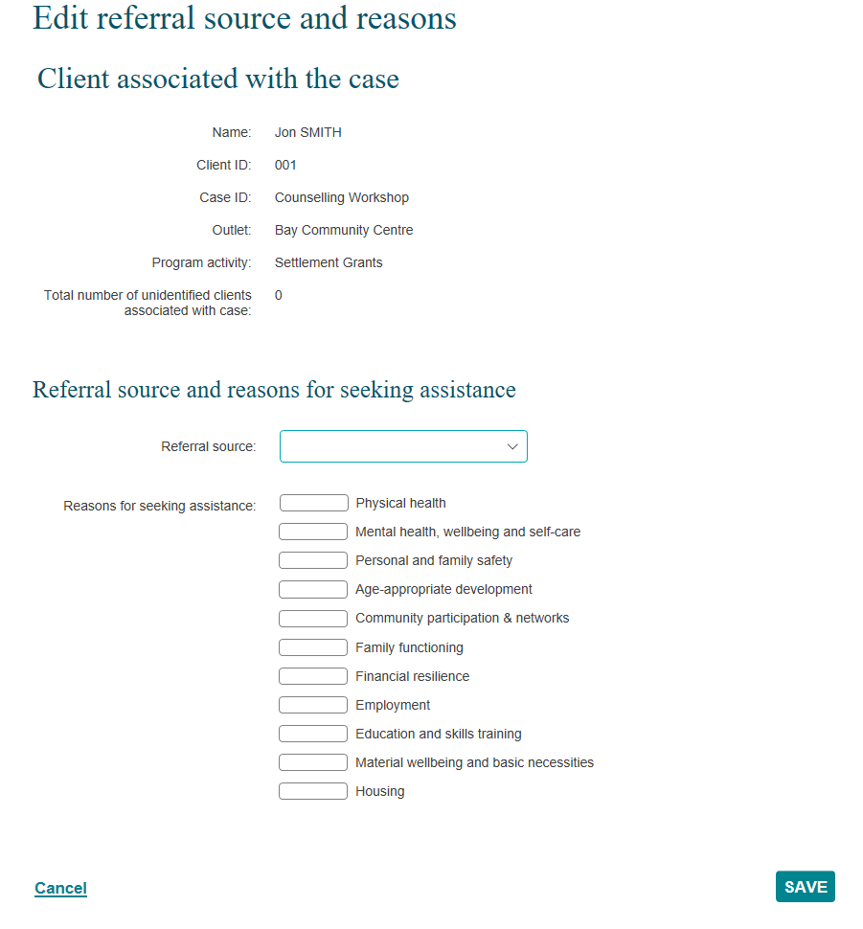
Table 3 –Field descriptions for the Edit referral source and reasons screen (Refer Figures 7 and 8)
FIELD | DESCRIPTION
Referral source | Select the appropriate referral source for the client.
Reasons for seeking assistance | Select the appropriate reason for seeking assistance.  One primary reason can be selected. More than one secondary reason can be selected.
Select the relevant Referral source and Reasons for seeking assistance. Refer to Figure 9.
Figure 9 – Edit referral source and reasons screen
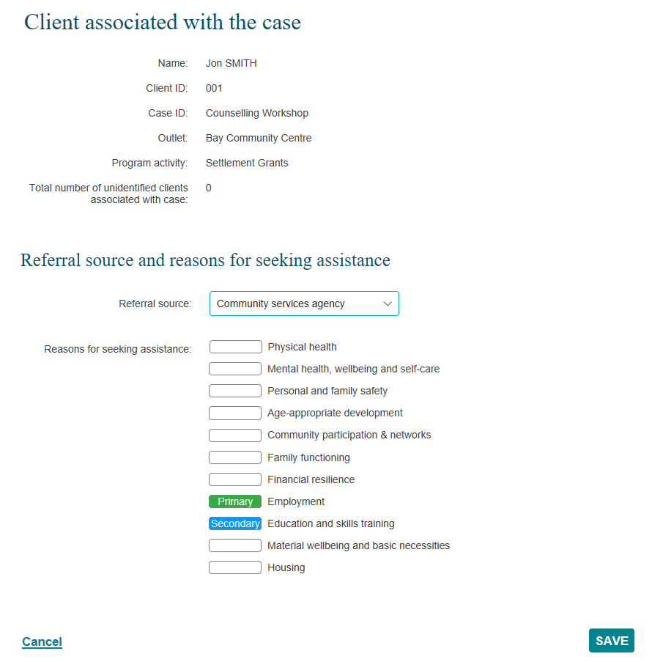
Select SAVE.
The Case details screen will display.
The Referral source and reasons icon will display as . Refer to Figure 10.
Figure 10 – Edit referral source and reasons screen
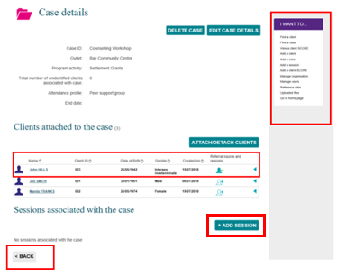
Select +ADD SESSION to add a session to the case.
Select <BACK to go to the Find a case screen, or the I want to… box where you can complete other tasks.

Special Data Entry Fields
Additional information for sub-contracted or consortia arrangements

Sub-contracted or consortia arrangement
If you are delivering a program activity under a sub-contracted or consortia arrangement:
Select the Program activity which shows the delivery partner’s name in brackets. Refer to Figure 11.
For example:
Figure 11 – Program activity showing as a sub-contracted or consortia arrangement
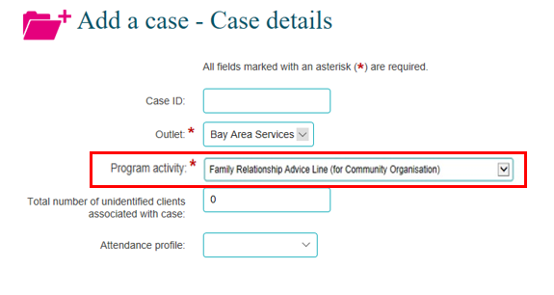
If you are directly funded to deliver the program activity only the name of the program activity will be shown. Refer to Figure 12.
Figure 12 – Program activity delivered by directly funded organisation
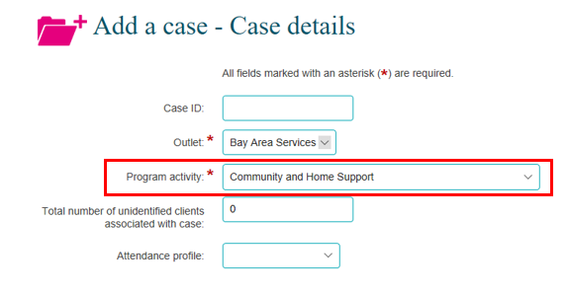

Additional fields for the Family Law Services program cases

Parenting agreement outcome
This field applies to all Family Law Services programs, except the Children’s Contact Services and Supporting Children after Seperation program activities. The Parenting Agreement Field has three options to select from. Refer to Figure 13.
Figure 13 – Parenting Agreement Outcome options
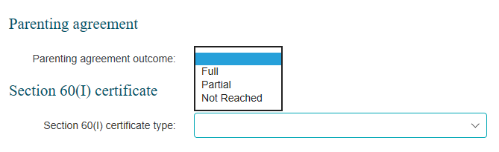
Once a Parenting agreement option is selected additional fields display. Refer to Figure 14.

Figure 14 – Parenting Agreement additional fields
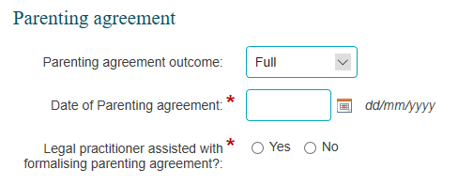
If you mistakenly select a value for the Parenting agreement outcome a blank value can be selected, cancelling out the incorrectly input value. Refer to Figure 15.
Figure 15 – Selecting a blank Parenting Agreement outcome
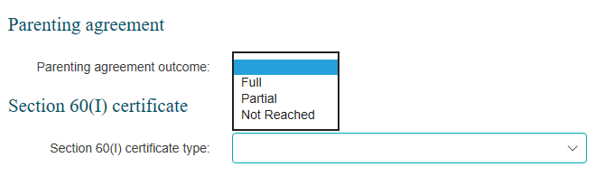
Once the fields are completed the next button can be selected to move to the next screen. Refer to Figure 16.
Figure 16 – Select the next button
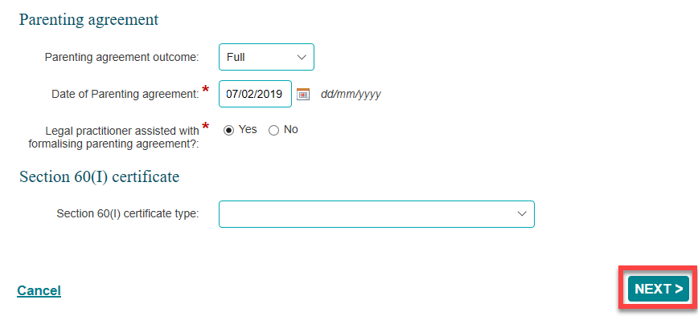
These fields can be completed at the time of creating the case, or at a later stage through the edit case process.

Section 60(I) certificate type
This field applies to all Family Law Services programs, except the Children’s Contact Services and Supporting Children after Seperation program activities. This field applies to relevant organisations delivering these services. The Section 60(I) certificate type field has five options to select from. Refer to Figure 17.
Figure 17 – Section 60(I) certificate type options
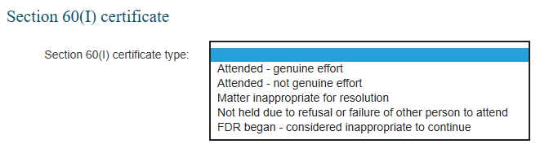
Once a Section 60(I) certificate type option is selected, an additional field displays. Refer to Figure 18.
Figure 18 – Section 60(I) certificate type additional fields
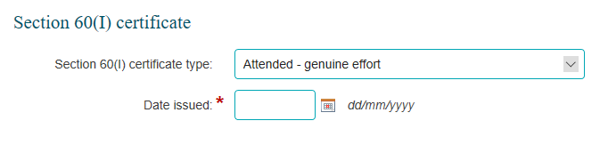
If you mistakenly select a value for the Section 60(I) ceritifcate type, a blank value may be selected, cancelling out the incorrectly input value. Refer to Figure 19.
Figure 19 – Selecting a blank Section 60(I) certificate type
Once the fields are completed the next button can be selected to move to the next screen. Refer to Figure 20.
Figure 20 – Select the next button
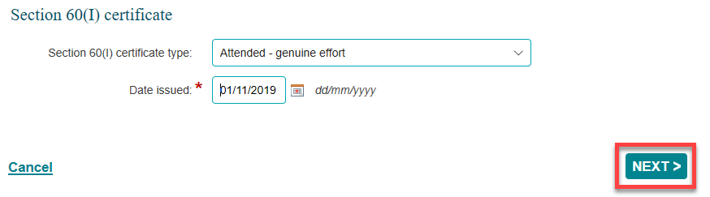
These fields can be completed at the time of creating the case, or at a later stage through the edit case process.

Additional fields for Commonwealth Home Support Program (CHSP) cases

Referral source and reasons
Extra referral sources and reasons are available for CHSP. To record a client's referral source and reason, open the existing case record and select the Referral source and reasons icon. Refer to Figure 21.
Figure 21 – Case screen
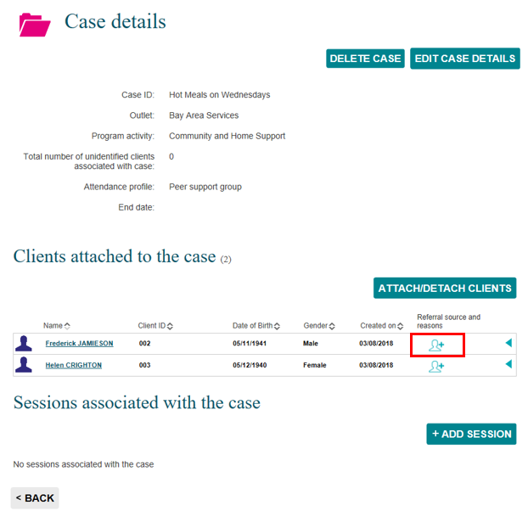
The Edit referral source and reason screen will display. Refer to Figure 22.
Figure 22 – Edit referral source and reasons screen
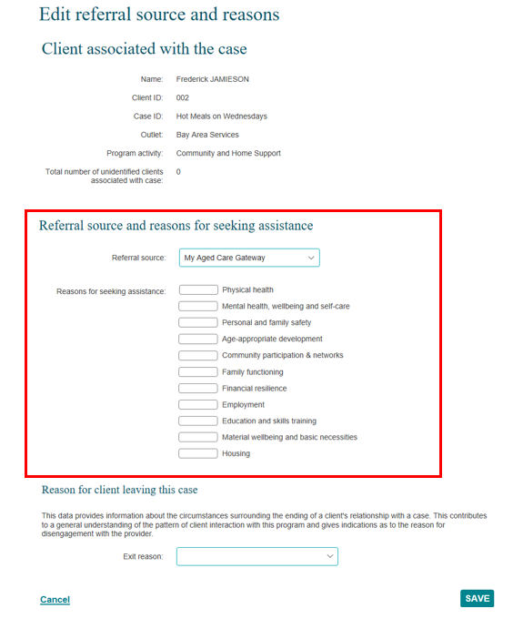

The Referral source will automatically populate with My Aged Care Gateway.
Select from the Referral source and the Reasons for seeking assistance drop down list the applicable source and reason. Refer to Figure 15.
NOTE: There are CHSP specific Referral sources. These include the Linkages Program and the CoS program.
Select SAVE.

Extra Client profile information
CHSP specific client profile data requirements will only appear if a client is attached to a case that has a CHSP specific program activity.
Once a client has added to the Data Exchange and attached to a CHSP specific program activity case, a yellow exclamation mark will display next to their name indicating that extra client profile information needs to be added for this client. Refer to Figure 23.
Select the client's name next to the yellow exclamation mark.
Figure 23 – Case screen highlighting yellow exclamation mark
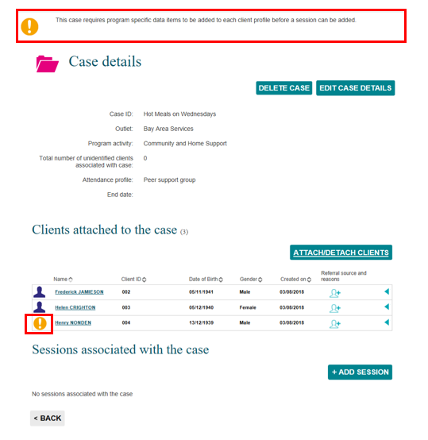

The Edit client details screen will display with the items that need to be completed. Refer to Figure 24.
Scroll to the Program specific client details section.
Figure 24 – Edit client details screen
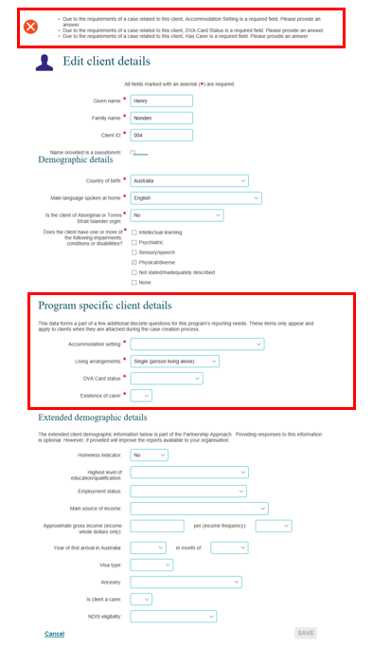
All the fields in the Program specific client details section are mandatory. Refer to Table 2.

Table 2 – Descriptions for CHSP program specific client details fields (Refer Figure 17)
FIELD | DESCRIPTION
Accommodation setting | Select the Accommodation setting that best describes the client's current status.
Living arrangements | Select the Living arrangement that best describes the client's current status.  If the client lives with others who are not accessing a service with your organisation they should be recorded as their current living arrangement status.  Example 1: A client attends a session alone and they reside with their partner; the Living arrangement selected is 'Couple'.  Example 2: A client attends a session alone and they reside with a relative such as their 40 year old child; the Living arrangement selected is 'Group (related adults)'.  Example 3: A client attends a session alone and they reside with non-related adults; the Living arrangement selected is Group (unrelated adults).
DVA Card status | Select the Department of Veteran Affairs (DVA) card that the client recieves.
Existence of carer | Select Yes or No.

Select SAVE.
Once the information is added, the green exclamation mark a Successfully saved message will display. Refer to Figure 25.
Figure 25 – Case screen with updated program specific client data
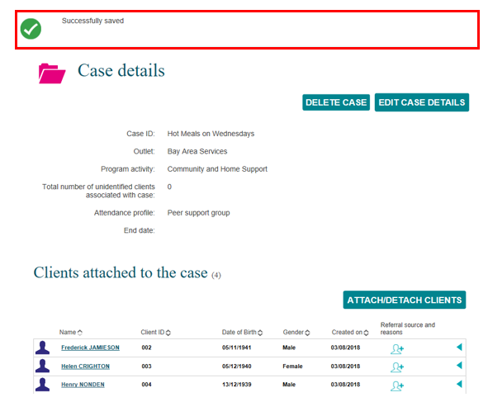

Exiting a Commonwealth Home Support Program client from a case
To record a client has exited from a CHSP case, open the existing case record and select the Referral source and reasons icon. Refer to Figure 26.
Figure 26 – Case screen – Referral source and reasons icon
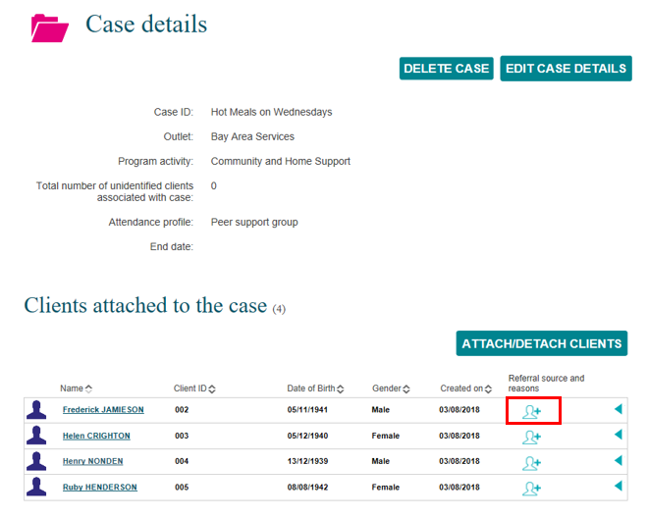
The Edit referral source and reason screen will display. Refer to Figure 27.
Figure 27 – Edit referral source and reasons screen
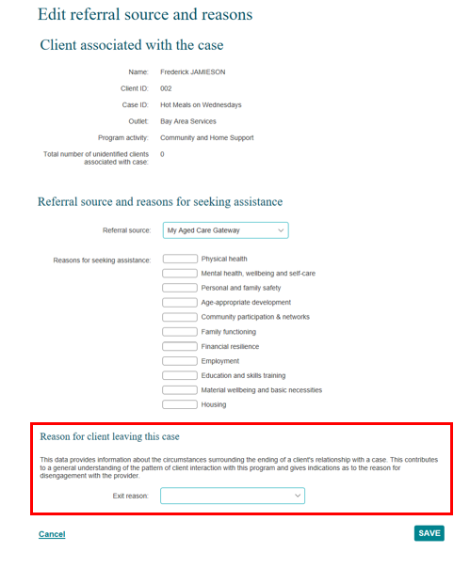
Select the exit reason from the Reason for client leaving this case drop down list.
Select SAVE.

The Case details screen will display and the Referral source and reasons icon updates to indicate that no further referral source and reasons information can be added for this client. Refer to Figure 28.
Figure 28 – Case details – Updated referral source and reasons icon
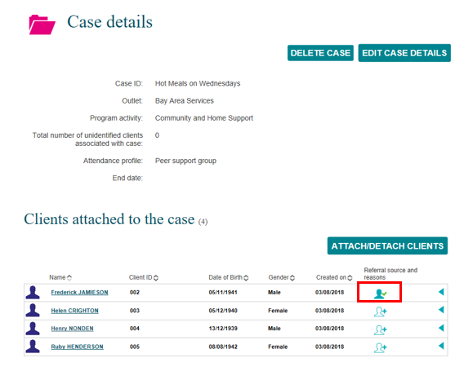

Go to the Commonwealth Home Support Programme Manual for more information about these program specific fields.

You can find more information on outlets, clients, cases, and sessions on the Data Exchange Protocols and the Training page.
For system support, contact the Data Exchange Helpdesk by email dssdataexchange.helpdesk@dss.gov.au or on 1800 020 283.

