Data Exchange Reports - Story
Task card
What is a story? 1
1 Add items to a story 3
2 Add a sheet (page) to the story 5
2.1 Method 1 – Insert a blank sheet to a story 5
2.2 Method 2 - Insert a live data Base sheet from a report 6
3 Add text to the story 8
4 Add animations to a story 11
5 Add snapshots to a story 16
5.1 Take a snapshot 17
5.2 Add a snapshot to your story 18
5.3 Arrange a snapshot 18
5.4 Add comments to a snapshot 19
5.5 Edit a snapshot 20
5.6 Replace a snapshot 21
6 Add shapes to the story 23
7 Preview the story 24
8 Export the story 26
8.1 Export story to PowerPoint 27
8.2 Export story to PDF 28

What is a story?
The Data Exchange reports allow you to create presentations, called Stories, based on the Data Exchange (DEX) data you can access. You create Stories by incorporating elements of the Data Exchange report, such as taking a snapshot of a table or chart, and adding them in your presentation to tell a “story” about the data your organisation is working with. You can also create animations and add shapes to make your Story more engaging.
To start, choose a report that interests you. On the report page, you can access your stories by clicking on the Stories tab of the report, as per Figure 1 below.
Figure 1 – Stories pop up box
You can find more information on how to use Data Exchange reports at the Tutorials page on the Qlik website.
- Add items to a Story
Table 1 – Add a new My story navigation icons
ITEM | DESCRIPTION
 | Select the Play button to play your story.
 | Select the Camera icon to select an image from your snapshots to insert into your story.
 | Select the A icon to insert text into your story.
 | Select the Shapes icon to select different shapes to insert into your story.
 | Select the Animation icon to animate your shape or image in your story.
 | Select the Media icon to select media objects to insert into your story.
 | Select the Add slide button to add a new slide to your story.
 | Select the Cut icon to remove an item from your story slide.
On the Stories page of the report you are interested to use, choose the Story you are want to work with, or create a new one. You can have multiple Stories.
Figure 2 – Stories pop up box
The Story page will display.
Figure 3 – Story page
The DEX reports allow you to add different items to a story. This can include animations, media, shapes, sheets (pages), snapshots and text.
Within your Story page, add items to the story, as required, by selecting the appropriate icon.
Figure 4 – Add items icons (Refer Table 1)
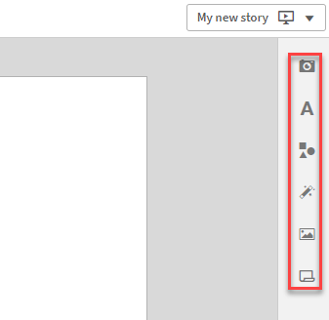
- Add a sheet (page) to the story
Table 2 – Add a page navigation items
ITEM | DESCRIPTION
 | Select the sheet icon to insert a new sheet into the story.
 | Select the sheet left-aligned icon to insert the image on the left hand side and add text on the right hand side.
 | Select the sheet centre-aligned icon to insert the image on the centre of the sheet.
 | Select the sheet right-aligned icon to insert the image on the right hand side and add text on the left hand side.
 | Select the blank icon to insert a blank sheet.
Within your Story page, you can add sheets (pages) to your Story. There are 2 different methods in order to do that.
  - Method 1 – Insert a blank sheet to a story
Select the icon on the bottom left of the story page.
Figure 5 – Add a page to the story icon
The additional slide will display in the side panel.
Figure 6 – Add an additional slide
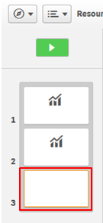

  - Method 2 - Insert a live data Base sheet from a report
Select the icon from the functions bar found on the right-hand side of the Story page.
Figure 7 – Insert Items panel
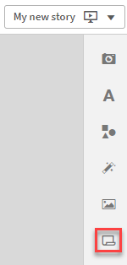
The Select sheet pop up box will display with the available Base sheets for the report.
Figure 8 – Select sheet pop up box
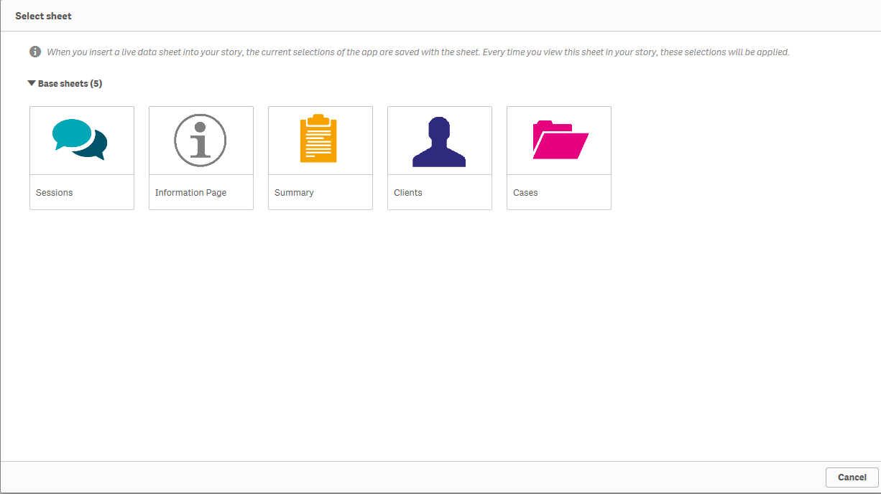
Select the required Base sheet.

The selected sheet will be inserted into the Story and the Embedded sheet pop up box will display.
Figure 9 - Selected Base sheet with Embedded sheet pop up box
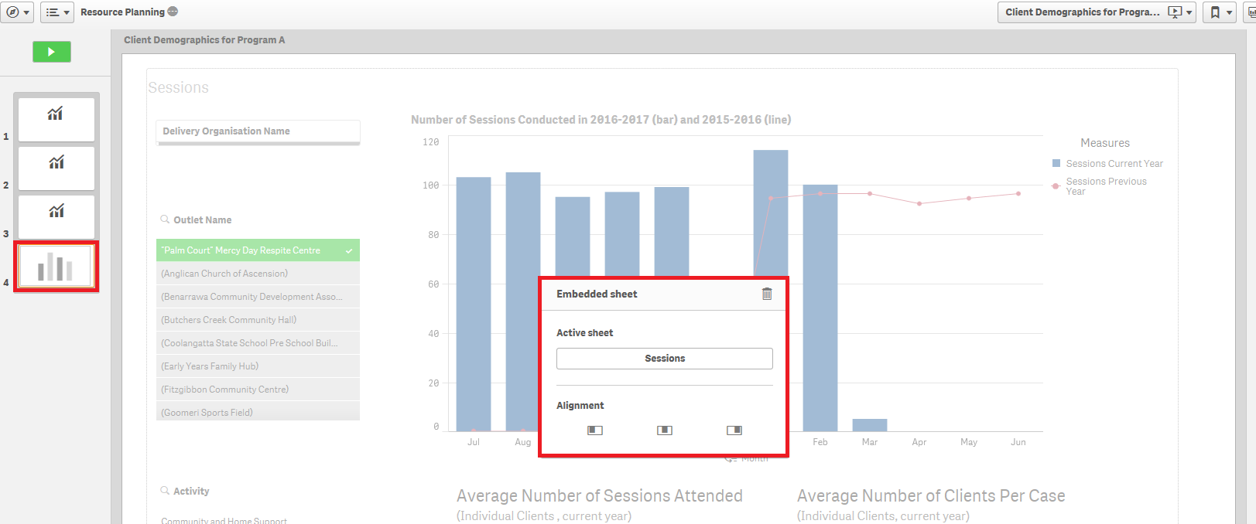
Select the appropriate Alignment icon for the inserted live data Base sheet.
Figure 10 - Embedded sheet pop up box
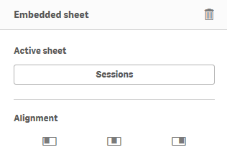
The current selections of the report are saved with the selected Base sheet. Every time you view this sheet in your story, the selections at that saved point of time will be applied.

- Add text to the story
In your Story, you can add text by using the Text objects selections.
Table 3 – Title and Paragraph boxes navigation items
ITEM | DESCRIPTION
 | Select the edit icon to display the different edit options available.
Within the Title box
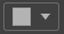 | Select the drop down arrow near the colour box to choose the font colour.
 | Select B, I or U to make the text bold, italic or underlined.
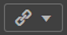 | Select the hyperlink icon to link a URL to the text.
 | Select the handles on the corner of the text box to resize the text box.
Within the Paragraph box - You can perform the functions available in the Title text box, as well as:
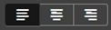 | Select the alignment options to change the alignment of the text.
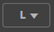 | Select the font size drop down arrow to change the size of the text.
After selecting the Story you would like to work on, you will land on the story page (Figure 3). You can then add text to the story page by selecting within the item functions bar found on the right-hand side of the Story page.
The Text objects pop up box will display.
Figure 11 – Text objects pop up box
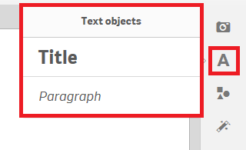
Double click on the displayed options to add either a Title or a Paragraph text box.
Example of Title box:
Figure 12 – Example of a Title box
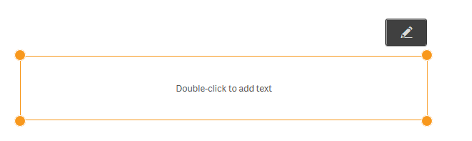
Select 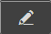 to display the Edit options.
Use to resize or move the image anywhere on the page.

Click and drag the text box where ever you want on the page.

Highlight the required text to amend the font size, style, colour or to add a hyperlink.
Figure 13 – Amending the text icons
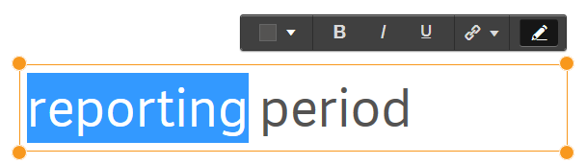
Example of Paragraph box:
Figure 14 – Example of a Paragraph box
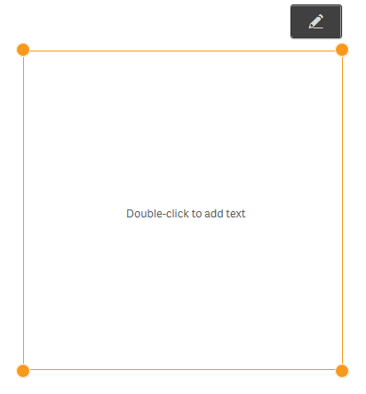
Select to display the Edit options.
Use to resize or move the image anywhere on the page.
Click and drag the text box where ever you want on the page.
Highlight the required text to amend the font size, style, colour, positioning or to add a hyperlink.
Figure 15 – Amending the paragraph icons
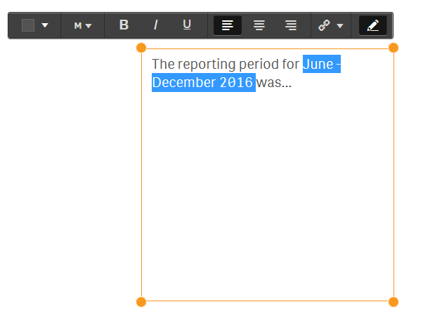

- Add animations to a story
You are able to add animations to your story by using the Effects library. These visual effects can only be used on bar charts, line charts and pie charts.
Table 4 – Effects library navigation items
Item | Description
 | Select the Highest value icon effect will make the highest value stand out by adding a label to the highest value and dimming the other values. For visualizations with grouped values, the highest value in each group will be highlighted
 | Select the Lowest value icon effect will make the lowest value stand out by adding a label to the lowest value and dimming the other values. For visualizations with grouped values, the lowest value in each group will be highlighted.
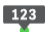 | Select the Any value icon effect will make a value, that you select manually, stand out by adding a label to the selected value and dimming the other values. For visualizations with grouped values, you can choose to highlight either a measure or a dimension. The selected measure or dimension will be highlighted in all the groups where it occurs.
 | Select to replace the image with another snapshot item in your Stories library.
 | Select to edit the image.
 | Select lock to prevent any changes being made to the snapshot.
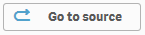 | Select to go to the originating sheet source of the snapshot.
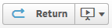 | Select to return to the Story that you are creating.

Choose the Story that interests you. Figure 16 shows an example Story, ‘Clients for Program A’.
Figure 16 – Stories drop down arrow and My stories tile
The Story page will then display.
Figure 17 – Story sheet with snapshot
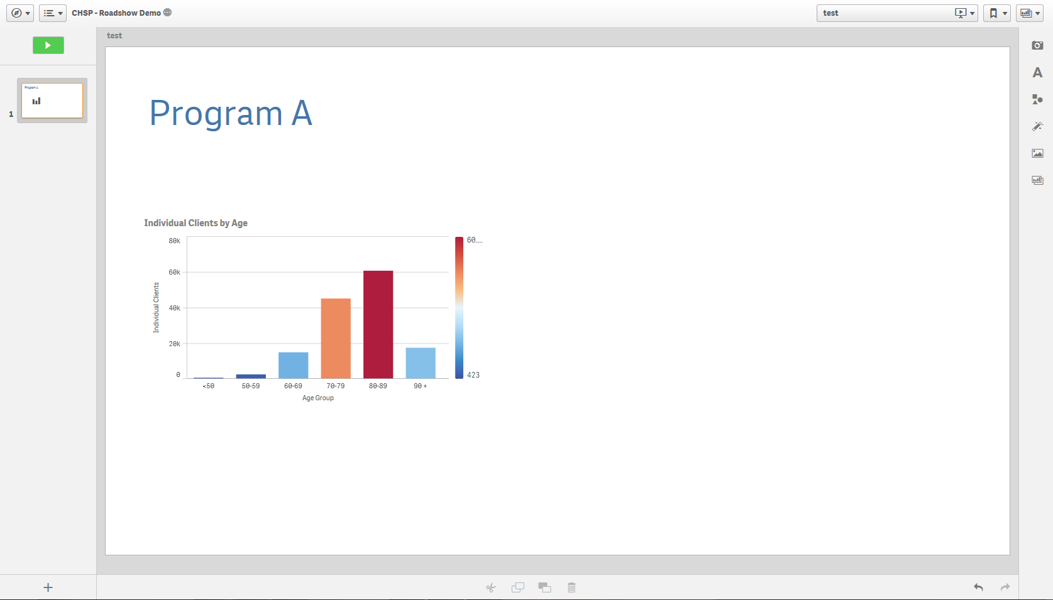
Select the icon on the right of the Story page.
The Effects library pop up box will display.
Figure 18 – Effects library pop up box
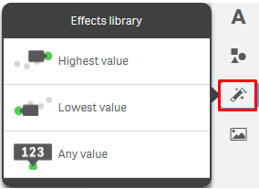
Click and drag the selected effect onto the snapshot.
The snapshot will display with the effect applied.
- Highest value effect applied - The column with the highest value will be highlighted and labelled. All other values will become dim.
Figure 19 – Highest value effects applied to snapshot
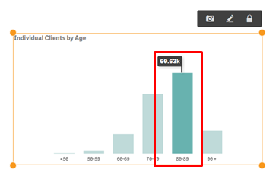
- Lowest value effect applied - The column with the lowest value will be highlighted and labelled. All other values will become dim.
Figure 20 – Lowest value effects applied to snapshot
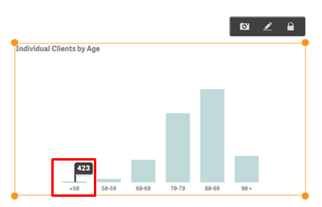
- Any value effect applied – The selected column will be highlighted and labelled. All other values will become dim.
Figure 21 – Any value effects applied to snapshot
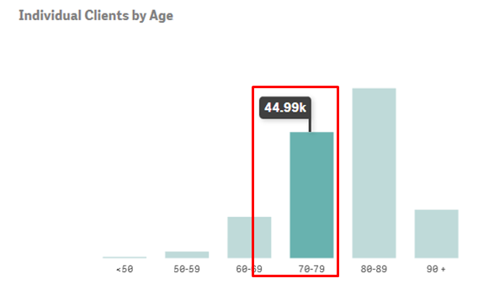
Click on the image to change the data item highlighted.
The Select data point pop up box will display.
Select the drop down arrow in the Select data point pop up box to change the value selection.
Figure 22 – Select data point pop up box
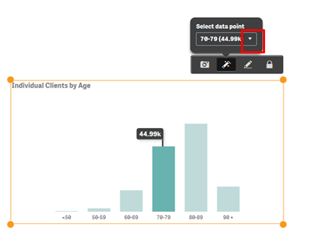
A pop up box will display with the items available in the image that can be selected.
Figure 23 – Select data point pop up box
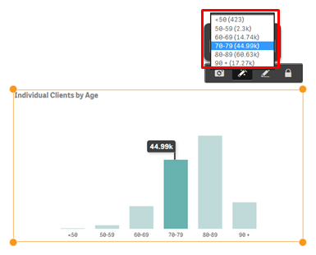
Select the required data point item, and the item will automatically update.
Figure 24 – Select data point pop up box
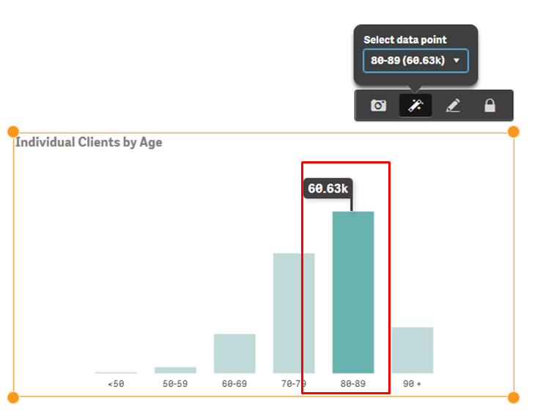

- Add snapshots to a story
You can add snapshots of graphs, pie charts, and line charts found in the reports, to your story.
Table 5 – Snapshot navigation items
Item | Description
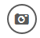 | Select to add an image to the Snapshot library.
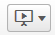 | Select to add or find a story in the report.
 | Select the handles on the corner of the image to resize the snapshot item.
 | Select to replace the image with another snapshot item in your Stories library.
 | Select to edit the image.
 | Select lock to prevent any changes being made to the snapshot.
 | Select to go to the originating sheet source of the snapshot.
 | Select to return to the Story that you are creating.
 | Select to send the item to the back of the image layers.
 | Select to send the item to the front of the image layers
 | Select to send the item back one layer of the image layers.
 | Select to send the item front one layer of the image layers.
 | Select to return to the sheet the image was taken from.
 | Select to remove the image from the story.

  - Take a snapshot
Access a report of interest, and select the item that you would like to add to the Snapshot library.
Figure 25 - Item selection for Snapshot library
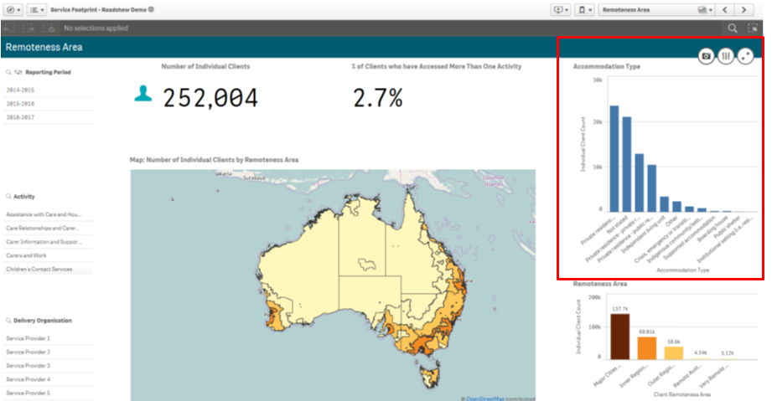
Select and the Snapshot annotation pop up box will display.
Figure 26 - Snapshot annotation pop up box
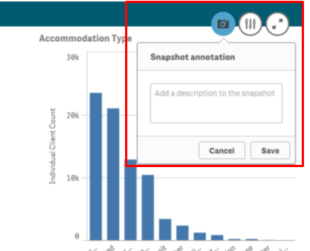
Enter a description of the snapshot and select.
The item will display in the Snapshot library.

  - Add a snapshot to your story
On the Story page (Figure 3), select and the Snapshot library pop up box will display with a listing of the snapshot items that have been saved for that report.
Figure 27 - Snapshot library items
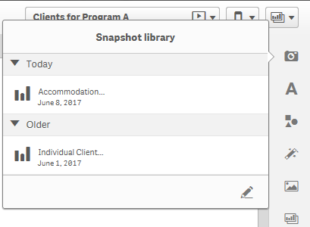
Click and drag the selected item onto the story sheet.
Figure 28 - Snapshot selection on the story sheet
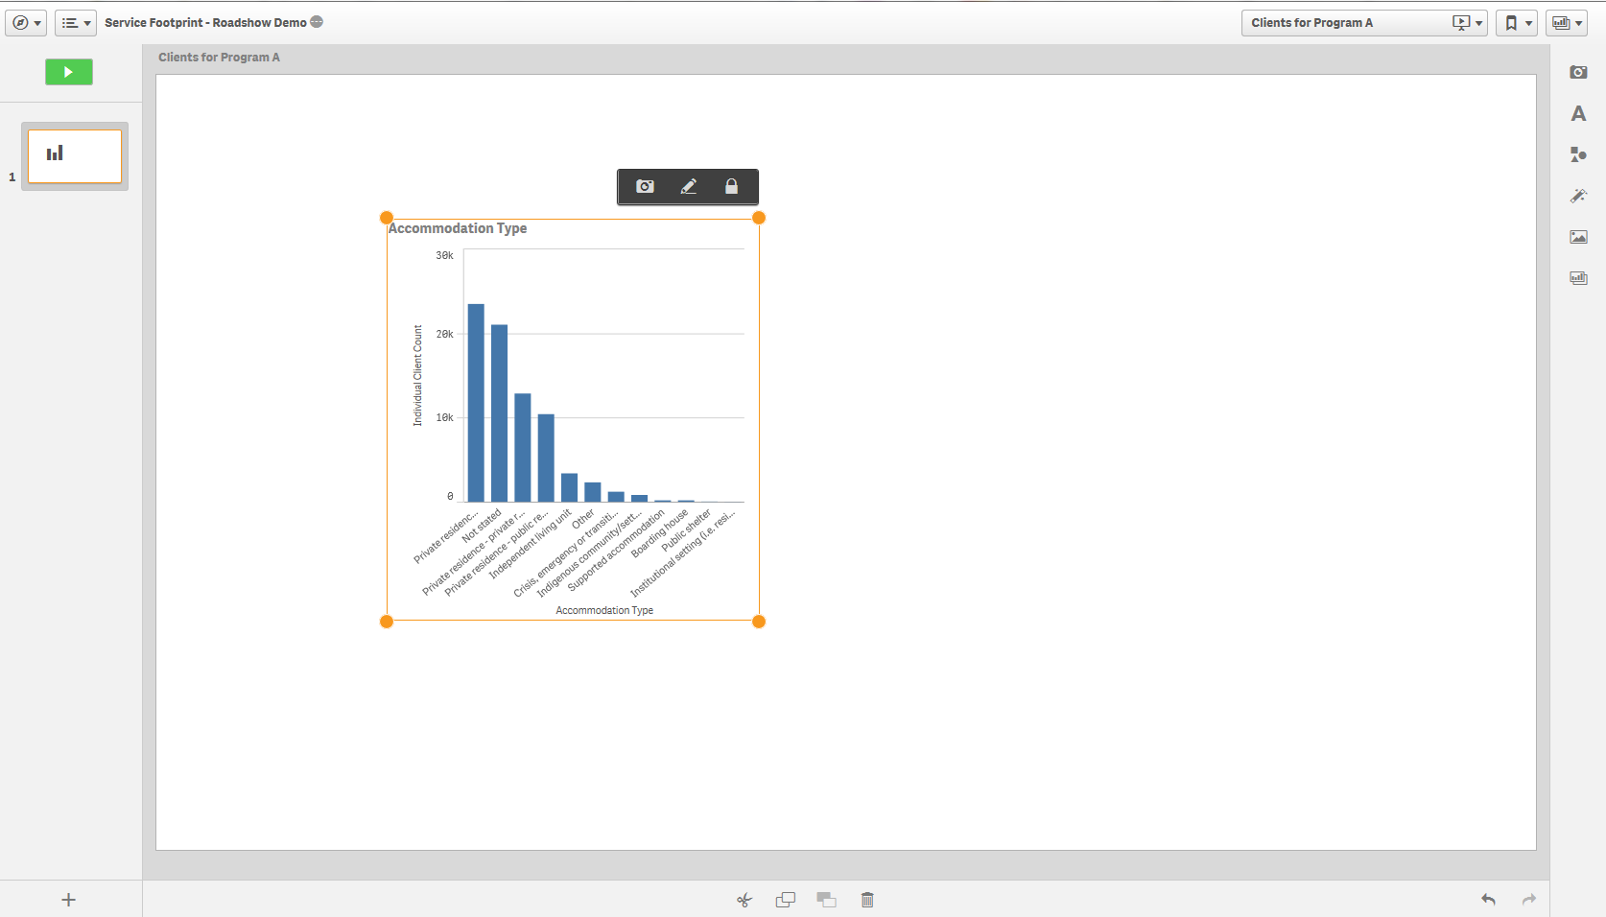
Use to resize or move the image anywhere on the page.

You can click and drag the snapshot wherever you want on the page.
  - Arrange a snapshot
You can also:
- Change the position of the image
- remove the effect on the image
- delete the image, or
- return to the sheet where the image originated from.
If you right click on the snapshot image, an options pop up box will display.
Figure 29 – Options pop up box
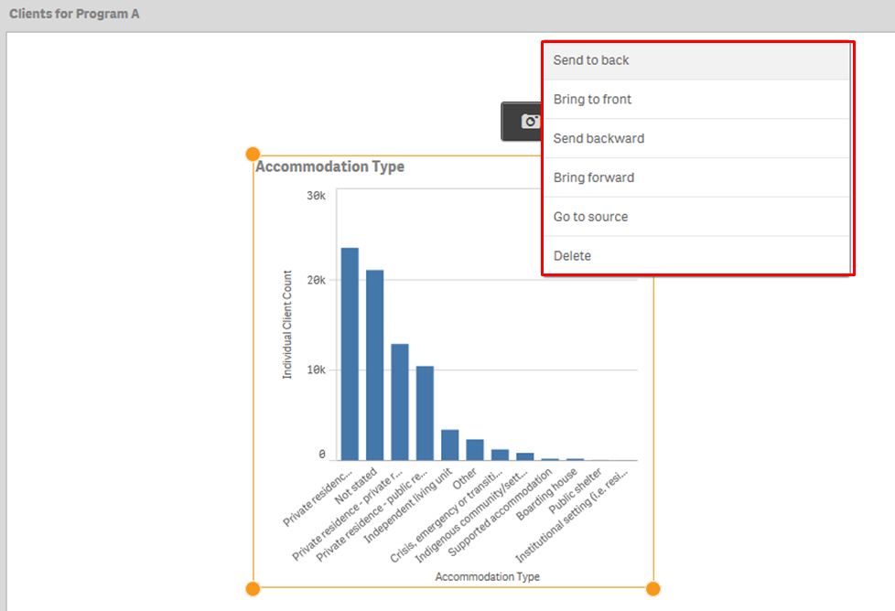
  - Add comments to a snapshot
You cannot change the title of a snapshot item. However, you can add comments to describe the snapshot item.
- Select the camera icon to open the Snapshot library.
- Select the pencil icon to open the comment fields.
- Select the snapshot item and type the details in the comments field.
Figure 30 – Snapshot library with comments field open
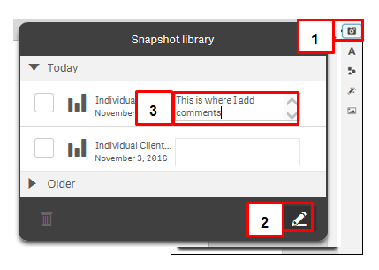
The comments will automatically save.
Figure 35 – Comments field for snapshot item updated
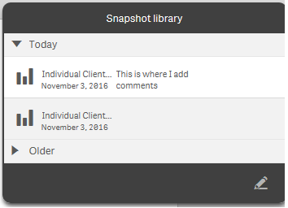
  - Edit a snapshot
Select to edit the snapshot.
An edit pop up box will display and you can amend titles, grid lines and labels.
Figure 36 – Edit options for snapshot
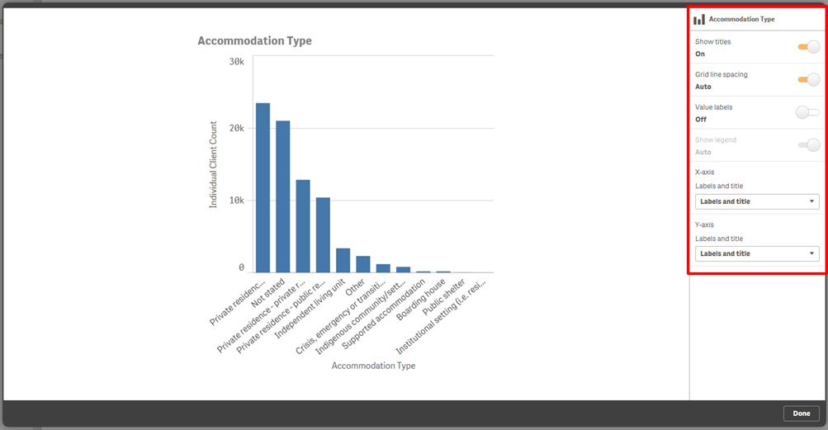
Select to save the amendments.
  - Replace a snapshot
Select to replace the snapshot.
The Replace snapshot pop up box will display with the image that has been selected to be replaced.
Figure 37 – Replace snapshot pop up box
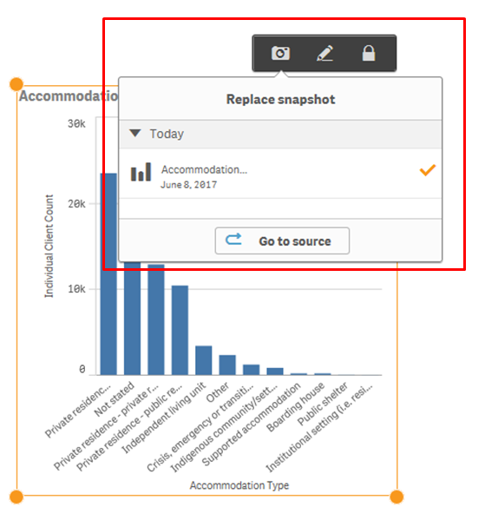
Select to choose another snapshot from the originating sheet source.
The originating sheet will display with a line around the original snapshot.
Figure 38 – Originating sheet for snapshot
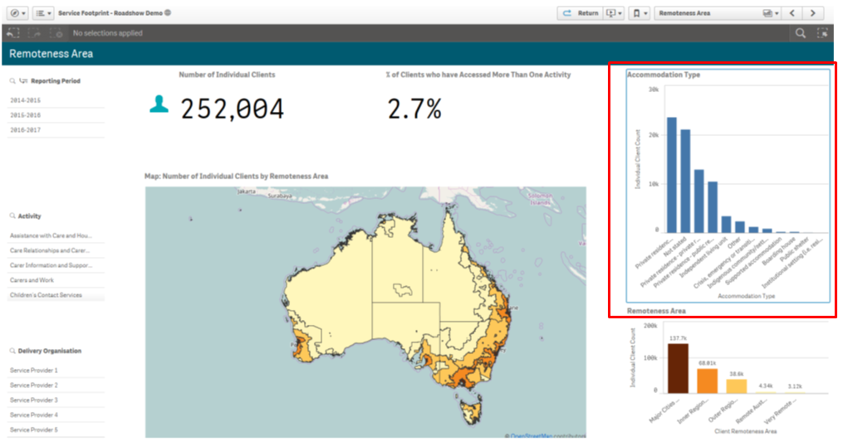
Select a different item to add to the Snapshot library.
Select to return to the story you are creating.
Figure 39 – Return to Story button
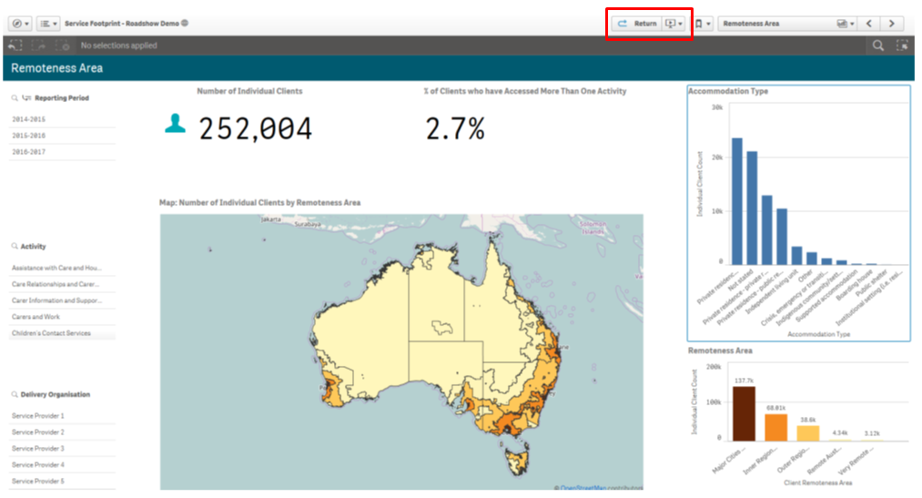
Select to open the Snapshot library and select your new snapshot item to your story.

- Add shapes to the story
You can add shapes to the story by using the Shapes library. You can add shapes to the story page by selecting within the functions bar found on the right-hand side of the story page.
The Shapes library pop up box will display.
Figure 42- Shapes library pop up box
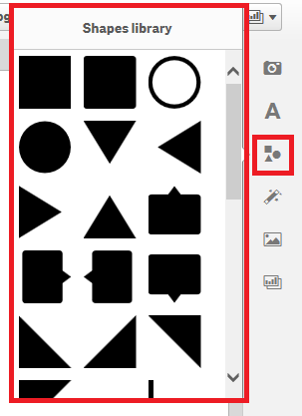
Click and drag, or double click on the desired shape, to add it to the Story page.
Figure 4 – Add shapes to the story pop up box
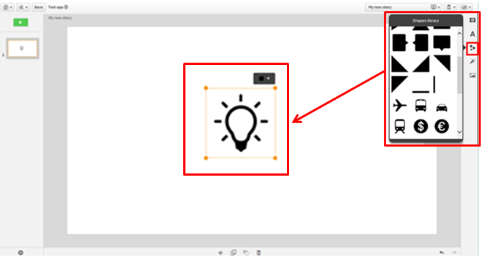
Use the to resize or move the shape anywhere on the page.
Select 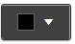 to edit the colour of the shape.
The icon confirms your colour selection.
Figure 43 – Edit the shape colour menu
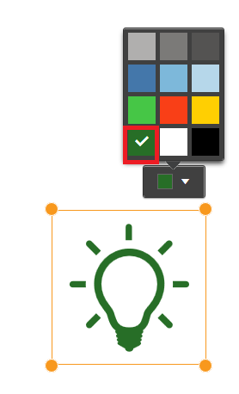
- Preview the story
You can preview your Story before exporting it.
Table 1 – Preview story navigation items
ITEM | DESCRIPTION
 | Select the Close button to close the preview.
 | Select the Actions button for options to move back and forward and export.
 | Select the Back button to go to the previous slide in the story.
 | Select the Forward button to go to the next slide in the story.
 | Select the Export button to export the story to PDF or PowerPoint.
 | Select the Play button to play the story.
To preview your story, choose the Story you are working on. On the Story page, select on the top left of the screen.
Figure 45 – Play your story button
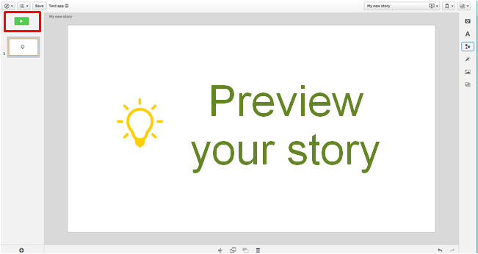
The Story will display in preview mode.
Figure 46 – Play your story screen
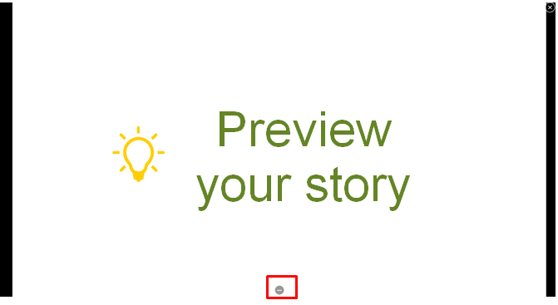
If you select at the bottom of the screen, the sheet navigation buttons will display.
Figure 47 – Play your story sheet navigation buttons
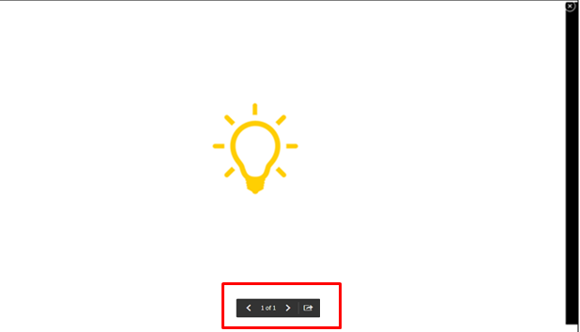

These buttons will allow you to move back and forward through the preview.
Select to export the story to PowerPoint or PDF.
Select to exit the preview.

- Export the story
If you want to print, or play the story outside of the Data Exchange Application, you will need to export the Story beforehand.
Table 1 –Export options navigation items
Item | Description
 | Select the Export story to PowerPoint icon to send the story to PowerPoint.
 | Select the Export story to PDF icon to send the story to PDF.
 | Select the Duplicate story icon to make a copy of the original story.
 | Select the Delete story icon to remove the story.
 | Select the Help icon to get online help from Sense website with the item that you are viewing.
 | Select the About icon to get information about the application.
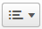 | Select the Menu icon to export the story.
On the Story page, select at the top left of screen to export the story to PDF or PowerPoint.
Figure 50 – Menu icon selection to export story
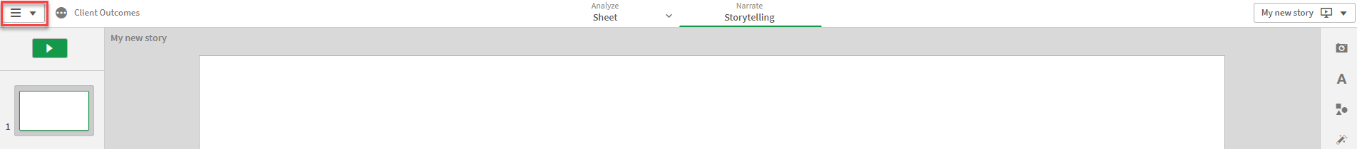
The Export Story pop up box will display.
Figure 51 – Export story pop up box
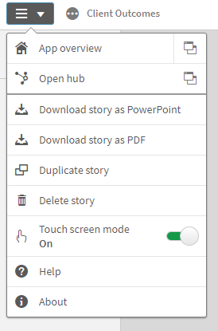

You can export your story as a PowerPoint or PDF.
  - Export story to PowerPoint
Make the appropriate changes to the PowerPoint settings then select .
Figure 52 – PowerPoint settings pop up box
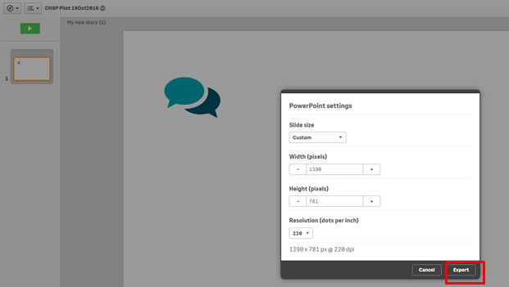

Select the PowerPoint hyperlink that displays.
Figure 53 – Click to download PowerPoint hyperlink
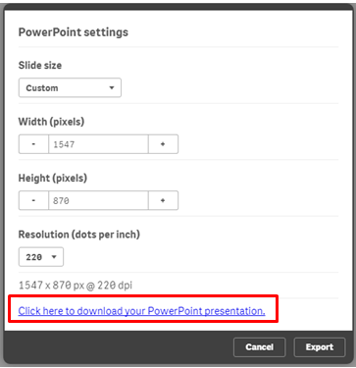
Select the options for the download.
If required, select to stop the download
Figure 54 – PowerPoint download options

  - Export story to PDF
Make the appropriate changes to the PDF settings then select .
Figure 55 – PDF settings pop up box
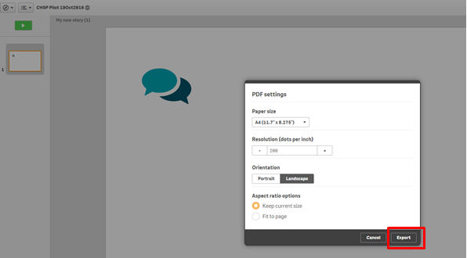

Select the PDF hyperlink that displays.
Figure 56– Click to download PDF hyperlink
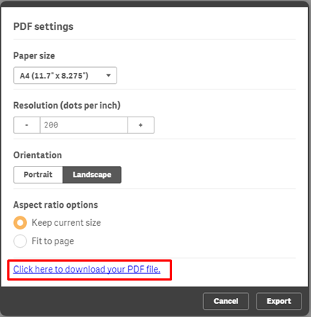
Select the options for the download.
If required, select to stop the download.
Figure 57 – PDF download options
You can find more information on reporting requirements in the Data Exchange Protocols. For further information on reports functionality, please visit the Training tab of the Data Exchange website.
For system support, contact the Data Exchange Helpdesk by email at dssdataexchange.helpdesk@dss.gov.au or on 1800 020 283.

