Add a client

Task card
This task card discusses the following:
- What is a client?
- How to add a client
  - Enter client details
  - Enter residential address
  - Enter demographic details
  - Enter extended demographics
  - Review and finish

KEY HIGHLIGHTS
- Do not add any personal information into the Client ID or Tag fields.
- Do not enter a client's full address if it is a sensitive location such as a refuge or shelter.
- Client and consent information is visible to the entire organisation and can be updated at any time.
- Searching for a client can be completed by using either full or partial client information.
- Refer to the Data Exchange Protocols for more information on conditions, disabilities and impairments.
- Organisation Editors and Viewer only users will only be able to view SCORE information for outlets and program activities they have access to.
- Adding partnership approach extended demographics and SCORE data will provide context as to why the client is accessing your services and demonstrate the outcomes they are achieving.

What is a client?
As defined by the Data Exchange Protocols, a client is “an individual who receives a service as part of a funded activity that is expected to lead to a measurable outcome.”
A client record only needs to be created once within an organisation, and can then be used and updated over multiple reporting periods.

How to add a client
At the Data Exchange web-based portal home page, select under the Add menu. Refer Figure 1.
Figure 1 – The Data Exchange home page
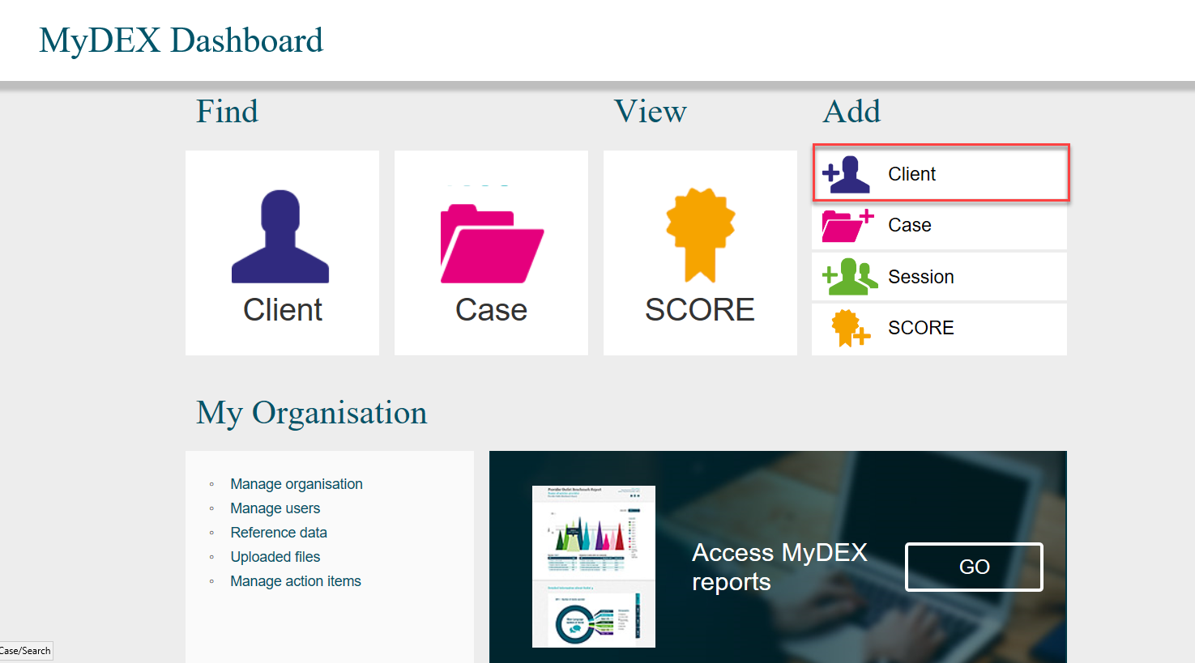
The Add a client – Client details screen will display.

Enter client details
Enter the client’s details. Refer Figure 2.
Fields marked with an * are mandatory and must be completed before you can move to the next screen.
A client’s identifiable information (name and address) is available only to your organisation to make navigation and data entry in the web-based portal easier.
Figure 2 – Add a client – Client details screen (Refer Table 1)
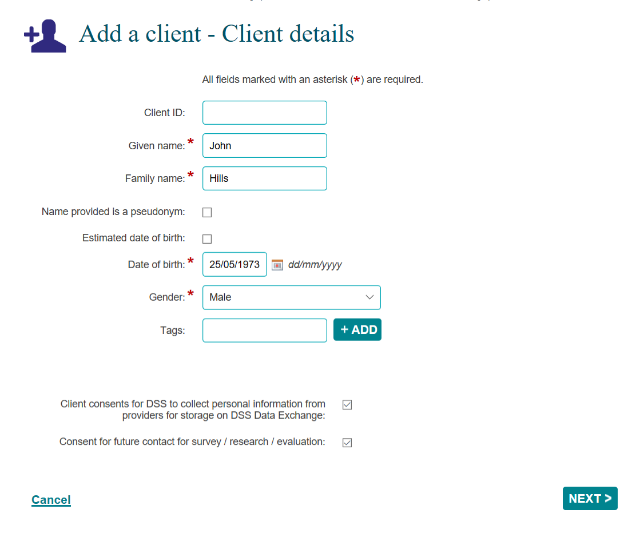

Do not enter any client personal information into the Client ID or Tags field, such as given or family names, Customer Reference Numbers (CRN) or My Aged Care reference numbers.

Table 1 details the information found in the Add a client – Client details screen. Refer Figure 2.
Table 1 – Add a client - Client details field descriptions (Refer Figure 2)
FIELD | DESCRIPTION
Client ID | Free text - if left blank a system generated number will be assigned in the web-based portal, beginning at 001.  If you have your own internal numeric or alpha-numeric client IDs, you can enter that here.  Do not enter any personal information on clients into this field.
Given name * | Free text – limit of 30 characters. Enter the client’s first or given name.  - If the client chooses not to disclose this information, enter a given name that is most commonly used or preferred to be used by the client and tick the Name is provided as a pseudonym box.  - If the client has one name only, you will also need to enter the same name in the Given name and Family name fields.
Family name * | Free text – limit of 30 characters. Enter the client’s last or family name.  - If the client does not have identification or chooses not to disclose this information, enter a family name that is commonly used or preferred to be used by the client and tick the Name is provided as a pseudonym box. This information can be updated at any time.  - If the client has one name only, you will also need to enter the same name in the Given name and Family name fields.
Name provided is a pseudonym | Tick this box where a client does not disclose their ‘real’ name.
Estimated date of birth | Select Estimated date of birth if a client’s date of birth is unknown.  This will change the Date of Birth field to Estimated year of birth. Enter the client's approximate year of birth (YYYY).
Date of birth * | Date format of dd/mm/yyyy. You can type the date of birth or use the calendar function 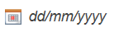.
Gender * | Select the gender that the client identifies as from the drop down list.
Tags | Add any relevant tags to the client profile for easy searching.  Tags work as search filters. They are unique to your organisation and you can create as many as you need. To create a tag, type in the new tag name (without spaces) and select Add. This tag will then exist for future use within your organisation.  Do not enter any personal information on clients into this field.
Consent for organisation to collect and store personal information on the Data Exchange | As many organisations seek consent for personal information, this box is pre-ticked.  Where client consent is not provided or withdrawn, you can un-tick this box. Once you create the client record, only the Client ID, Date of birth and gender will be visible to your organisation.  If a client changes their mind and decides to provide consent, you can edit the client details, tick the box and re-enter the client’s given and last name, and address line 1 and 2.  Refer to the Data Exchange Protocols for information on notification, consent and privacy.
Consent for future contact for survey / research / evaluation | As many organisations ask their clients whether they’re interested in future surveys and research, this box is pre-ticked.  Where clients do not wish to participate, this box can be un-ticked. If the client changes their mind and wishes to participate, this box can be re-ticked.  Refer to the Data Exchange Protocols for information on notification, consent and privacy.
A message will appear to alert you if any of these details are similar to another client record, and the matching record(s) will display at the bottom of the screen. Refer Figure 3.
Figure 3 – Matching client record field
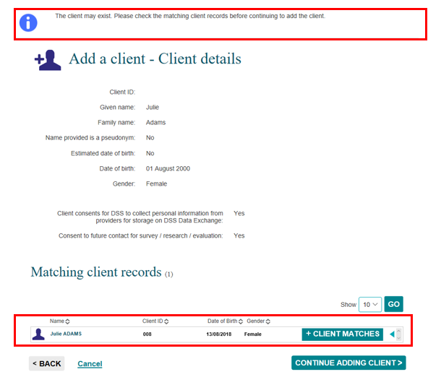

Select the blue triangle to expand the information to clarify if the clients are different. Refer Figure 4.
Figure 4 – Client matches expand arrow
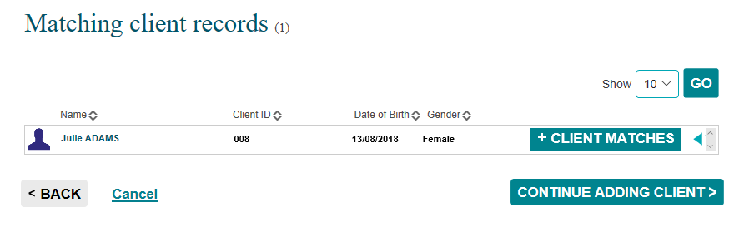

The Client matches field will display the matching client’s information. Refer Figure 5.
Figure 5 - Matching client record expanded screen
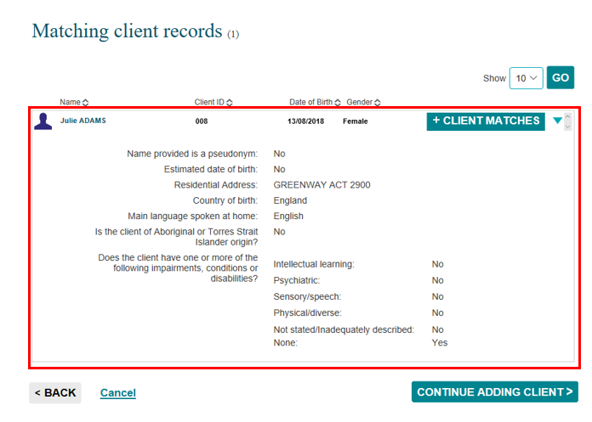

If the client you are creating is the same person as the client in the Client match field, select CLIENT MATCHES.
If the client you are creating is a different person, select CONTINUE ADDING CLIENT>.
Select if the client details you have started entering are incorrect.
Select to stop the creation of the new client record.

Enter residential details
The Add a client – Residential address screen will display. Refer Figure 6 and Table 2.
Figure 6 - Add a client – Residential address
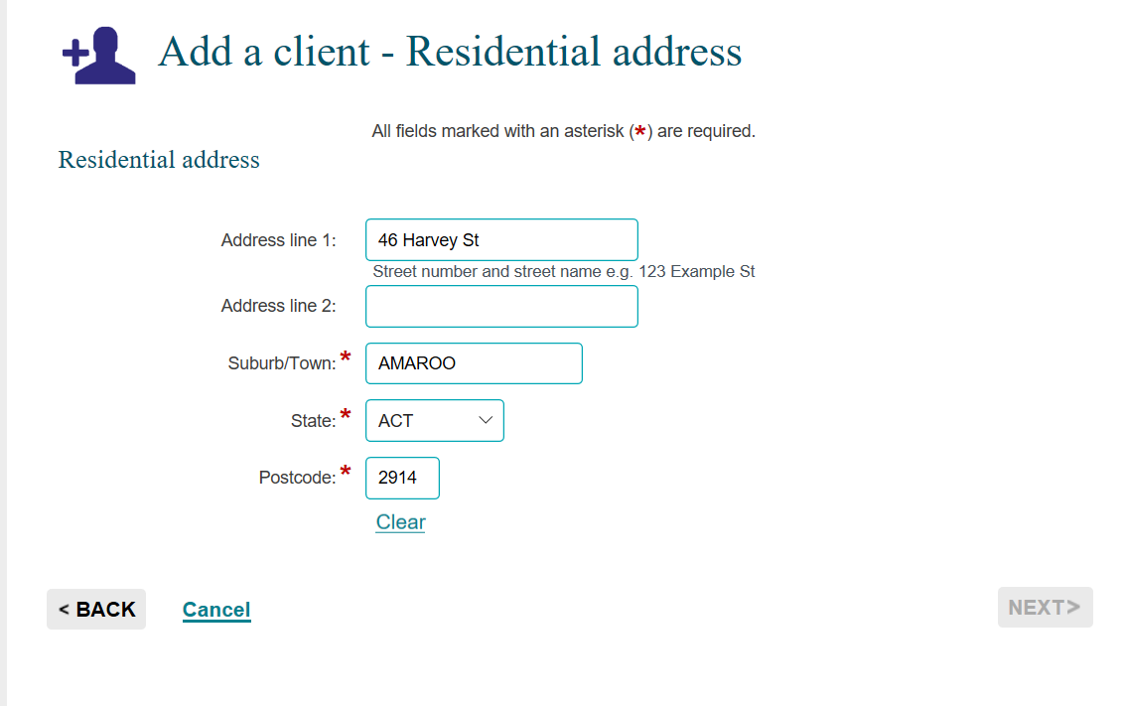
Enter the address details. The minimum amount of information required is the Suburb, State and Postcode.

Do not enter a client's full address if it is a sensitive location such as a refuge or shelter.
Refer to the Data Exchange Protocols "Collecting the mandatory priority requirements."

Table 2 – Add a client – Residential address field descriptions (Refer Figure 6)
FIELD | DESCRIPTION
Address line 1 | Street address.
Address line 2 | Street address.  Where a client has no fixed address, these lines can be left blank.  A flag to indicate if the client is homeless is available in the extended demographic details, as part of the partnership approach information.
Suburb / Town * | Free text – limit of 20 characters. Enter the suburb/town.
State * | Select the state/territory from the drop down list.
Postcode * | Free text – limit of six characters. Enter the postcode.
Select NEXT >.
The system will verify that the address details are valid. If the details are unable to be validated, alternative address options will be shown. Select the closest match.

If the street address entered is not able to be matched with an actual address in the area, a list of acceptable addresses will be provided. Refer Figure 7.
If none of these options are the correct address, you can leave the street details (Address lines 1 and 2) blank and enter the Suburb, State and Postcode, or select the address you entered, from the list.
Figure 7 - Add a client – Residential address
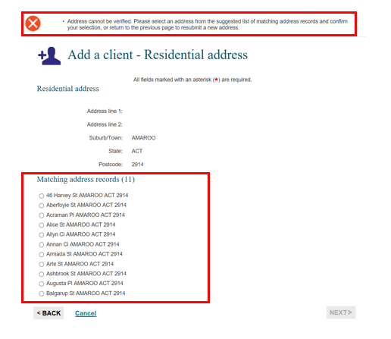

Enter demographic details
The Add a client – Demographic details screen will display.
Enter the demographic details. Refer Figure 8 and Table 3.
Figure 8 – Add a client - Demographic details screen
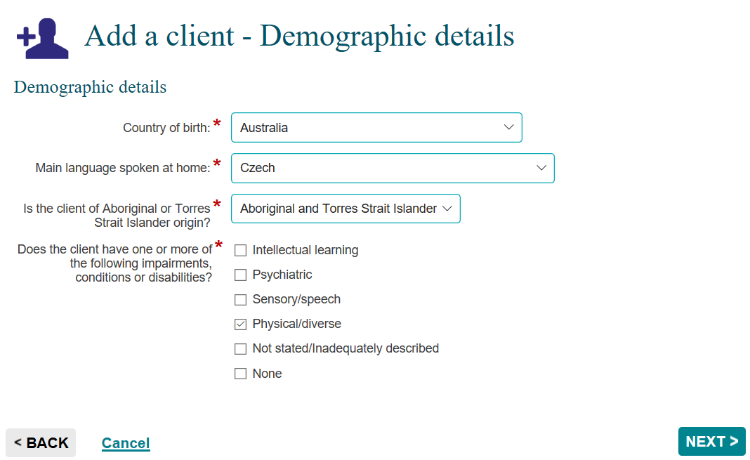
Select NEXT >.

Table 3 – Add a client - Demographic details field descriptions (Refer Figure 8)
FIELD | DESCRIPTION
Country of birth * | Select or scroll through the list of countries to populate the field. Alternatively, type the first few letters of the country and it will go to that section of the list.
Main language spoken at home * | Select or scroll through the list of languages to populate the field. Alternatively, type the first few letters of the language and it will go to that section of the list.
Is the client of Aboriginal or Torres Strait Islander origin?* | Select as the client identifies from the drop down list.
Impairments, conditions or disabilities * | Tick the box(s) as the client identifies. More than one box can be selected. Select None If the client has not identified as having impairment or chooses not to disclose that information.  Medical documentation is not required. More information about which disabilities and impairments fall into which categories can be found in the Data Exchange Protocols.

Enter extended demographics
The Add a client – Extended demographics screen will display. Refer Figure 9.
Providing responses to this information is optional unless specified in the Program Specific Guidance for the Program Activity your organisation delivers.
Figure 9 – Add a client – Extended Demographics screen (Refer Table 4)
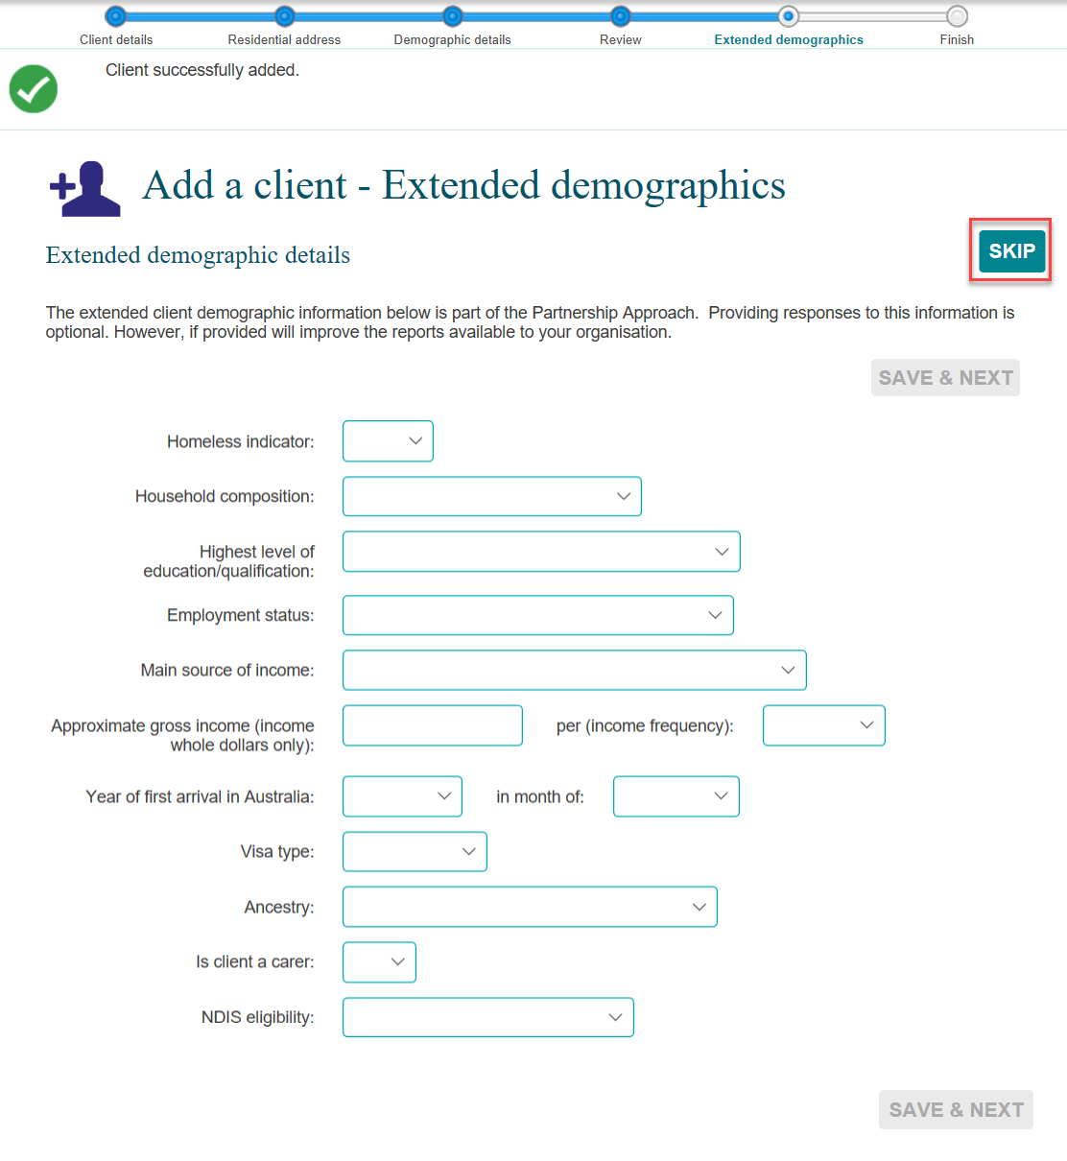
Select < Back to edit information.
Scroll down the page and select if you are satisfied with the information.
If you chose to not include this additional data, the Save & Next button will not be available. Press 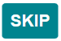to progress to the final screen.
Table 4 – Add a client – Extended Demographic details field descriptions (Refer Figure 9)
FIELD | DESCRIPTION
Homeless Indicator | Select the most appropriate option as to the client’s current housing situation, including if the client is at risk of homelessness.  The different options are:  - Yes  - No  - At risk
Household Composition | This field allows you to indicate household composition. This can allow organisations to indicate where services are provided to people living in the same household who may not be related.
Highest Level of education/qualifications | Scroll through and select from the list of education / qualifications to populate the field. The different options are:  - Pre-primary education  - Primary education  - Secondary education  - Certificate level  - Advanced diploma and diploma level  - Bachelor degree level  - Graduate diploma level and graduate certificate level  - Postgraduate degree level  - Other education
Employment status | Select the closest description for the client.  If the client is undertaking a combination of employment types (such as working part-time and studying) select the option that the client identifies as the main status at the time. The different options are:  - Paid work full-time  - Paid work part-time  - Unpaid work (includes volunteering)  - Not working and not looking for work  - Unemployed (not working but looking for work)  - Studying full-time  - Studying part-time  - Caring  - Parenting
Main source of income | Select the closest description for the client.  If the client receives income from multiple sources (e.g. Wages and Government Payment), select the one that they receive the highest amount of income from.
Approximate gross income (income whole dollars only) | Include whole dollars only if provided by client.
Per (income frequency) | Income frequency can be weekly / fortnightly / monthly or yearly.  Select the most appropriate as advised by the client.
Year of first arrival in Australia | Scroll through and select the year the person arrived in Australia if an immigrant.
In month of | Scroll through and select the month the person arrived in Australia if an immigrant.
Visa type | Select the most appropriate Visa type.
Ancestry | Select the option that the client self identifies with from the list provided.
Is client a carer? | Indicate whether the client is a carer of another person. The different options are:  - Yes  - No
NDIS eligibility | Applicable to programs that need to capture the NDIS eligibility status of the client. The different options are:  - NDIS in-progress access request  - NDIS eligible  - NDIS ineligible

Review and finish
The Add a client – Finish screen will display with the following. Refer Figure 10.
- A summary of the client you have created.
- If you did not enter a client ID, a Client ID will automatically be created.
- What can you do now? section where you can Add a case for the client, Find a case to attach this client, Add another client.
Figure 10 - Add a client - Finish screen
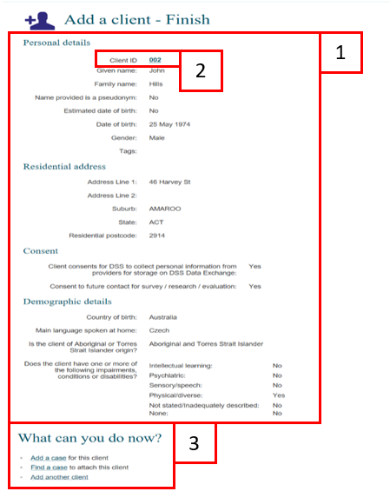

You can find more information on outlets, clients, cases, and sessions on the Data Exchange Protocols, and Training page.
For technical support, contact the Data Exchange Helpdesk by email at dssdataexchange.helpdesk@dss.gov.au or on 1800 020 283.

