Add and edit a user

Task card
This task card discusses the following:
- Access levels
- Access the manage users link
- Add a new user
- Assign an outlet and program activity to a user
  - To assign an outlet to a user
  - To assign a program activity to a user
- Viewing a user’s role
- Editing a user
  - Upgrading a user’s role to a Data Exchange Organisation administrator
  - Removing Organisation administrator access

KEY HIGHLIGHTS
- Prior to requesting a Data Exchange account an individual account holder must have their own Digital Identity (myGovID).
- Only a Data Exchange Organisation administrator can add and maintain user and outlet information in the Data Exchange.
- The email address entered for a new user must match the email address that has been set up in Relationship Authorisation Manager (RAM) for that user.
- A user can only edit or view information for an outlet or program activity that they have been attached to by the Data Exchange Organisation administrator.
- A user’s access can be updated to a Data Exchange Organisation administrator by the organisation’s current Data Exchange Organisation administrator at any time.

Access levels
The following access levels within the Data Exchange are available:
- Data Exchange Organisation administrator (Org administrator) access: Each organisation will need at least one Data Exchange Organisation administrator who will set up the organisation details, create and manage users, outlets, program activities and delivery partners. The Data Exchange Organisation administrator is the first person to access the web-based portal and will maintain user and outlet information.
Data Exchange Organisation administration access should be granted to staff members who will be responsible for setting up the Data Exchange, managing users and if applicable, uploading XML files.
NOTE: An organisation must have their first Data Exchange Organisation administrator complete a User access request form. Once this has been approved by the Data Exchange Helpdesk, they can then set up other Data Exchange Organisation administrators for their organisation via the Data Exchange web-based portal. Refer to the Updating a user’s role to a Data Exchange Organisation administrator section in this task card.
- Editor access: A Data Exchange Organisation Editor has access to add and edit records within the web-based portal. Access is restricted to outlets and program activities to which the organisation's Data Exchange Org Administrator has granted access to the editor. This access is also mirrored in their access to data that can be viewed in reports. Editor access should be granted to program and activity delivery staff members that are required to enter data into the Data Exchange.
- View only access: A Data Exchange Organisation View Only user has access to view cases, clients and sessions but cannot enter or edit records. Access is restricted to outlets and program activities to which the organisation's Data Exchange Org Administrator has granted access to the view only user. This access is also mirrored in their access to data that can be viewed in reports. View Only access should be granted to organisation staff members who need information regarding clients and services, but are not expected to enter information.

All clients entered into the Data Exchange web-based portal by the service are visible to all users within the organisation.
Clients are associated to your organisation and not just the program that they may initially access.

Access the Manage users link
As a Data Exchange Org Administrator, log into the Data Exchange web-based portal and select the
Manage users link under the My Organisation heading. Refer Figure 1.
Figure 1 – The Manage users link on the Data Exchange web-based home page
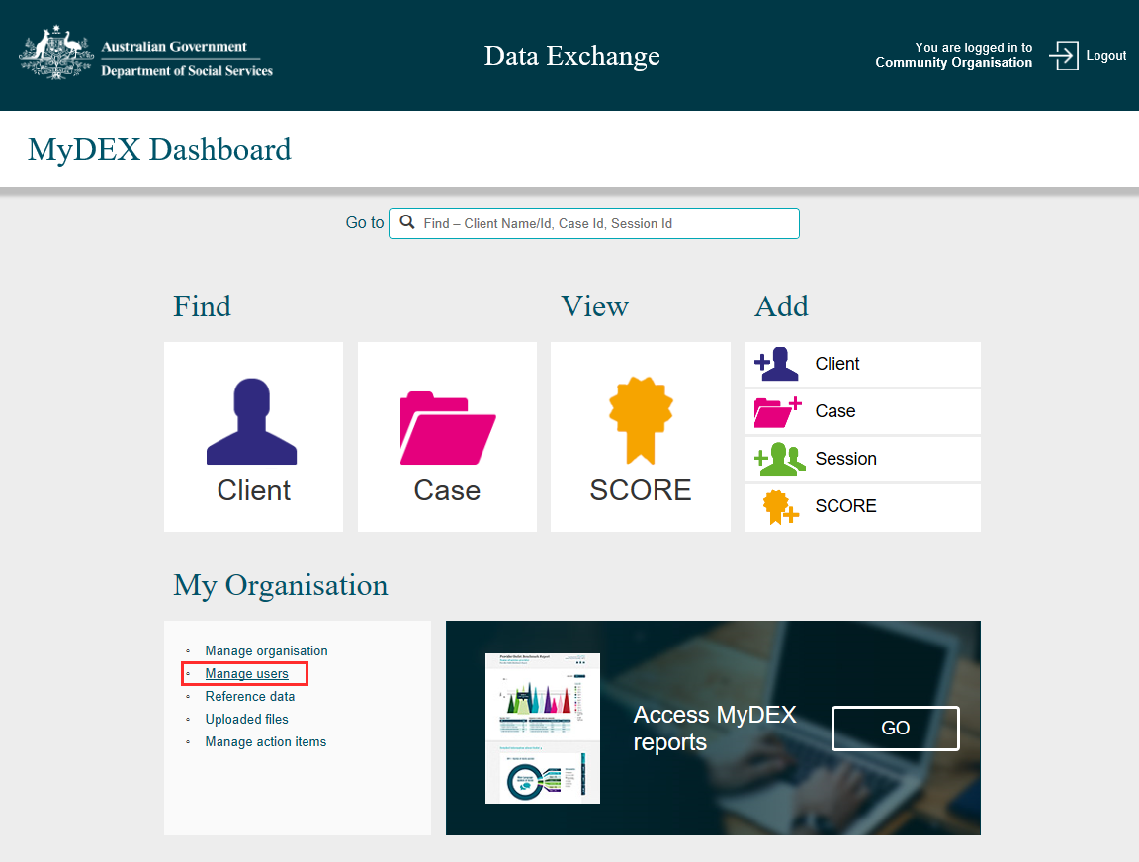

The Manage users screen will display. Refer Figure 2.
Figure 2 – Manage Users screen
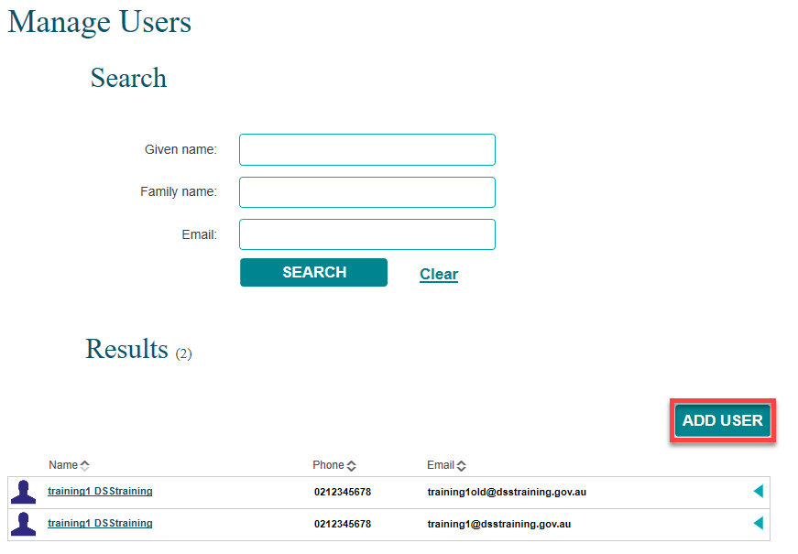

Add a new user

If already created, a list of existing users will be displayed at the bottom of the screen.

If you wish to add a new user to the system, select ADD USER.
The Add user screen will display. Refer to Figure 3.
Fields marked with an * are mandatory and must be completed before you can move to the next screen.
Figure 3 – Add user screen
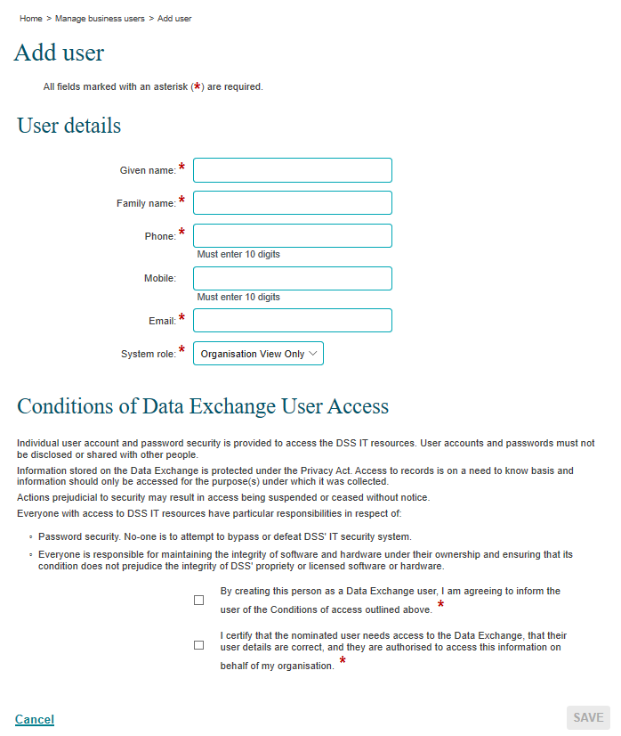

Table 1 – Add user screen field descriptions (Refer Figure 3)
FIELD | DESCRIPTION
Given name* | Enter the new user's given name.
Family name* | Enter the new user's family name.  Note: Where the new user has only one name, you will need to enter the name into both the Given name and Family name fields.
Phone* | Enter the new user's work contact phone number.
Mobile | Enter the new user’s mobile phone number.
Email* | Enter the new user's work email address.
System role* | Select the required system role:  - Organisation View Only – can only view records.  - Organisation Editor – can create, edit and view records.  Note: These roles can be upgraded to a Data Exchange Organisation administrator by an organisation’s current Data Exchange Organisation administrator at any time.
Conditions of Data Exchange User Access* | The Data Exchange Organisation administrator must check off the two mandatory items in this section to create and save this new user.  They must advise the new user of the terms and conditions of Data Exchange user access.

Complete the required fields and select SAVE.
The User profile screen will display. Refer Figure 4.
Figure 4 – User profile screen
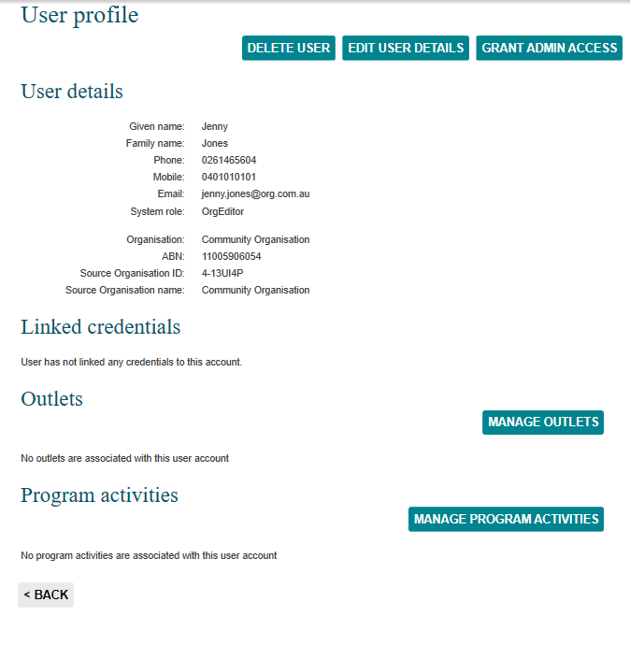

Assign an outlet and program activity to a user

Once a new user has been created, they need to be assigned to at least one outlet and one program activity to be able to enter and/or view data.

Users will only be able to view the detailed case and session details for outlets and program activities they have been assigned to via this function by their Data Exchange Organisation administrator. However, users will still be able to see any clients that the organisation has engaged with and recorded in the Data Exchange.

To assign an outlet to a user
Select MANAGE OUTLETS from the User profile screen. Refer to Figure 4.
The Manage outlets screen will display. Refer Figure 5.
Figure 5 – Manage outlets screen
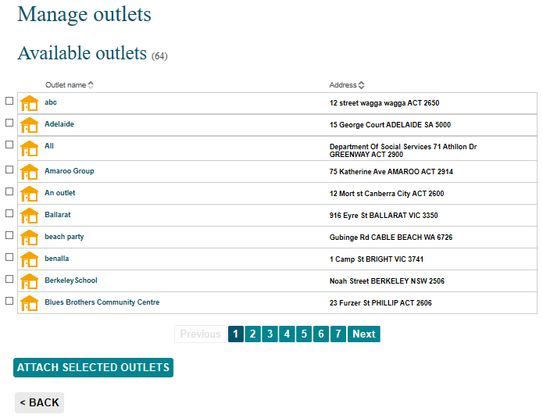

Assign the outlet(s) to the user by checking the tick box(s) next to the relevant outlet(s) name.
Select ATTACH SELECTED OUTLETS. Refer Figure 6.
Figure 6 – Outlets selected
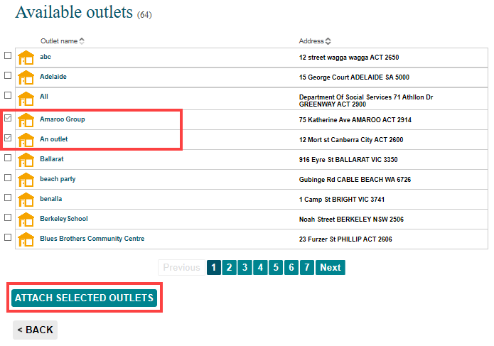
The outlets will display under the Selected outlets heading. Refer Figure 7.
Once you have assigned the outlet for the user, select <BACK.
Figure 7 – Selected outlets heading
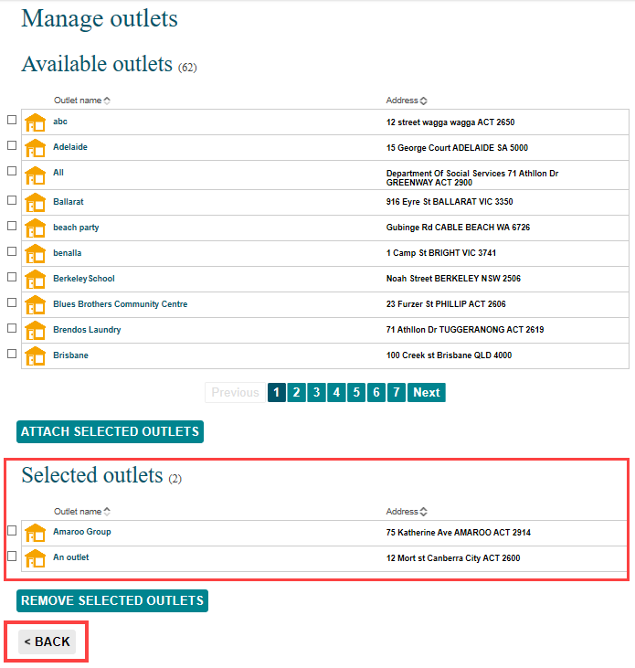

The User profile screen will display. Refer Figure 8.

Figure 8 – User profile screen highlighting outlets attached to a user
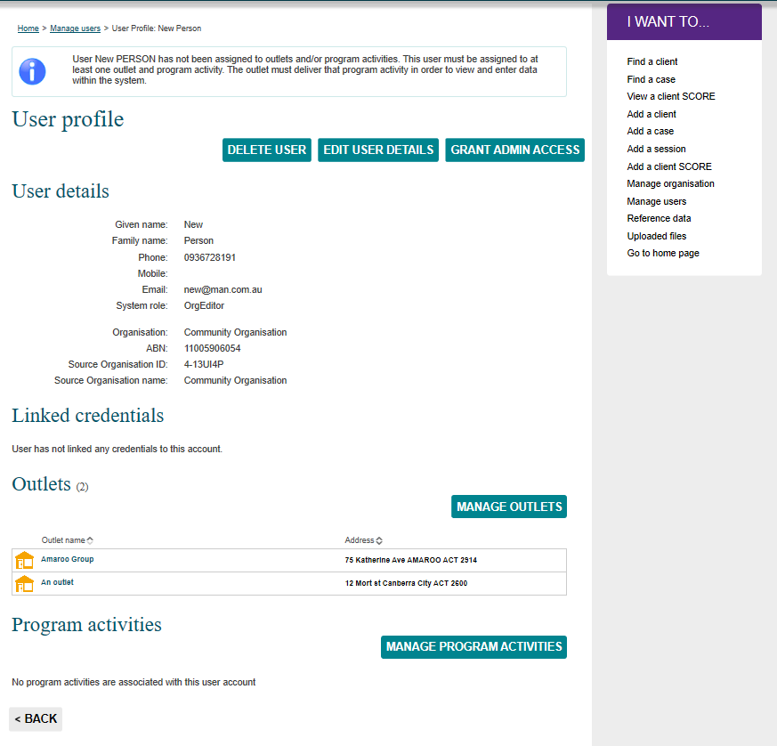

To assign a program activity to a user
Select MANAGE PROGRAM ACTIVITES from the User profile screen. Refer to figure 9.
Figure 9 – User profile screen
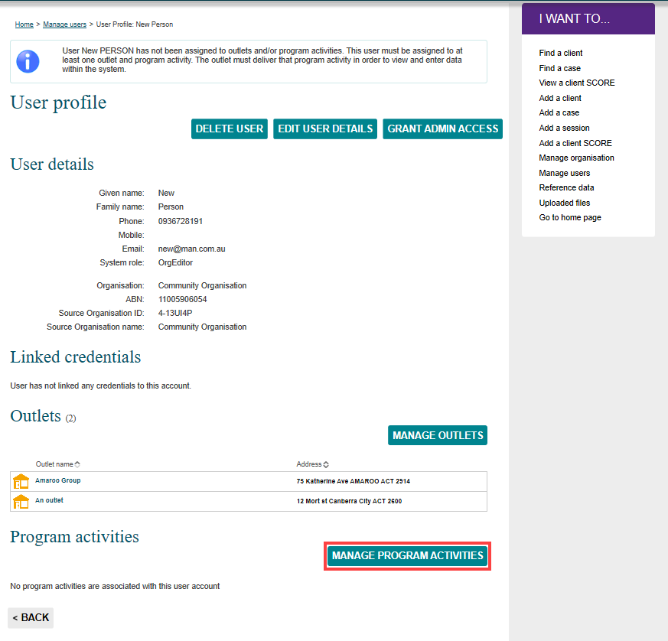

The Manage program activities screen will display.
Only the program activity(s) that are attached to the selected outlet will display under the Available program activities heading.
- Assign the program activity(s) to the user by checking the tick box(s) next to the relevant program activity(s) name.
- Select ATTACH SELECTED PROGRAM ACTIVITIES. Refer Figure 10.
Figure 10 – Manage program activities screen
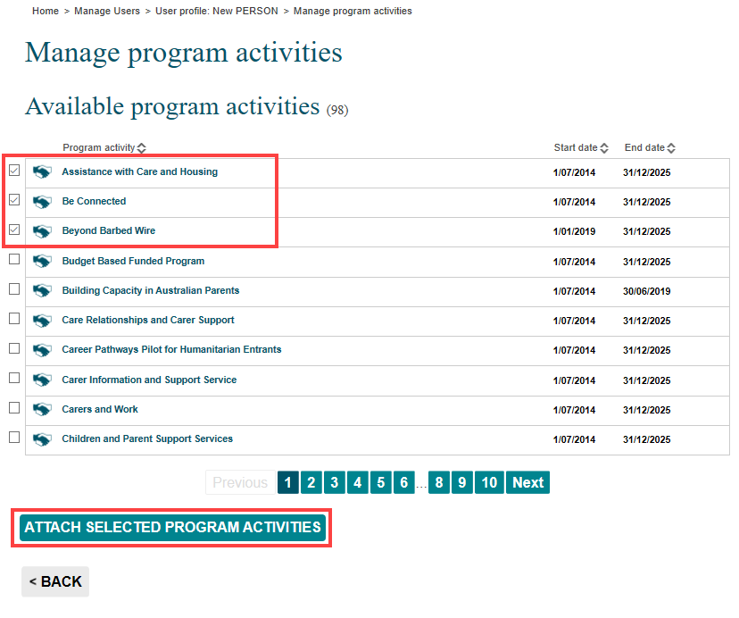
The program activities will display under the Selected program activities heading. Refer Figure 11.
Once you have assigned the program activities for the user, select <BACK.
Figure 11 - Selected program activities section
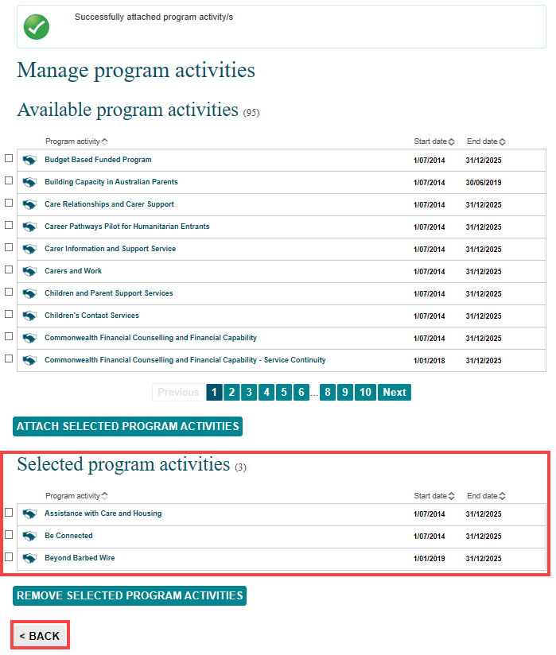
The User profile screen will display. Refer Figure 12.
Figure 12 – User profile screen
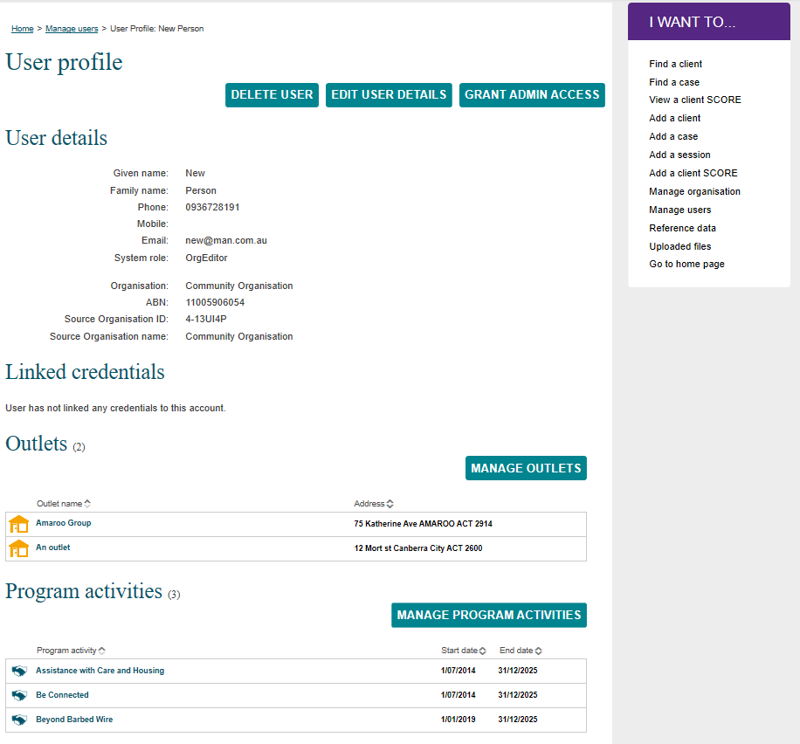

Note: Linked credentials information will update once the user has accessed the Data Exchange
web-based portal for the first time.

Viewing a user’s role
Go to the Manage Users screen and search for the relevant user. Select the next to the user’s name. Refer Figure 15.
Figure 15 – Manage Users screen
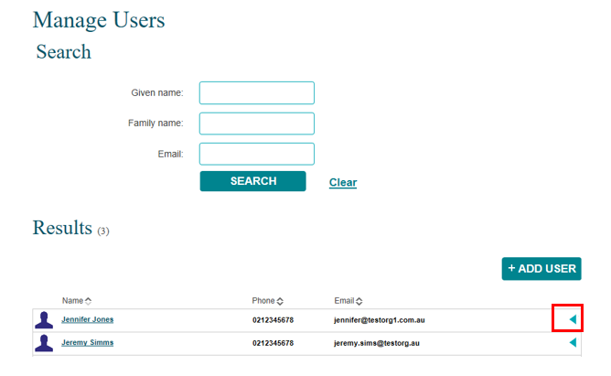
The user’s role will display. Refer Figure 16.
Figure 16 – Manage Users screen – user role
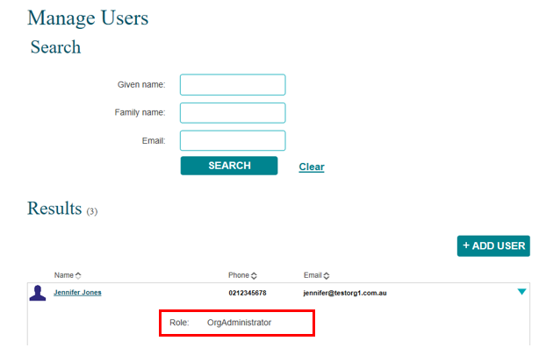
Select the to collapse the view.

Editing a user
A user’s profile can be updated by an organisation’s Data Exchange Organisation administrator at any time.
As a Data Exchange Organisation Administrator, log into the Data Exchange web-based portal and select the Manage users link under the My Organisation heading. Refer Figure 17.
Figure 17 – The Manage users link on the Data Exchange web-based home page
The Manage Users screen will display. Refer Figure 18.
Find the relevant user by either using the Search fields or the Results section.
Figure 18 – Manage Users screen highlighting relevant user
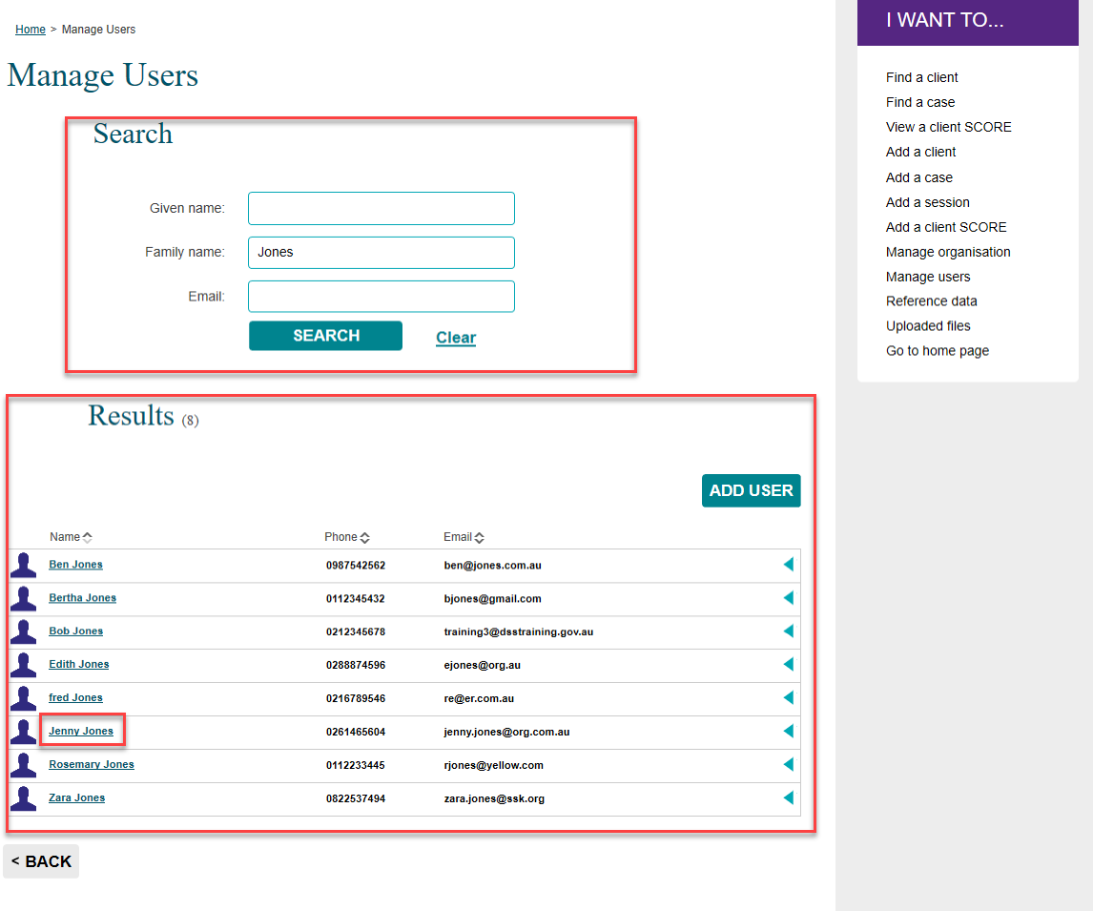

Select the hyperlink of the relevant user. The User profile screen will display. Refer Figure 19.
Select EDIT USER DETAILS.
Figure 19 – User profile - Edit user details button
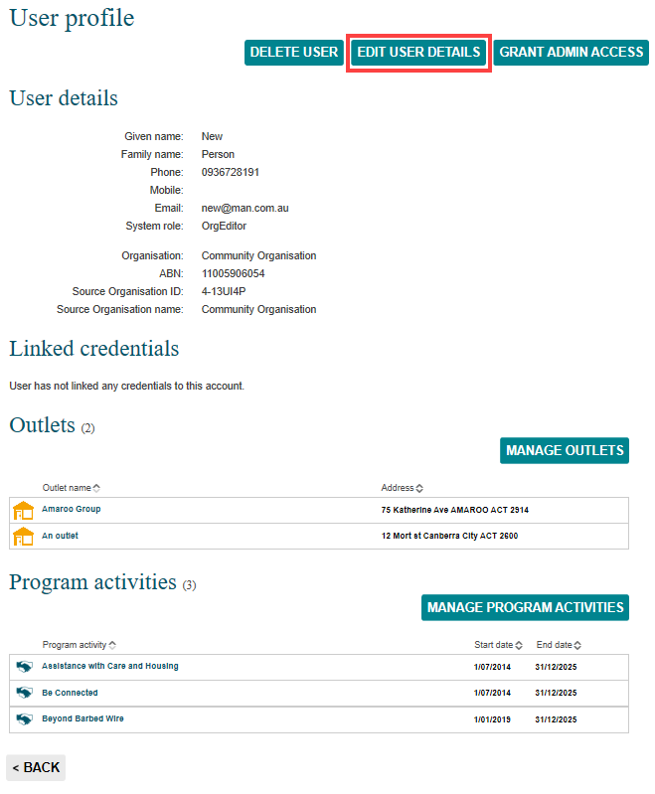
The Edit user details screen will display. Refer Figure 20.
Figure 20 – Edit user details screen
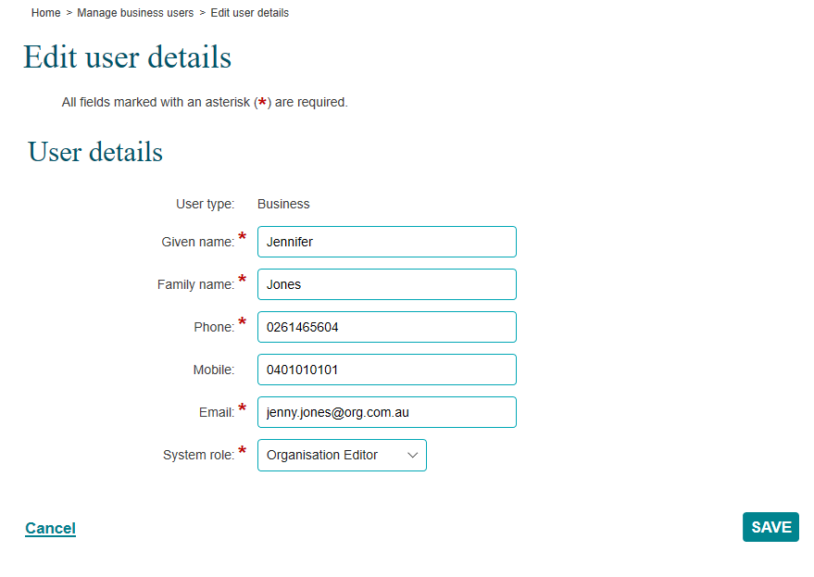
Update the details as required and select SAVE.

Upgrading a user’s role to a Data Exchange Organisation administrator
A user’s role can be upgraded from an Organisation Editor or Organisation View only to a Data Exchange Organisation administrator. This can be completed by the organisation’s current Data Exchange Organisation administrator without the need of completing a User access request form.

Note: The change to the Data Exchange Organisation administrator user role will provide the user with access to data for all outlets and program activities for that organisation.
Select GRANT ADMIN ACCESS from the User profile screen. Refer Figure 21.
The system role in this example is OrgEditor.
Figure 21 – User profile screen updating role
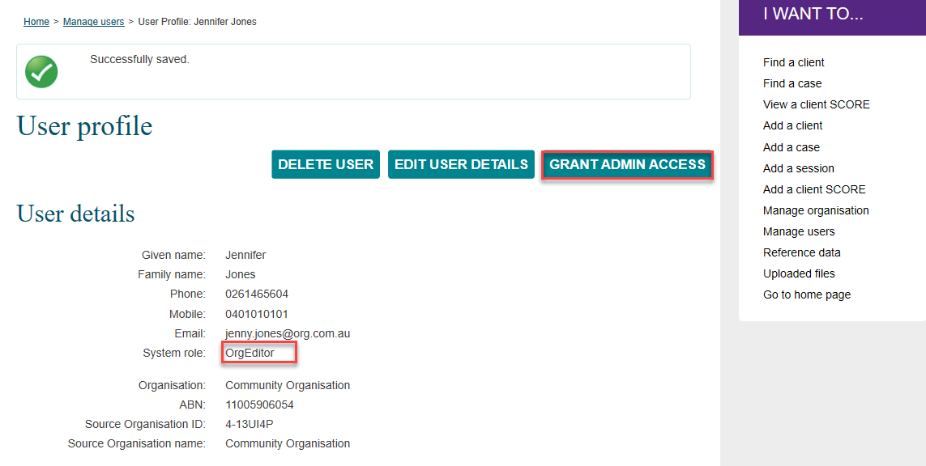
The Grant admin access? pop up box will display. Refer Figure 22.
Figure 22 – Grant admin access? pop up box
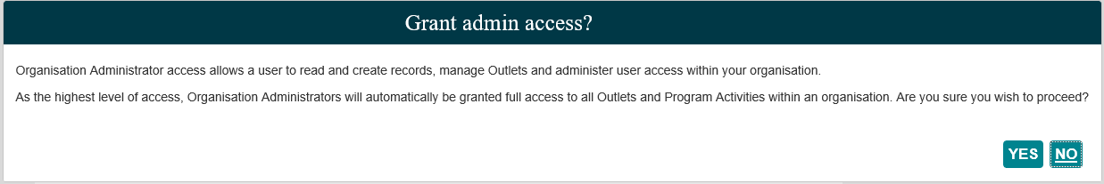
Select YES.
The User profile screen will display with the users system role upgraded to OrgAdministrator (Organisation Administrator). Refer Figure 23.
Figure 23 – User profile screen - Updated user details
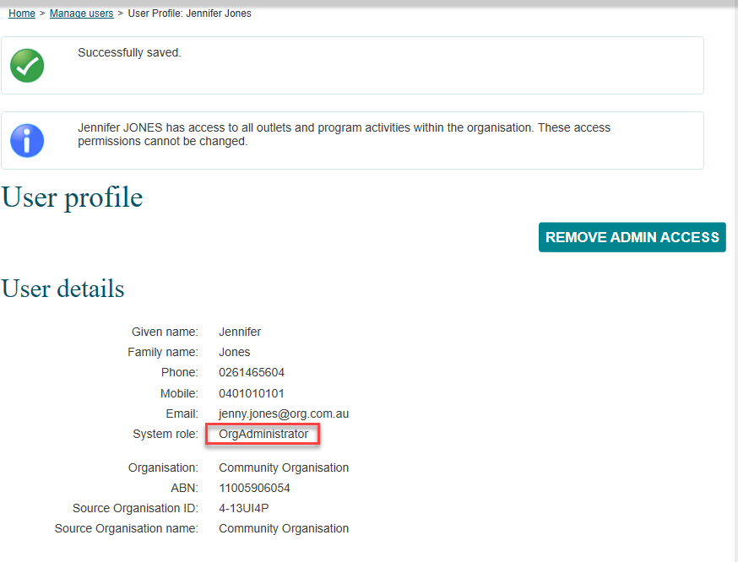

Removing Organisation administrator access
A user can have their Data Exchange Organisation administrator access removed and reverted back to their original system role by another Data Exchange Organisation administrator.
Select REMOVE ADMIN ACCESS from the User profile screen. Refer Figure 24.
Figure 24 – User profile screen – Removing admin access
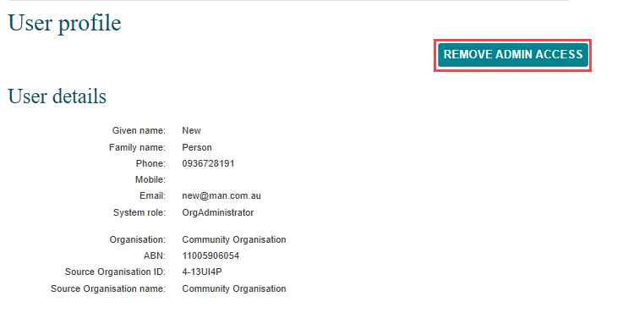
The Remove admin access pop up box will display. Refer Figure 25.
Figure 25 – Remove admin access? pop up box
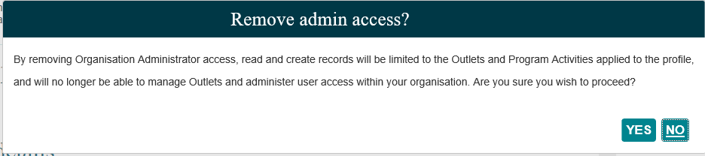
Select YES.
The User profile screen will display with the users system role updated to Organisation Editor. Refer Figure 26.
Figure 26 – Updated User profile screen
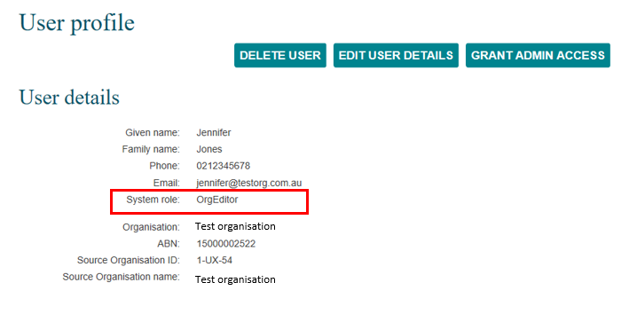

Deleting an organisation user
A Data Exchange organisation administrator can delete organisation users from the Data Exchange. The organisation administrator must revoke that user’s admin access (if any) before proceeding with deleting them.
Select DELETE USER from the User profile screen. Refer Figure 27.
Figure 27 – Delete user profile screen
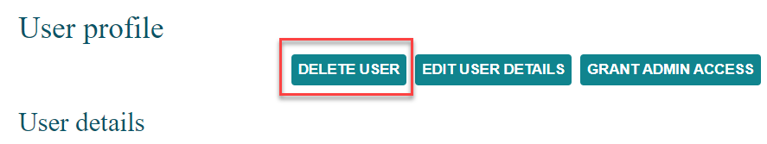
When the confirmation pop up box displays, select YES, as shown in Figure 28.
Figure 28 – Confirm delete user pop up box
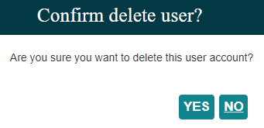

You can find more information on outlets, clients, cases, and sessions on the Data Exchange Protocols, and Training page.
For technical support, contact the Data Exchange Helpdesk by email at dssdataexchange.helpdesk@dss.gov.au or on 1800 020 283.

