# Upload methods

## Task card

This task card discusses the following:

* Bulk file upload
* Reference data section
* Reference data administration functions
  + File upload XML schema
  + Reference data
  + Outlets and program activities data
* Uploaded files section
* System-to-system
  + Access to staging / testing environment
  + Back up data files
* Client IDs and change of upload methods
* Reminder for the end of reporting period for bulk XML and system-to-system uploads

| **KEY HIGHLIGHTS** |
| --- |
| * Ensure that the client ID does not include any personal information that can identify the client. * Download the file upload XML schema and reference data files regularly to ensure you have up to date data codes. * Maximum file size uploads for bulk XML is 10MB. Upload your data on a regular basis rather than all at once to avoid delays in uploading to the Data Exchange. * Be aware of the ‘Pending’ and ‘Processing’ status stages. * Ensure that client IDs are different or start after the last ID number created if changing upload methods. |

### Bulk file upload

Bulk file upload is used where an organisation has its own client management system and their IT vendor/technical team creates a function where the organisation manually bulk uploads their data in an XML format. This means that the relevant fields for the Data Exchange are extracted from the software as an XML file. The Data Exchange Organisation Administrator must then upload the file to the Data Exchange web-based portal.

When you log in to the Data Exchange web-based portal as a Data Exchange Organisation Administrator, the screen options will display. Refer Figure 1.

**Reference data** and **Uploaded files** links are accessible via the **My Organisation** box.

Figure 1 – The Data Exchange home page

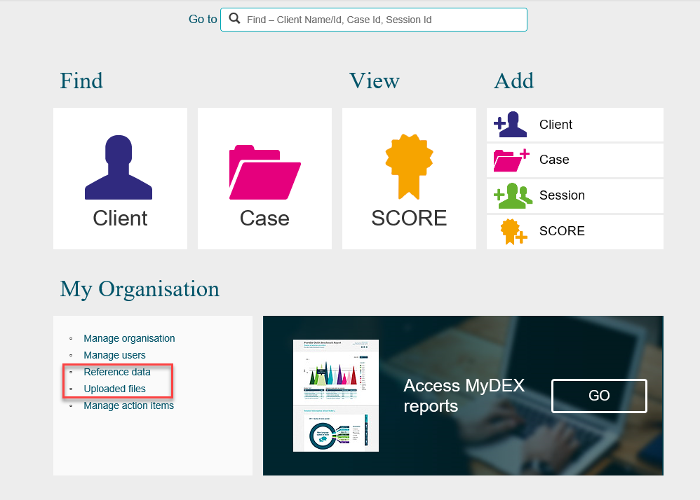

### Reference data section

The **Reference data** section is only for those organisations that perform bulk uploads into the Data Exchange.

Files that contain all the Data Exchange codes can be downloaded through **Reference data**.

Select **Reference Data** on the Data Exchange home page to download data fields from Data Exchange.

The **Reference data** screen displays. Refer Figure 2.

Figure 2 - Reference data screen

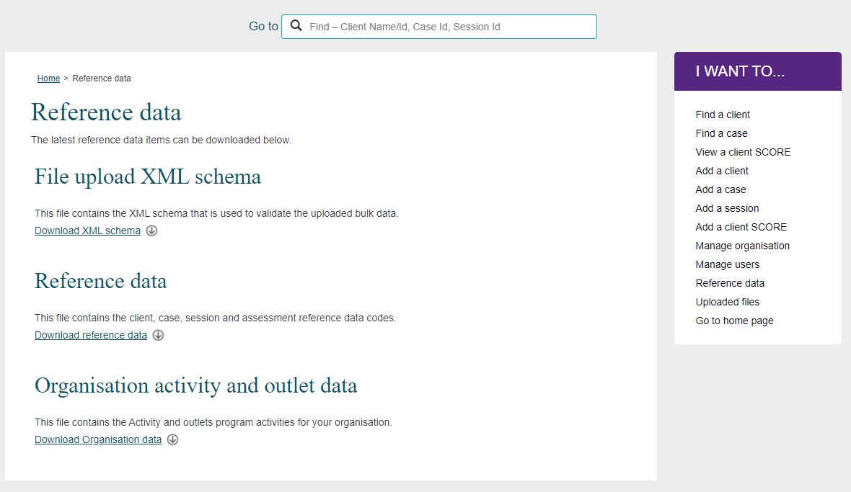

### Reference Data administration functions

### File upload XML schema

It is recommended that this file is downloaded regularly, at least every 3 months, so that any changes to the validation rules in the Data Exchangeare up to date.

This file defines the validation rules for bulk upload, for your organisation to validate your own bulk data XML file against prior to uploading to ensure there are no errors.

* Select **Download XML schema.**
* Select to either **Save** or **Open** the DEXFileUpload.xsd file.

### Reference Data

It is recommended that this file is downloaded regularly and at least every 3 months, so that any changes to data codes in the Data Exchangeare up to date in your system.

This file contains all the data codes for the clients, cases, sessions and SCORE assessments.

* Select **Download reference data.**
* Select to either **Save** or **Open** the DEXReferenceData.xml file.

### Outlets and Program activities data

It is recommended that this file is downloaded whenever there are changes to outlets or program activities so that any changes to data codes in the Data Exchangeare up to date in your system.

This file is relevant to your organisation only as it contains your outlets and program activities.

* Select **Download Outlets and Program activities data.**
* Select to either **Save** or **Open** the OutletActivityData.xml file.

### Organisation Activity data

This file is only relevant to organisations that choose to create their outlets via bulk XML upload.

It is recommended that this file is downloaded whenever an organisation creates new outlets or receives new program activities so that any changes to data codes are up to date.

* Select **Download Organisation Activity data.**
* Select to either **Save** or **Open** the OrganisationActivityData.xml file.

### Uploaded Files section

**Uploaded files** are for organisations that perform bulk upload into the Data Exchange.

The maximum file size that can be uploaded at a time is **10MB**. Bulk uploading your data on a regular basis, rather than all at once, will help avoid going over this limit.

In order to upload a file:

* Select **Uploaded Files** on the Data Exchange home pageto upload a new .xml file.
* The **Uploaded files** screen displays. Refer Figure 3.

Figure 3 - Uploaded files screen

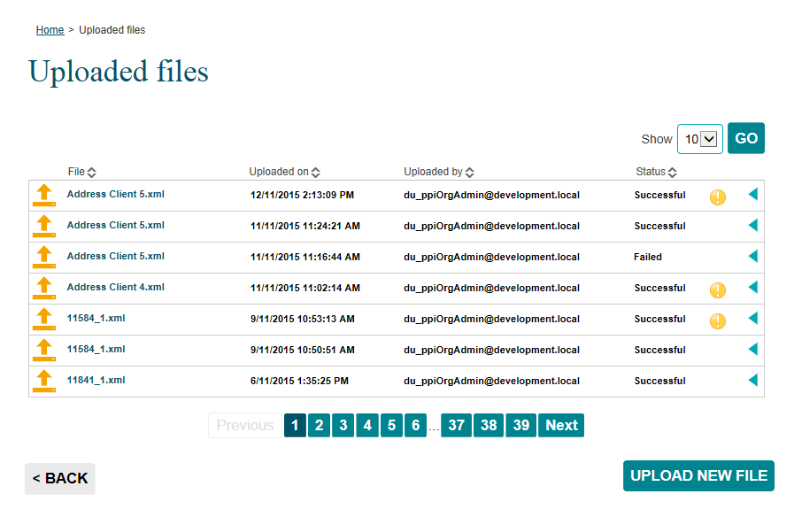

* Select **UPLOAD NEW FILE.**
* The **Upload new file** screen displays. Refer Figure 4.

Figure 4 - Upload new file box

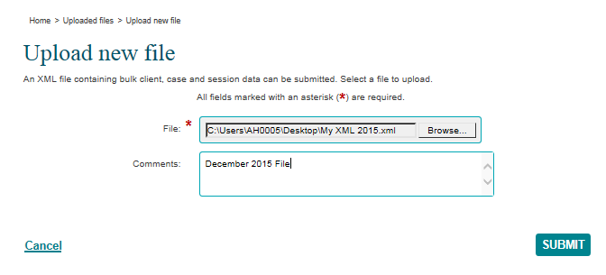

* Select Browse… to choose your .xml file that you wish to upload.
* Select the file and select Open.
* Use the **Comments** field to add additional information about the file as needed.
* Select **SUBMIT**.

On initial upload of your XML file, a message will be displayed advising that the file has been **successfully accepted** by the Data Exchange for processing.

Please note that this **does not** mean that your file has been **successfully processed** or that it is without errors.

After upload, your XML file will move from a status of **‘Pending’** (refer Figure 5) into **‘Processing’** (refer Figure 6), which is the stage that your file is being read, and data is being written to the system.

Figure 5 - Upload file details – ‘Pending’ status

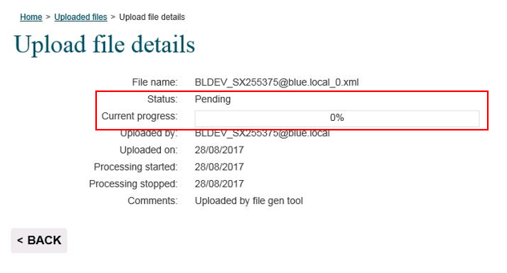

Figure 6 - Upload file details – ‘Processing’ status

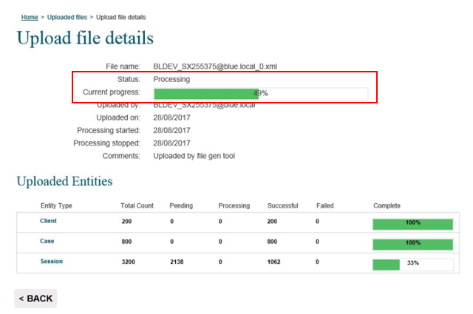

After **‘Processing’** is complete, your file will receive a status message of either **‘Successful’** (refer Figure 7), **‘Successful (with warning flag)’** or **‘Failed’** (refer Figure 8), indicating if the data contained in your XML file is correct or incorrect.

Figure 7 - Upload file details – ‘Successful’ status

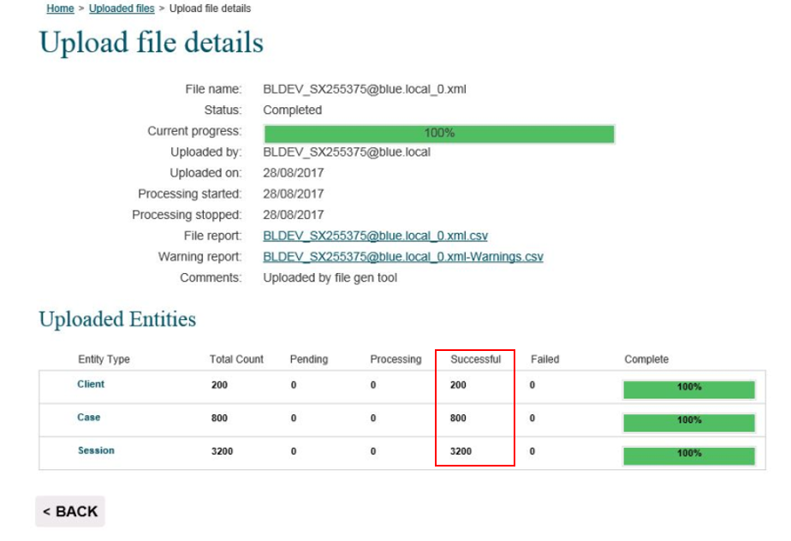

Figure 8 - Upload file details – ‘Failed’ status

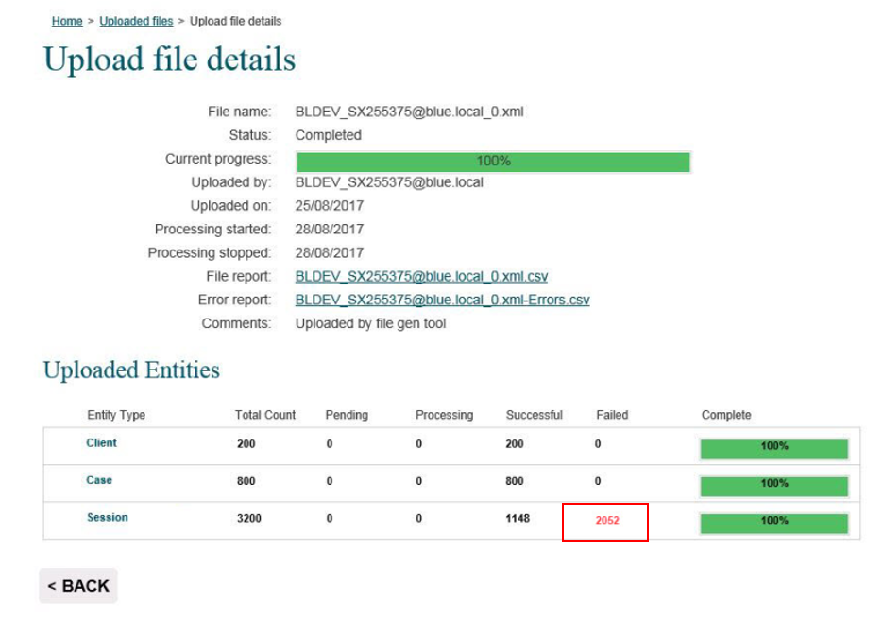

**‘Processing’** times vary depending on file size and system traffic. You will need to check the status of your file a few hours after the initial upload to confirm if your upload has been successful, or contains errors that need resolving.

Figure 9 - Uploaded files screen

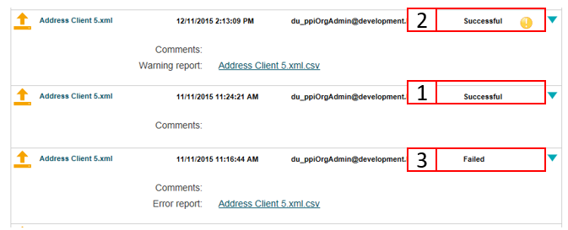

1. The file will show the status of **Successful** once it has been successfully uploaded. Refer Figure 9.
2. There may be some instances your file status can be **Successful** with a **Warning** This is a screen shot of the Successful with a warning icon which is a yellow exclaimation mark.to flag that addresses, or multiple addresses, were modified slightly in order to pass validation. These changes can be viewed on the Warning Report.
3. If the file did not upload completely, the status will show **Failed**. The records that failed can be viewed on the Error Report.

To view the report:

* Select This is a screen shot of the blue arrow that is selected to view details of he uploaded report. to access the report.
* Select the **report name hyperlink** to open the file and view the errors that have occurred.

## System-to-system

System-to-system transfer means that you are using your own client management system software to enter data and your IT vendor/technical team modifies the specifications of the software so that Data Exchange relevant fields are automatically uploaded to the Data Exchange at regular intervals (such as midnight each night).

### Access to staging / testing environment

It is mandatory for software vendors of organisations that are going to be using system-to-system as their data upload method to apply for access to the staging/testing environment. This is to ensure that the data will perform correctly prior to live upload to the Data Exchange environment. Please liaise with your software vendors to ensure that the system you are intending to use is compatible with the Data Exchange and that the required testing has been completed.

Access for the staging/testing environment can be requested via the Data ExchangeHelpdesk [dssdataexchange.helpdesk@dss.gov.au](mailto:dssdataexchange.helpdesk@dss.gov.au) or on 1800 020 283 between 08.30am - 5.30pm (AEST/AEDT) Monday to Friday.

### Back up data files

It is recommended for organisations back up their data prior to live upload into the Data Exchange. This is to ensure that data is not lost if there has been a problem with the upload process.

If you experience errors during the upload process please contact the Data ExchangeHelpdesk [dssdataexchange.helpdesk@dss.gov.au](mailto:dssdataexchange.helpdesk@dss.gov.au) or on 1800 020 283 between 08.30am - 5.30pm (AEST/AEDT) Monday to Friday.

### Client IDs and change of upload method

If your organisation is changing your upload method from manual entry in the web-based portal to bulk upload or system-to-system, you will need to ensure that any IDs for the new method of upload are different or start after the last ID number allocated in the web-based portal.

For example: If the last client created in the web-based portal has a Client ID of A0015 then the new upload method Client ID must start at A0016.

If the IDs are not adjusted and unique, then any existing records that you have entered into the web‑based portal with a matching ID, will be overwritten with the new information.

### Reminder for the end of reporting period for bulk XML uploads and system-to-system

The end of a reporting period can be a very busy time for organisations uploading their data. The data that is uploaded **must** reach a status of **‘Successful’** before the end of the reporting cut off time of midnight AEST / AEDT on the relevant date for the data to be successfully transmitted to the Data Exchange portal. Data that is still being processed and is not finalised past this time will **not** be accepted.

Organisations should allow themselves time to correct and re-submit any errors that may occur from a **‘Failed’** upload. Organisations should also take into account the size of their file, how many files they intend to upload and system traffic for processing times.

It is recommended that data is updated on a regular basis during the reporting period well before the final reporting period due date (30 July and 30 January each year). The upload process for bulk upload and system-to-system can take longer during peak periods.

For more information, refer to the [Web Services Technical Specifications](https://dex.dss.gov.au/document/126) and [Bulk File Upload Technical Specifications](https://dex.dss.gov.au/document/131) documents.

For technical support; contact the Data Exchange Helpdesk by email [dssdataexchange.helpdesk@dss.gov.au](mailto:dssdataexchange.helpdesk@dss.gov.au) or on 1800 020 283 between 08.30am - 5.30pm (AEST/AEDT) Monday to Friday.