Update participation in the Partnership Approach

Task card

This task card discusses the following:
- How to update participation in the Partnership Approach
  - Part A - At the organisation level
  - Part B - At the program activity level

KEY HIGHLIGHTS
- Requirements for participation in the partnership approach may be specified in the grant opportunity guidelines or your grant agreement.
- Opting in to the Partnership Approach will provide your organisation with access to a number of extra partnership reports.
- Contact your funding arrangement manager for more information.

How to update participation in the Partnership Approach
Your organisation can elect to opt in or out of the Partnership Approach for one, some or all of the program activities your organisation delivers. Opting in to the Partnership Approach will provide your organisation with access to a rich data source of partnership reports which includes extra demographic and outcomes information. Requirements for participation in the partnership approach may be specified in the grant opportunity guidelines or your grant agreement.
Changes to your organisation's participation in the Partnership Approach must be reflected in your grant agreement. Contact your funding arrangement manager to discuss this further.
Once your grant agreement has been updated, your organisation will be able to access Partnership Approach reports however you can start entering the data at any time.
More information about the Partnership Approach can be found in the Data Exchange Protocols. Task cards on how to run Partnership Approach reports can be found on the Data Exchange website.

Part A - At the organisation level
From the Data Exchange web-based portal home page, select > Manage organisation found in the
My Organisation menu. Refer Figure 1.
Figure 1 – My Organisation screen
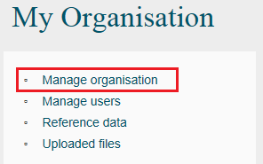
The Manage organisation screen will display. Refer Figure 2.
Select EDIT ORGANISATION DETAILS.
Figure 2 – Manage organisation screen
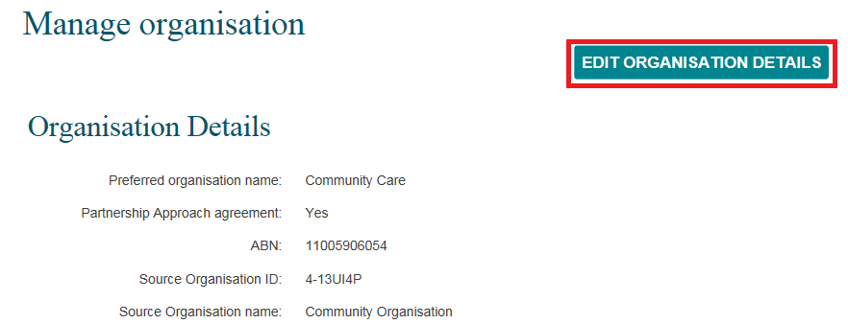
The Edit organisation details screen will display. Refer Figure 3.
Select Yes or No to indicate whether your organisation is or isn’t participating in the Partnership Approach, then select SAVE.
This will apply to all program activities your organisation delivers. If you have only elected certain program activities for the Partnership Approach, complete the steps outlined in Part B.
Figure 3 – Edit organisation details screen
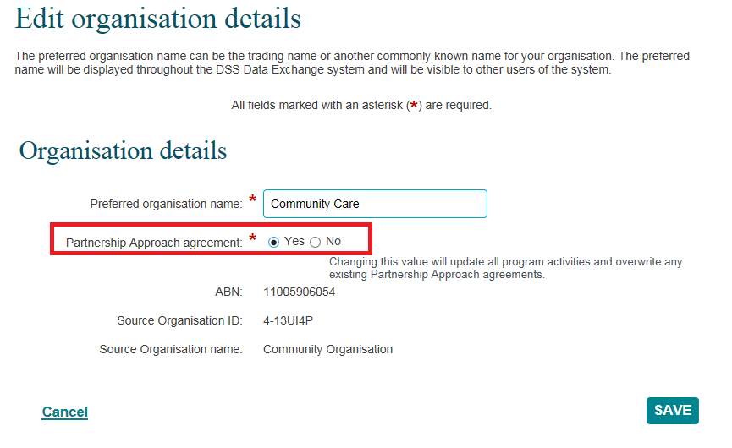

Part B - At the program activity level
Your organisation can opt out of the Partnership Approach for an individual program activity even if they have opted in at an organisation level.
If your organisation delivers the same program activity at multiple outlets, each of these outlets must all opt-in or out, as participation cannot be assigned at the outlet level.
To opt in or out of the Partnership Approach for an individual program activity, go to the Manage organisation screen and select the appropriate Program activity hyperlink. Refer Figure 4.
Figure 4 – Program activity selected at the Manage organisation screen
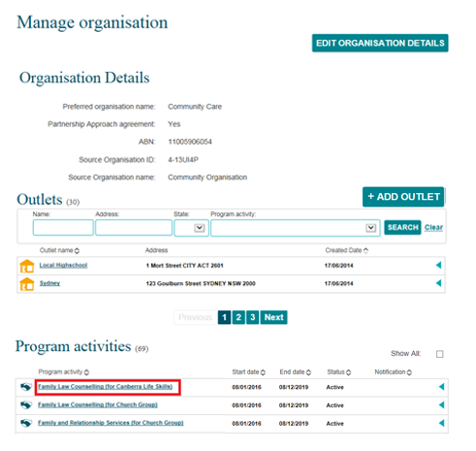

The Program activity screen will display. Refer Figure 5.
Select EDIT PROGRAM ACTIVITY.
Figure 5 – Program activity screen
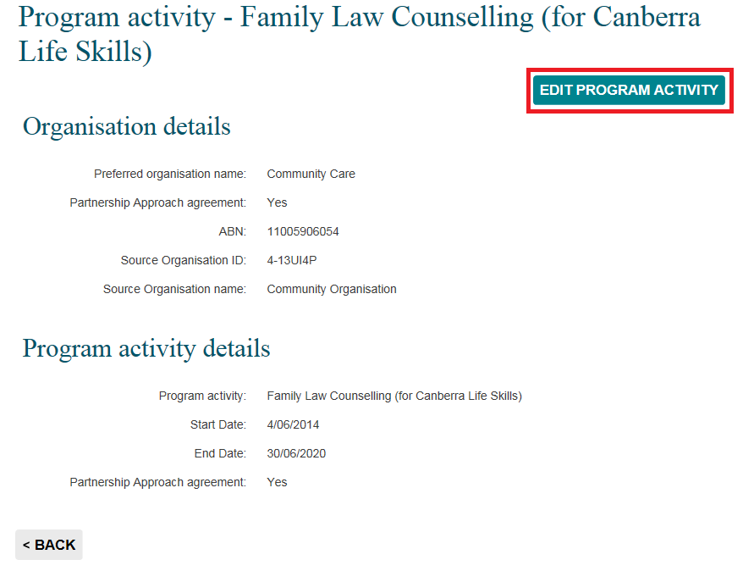
The Edit program activity screen will display. Refer Figure 6.
Change the Partnership approach agreement radio button as required, then select SAVE.
Figure 6 – Edit program activity screen
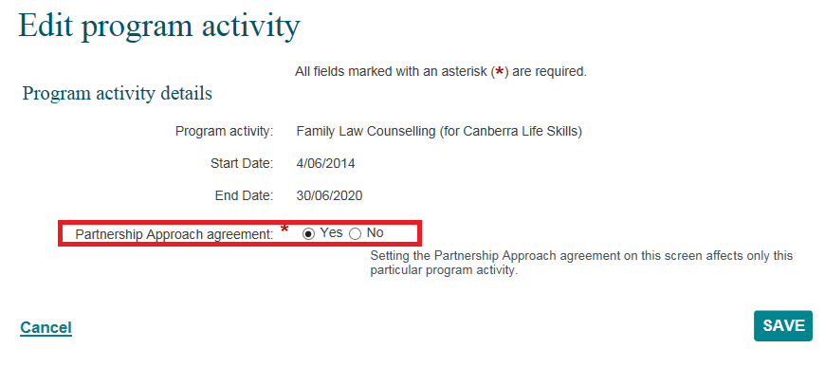

Go to the Data Exchange Protocols and the Training page on the Data Exchange website for more information on outlets, clients, cases and sessions.
For technical support; contact the Data Exchange Helpdesk by email dssdataexchange.helpdesk@dss.gov.au or on 1800 020 283 between 08.30am – 5.30pm (AEST/AEDT) Monday to Friday.

