Preview the story
More information on how to use Qlik can be found at Tutorials - Qlik Sense
Table 1 – Preview story navigation items
ITEM | DESCRIPTION
 | Select the Close button to close the preview.
 | Select the Actions button for options to move back and forward and export.
 | Select the Back button to go to the previous slide in the story.
 | Select the Forward button to go to the next slide in the story.
 | Select the Export button to export the story to PDF or PowerPoint.
 | Select the Play button to play the story.
Select from the required report. The Stories pop up box will display.
Figure 1 – Stories pop up box
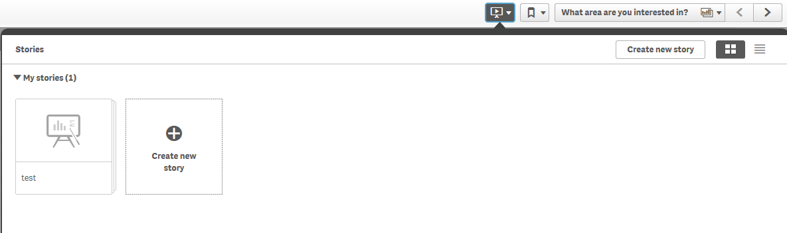

Select the required Story. The story page will display.
Select on the top left of the screen.
Figure 1 – Play your story button
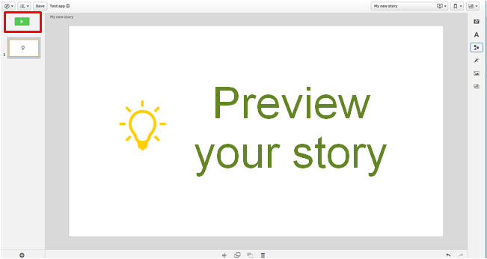
The Story will display.
Figure 2 – Play your story screen
Select at the bottom of the screen.

The sheet navigation buttons will display.
Figure 3 – Play your story sheet navigation buttons
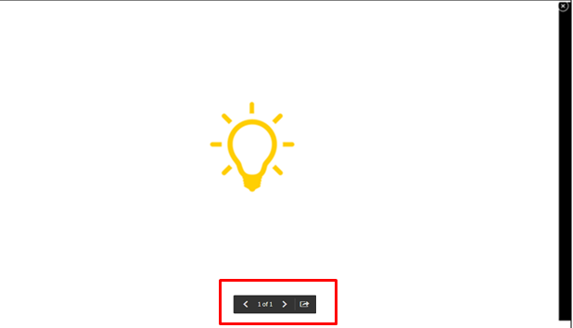

These buttons will allow you to move back and forward through the preview.
Select to export the story to PowerPoint or PDF.
Select to exit the preview.

More information on reporting requirements can be found in the Data Exchange Protocols. Information on reports functionality can be found in the Data Exchange Reports learning module.
For technical support; contact the Data Exchange Helpdesk by email dssdataexchange.helpdesk@dss.gov.au or on 1800 020 283 between 08.30am - 5.30pm (AEST/AEDT) Monday to Friday.

