# Find and edit a session

## **Task card**

This task card discusses the following:

* Information on updating sessions
* Find a Session
  + Method 1 – From the Go to field
  + Method 2 – From the Find Case button
* Results section
* Edit a Session

| **KEY HIGHLIGHTS** |
| --- |
| * At least one session must be recorded during a reporting period for the session and associated clients to be counted in reports. * A session can be updated any time only during the relevant reporting period. * The use of special characters such as * & % # @ should **not** be included in the free text fields as they are used as search functions in the Data Exchange. |

### Information on updating sessions

A session records what service was delivered on a particular date within a reporting period, the type of service delivered and which clients attended. Sessions are a critical part of the service record of a service provider and drive the reporting function of the Data Exchange.

At least **one session** must be recorded as occurring within a reporting period for the session and associated clients to be counted in reports.

### Find a session

There are a number of ways to find an existing session. Refer Figure 1.

Go to the Data Exchange home page and either:

1. Enter information in the **Go to** field
2. Select the **Find Case** action tile

Figure 1 - Data Exchange home page

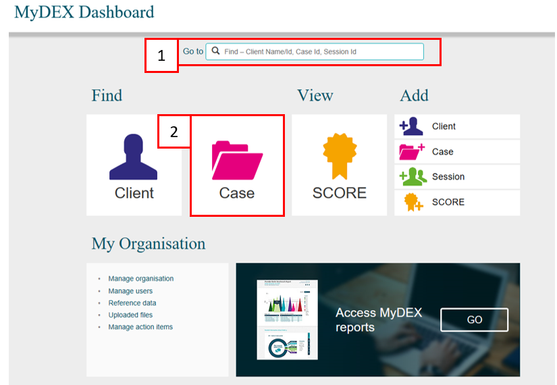

### 

### Method 1 – From the Go to field

Start typing the session ID (this could be numerical or alphabetical) in the **Go to** field

The field will provide a drop down list to select the required session. Refer Figure 2.

**Figure 2 – Data Exchange home page - Go to field**

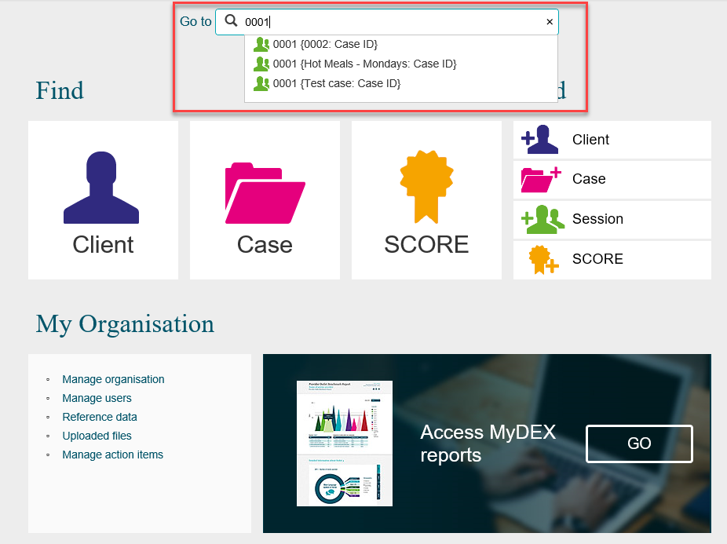

The **Session details** screen will display. Refer Figure 3.

**Figure 3 – Session details screen**

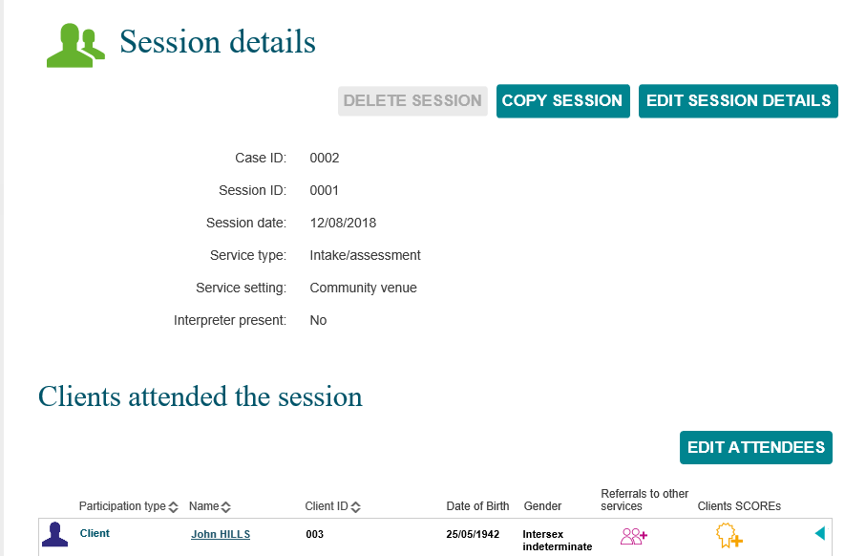

Refer to the Edit a session details in this task card for further instructions.

### 

### Method 2 – from the Find a Case button

The **Find a case** screen will display. Refer Figure 4.

Find your session by selecting the corresponding case

Figure 4 – Find a case screen

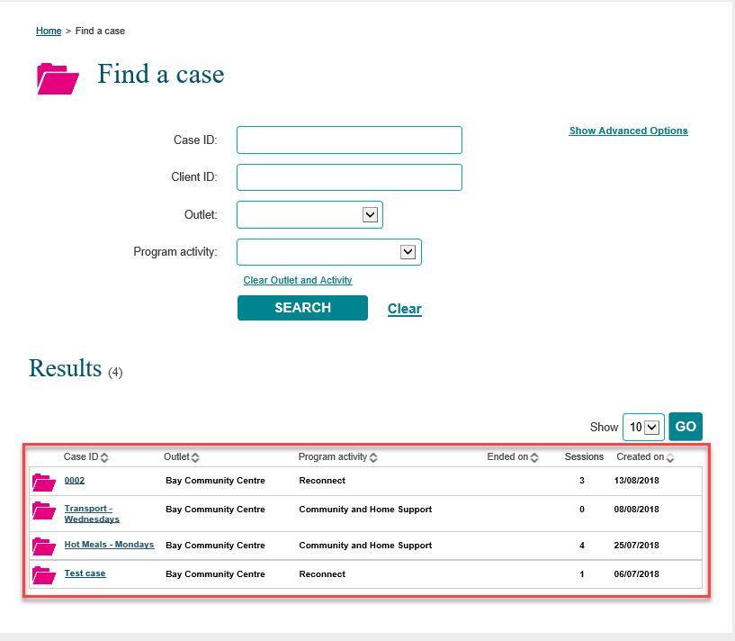

### Results section

The most recently created cases will display in the **Results** section. Refer Figure 5.

1. Select **GO** to change the amount of records displayed on the screen. The options are 10, 20 and 50.
2. Click on the heading hyperlinks of Case ID, Outlet, etc. to filter columns from ascending to descending order and visa-versa either alphabetically or numerically.
3. Click on the case hyperlink to select the case.

**Figure 5 – Results section**

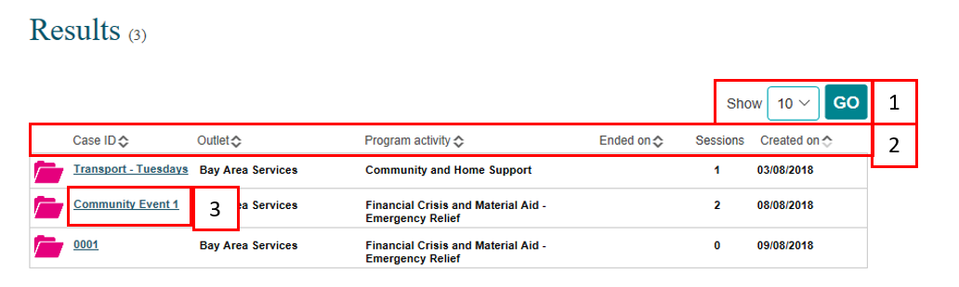

Select the relevant case hyperlink and the **Case details** screen will display. Refer Figure 6.

**Figure 6 – Case details screen**

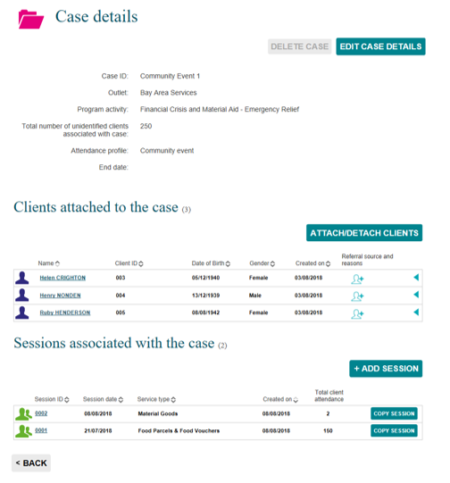

Select the relevant session hyperlink and session details will display. Refer Figure 7.

**Figure 7 – Session screen**

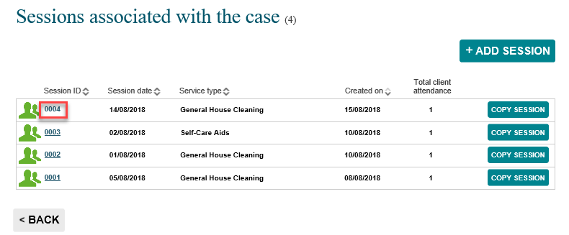

Refer to the Edit a session details in this task card for further instructions.

### Edit a session

There are a number of ways to edit an existing session. Refer Figure 8.

1. Delete a session

**NOTE:** you can only delete a session that is in the current reporting period.

1. Copy a session
2. Edit a session

**NOTE:** The use of Special characters such as * & % # @ should **not** be included in the free text fields as they are used as search functions in the Data Exchange.

1. Edit Attendees

**Figure 8 – Session details screen**

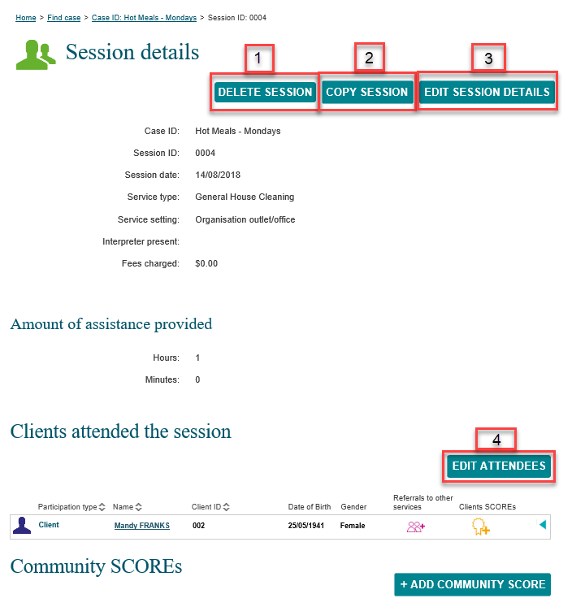

More information on outlets, clients, cases and sessions can be found in the [Data Exchange Protocols](https://dex.dss.gov.au/document/81) and the [Training resources](https://dex.dss.gov.au/training) tab.

For technical support; contact the Data Exchange Helpdesk by email [dssdataexchange.helpdesk@dss.gov.au](mailto:dssdataexchange.helpdesk@dss.gov.au) or on 1800 020 283 between 08.30am - 5.30pm (AEST/AEDT) Monday to Friday.