Export the story
More information on how to use Qlik can be found at Tutorials - Qlik Sense
A story will need to be exported before it can be printed or played outside of the Data Exchange application.
Table 1 –Export options navigation items
Item | Description
 | Select the Export story to PowerPoint icon to send the story to PowerPoint.
 | Select the Export story to PDF icon to send the story to PDF.
 | Select the Duplicate story icon to make a copy of the original story.
 | Select the Delete story icon to remove the story.
 | Select the Help icon to get online help from Sense website with the item that you are viewing.
 | Select the About icon to get information about the application.
 | Select the Menu icon to export the story.
Access the required report and select . The Stories pop up box will display.
Figure 1 – Stories pop up box
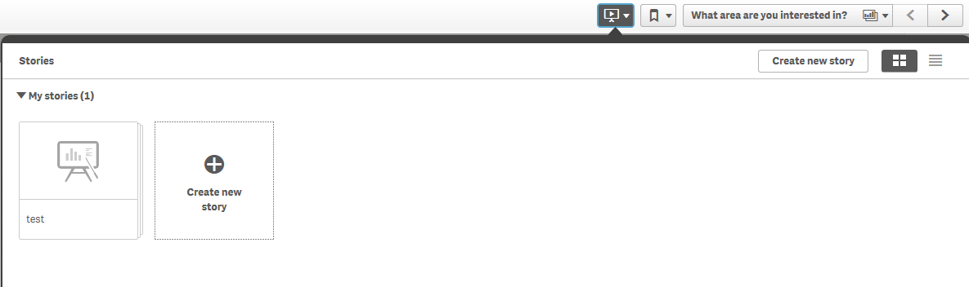

Select the required Story. The story page will display.

Figure 2 – Story page
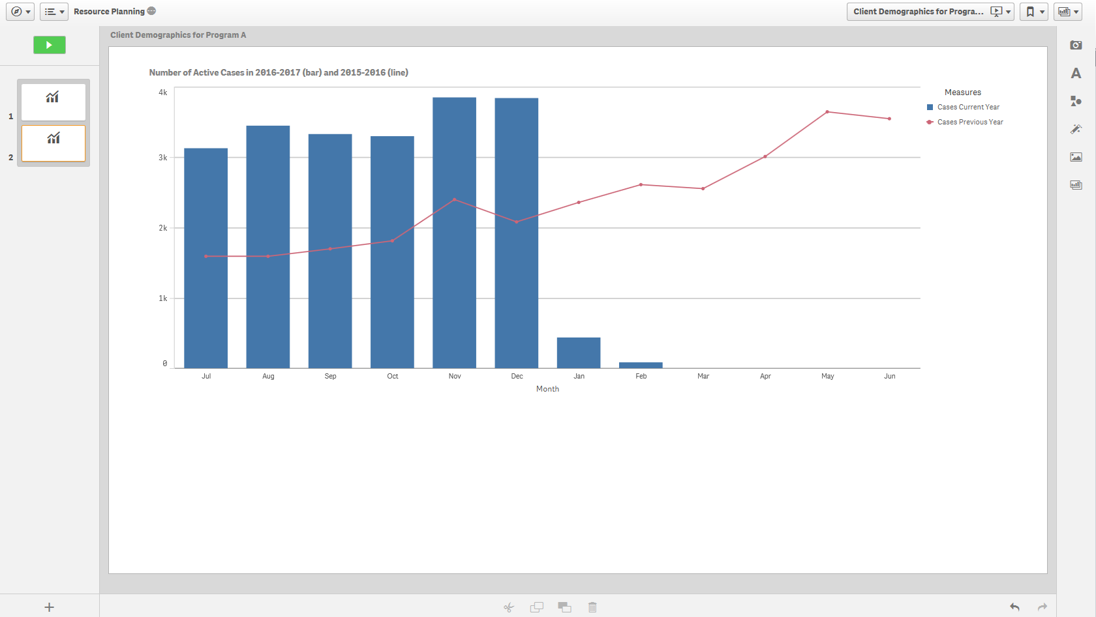
Select at the top left of screen to export the story to PDF or PowerPoint.
Figure 3 – Menu icon selection to export story
The Export story pop up box will display.
Figure 4 – Export story pop up box
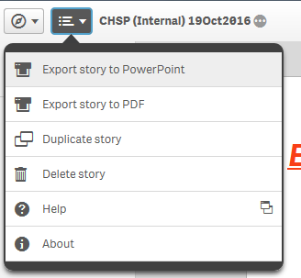

The following options for export are:

- Export story to PowerPoint
Make the appropriate changes to the PowerPoint settings then select .
Figure 5 – PowerPoint settings pop up box
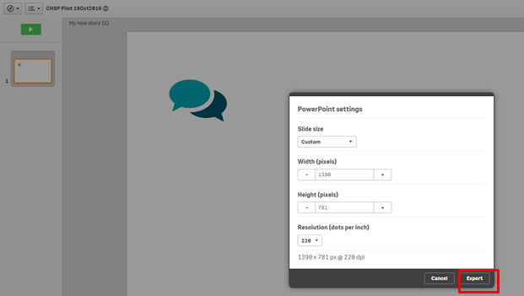

Select the PowerPoint hyperlink that displays.
Figure 6 – Click to download PowerPoint hyperlink
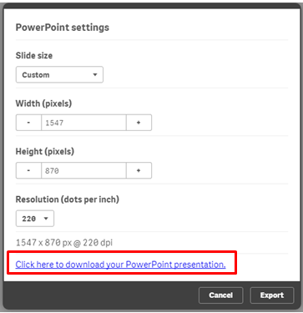

Select the options for the download.
If required, select to stop the download
Figure 7 – PowerPoint download options

- Export story to PDF
Make the appropriate changes to the PDF settings then select .
Figure 8 – PDF settings pop up box
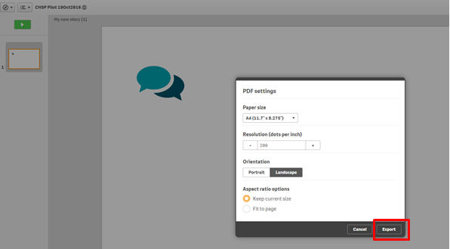

Select the PDF hyperlink that displays.
Figure 9– Click to download PDF hyperlink
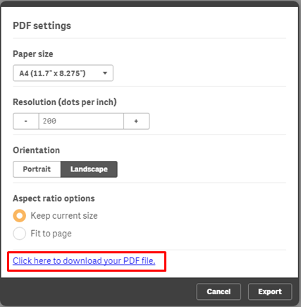

Select the options for the download.
If required, select to stop the download.
Figure 10 – PDF download options

More information on reporting requirements can be found in the Data Exchange Protocols. Task Cards on reports functionality can be found on the Data Exchange Reports tab.
For technical support; contact the Data Exchange Helpdesk by email dssdataexchange.helpdesk@dss.gov.au or on 1800 020 283 between 08.30am - 5.30pm (AEST/AEDT) Monday to Friday.

