Add shapes
More information on how to use Qlik can be found at Tutorials - Qlik Sense

Add shapes to the story
The Data Exchange reports allows you to Add shapes to the story by using the Shapes library.
Access the required report and select 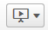. The Stories pop up box will display.
Figure 1 – Stories pop up box
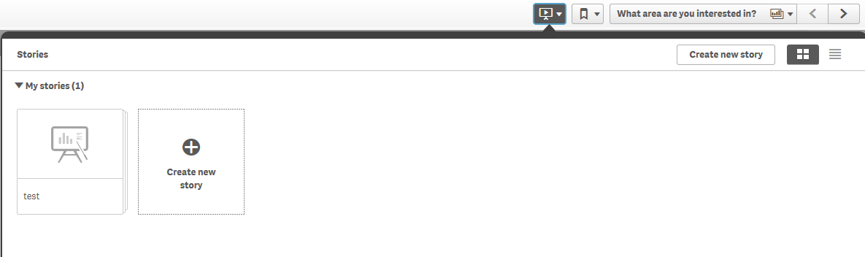

Select the required Story. The story page will display.
Figure 2 – Story page
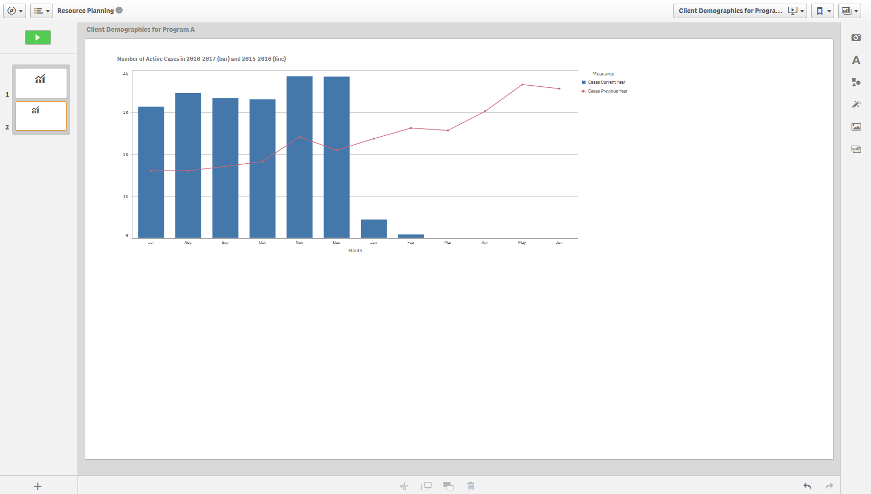
Add shapes to the story page by selecting within the functions bar found on the right-hand side of the story page.

The Shapes library pop up box will display.
Figure 3- Shapes library pop up box
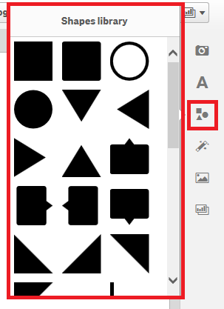
Click and drag or double click on the desired shape to add it to the story page.
Figure 4 – Add shapes to the story pop up box
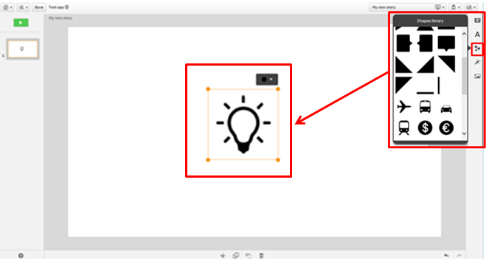
Use the to resize or move the shape anywhere on the page.
Select 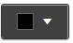 to edit the colour of the shape.
The confirms your colour selection.
Figure 5 – Edit the shape colour menu
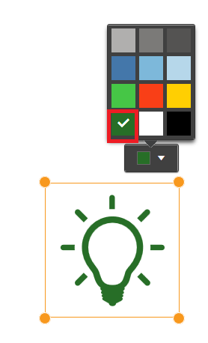
More information on reporting requirements can be found in the Data Exchange Protocols. Further information on reports functionality can be found in the Data Exchange Reports learning module.
For technical support; contact the Data Exchange Helpdesk by email dssdataexchange.helpdesk@dss.gov.au or on 1800 020 283 between 08.30am - 5.30pm (AEST/AEDT) Monday to Friday.

