# Add items to a story

More information on how to use Qlik can be found at [Tutorials - Qlik Sense](https://help.qlik.com/en-US/sense/2.2/Content/Tutorials.htm)

Add items to a story

The Data Exchange reports allow you to add different items to a story, this can include animations, media, shapes, sheets (pages), snapshots and text.

Table 1 – Add a new My story navigation icons

| **ITEM** | **DESCRIPTION** |
| --- | --- |
| Play button | Select the **Play** button to play your story. |
| Camera icon | Select the **Camera icon** to select an image from your snapshots to insert into your story. |
| A icon to insert text | Select the **A** icon to insert text into your story. |
| Shapes icon | Select the **Shapes** icon to select different shapes to insert into your story. |
| Animation icon | Select the **Animation** icon to animate your shape or image in your story. |
| Media icon | Select the **Media** icon to select media objects to insert into your story. |
| Add slide button | Select the **Add slide** button to add a new slide to your story. |
| cut icon | Select the **Cut** icon to remove an item from your story slide. |

Access the required report and select This is a screen shot of the story icon which you would select to start a story.. The **Stories** pop up box will display.

Select the required **My stories** tile.

Figure 1 – Stories drop down arrow and My stories tile

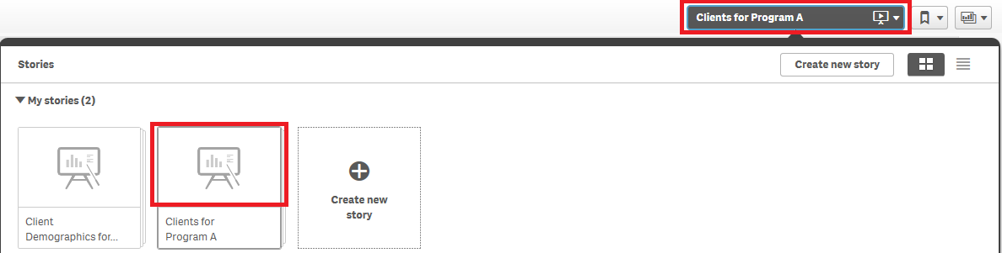

The **Story** page will display.

Figure 2 – Create a Story sheet

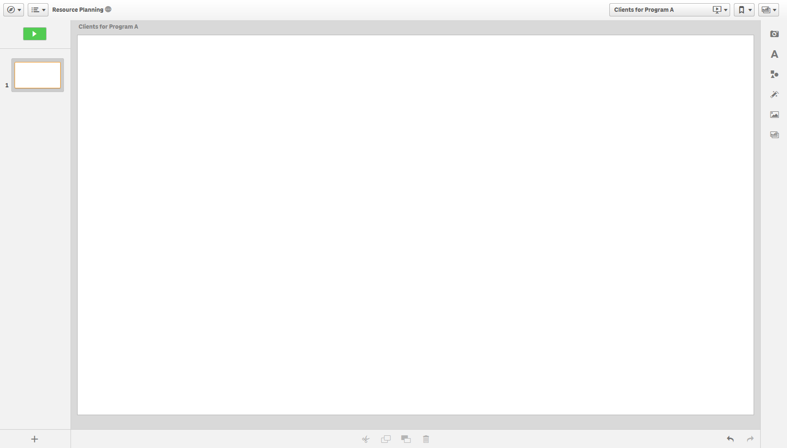

Add items to the story as required by selecting the appropriate icon.

Figure 3 – Add items icons (Refer Table 1)

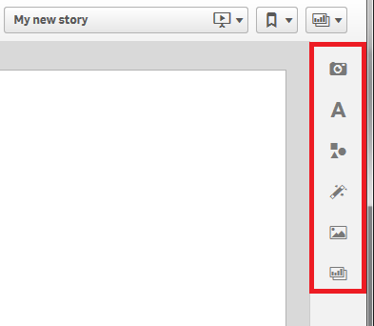

More information on reporting requirements can be found in the [Data Exchange Protocols.](https://dex.dss.gov.au/document/81) Further information on reports functionality can be found in the [Data Exchange Reports](https://dex.dss.gov.au/document/746) learning module.

For technical support; contact the Data Exchange Helpdesk by email [dssdataexchange.helpdesk@dss.gov.au](mailto:dssdataexchange.helpdesk@dss.gov.au) or on 1800 020 283 between 08.30am - 5.30pm (AEST/AEDT) Monday to Friday.