Add animations
More information on how to use Qlik can be found at Tutorials - Qlik Sense

Add animations to a story
The Data Exchange allows you to Add animations to your story by using the Effects library. These visual effects can only be used on bar charts, line charts and pie charts.
Table 1 – Effects library navigation items
Item | Description
 | Select the Highest value icon effect will make the highest value stand out by adding a label to the highest value and dimming the other values. For visualizations with grouped values, the highest value in each group will be highlighted
 | Select the Lowest value icon effect will make the lowest value stand out by adding a label to the lowest value and dimming the other values. For visualizations with grouped values, the lowest value in each group will be highlighted.
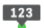 | Select the Any value icon effect will make a value, that you select manually, stand out by adding a label to the selected value and dimming the other values. For visualizations with grouped values, you can choose to highlight either a measure or a dimension. The selected measure or dimension will be highlighted in all the groups where it occurs.
 | Select to replace the image with another snapshot item in your Stories library.
 | Select to edit the image.
 | Select lock to prevent any changes being made to the snapshot.
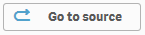 | Select to go to the originating sheet source of the snapshot.
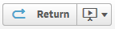 | Select to return to the Story that you are creating.

Access the required report and select 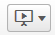. The Stories pop up box will display.
Access the required Stories tile.
Figure 1 – Stories drop down arrow and My stories tile
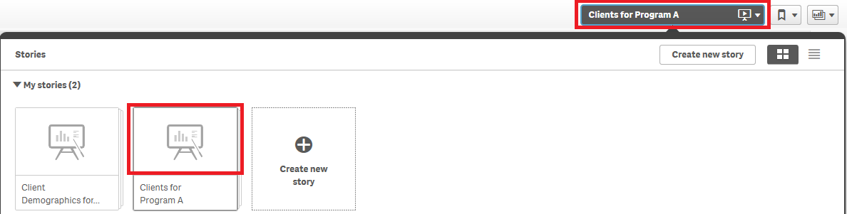

The Story page will display.
Figure 2 – Story sheet with snapshot
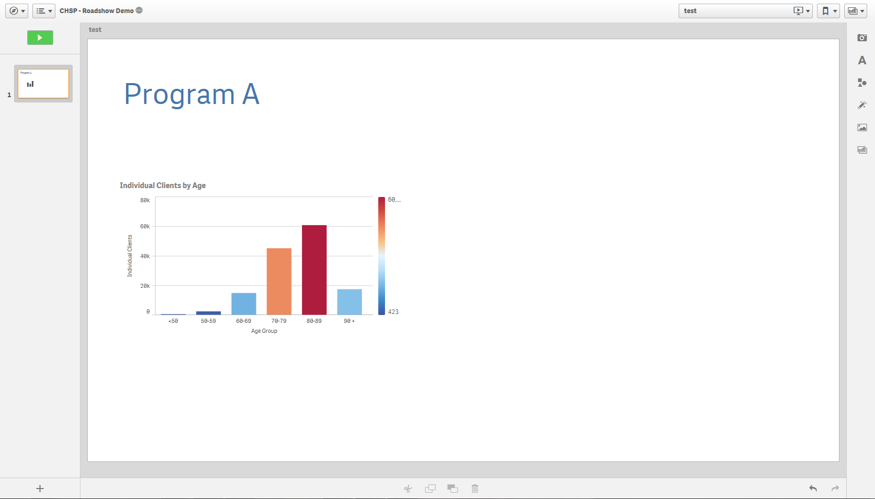
Select the icon on the right of the Story page.
The Effects library pop up box will display.
Figure 3 – Effects library pop up box
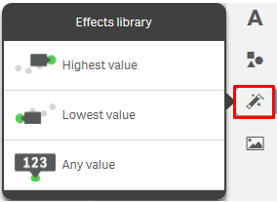

Click and drag the selected effect onto the snapshot.
The snapshot will display with the effect applied.
- The Highest value will apply a highlight and label to the column of the graph with the highest value and dim the other values.
Figure 4 – Highest value effects applied to snapshot
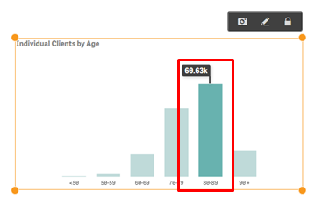

- The Lowest value will apply a highlight and label to the column of the graph with the lowest value and dim the other values.
Figure 5 – Lowest value effects applied to snapshot
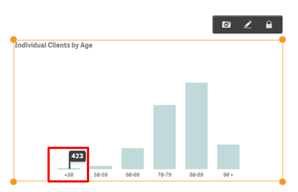

- The Any value will apply a highlight and label to the selected column of the graph and dim the other values.
Figure 6 – Any value effects applied to snapshot
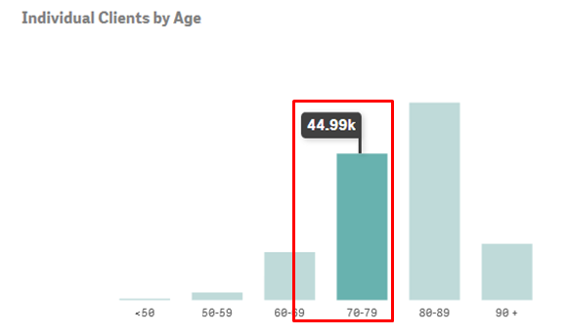

Click on the image to change the data item highlighted.
The Select data point pop up box will display.
Select the drop down arrow in the Select data point pop up box to change the value selection.
Figure 7 – Select data point pop up box
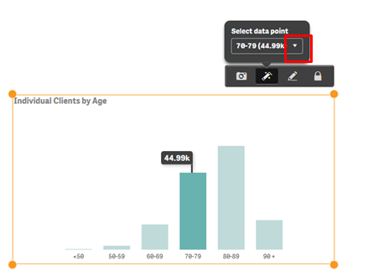

A pop up box will display with the items available in the image that can be selected.
Figure 8 – Select data point pop up box
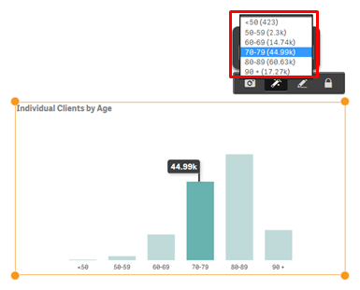

Select the required data point item, and the item will automatically update.
Figure 9 – Select data point pop up box
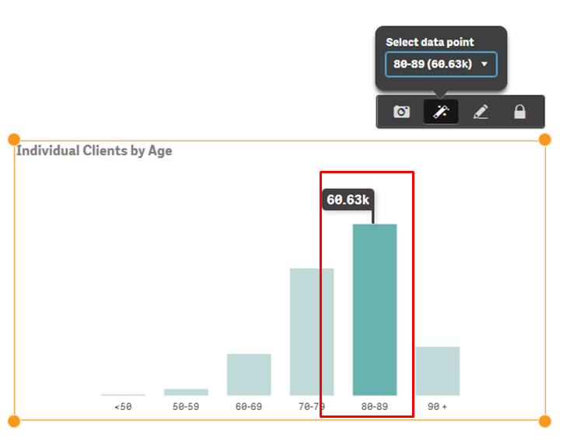
More information on reporting requirements can be found in the Data Exchange Protocols. Further information on reports functionality can be found in the Data Exchange Reports learning module.
For technical support; contact the Data Exchange Helpdesk by email dssdataexchange.helpdesk@dss.gov.au or on 1800 020 283 between 08.30am - 5.30pm (AEST/AEDT) Monday to Friday.

