Add a SCORE assessment

This task card discusses the following:
- What is SCORE?
- Client SCORE or Community SCORE
- SCORE icons
- Add a client SCORE
  - Method 1 – Add SCORE in an existing session
  - Method 2 – After adding a session
  - Method 3 – From the Client ID field in the View SCORE section
  - Method 4 – From the Add SCORE field in the View SCORE section
- Add a Community SCORE
  - Step 1 – Select the session
  - Step 2 – Enter assessment details

KEY HIGHLIGHTS
- SCORE helps tell the story of what has been achieved for a client / group / community as a result of service delivery.
- You do not need to record SCORE assessments against each domain listed; only those applicable to the client.
- SCOREs should be recorded using the same domain to measure the changes experienced by clients over time.
- It is optional to record how the SCORE was assessed.

What is SCORE?
SCORE stands for Standard Client/Community Outcomes Reporting. It forms part of the Data Exchange partnership approach.

Client SCORE or Community SCORE
There are four different types of outcomes measured through SCORE to help tell the story of what has been achieved for an individual client and/or group/community activities. The SCORE components for individual clients are:
- Circumstances
- Goals
- Satisfaction

Once a session is recorded, an individual client SCORE can be added. If you wish to add a SCORE assessment for each client involved in the session, each assessment must be entered separately.

An individual client SCORE assessment should be recorded at least twice, towards the beginning of service delivery and again towards the end. Numerous SCORE assessments can be added if the client will be accessing the activity long term. These SCOREs should be recorded using the same domain to measure the changes experienced by clients over time.

The SCORE component for group / community activity is:
- Community
The Community component has been designed to report outcomes being achieved for large group where it is not feasible to record changes for individuals. Community SCOREs is recorded in a similar way to client SCOREs.
You do not need to record SCORE assessments against each domain listed. Select the domains that are relevant for the client at the time of the assessment.

SCORE icons
Table 1 details the various SCORE icons and their meanings.
Table 1 – SCORE icons and their meanings
FIELD | DESCRIPTION
 | The SCORE ‘outline’ icon displays on a client record summary attached to a session. You can use this icon to add, delete or edit SCORE assessment types (Goal, Circumstance or Satisfaction) for a client resulting from a session.
 | The SCORE ‘coloured’ icon displays when one SCORE assessment has been added to a client record at a session and another SCORE assessment can be added.
 | The SCORE ‘tick’ icon displays when the full quota of (two) SCORE assessments have been added to a client record at a session.
 | The SCORE icon displays on a client record advising a SCORE assessment has been added to the client. Displays in the Find a client screen.

Add a client SCORE
There are a number of methods to add an individual client SCORE assessment:
- Method 1 – adding a SCORE in an existing session
- Method 2 – after adding a session
- Method 3 – from the Client ID field in the View SCORE section
- Method 4 – from the Add SCORE field in the View SCORE section

Method 1 – Adding a SCORE in an existing session
From the home page select the Add SCORE icon. Refer Figure 1.
Figure 1 – Data Exchange home page
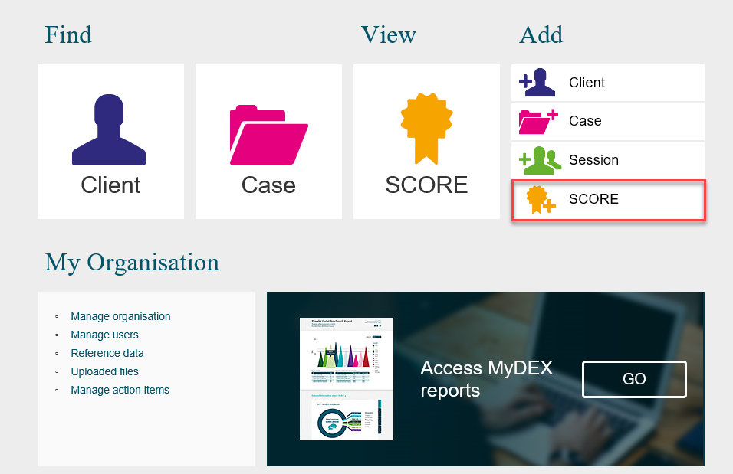
The Add a SCORE – Find a client screen will display. Refer Figure 2.
- Select the outlet the client attended the service at
- Select the activity that will be associated with the session.
Figure 2 – Add a SCORE – Find a client - Add outlet and activity
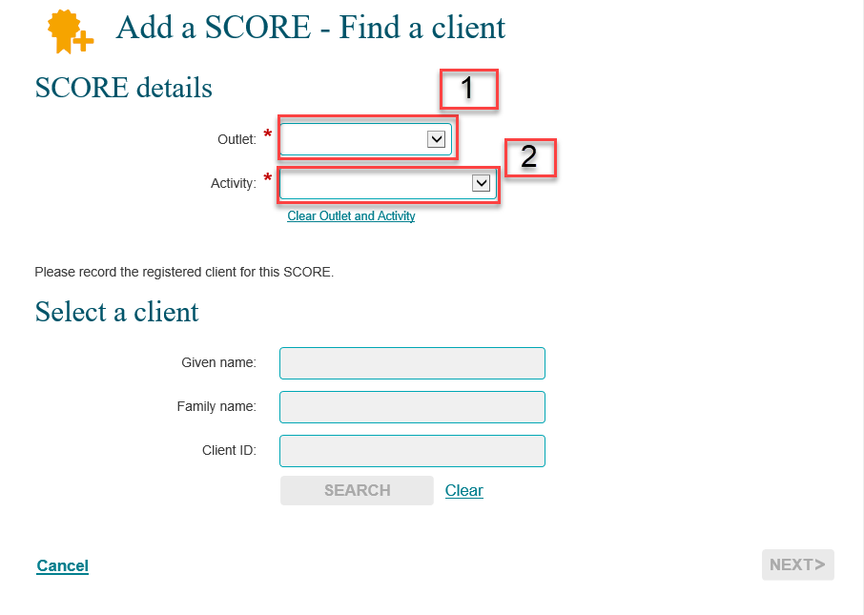
Once you have selected the Outlet and the Activity you are able to search for the Client by entering given name, family name or client ID in the Select a Client fields and select SEARCH. Refer Figure 3.
Figure 3 - Find a client
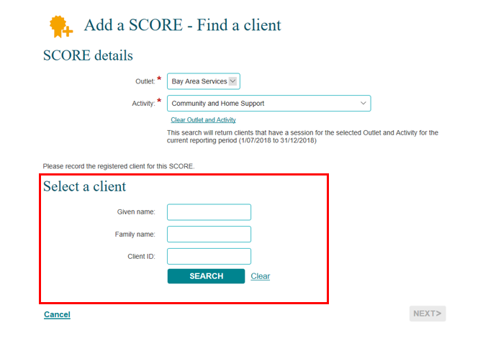

Select the client using the tick box and click NEXT>. Refer Figure 4.
Figure 4 - Select client tick box
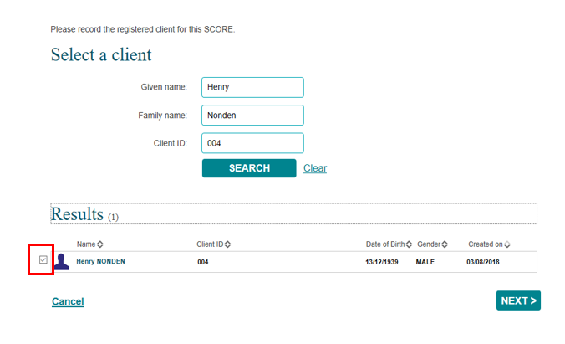

The Add a SCORE – Find a session screen will display. Refer Figure 5.
Figure 5 – Add a SCORE – Find a session screen
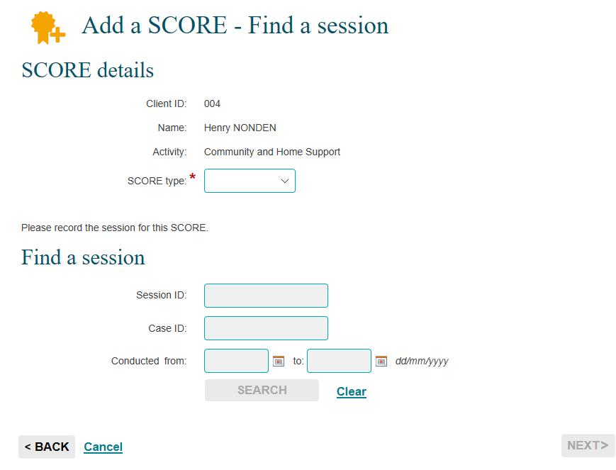

Note: There is no longer reference to ‘pre’ and ‘post’ SCOREs in the web-based portal. The Data Exchange system will recognise which SCORE assessment has been recorded first by the date and time the assessment was recorded or added in the web-based portal. Refer Figure 18.

Select the SCORE type from the drop down. Refer Figure 6.
Figure 6 –Selecting SCORE type
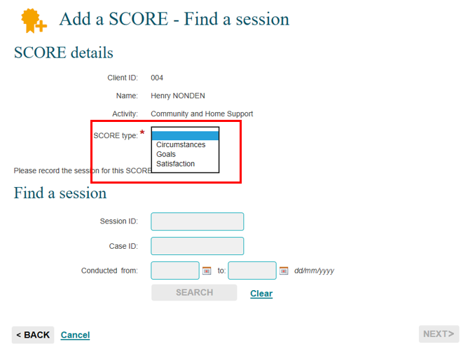

Select SEARCH to find the session to record the SCORE against.
The sessions that are associated with the client will display. Refer Figure 7.
Select the session that the SCORE is to be recorded against by clicking in the box and then selecting NEXT.
Figure 7 – Session selected
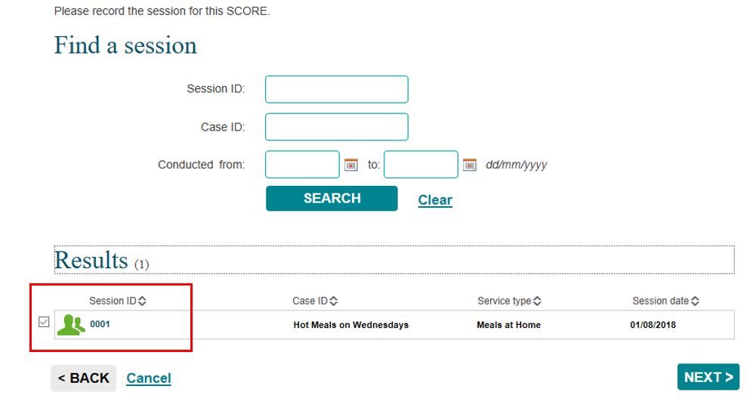

The Add a SCORE – Client SCORE details screen will display. Refer Figure 8.
- The client’s case and session details will display along with an optional Assessed by field. Refer Table 2.
- The domains that relate to the SCORE type will display.
- For each domain there will be a numerical rating value of 1 to 5.
- To view a description of the ratings select the definitions hyperlink in the top right hand corner of the domains table.
Figure 8 – Add a SCORE – Client SCORE details screen
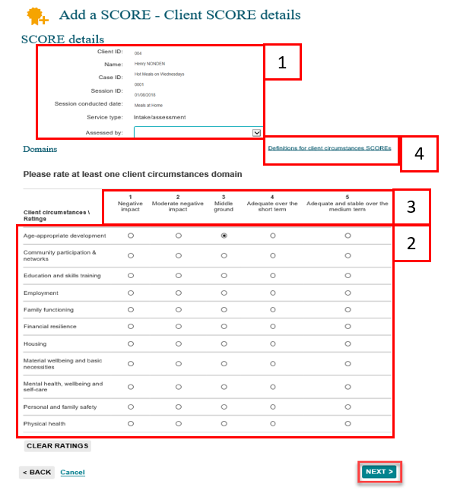

Table 2 – Assessed by field (Refer Figure 8)
FIELD | DESCRIPTION
Assessed by | Select the appropriate assessed by for the client. The different options are:  - SCORE directly – client  - SCORE directly – practitioner  - SCORE directly – joint  - SCORE directly – support person  - Validated outcomes tool - client  - Validated outcomes tool - practitioner  - Validated outcomes tool - joint  - Validated outcomes tool – support person

Select the rating against the corresponding domain and select NEXT.

The Add a SCORE – Review screen will display detailing the SCORE type, domains and ratings selected. Refer Figure 9.
Figure 9 – Add a SCORE - Review screen
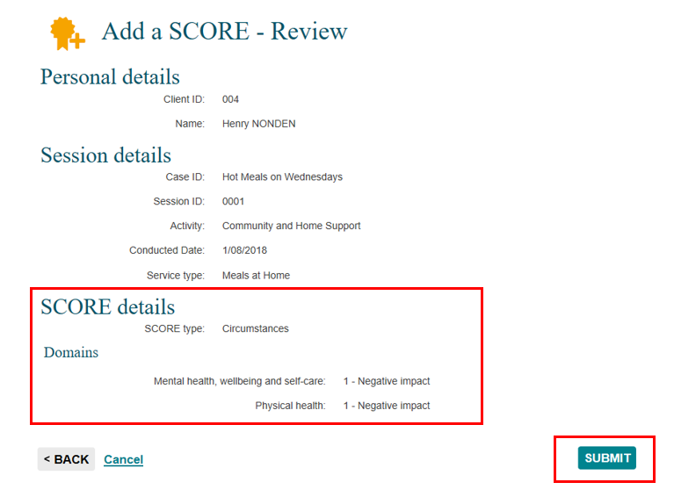
Select SUBMIT.
The Add a SCORE – Finish screen will display. Refer Figure 10.
Figure 10 – Add a SCORE - Finish screen
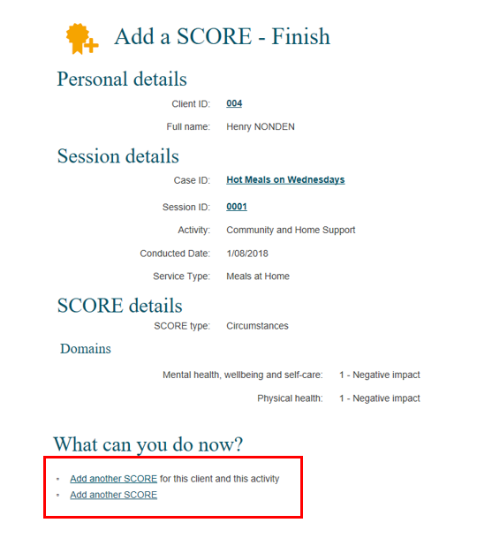

Under the “What can you do now?” heading, you can Add another SCORE for this client and this activity or Add another SCORE for a different client.

When you go to the Find a client screen, the client record will display the icon that indicates that a SCORE assessment has been recorded for this client. Refer Figure 11.
Figure 11 - Find a client - SCORE assessment made icon
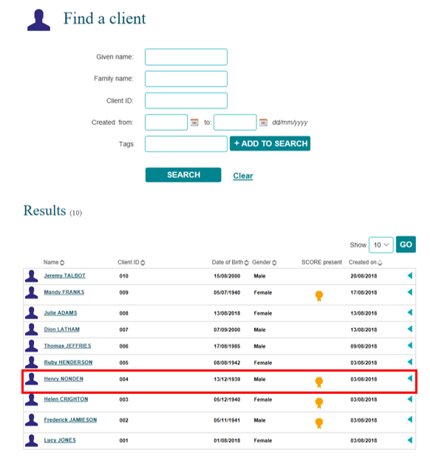

Method 2 - After adding a session
When you have completed adding a session the Add a session – Finish screen will display. Refer Figure 12.
Select the Session ID hyperlink to start to add a SCORE assessment.
Figure 12 – Add a session – Finish screen
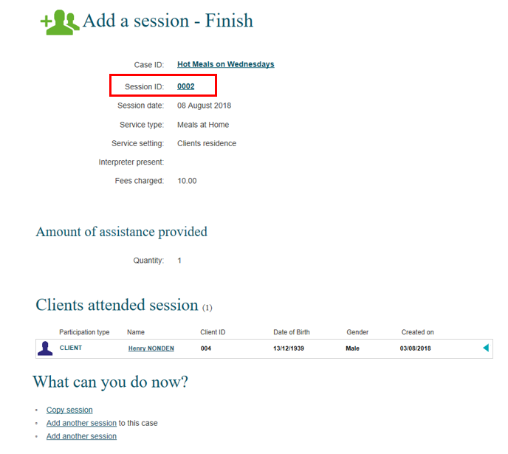
The Session details screen will display. Refer Figure 13.
Figure 13 – Session details screen
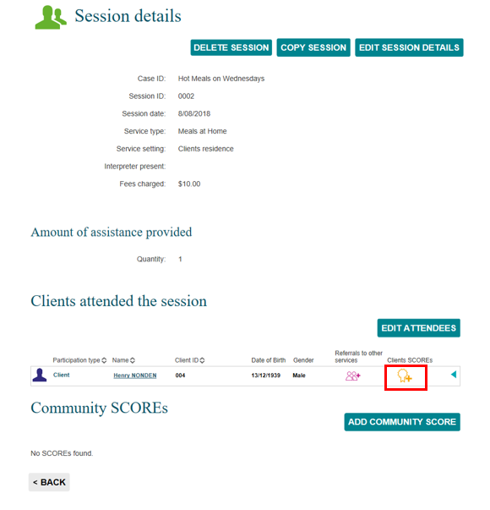
Select the Client SCOREs icon.

The Add client SCORE screen will display. Refer Figure 14.

Select the corresponding SCORE type form the drop down list.
Figure 14 - Add client SCORE – SCORE type
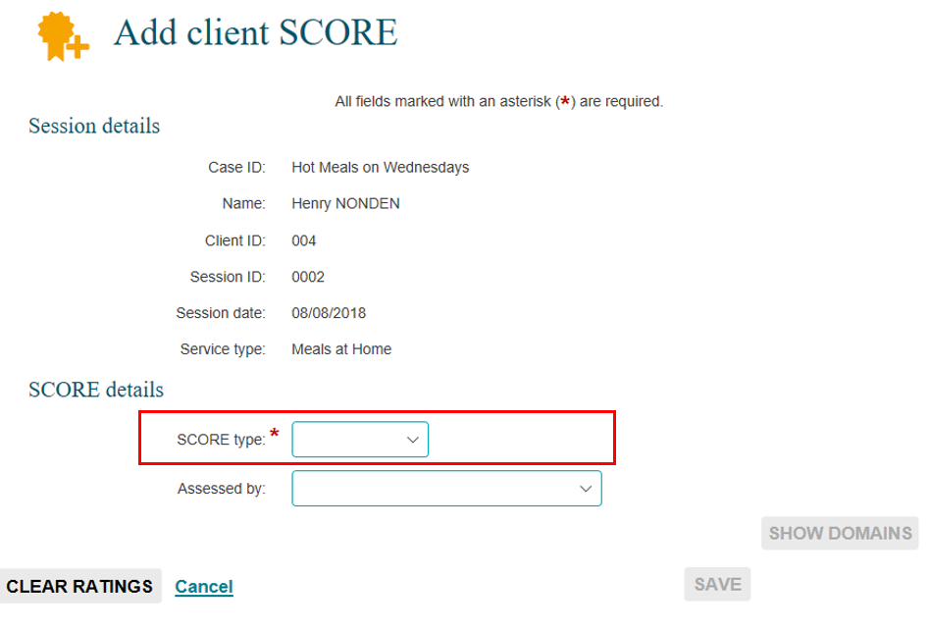
Select the Assessed by drop down arrow to select how the assessment was made. Refer Figure 15.
Figure 15 - Add client SCORE - Assessed by field
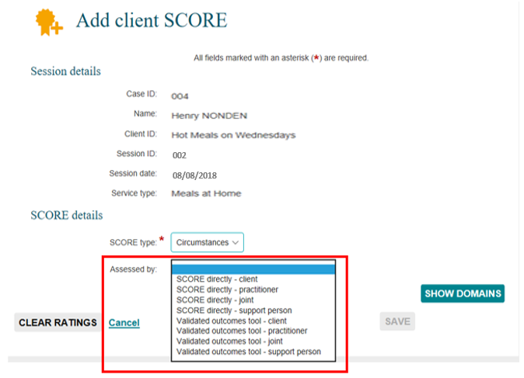
Select SHOW DOMAINS. Refer Figure 16.
- The domains that relate to the SCORE type will display.
- For each domain there will be a numerical rating value of 1 to 5.
- To view a description of the ratings select the definitions hyperlink in the top right hand corner of the domains table.
Figure 16 - Add client SCORE – Domains section
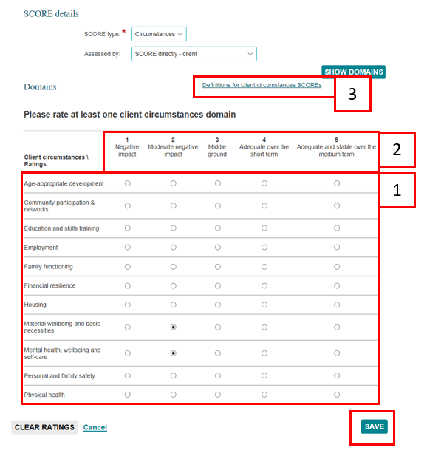
Select SAVE.
The Session details screen will display. Refer Figure 17.
Figure 17 – Session details screen with Client SCORE assessment made
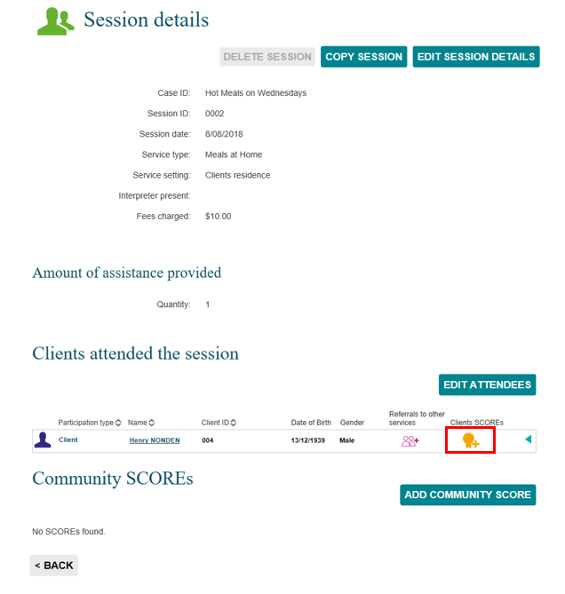
Select to expand and collapse to view the completed SCORE assessment. Refer Figure 18.
The SCORE assessments recorded will display. If two SCORE assessments are recorded for the one SCORE component i.e. Circumstances, the second SCORE will display with the number (2) after the SCORE component name. This will be counted as the ‘post’ SCORE.
Figure 18 – Session details – SCORE details section
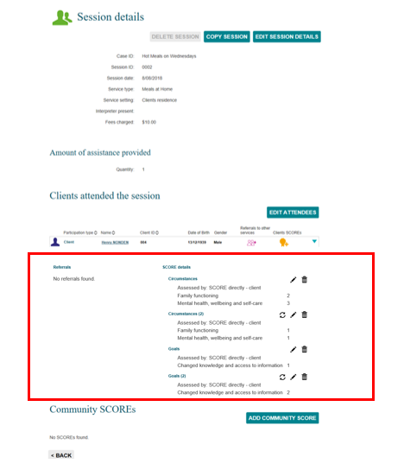

Method 3 – from the Client ID field in the View SCORE section
From the Data Exchange web-based portal home page, select the View SCORE tile. Refer Figure 19.
Figure 19 - Data Exchange home page
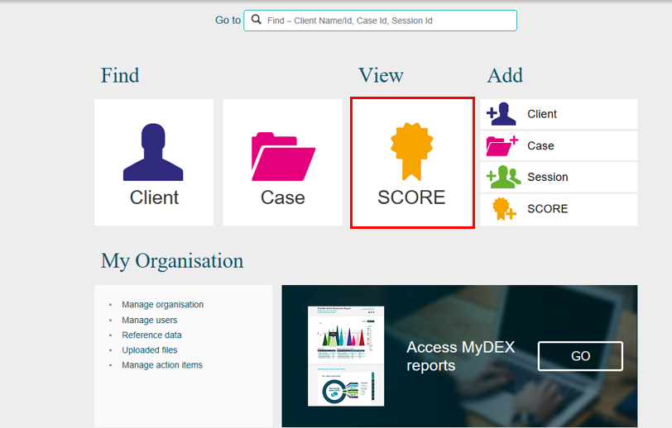
The View client SCORE screen will display. Refer Figure 20.
Figure 20 – View client SCORE screen
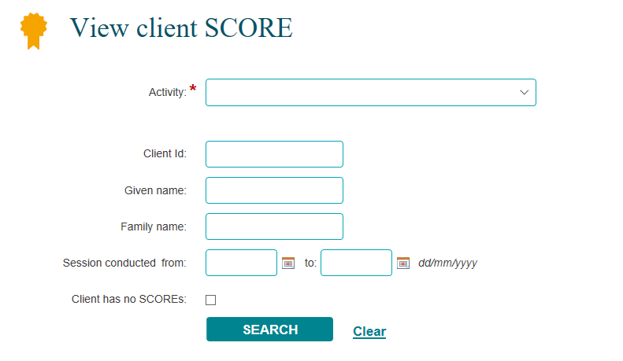
Refer Figure 21.
- Select the relevant Activity from the drop down list.
- Select SEARCH.
- The Client IDs will display under the Results section.

Figure 21 – Selecting relevant items on the View client SCORE screen
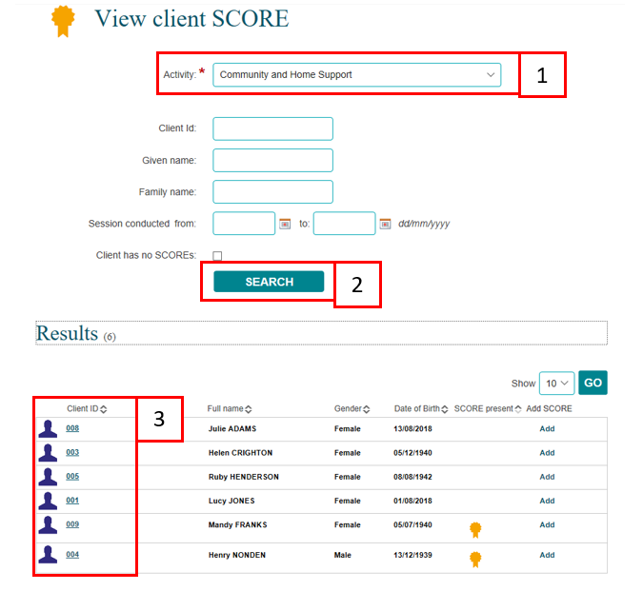
Select the relevant Client ID hyperlink. Refer Figure 22.
Figure 22 – Select relevant Client ID hyperlink
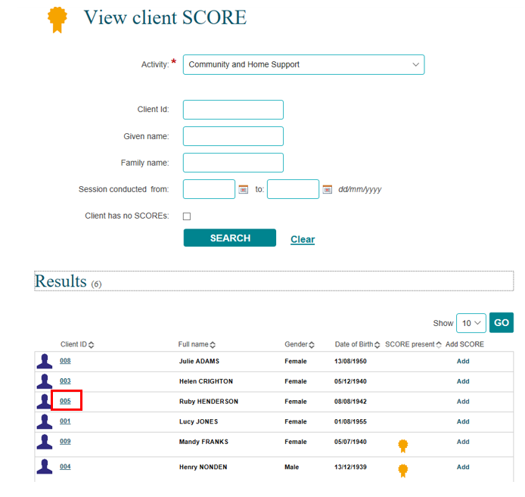
The Client profile screen will display. Refer Figure 23.
The cases that the client has been attached to for this activity will display under the Cases heading.
The most recent sessions that the client has attended for those cases will display under the Sessions heading.
Select at the top of the column/s to sort the records.
Figure 23 – Client profile screen
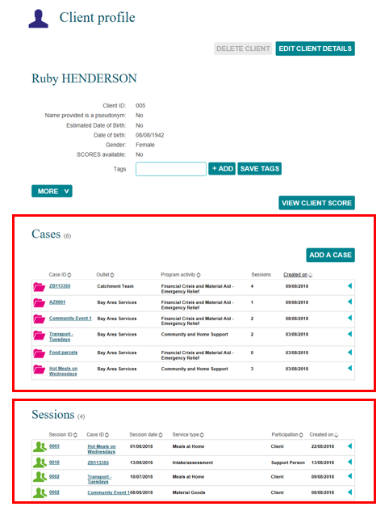

Select the Session ID hyperlink where the SCORE assessment is to be added. Refer Figure 24.
Figure 24 – Session ID hyperlink
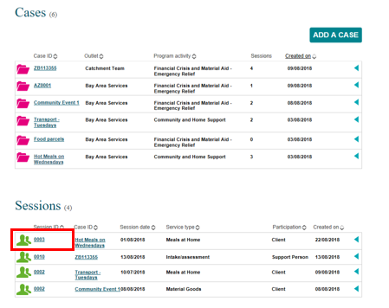
The Session details screen will display. Refer Figure 25.
Figure 25 – Session details screen
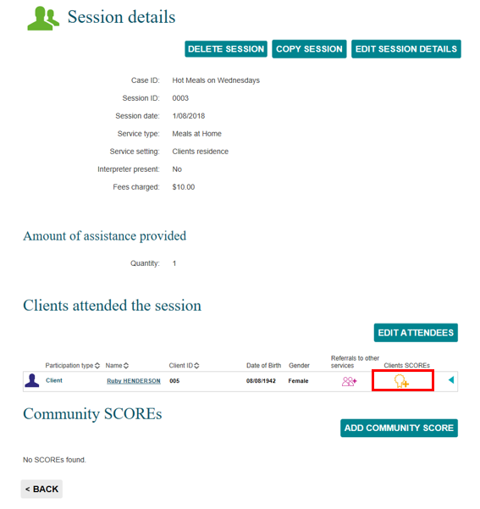
Find your client (if more than one).
Select to add a SCORE assessment. The Add client SCORE screen will display. Refer Figure 26.
Figure 26 – Add client SCORE screen
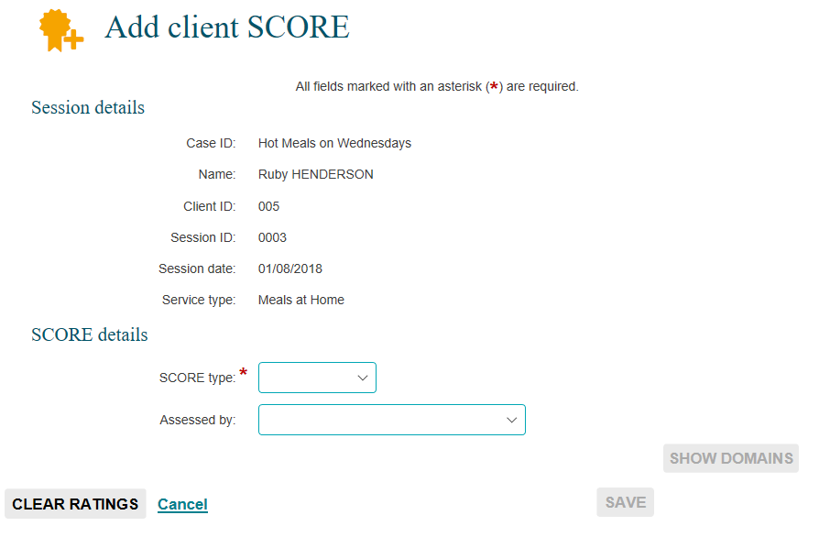
Refer to the Method 2 from the Add client SCORE screen on page 10 on how to add a SCORE assessment from this screen.

Method 4 – from the Add SCORE field in the View SCORE section
From the Data Exchange web-based portal home page, select the View SCORE tile. Refer Figure 27.
Figure 27 - Data Exchange home page
The View client SCORE screen will display. Refer Figure 28.
Figure 28 – View client SCORE screen
Refer Figure 29.
- Select the relevant Activity from the drop down list.
- Select SEARCH.
- The Client IDs will display under the Results section.

Figure 29 – Selecting relevant items on the View client SCORE screen
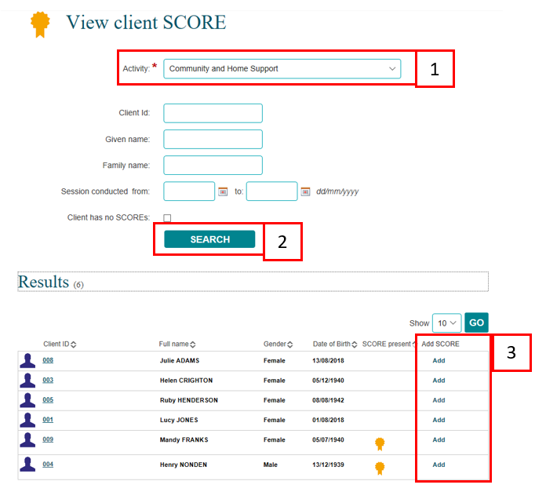

Select the Add hyperlink for the relevant client from the View client SCORE screen. Refer Figure 30.
Figure 30 – View client SCORE screen – Add SCORE hyperlink
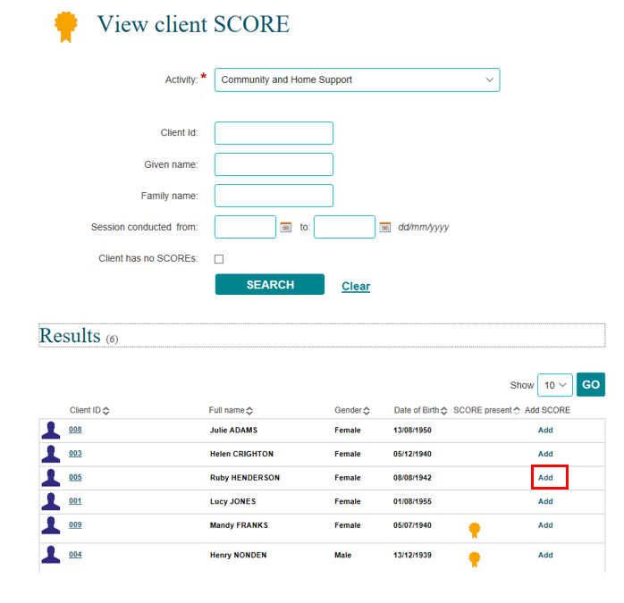

The Add a SCORE – Find a session screen will display. Refer Figure 31.
Figure 31 – Add a SCORE – Find a session screen
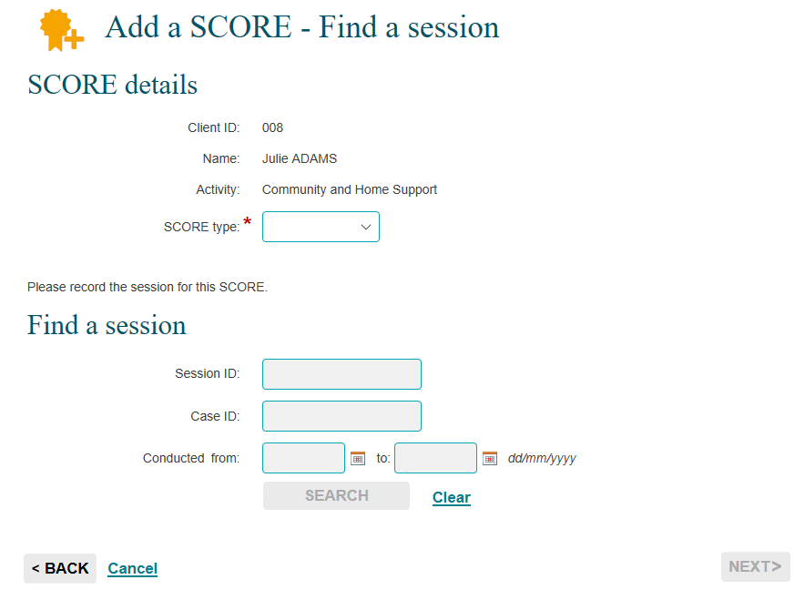

Refer to the Method 1, Add a SCORE – Find a session on page 4 on how to add a SCORE assessment from this screen.

Add a Community SCORE
A Community SCORE can be added to any community case session that has been created. Refer to the Add a case and Find and edit a case task cards if required.
The Community SCORE is linked to three ratings which reflect changes that may occur for a group or community rather than individual clients. Community SCORE uses the same 1 to 5 numerical value scale as client SCOREs.

Step 1 – Select the session
You can add a Community SCORE after adding a session or by selecting the session from within a case.
Open the session record.
Select ADD COMMUNITY SCORE.
The Add community SCORE screen will display. Refer Figure 32.

Step 2 – Enter assessment details
Figure 32 - Community SCORE table
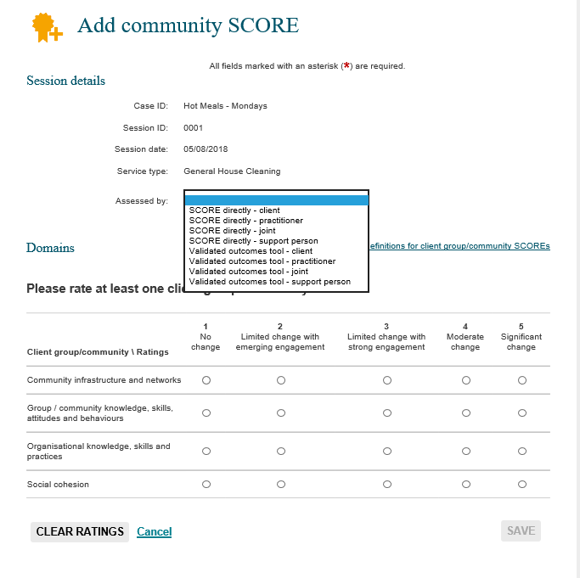
Select the Assessment by if required, from the drop down box.
The domains within the Community SCORE will display.
For each rating there will be a numerical value of 1 to 5.
Select a numerical value for one or all three ratings in the Community domain, then select SAVE.
The ratings and numerical values chosen will be listed under the client record on the Community SCOREs section. Refer Figure 33.
Figure 33 – Community score ratings

More information on SCORE and the Data Exchange can be found in the Data Exchange Protocols.
For technical support; contact the Data Exchange Helpdesk by email dssdataexchange.helpdesk@dss.gov.au or on 1800 020 283 between 08.30am - 5.30pm (AEST/AEDT) Monday to Friday.

