Log in to the Data Exchange web-based portal
Task card
This task card discusses the following:
- Before accessing the Data Exchange
- First time accessing the Data Exchange
  - Step 1 – Request access to the Data Exchange
  - Step 2 – Log in to the Data Exchange
  - Step 3 – Digital Identity Login screen
  - Step 4 – Login for the first time
  - Step 5 – Accept the code
  - Step 6 – Provide consent
  - Step 7 – Request activation code
  - Step 8 – Confirm activation code
  - Step 9 – Finish screen
  - Step 10 – Data Exchange web-based portal home page
KEY HIGHLIGHTS
- You must have a Digital Identity (myGovID) before you request access to the Data Exchange.
- The first person accessing the Data Exchange must complete a User Access Request form and send to the Helpdesk before they can create additional users in the Date Exchange web-based portal.
- The account activation process for the Data Exchange needs to be completed once by all users.
- Please Note: Internet Explorer is no longer a supported browser for logging into the Data Exchange. Please choose an alternative web browser such as Microsoft Edge, Chrome etc.

Before accessing the Data Exchange
Before requesting a Data Exchange web-based portal user account, you must have a Digital Identity (myGovID) linked to your organisation though the Relationship Authorisation Manager (RAM).
The principal authority within the organisation needs to link your organisation to an Australian Business Number (ABN) in Relationship Authorisation Manager (RAM). Once linked, they can set up authorisations for employees and others to act on behalf of the business.
Once you have linked your Digital Identity (myGovID) to a business, you can access selected government online services, such as the Data Exchange, using Digital Identity (myGovID).

Accessing the Data Exchange for the first time
All users accessing the Data Exchange web-based portal for the first time with their Digital Identity (myGovID) must complete the following account activation steps. The account activation process only needs to be completed once. As a returning user, you will only need to complete steps 2, 3, 4 and 5.

Step 1 – Request access to the Data Exchange
The first person accessing the Data Exchange on behalf of an organisation must complete a User access request form and submit it to the Data Exchange Helpdesk before they can access the Data Exchange web-based portal. Organisation Administrators are then able to set up other staff in the Data Exchange as new users.

Step 2 – Log in to the Data Exchange
Select the Log In button on the Data Exchange website home page. Refer to Figure 1.
Figure 1 – The Data Exchange home page
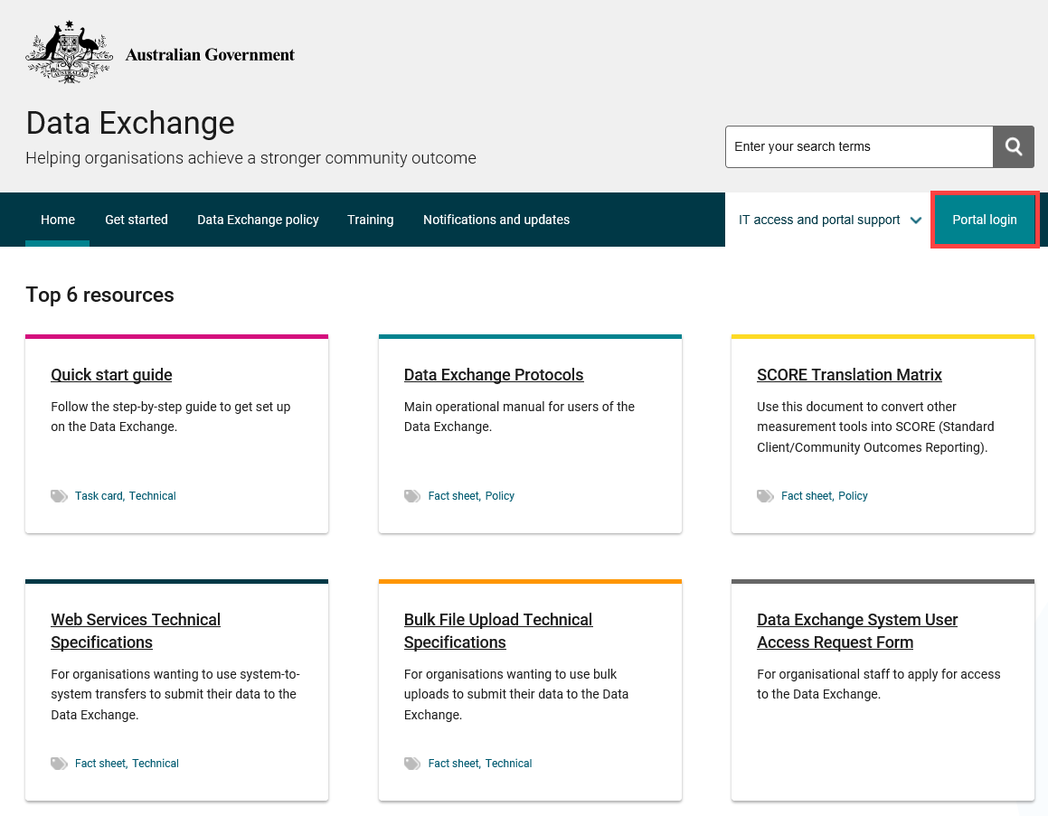

Step 3 –Digital Identity Login screen
The Digital Identity Login screen will display. Select Digital Identity. Refer to Figure 2.
Figure 2 - Digital Identity Login screen
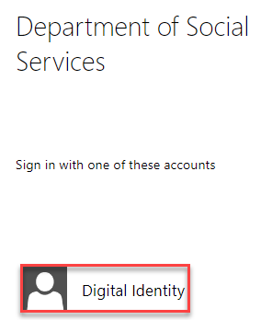

You will be redirected to the ‘Select your identity provider’ webpage where you can choose the myGovID Digital Identity option. Refer to Figure 3.
Figure 3 – The myGovID selection screen
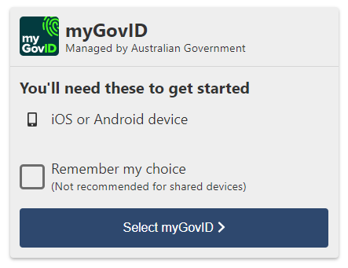

Step 4 – Login for first time
The first time you do this process you will need to enter your email address and a code.
You can follow the link to download the myGovID app from this page or if you have already done this step, enter your myGovID email address.
You can also click the ‘remember me’ option if you are using a computer that you often use. Refer to Figure 4.
Figure 4 – The myGovID email address entry screen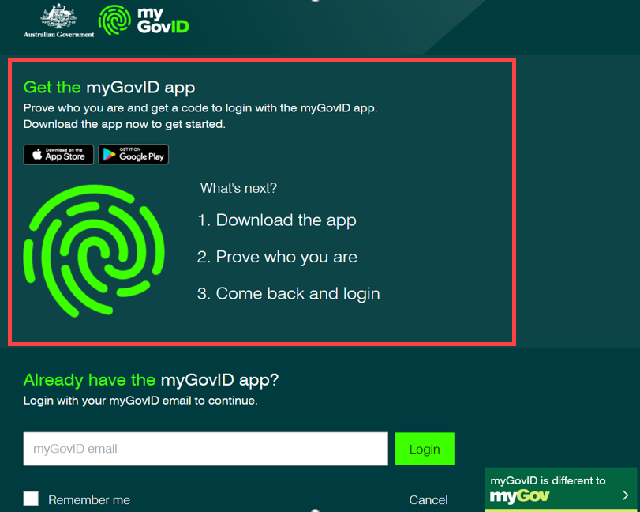

Step 5 – Accept the code
A code will appear on your phone and computer – if the codes match, accept the code on your phone.
Remember, the code only lasts for 60 seconds. Refer to Figure 5.
Figure 5 – The myGovID code verification screen
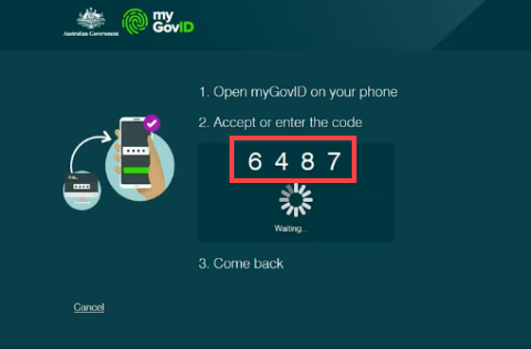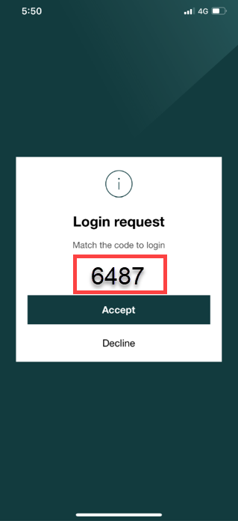

Step 6 – Provide consent
The Provide consent screen will appear. Refer to Figure 6.
Figure 6 – The Consent to share details with DSS screen
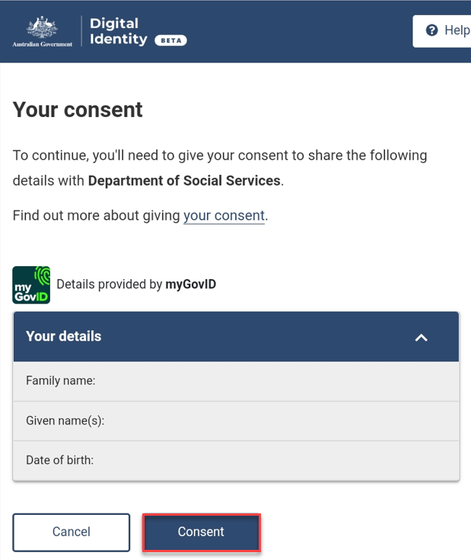

Step 7 – Request activation code
The Request activation code for the Data Exchange will display. Refer to Figure 7.
Figure 7 – - Request activation code for Data Exchange screen
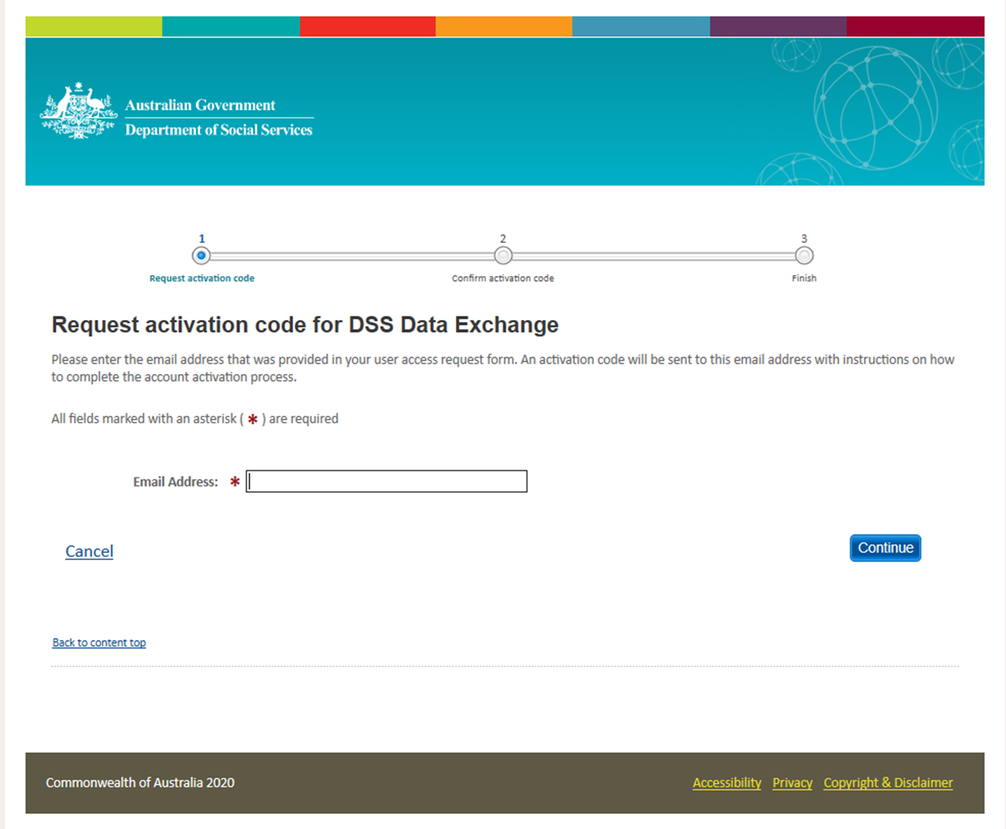
Type in your email address that matches your Data Exchange User Account and select Continue.
You will be sent an email containing your activation code.

Step 8 – Confirm activation code
The Confirm activation code for Data Exchange screen will display. Refer to Figure 8.
Figure 8 – Confirm activation code screen
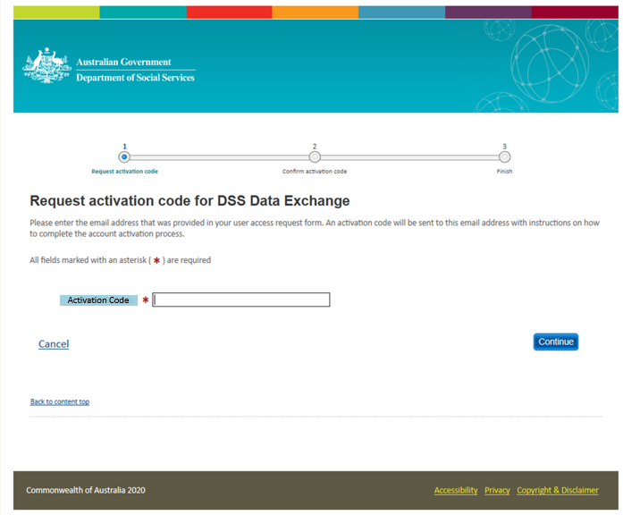
Enter the activation code contained in the email and select Confirm.

Step 9 – Finish screen
When you have confirmed your activation code the Finish screen will display. Refer to Figure 5.
This confirms that you have successfully completed the account activation process. Select the Go to Data Exchange link to access the portal. Refer to Figure 9.
Figure 9 – Finish screen
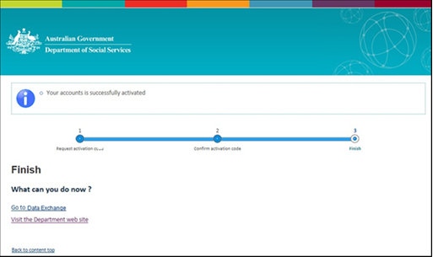

Step 10 – Data Exchange web-based portal home page
The Data Exchange web-based portal home page will display and you are ready to start entering data.
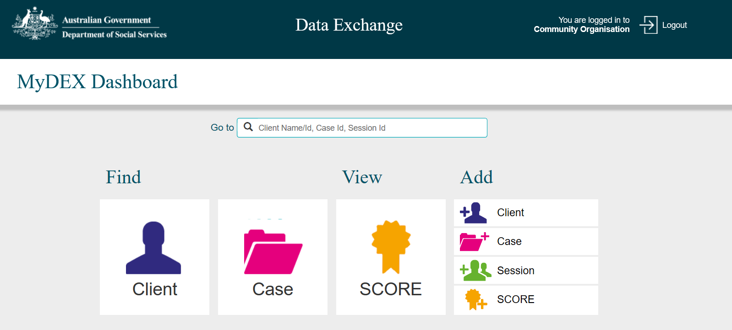

More information on the Data Exchange can be found in the Data Exchange Protocols and the Training page.
For technical support; contact the Data Exchange Helpdesk by email dssdataexchange.helpdesk@dss.gov.au or on 1800 020 283 between 08.30am - 5.30pm (AEST/AEDT) Monday to Friday.

