Find and edit case

Task card
This task card discusses the following:
- Information on updating cases
- Finding a case
- Search area fields
- Results section
- Ending a case

KEY HIGHLIGHTS
- A case can be updated at any time and is not dependant on a reporting period.
- Cases can be closed if they are no longer required.
- The use of special characters such as * & % # @ should not be included in the free text fields as they are used as search functions in the Data Exchange.

Information on updating cases
A case is not dependent on a reporting period and can be updated at any time. Case IDs should not contain any personal information, such as a client’s first or last names, Customer Reference Numbers (CRN) or My Aged Care reference numbers.

Finding a case
There are a number of ways to find an existing case. Refer Figure 1. Go to the Data Exchange homepage and either:
- In the Go to field - start typing the case ID or name and the field will provide a drop down list to select from
- Select the Find Case action tile
Figure 1 - Data Exchange Home Page
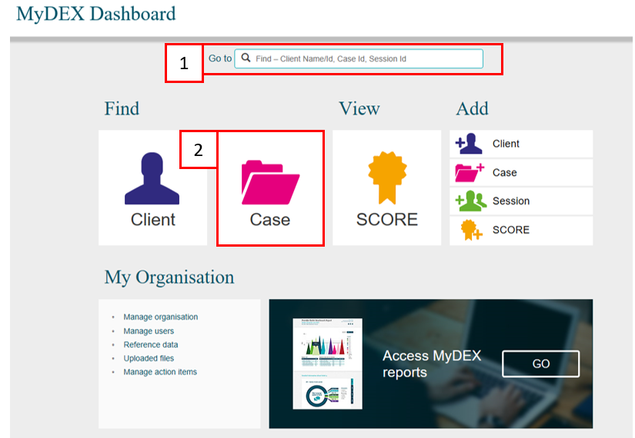

The Find a case screen will display. Refer Figure 2.
Find your case by either using the:
- Typing in the fields in the search area
- Selecting from the Results section
Figure 2 – Find a case screen (Refer Table 2)
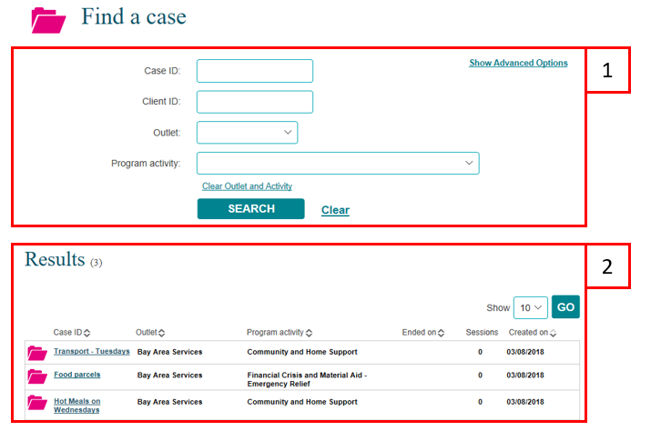

Search area fields
Searching for a case using the Search area fields will only display current cases. More information on the Search area fields can be found in Table 2.
Table 2 – Find a case search area fields (Refer Figure 2)
FIELD | DESCRIPTION
Case ID | Enter either the partial or full Case ID.
Client ID | Enter the Client ID of a client you know is associated with the case.
Outlet | Select the outlet from the drop down list, where the case is delivered from.
Program activity | Select the program activity from the drop down list the case is associated with.
Show Advanced Options hyperlink | Select the hyperlink to expand the advanced search options.

Selecting the Show Advanced Options hyperlink will display the following search options. Cases that have been ‘closed’ will only display if you use the End from search field. Refer Figure 3.
More information on the Show advanced options fields can be found in Table 3.
Figure 3 – Find a case – Show advanced options (Refer Table 3)
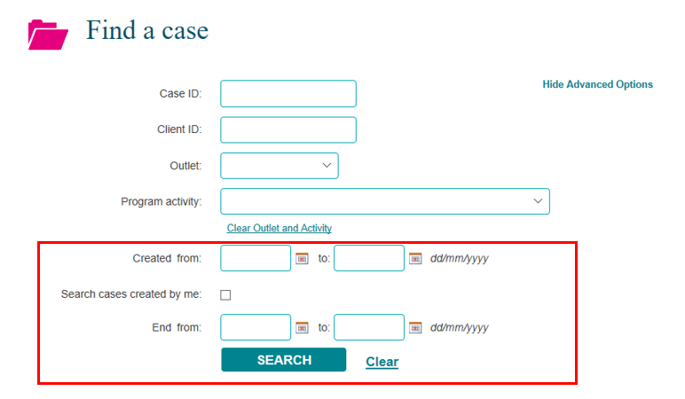
Table 3 – Show advanced options search fields (Refer Figure 3)
FIELD | DESCRIPTION
Created from | Enter to and from dates to search for open and closed cases.
Search cases created by me | Tick the check box to search for cases created by you.
End from | Enter to and from dates to only search for cases that have been closed.
Hide Advanced Options hyperlink | Select the hyperlink to collapse the advanced search options.

Results section
The most recently created cases will display in the Results section. Refer Figure 4.
- Select GO to change the amount of records displayed on the screen. The options are 10, 20 and 50.
- Click on the heading hyperlinks of Case ID, Outlet, etc. to filter columns from ascending to descending order and visa-versa either alphabetically or numerically.
- Click on the case hyperlink to select the case.
Figure 4 – Results section
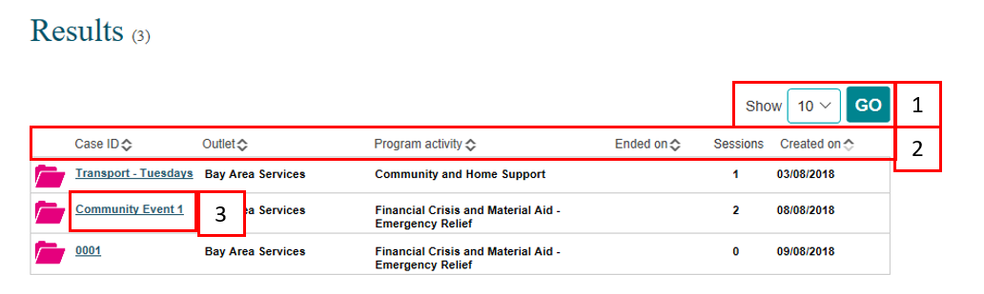

Select the relevant case hyperlink and the Case details screen will display. Refer Figure 5 and Table 4.
Figure 5 – Case details screen (Refer Table 4)
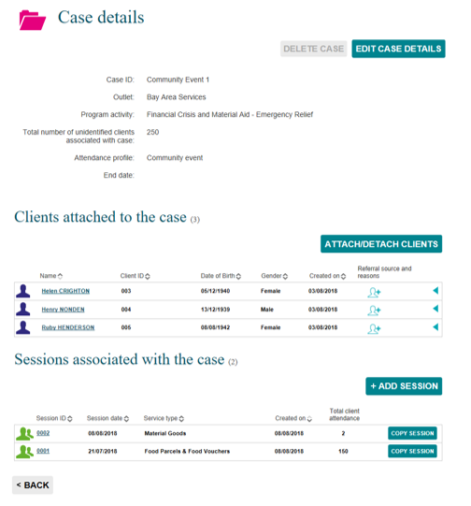
Table 4 – Case details screen (Refer Figure 5)
FIELD | DESCRIPTION
Case details section | Displays case ID, outlet, program activity, etc. associated with the case.  Select the EDIT CASE DETAILS button to amend this information.  Select the DELETE CASE button to delete the case. A case can only be deleted if there are no sessions attached to it.  Note: The use of Special characters such as * & % # @ should not be included in the free text fields as they are used as search functions in the Data Exchange.
Clients attached to the case | Displays the clients attached to the case.  Select the ATTACH/DETACH CLIENTS button to add or remove clients to the case.  Select the Referral source and reasons icon to add referral source and reasons for an individual client. Refer to the Add a case task card for more information.  Select the expand button to view the client’s referral source and reasons.
Sessions associated with the case | Displays the sessions attached to the case.  Select the +ADD SESSION button to add a new session to the case.  Select the COPY SESSION button to copy an existing session to the case.  Select the Session ID hyperlink to amend the session ID to display the Session details screen, Referrals to other services and Client SCOREs icons.  Select the column headings such as Session ID, Session date, to filter columns from ascending to descending order and visa-versa either alphabetically or numerically.  Refer to the Add a session task card for more information.
Back button | Select the <BACK button to go back to the Find a case screen.

Ending a case

A case can be closed or ended at any time. A case can only be ended on the actual date required and not a date in the future. An ended case can be reopened at any time.

Refer to the Find a case instructions found in this task card.

Once you have found and selected the hyperlink to the relevant case the Case details screen will display. Refer Figure 6.
Figure 6 – Case details screen – Edit case details button
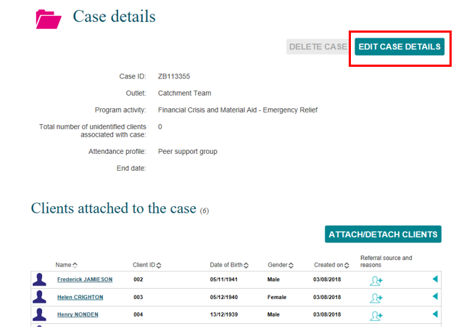

Select EDIT CASE DETAILS.

The Edit case details screen will display. Refer Figure 7.

Enter the End date for the case by either typing the date in or using the calendar function.
Figure 7 – Edit case details screen – End date field
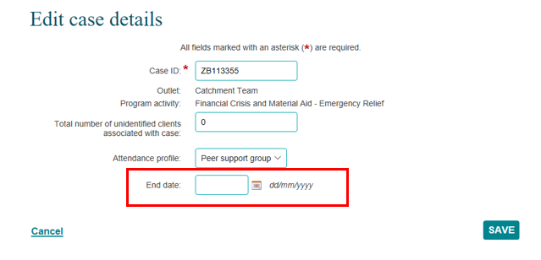

Select SAVE.

The Case details screen will display with the End date field updated. Refer Figure 8.
Figure 8 – Edit case details screen – Updated end date field
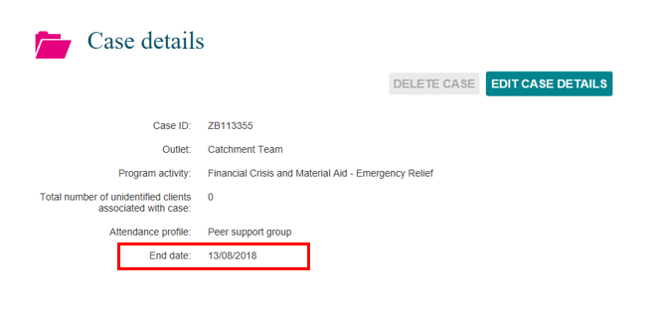

Sessions conducted can continue to be added to an ended case until the close date. For example, a case that has the end date of 13 August 2018 can have sessions added to it within the relevant reporting period if the sessions occurred either before or on the end date.

More information on outlets, clients, cases and sessions can be found in the Data Exchange Protocols and the Training resources tab.
For technical support; contact the Data Exchange Helpdesk by email dssdataexchange.helpdesk@dss.gov.au or on 1800 020 283 between 08.30am - 5.30pm (AEST/AEDT) Monday to Friday.

