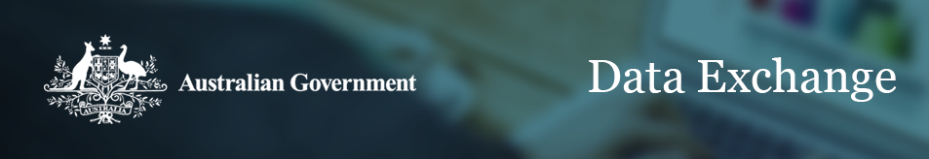
A partnership approach to reporting outcomes
Overview
The Data Exchange partners with funding agencies and organisations to support better use of data in gaining insights about client outcomes. Organisations participating in the partnership approach use the Data Exchange’s streamlined system to report outcomes data on their services. Outcomes data is collected using SCORE (Standard Client/Community Outcomes Reporting).
SCORE helps measure the results of a client’s interaction with a service. Organisations who already use their own outcomes measurement tools can continue to use them, needing only report using the SCORE approach. The SCORE Translation Matrix is provided to help organisations convert their data into SCORE. Further information on SCORE is available on the Data Exchange website.
The Data Exchange organises the data into an extended suite of reports that create easy to understand visualisations. Partners also gain access to data from publicly available government data sets, which helps them gain a richer picture of the context in which their services operate.

Main principles of the partnership approach
The partnership approach helps build an evidence base about the effectiveness of programs and shares this knowledge back with organisations in order to understand the difference services make for a client’s life. In practice, this means:
- Organisations reporting through the partnership approach have access to reports focused on client outcomes and extended client data for the programs they deliver, as well as data from government data sets and follow-up client surveys.
- Organisations commit to using their best efforts to report a small set of additional data items related to outcomes for each client-level unit record – ideally using data that is already collected as part of existing service and case management practices.
- Organisations collect and report the additional data items for as many clients as possible, with flexibility to accommodate situations where it is not practical or appropriate to collect particular data items.
- Organisations who do not have their own case management tools can access the Data Exchange web-based portal at no cost. Through the web-based portal organisations can record client, service and outcomes data that meet all the program performance data requirements of grant agreements. It also allows organisations to manage confidentially their core client and case information.
- Bulk uploading and system-to-system transfers. The Data Exchange supports organisations who have compatible case management software to transfer information directly from their own systems through bulk uploading and system-to-system transfers.

The extended data requirements of the partnership approach
Under the Data Exchange, data requirements are divided into two parts: a small set of mandatory priority requirements that all funded services report, and an extended data set that organisations share under the partnership approach.

Figure 1. Data requirement sets
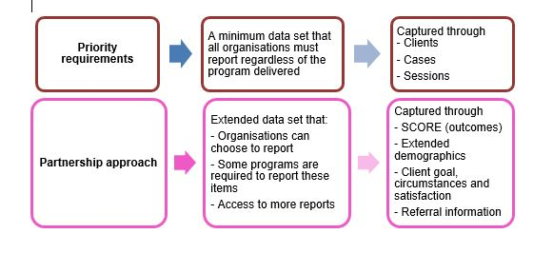
This small set of extended data requirements focuses on outcomes related to:
- Client circumstances: these provide the context for interpreting outcomes data such as the reason for seeking help, referral source, household composition, and income source
- Client goals related to their progress against their service goals
- Client satisfaction; the client’s perception how well the service responded to their needs.

