View and edit a SCORE assessment

Task card

This task card discusses the following:
- View a SCORE assessment
- Edit a SCORE assessment
- Add a SCORE assessment

KEY HIGHLIGHTS
- A SCORE assessment can only be recorded within the relevant reporting period.
- The Activity field must be completed before a search of the client can be made.
- If you are unsure of the client details, you can search for your client without completing any of the search fields.

View a SCORE assessment
From the Data Exchange web-based portal home page, select the View SCORE tile. Refer Figure 1.
Figure 1 - Data Exchange home page
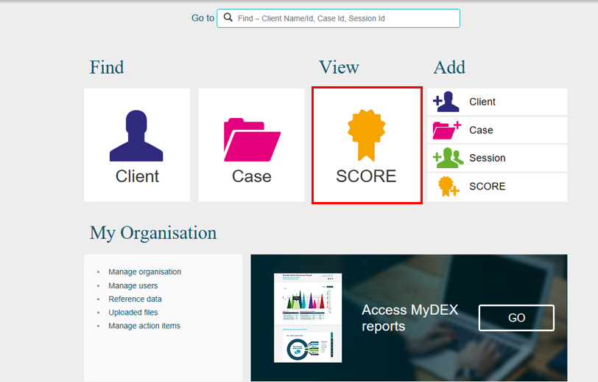

The View client SCORE screen will display. Refer Figure 2
- Select the Activity that the client attended. This field must be completed before a search of the client can be made.
- Enter either partial or full details into the search fields or leave blank.
- Leave the tick box unchecked to search for all clients who have attended that activity or check the tick box for clients that have not had a SCORE assessment recorded.
Figure 2 – View client SCORE screen
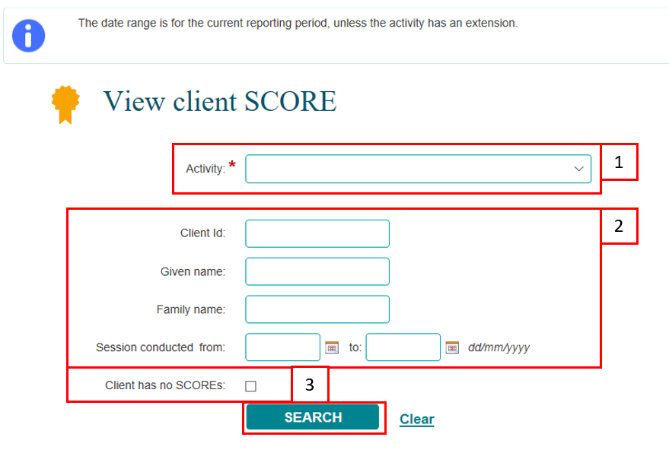
Select SEARCH.
Note: If you are unsure of the client details, you can select SEARCH without completing any of the search fields.
The results of the search will display under the Results section of the View client SCORE screen. Refer Figure 3.
Figure 3 – Results section
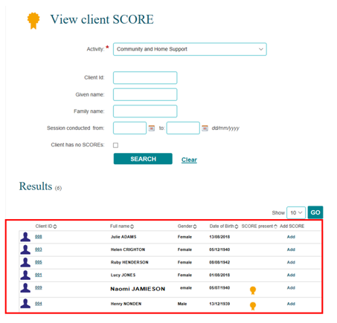

Under the View client SCORE screen you are able to identify if a SCORE assessment has been made for a client. Refer Figure 4.
The SCORE present column will display with indicating that a SCORE assessment has been added to the client.
Figure 4 – SCORE present field
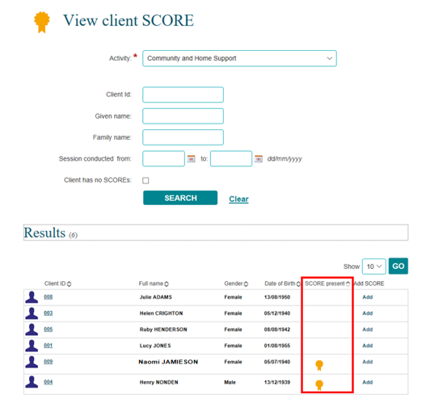
Select at the top of the column to sort the records. Refer Figure 5.
Figure 5 – SCORE present field sort function
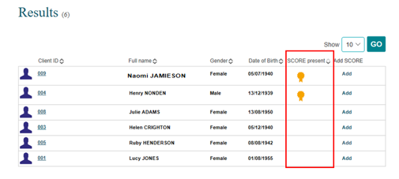

Select the Client ID hyperlink of the client that the SCORE assessment is to be viewed. Refer Figure 6.
Figure 6 – Client ID hyperlink
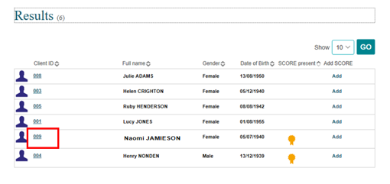

The Client profile screen will display with the cases and sessions that the client has attended. Refer Figure 7.
Select VIEW CLIENT SCORE to view the SCOREs that have been recorded for this client.
Figure 7 – Client profile screen
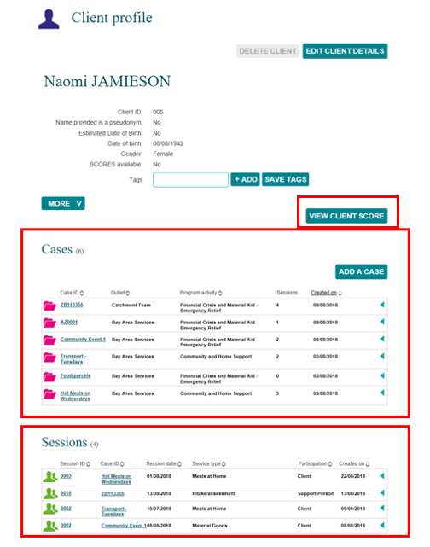

The SCORE Assessments screen displays with a listing of the SCORE assessments that have been recorded for the selected client. Refer Figure 8.
Figure 8 – SCORE Assessments screen
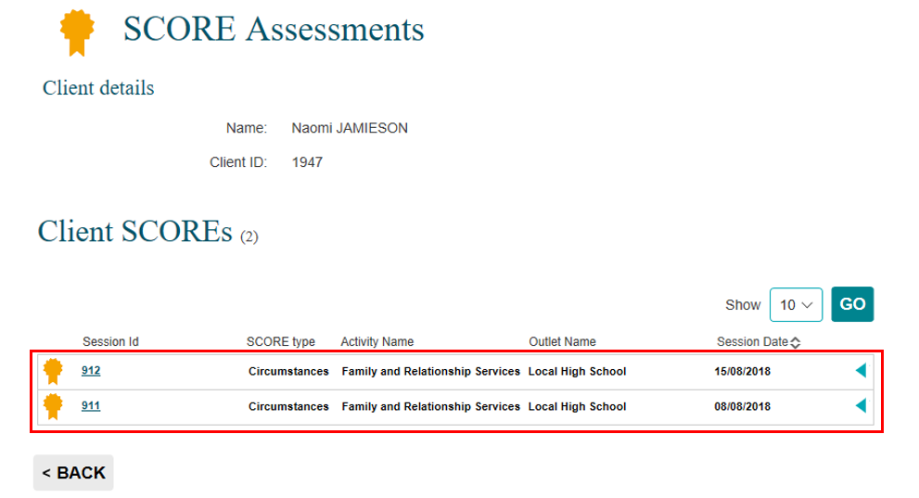
Select to expand the extra details fields. Refer Figure 9.
Figure 9 – Extra details fields for SCORE
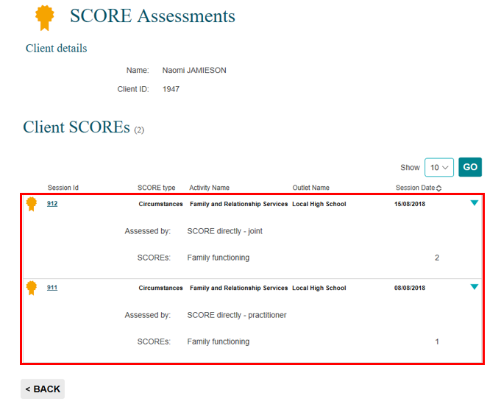
Select to collapse the extra details fields.

Edit a SCORE assessment
SCORE assessments can be edited at any time within the reporting period that they were recorded.
Start from the SCORE Assessments screen at Figure 9.
Select the Session Id hyperlink for the session the SCORE is recorded against. Refer Figure 10.
Figure 10 – SCORE Assessments screen – Session Id hyperlink
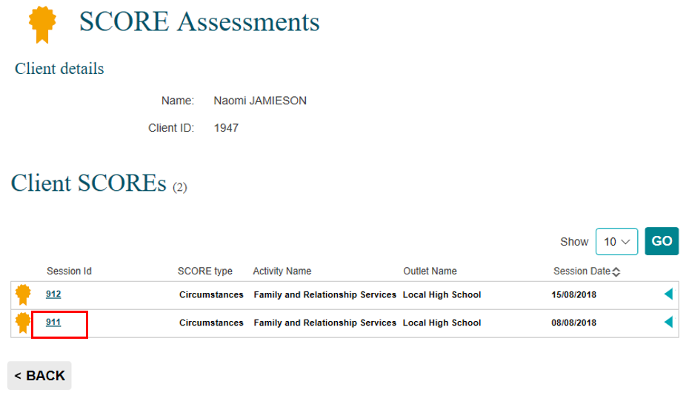
The Session details screen will display with a listing of the clients that attended the session. Refer Figure 11.
Select to expand the extra details fields.
Figure 11 – Session details screen
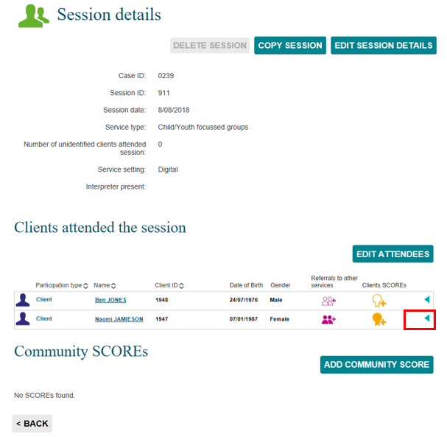

The SCORE details field will display the SCORE assessment recorded. Refer Figure 12.
Select to edit the SCORE record.
Figure 12 – Edit a SCORE assessment
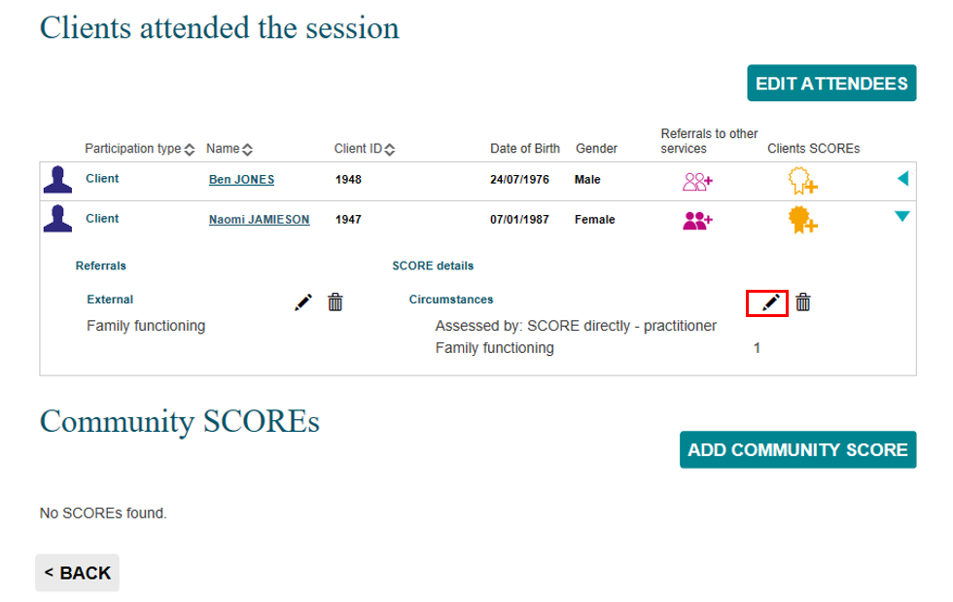
Adjust the rating/s as required and select SAVE.
Select to collapse the extra details fields.

Add a SCORE assessment
SCORE assessments can also be added from the View client SCORE screen. Refer Figure 13.
- Add a SCORE assessment – from the Client ID field.
- Add a SCORE assessment – from the Add SCORE field.
Figure 13 – View client SCORE - Add a SCORE functions
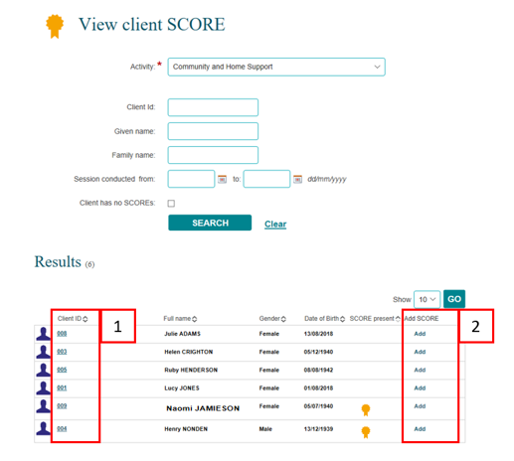

Refer to the Add a SCORE assessment task card for more information on how to add a SCORE from this screen.

More information on SCORE and the Data Exchange can be found in the Data Exchange Protocols and the Training resources tab.
For technical support; contact the Data Exchange Helpdesk by email dssdataexchange.helpdesk@dss.gov.au or on 1800 020 283 between 08.30am - 5.30pm (AEST/AEDT) Monday to Friday.

