Add a sheet (page)
More information on how to use Qlik can be found at Tutorials - Qlik Sense and at Qlik Sense tutorials
on YouTube.

Add a sheet (page) to the story
Table 1 – Add a page navigation items
ITEM | DESCRIPTION
 | Select the sheet icon to insert a new sheet into the story.
 | Select the sheet left-aligned icon to insert the image on the left hand side and add text on the right hand side.
 | Select the sheet centre-aligned icon to insert the image on the centre of the sheet.
 | Select the sheet right-aligned icon to insert the image on the right hand side and add text on the left hand side.
 | Select the blank icon to insert a blank sheet.

A story can contain multiple sheets (pages).
There are different methods to insert a sheet (page) into a story.
Access the required report and select 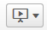. The Stories pop up box will display.
Figure 1 – Stories pop up box
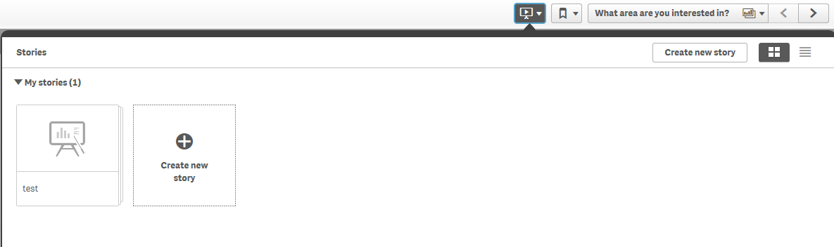

Select the required Story. The story page will display.
Figure 2 – Story page
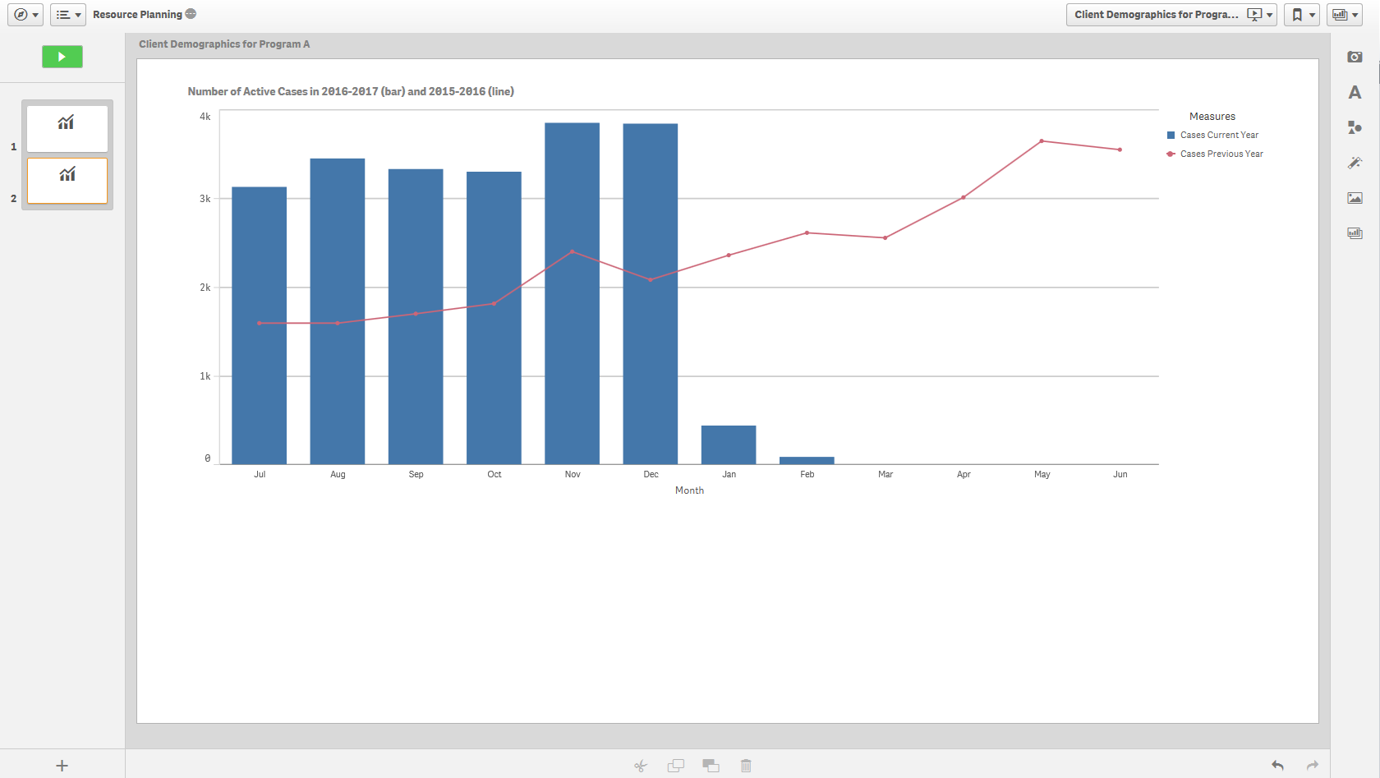

Method 1 – Insert a blank sheet to a story
Select the icon on the bottom left of the story page.
Figure 3 – Add a page to the story icon
The additional slide will display in the side panel.
Figure 4 – Add an additional slide
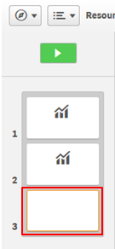

Method 2 - Insert a live data Base sheet from a report
Select the icon from the functions bar found on the right-hand side of the story page.
Figure 5 – Insert Items panel
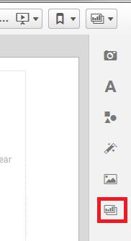

The Select sheet pop up box will display with the available Base sheets for the report.
Figure 6 – Select sheet pop up box
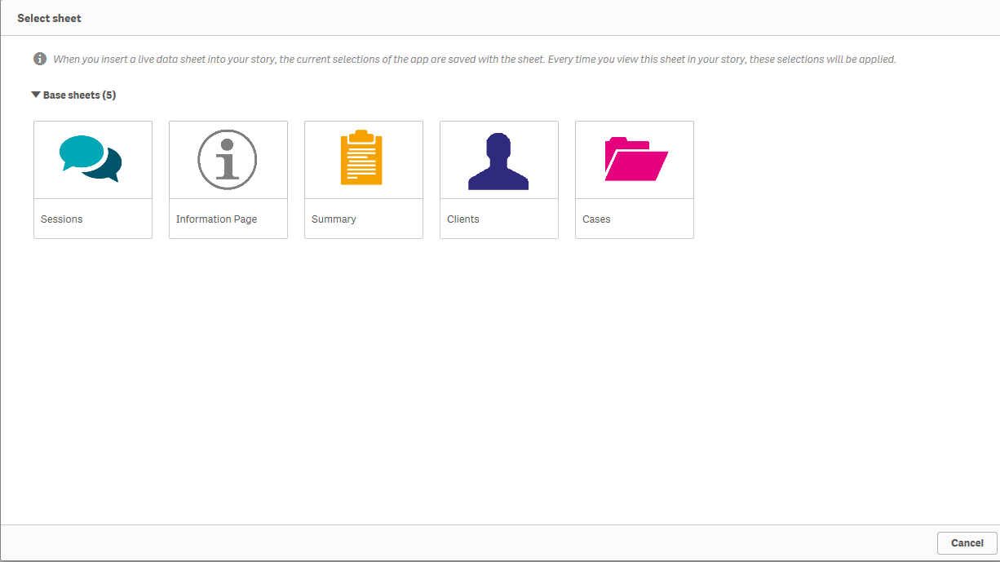

Select the required Base sheet.

The selected sheet will be inserted into the story and the Embedded sheet pop up box will display.
Figure 7- Selected Base sheet with Embedded sheet pop up box
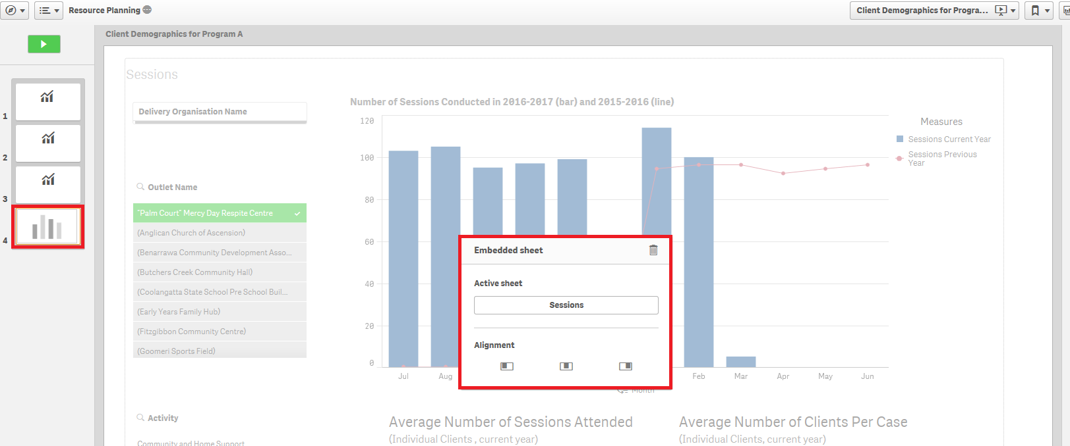

Select the appropriate Alignment icon for the inserted live data Base sheet.
Figure 8- Embedded sheet pop up box
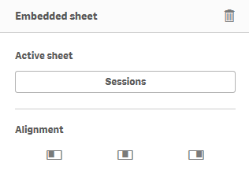
The current selections of the report are saved with the selected Base sheet. Every time you view this sheet in your story, those selections at that saved point of time will be applied.

More information on reporting requirements can be found in the Data Exchange Protocols. Task Cards on reports functionality can be found on the Self-Service Reports tab.
For technical support; contact the Data Exchange Helpdesk by email dssdataexchange.helpdesk@dss.gov.au or on 1800 020 283 between 08.30am - 5.30pm (AEST/AEDT) Monday to Friday.

