# Add animations

More information on how to use Qlik can be found at [Tutorials - Qlik Sense](https://help.qlik.com/en-US/sense/2.2/Content/Tutorials.htm) and at [Qlik Sense tutorials](http://www.bing.com/videos/search?q=qlik+sense+tutorials+youtube&qpvt=qlik+sense+tutorials+youtube&FORM=VDRE)   
on YouTube.

## Add animations to a story

The Data Exchange allows you to Add animations to your story by using the **Effects library**. These visual effects can only be used on bar charts, line charts and pie charts.

**Table 1 – Effects library navigation items**

| **Item** | **Description** |
| --- | --- |
| Highest value button | Select the **Highest value** icon effect will make the highest value stand out by adding a label to the highest value and dimming the other values. For visualizations with grouped values, the highest value in each group will be highlighted |
| Lowest value button | Select the **Lowest value** icon effect will make the lowest value stand out by adding a label to the lowest value and dimming the other values. For visualizations with grouped values, the lowest value in each group will be highlighted. |
| Any value button | Select the **Any value** icon effect will make a value, that you select manually, stand out by adding a label to the selected value and dimming the other values. For visualizations with grouped values, you can choose to highlight either a measure or a dimension. The selected measure or dimension will be highlighted in all the groups where it occurs. |
| Replace button | Select to **replace** the image with another snapshot item in your Stories library. |
| Edit button | Select to **edit** the image. |
| Lock button | Select **lock** to prevent any changes being made to the snapshot. |
| Go to source button | Select to **go to** the originating sheet source of the snapshot. |
| Return button | Select to **return** to the Story that you are creating. |

Access the required report and select This is a screen shot of the story icon which you would select to start a story.. The **Stories** pop up box will display.

Access the required **Stories** tile.

Figure 1 – Stories drop down arrow and My stories tile

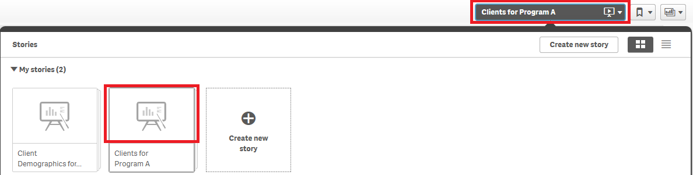

The **Story** page will display.

Figure 2 – Story sheet with snapshot

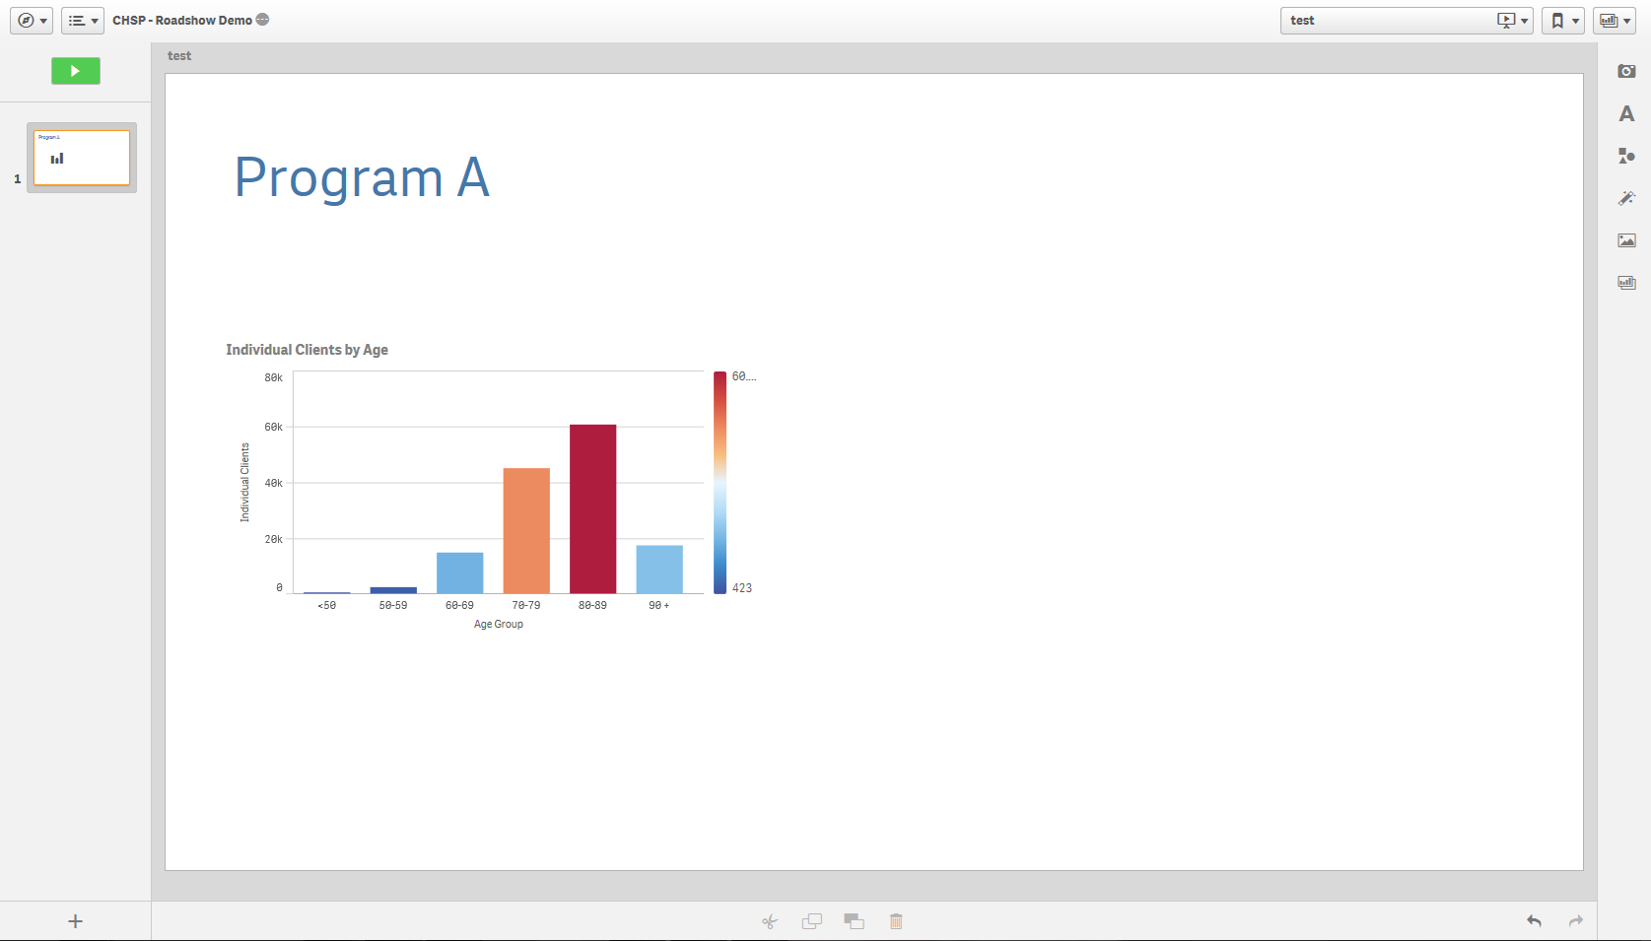

Select the This is a screen shot of the Animations icon. icon on the right of the Story page.

The **Effects library** pop up box will display.

Figure 3 – Effects library pop up box

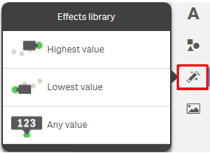

**Click** and **drag** the selected effect onto the snapshot.

The snapshot will display with the **effect** applied.

* The **Highest value** will apply a highlight and label to the column of the graph with the highest value and dim the other values.

Figure 4 – Highest value effects applied to snapshot

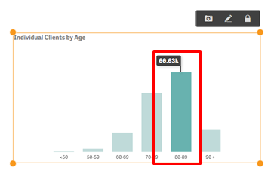

* The **Lowest value** will apply a highlight and label to the column of the graph with the lowest value and dim the other values.

Figure 5 – Lowest value effects applied to snapshot

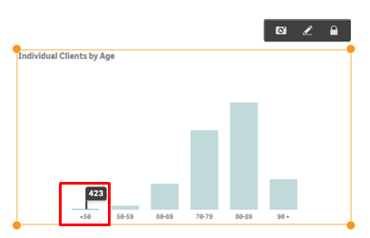

* The **Any value** will apply a highlight and label to the selected column of the graph and dim the other values.

Figure 6 – Any value effects applied to snapshot

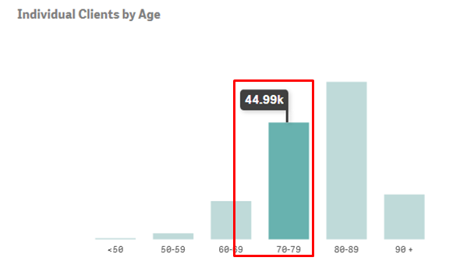

Click on the image to change the data item highlighted.

The **Select data point** pop up box will display.

Select the drop down arrow in the **Select data point** pop up box to change the value selection.

Figure 7 – Select data point pop up box

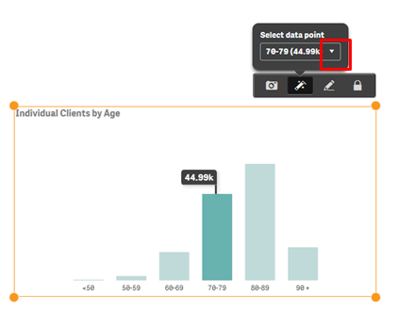

A **pop up** box will display with the items available in the image that can be selected.

Figure 8 – Select data point pop up box

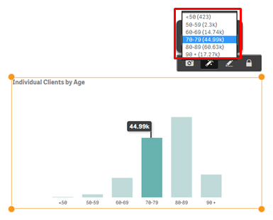

Select the **required data point** item, and the item will automatically update.

Figure 9 – Select data point pop up box

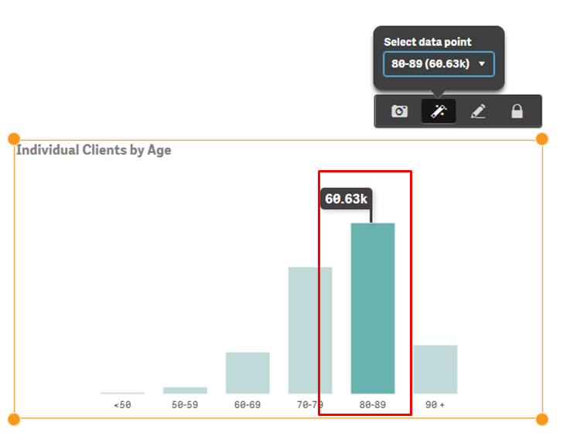

More information on reporting requirements can be found in the [Data Exchange Protocols](https://dex.dss.gov.au/data-exchange-protocols/). Task Cards on reports functionality can be found on the [Self-Service Reports tab](https://dex.dss.gov.au/reports/).

For technical support; contact the Data Exchange Helpdesk by email [dssdataexchange.helpdesk@dss.gov.au](mailto:dssdataexchange.helpdesk@dss.gov.au) or on 1800 020 283 between 08.30am - 5.30pm (AEST/AEDT) Monday to Friday.