Add a snapshot
More information on how to use Qlik can be found at Tutorials - Qlik Sense and at Qlik Sense tutorials
on YouTube.

Add snapshots to a story
The Data Exchange reports allow you to add snapshots of the image items such as graphs, pie charts and line charts found in the reports to build a story.
Table 1 – Snapshot navigation items
Item | Description
 | Select to add an image to the Snapshot library.
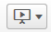 | Select to add or find a story in the report.
 | Select the handles on the corner of the image to resize the snapshot item.
 | Select to replace the image with another snapshot item in your Stories library.
 | Select to edit the image.
 | Select lock to prevent any changes being made to the snapshot.
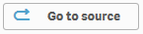 | Select to go to the originating sheet source of the snapshot.
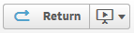 | Select to return to the Story that you are creating.
 | Select to send the item to the back of the image layers.
 | Select to send the item to the front of the image layers
 | Select to send the item back one layer of the image layers.
 | Select to send the item front one layer of the image layers.
 | Select to return to the sheet the image was taken from.
 | Select to remove the image from the story.

Take a snapshot
Access the required report and select the item that you would like to add to the Snapshot library.
Figure 1 - Item selection for Snapshot library
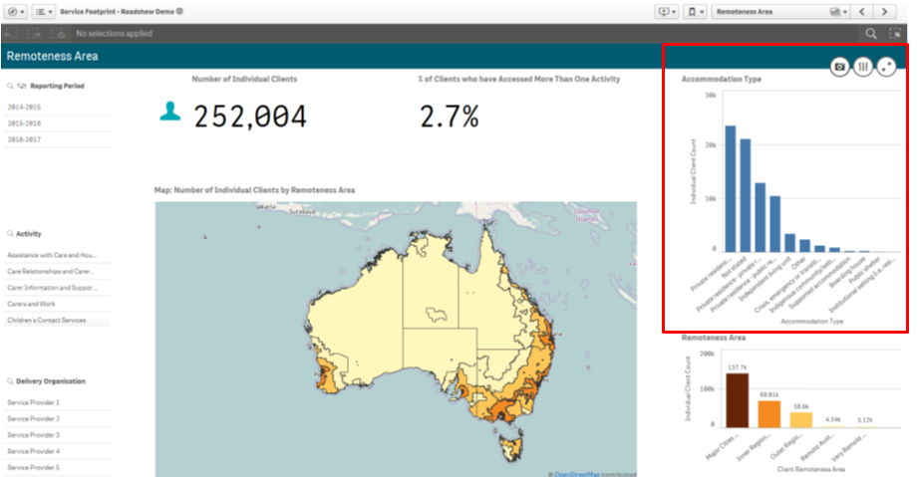
Select and the Snapshot annotation pop up box will display.
Figure 2 - Snapshot annotation pop up box
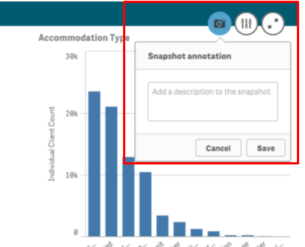
Enter a description of the snapshot and select.
The item will display in the Snapshot library.

Add a snapshot to your story
Select to add the snapshot to a sheet. The Stories pop up box will display.
Access the required Stories tile.
Figure 3 – Stories drop down arrow and My stories tile
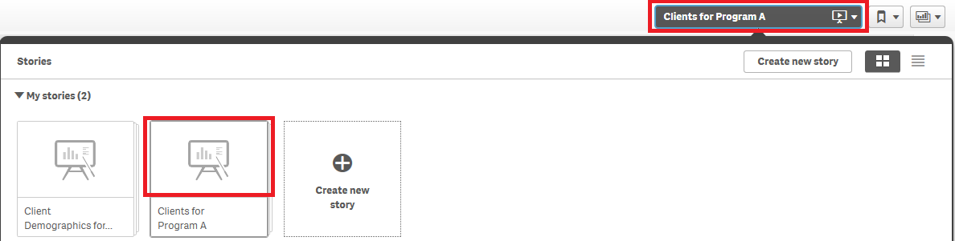

The Story page will display.
Figure 4 – Story sheet with snapshot
Select and the Snapshot library pop up box will display with a listing of the snapshot items that have been saved for that report.
Figure 5 - Snapshot library items
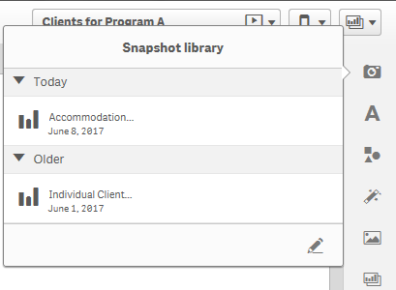
Click and drag the selected item onto the story sheet.
Figure 6 - Snapshot selection on the story sheet
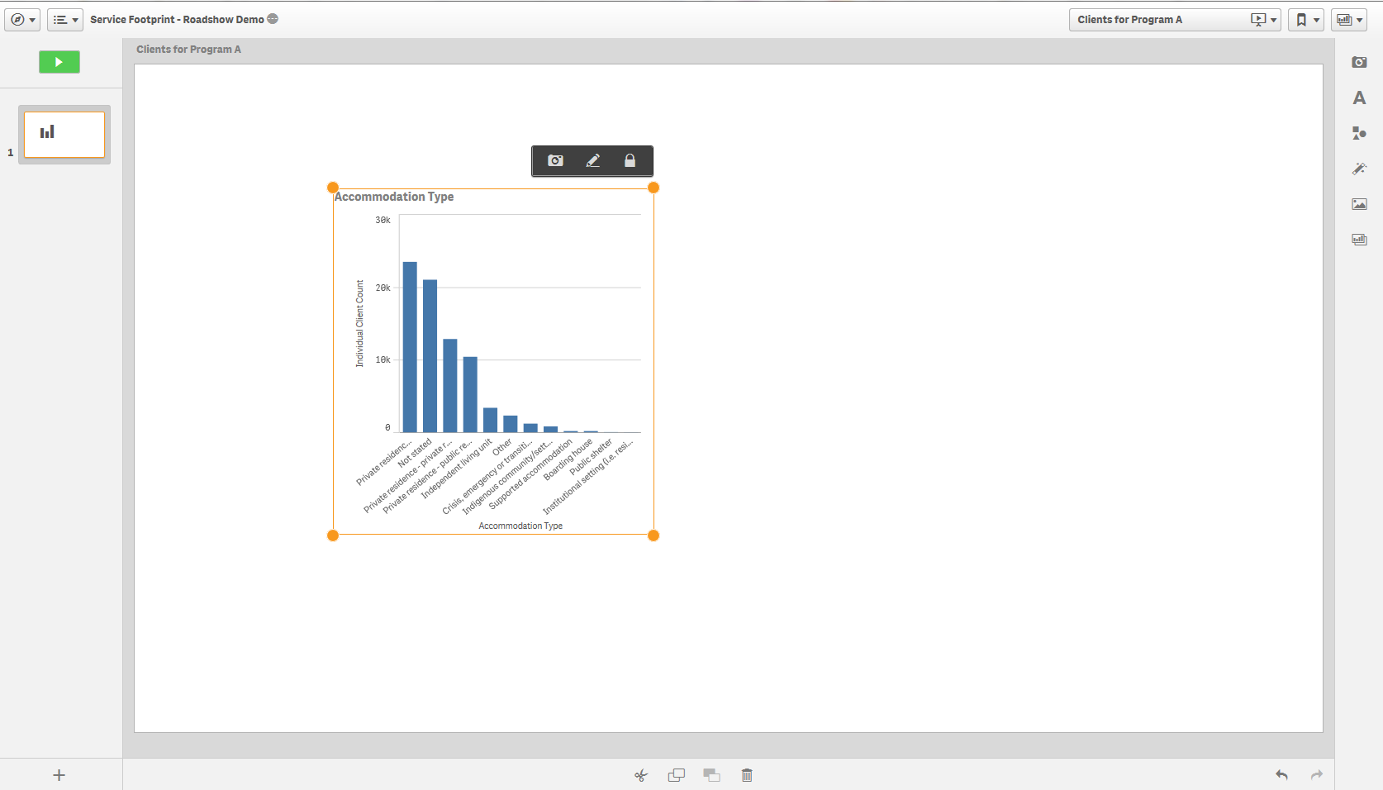
Use to resize or move the image anywhere on the page.

Click and drag the snapshot wherever you want on the page.

Arrange a snapshot
You can change the position of the image, remove the effect on the image, delete the image or go back to the sheet where the image originated from.

Right click on the snapshot image and an options pop up box will display.
Figure 7 – Options pop up box
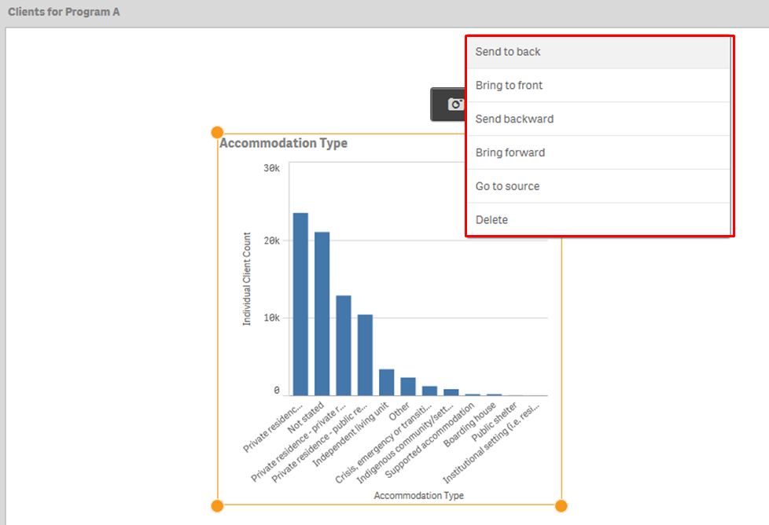

Add comments to a snapshot
Whilst the title of a snapshot item cannot be changed, comments can be added to describe the snapshot item.

- Select the camera icon to open the Snapshot library.
- Select the pencil icon to open the comment fields.
- Select the snapshot item and type the details in the comments field.
Figure 8 – Snapshot library with comments field open
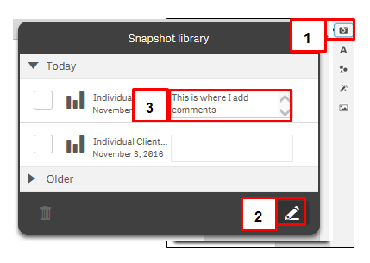
The comments will automatically save.
Figure 9 – Comments field for snapshot item updated
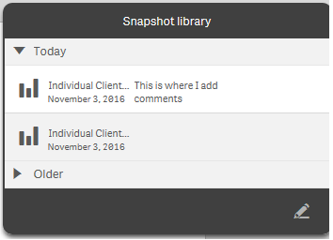

Edit a snapshot
Select to edit the snapshot.
An edit pop up box will display and you can amend titles, grid lines and labels.
Figure 10 – Edit options for snapshot
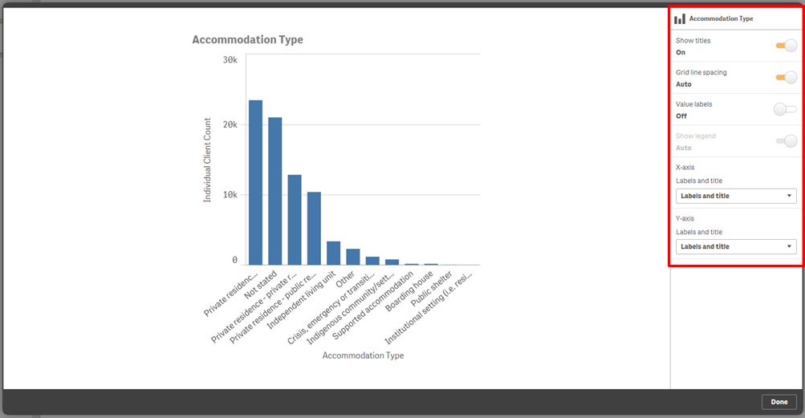
Select to save the amendments.

Replace a snapshot
Select to replace the snapshot.
The Replace snapshot pop up box will display with the image that has been selected to be replaced.
Figure 11 – Replace snapshot pop up box
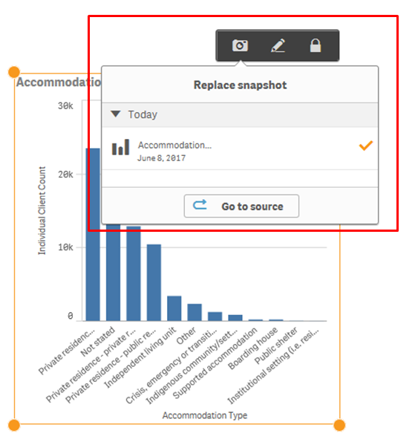
Select to choose another snapshot from the originating sheet source.
The originating sheet will display with a line around the original snapshot.
Figure 12 – Originating sheet for snapshot
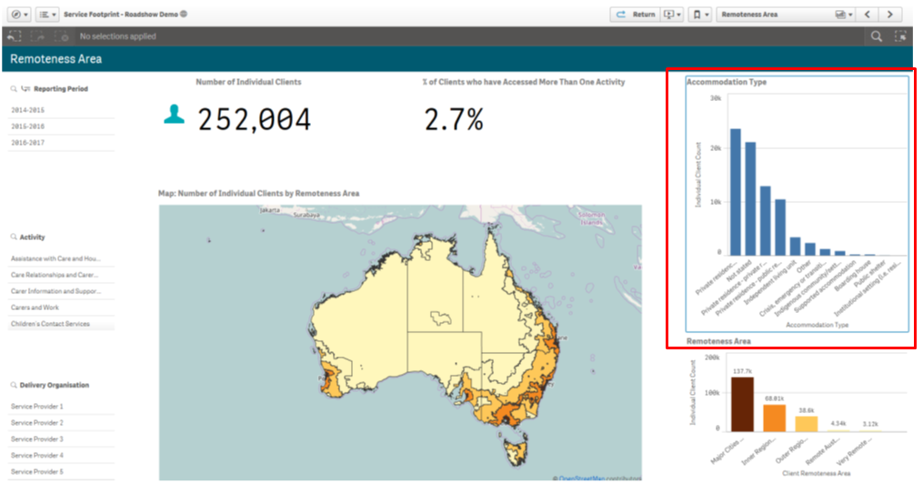

Select a different item to add to the Snapshot library.
Select to return to the story you are creating.
Figure 13 – Return to Story button
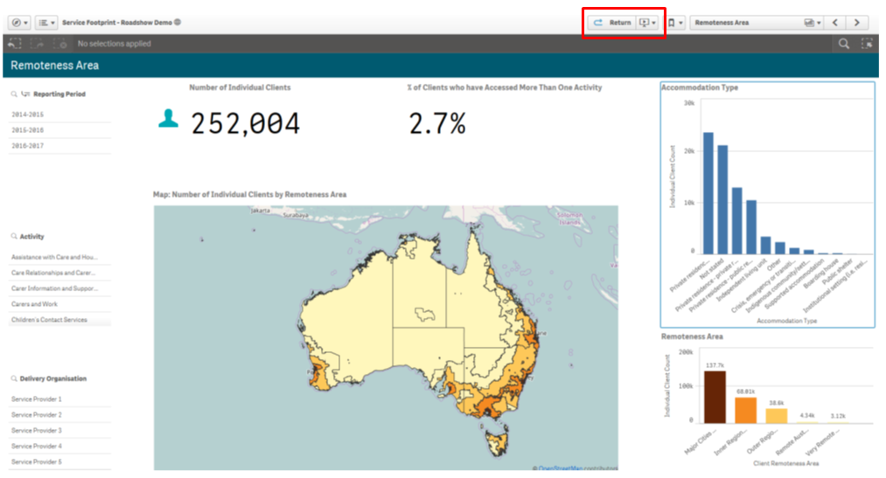
Select to open the Snapshot library and select your new snapshot item to your story.

More information on reporting requirements can be found in the Data Exchange Protocols. Task Cards on reports functionality can be found on the Self-Service Reports tab.
For technical support; contact the Data Exchange Helpdesk by email dssdataexchange.helpdesk@dss.gov.au or on 1800 020 283 between 08.30am - 5.30pm (AEST/AEDT) Monday to Friday.

