Add text
More information on how to use Qlik can be found at Tutorials - Qlik Sense and at Qlik Sense tutorials
on YouTube.

Add text to the story
The Data Exchange reports allow you to Add text to the story by using the Text objects selections.
Table 1 – Title and Paragraph boxes navigation items
ITEM | DESCRIPTION
 | Select the edit icon to display the different edit options available.
Within the Title box
 | Select the drop down arrow near the colour box to choose the font colour.
 | Select B, I or U to make the text bold, italic or underlined.
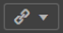 | Select the hyperlink icon to link a URL to the text.
 | Select the handles on the corner of the text box to resize the text box.
Within the Paragraph box - You can perform the functions available in the Title text box, as well as:
 | Select the alignment options to change the alignment of the text.
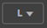 | Select the font size drop down arrow to change the size of the text.
Access the required report and select 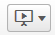. The Stories pop up box will display.
Figure 1 – Stories pop up box
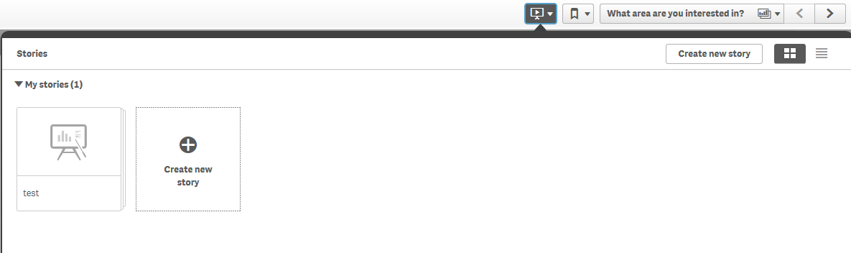

Select the required Story. The story page will display.
Figure 2 – Story page
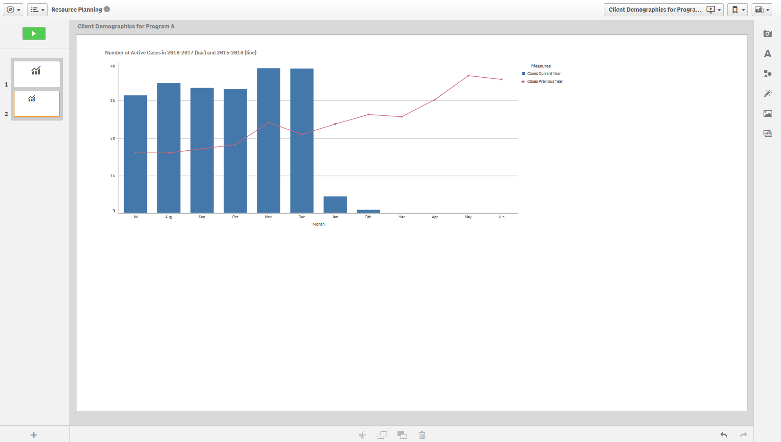
Add text to the story page by selecting within the functions bar found on the right-hand side of the story page.
The Text objects pop up box will display.
Figure 3 – Text objects pop up box
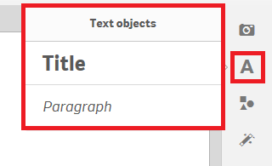
Double click on the displayed options to add either a Title or a Paragraph text box.
Example of Title box:
Figure 4 – Example of a Title box
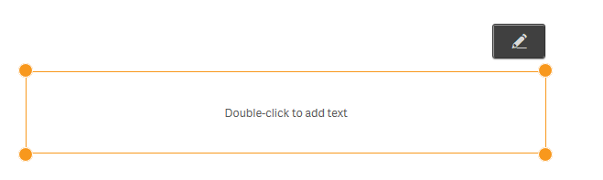
Select to display the Edit options.
Use to resize or move the image anywhere on the page.

Click and drag the text box where ever you want on the page.

Highlight the required text to amend the font size, style, colour or to add a hyperlink.
Figure 5 – Amending the text icons
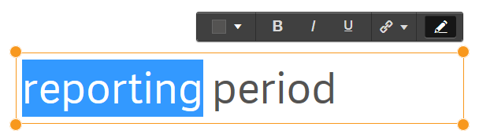

Example of Paragraph box:
Figure 6 – Example of a Paragraph box
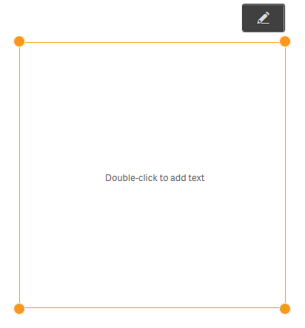
Select to display the Edit options.
Use to resize or move the image anywhere on the page.

Click and drag the text box where ever you want on the page.

Highlight the required text to amend the font size, style, colour, positioning or to add a hyperlink.
Figure 7 – Amending the paragraph icons
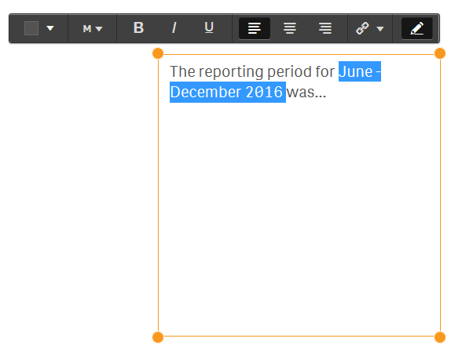
More information on reporting requirements can be found in the Data Exchange Protocols. Task Cards on reports functionality can be found on the Self-Service Reports tab.
For technical support; contact the Data Exchange Helpdesk by email dssdataexchange.helpdesk@dss.gov.au or on 1800 020 283 between 08.30am - 5.30pm (AEST/AEDT) Monday to Friday.

