Benchmarking under the Data Exchange
Framework

Discussion Paper - December 2015
Version 12 December 2015

Contents

Introduction 3

Discussion questions 3

Acknowledgement 4

Section One: What is benchmarking? 5

Introduction 5

Benchmarking within Data Exchange grant programmes 5

Section Two: Key principles for benchmarking 8

1. Benchmarking should empower service providers 8

2. Benchmarking should enable simple, relevant and transparent comparisons 8

3. Benchmarking should be a starting point for ongoing discussions 9

4. Service provider privacy should be protected 9

5. Implementation of benchmarking will be monitored and reviewed 9

Section Three: Benchmarking methodology 10

Introduction 10

KPI Data 10

Creating comparison groups 11

Programme Activity 11

Location of service delivery 11

Number of service providers in a comparison group 12

Comparing KPIs for comparison groups 12

Section Four: How the comparative data from benchmarking will be used 13

Self-service reporting in the Data Exchange 13

How the reports will be used 14

Supporting the everyday use and understanding of the reports 14

An example: The Service Provider Benchmark Report (Partnership reporting suite) 15

Conclusion 16

Glossary 1

Appendix A

Introduction
The Department of Social Services (DSS) Data Exchange Framework (the Framework) outlines a new approach to collecting and using programme performance data to reduce red tape for service providers and shift the focus of performance measurement from outputs to outcomes.
As part of this new way of working, all grant agreements covered by the Framework will reflect five key performance indicators (KPIs) informed by a small set of standardised data sourced from the Data Exchange.
- Number of clients assisted
- Number of events/service instances delivered
- Percentage of participants from priority target groups
- Percentage of clients achieving individual goals related to independence, participation and wellbeing
- Percentage of clients achieving improved independence, participation and wellbeing.
This information is intended to help tell the story of what outcomes are being achieved, and how services respond to individual, family and community needs.
Performance against these standard KPIs will be measured using a process known as benchmarking, to help improve the way the Department collects and uses programme performance data. This discussion paper has been developed to explain the proposed approach to benchmarking under the Framework and seek feedback from service providers and other interested stakeholders to refine and enhance the methodology prior to implementation.
The paper addresses how benchmarking has been used in other contexts
(Section 1), proposes five key principles underpinning benchmarking as part of the Framework (Section 2), describes how the methodology is proposed to be established (Section 3) and considers how this information could be used by Department staff and service providers (Section 4).
Discussion questions
Feedback is sought from service providers and other interested stakeholders about the proposed approach outlined in this Discussion Paper.
Following feedback on these discussion questions, a final benchmarking methodology will be developed and incorporated into the Data Exchange.
- Key principles
Are the key principles underpinning the proposed approach to benchmarking appropriate (Section two)?
- Comparison groups
Is the proposed approach to determining comparison groups a reasonable starting point for benchmarking reports (Section three)?
Is the proposed minimum size of three to five providers for a comparison group appropriate?
- Implementation
What issues need to be considered to ensure the successful implementation of benchmarking within the Data Exchange?

- Post Implementation review
What evaluation questions need to be included in the Post-Implementation Review process for assessing the initial benchmarking methodology after the first 12 to18 months?
- General
Do you see any issues with the proposed approach?

Acknowledgement
DSS acknowledges the assistance and expert advice provided by Michael Brooks and ARTD Pty Ltd in the development of this discussion paper.

Section One: What is benchmarking?

Introduction
Benchmarking was developed in the late 1970s as a way of measuring and improving performance. It is now a common business management tool that is used in a range of different contexts. As a basic definition, benchmarking is a process of comparing one’s organisation to similar organisations to identify areas of success and opportunities for improvement.
The goal of this comparison is ‘self-improvement’. The benchmarking process can be used to test assumptions about service delivery and highlight opportunities to sustain or generate improvement. This information can be used to develop business improvement plans and prioritise investment to where it is most needed.
Benchmarking is especially useful when organisations use data to gain meaningful insights within their organisation and share knowledge across their local service networks.
Benchmarking is used extensively in the for-profit and not-for-profit sectors to analyse costs and activities—although the methodologies for benchmarking human services outcomes are less well established. In a large part this has reflected a historical legacy where there was limited agreement on how to collect outcomes data and limited systems were available to support services to compare outcomes information. The Data Exchange Framework seeks to address these issues by providing a standard approach to reporting outcomes and a common system for collecting and sharing outcomes data.
Benchmarking within Data Exchange grant programmes
Having considered the meanings and use of benchmarking more broadly, this section discusses how benchmarking is defined in the Data Exchange Framework, identifies the broad outcomes anticipated from grant funded programmes and how reporting key programme results through benchmarking will contribute to providing insights into the outcomes being achieved for people and families in Australia.
The outcomes that are achieved from each programme contributes to and aligns with the achievement of the core outcomes of promoting individual and family independence, resilience, participation and the wellbeing of the Australian population (Figure 1). The figure below identifies the links between service provision, client needs and satisfaction with the client outcomes from services received. This is then aligned with the outcomes anticipated at a population level through the delivery of grant funded programmes that individually and collectively contribute to ‘Improving the lifetime wellbeing of people and families in Australia’.
Figure 1: Programme performance story (outcomes)

 | DSS Purpose | Improving the lifetime wellbeing of people and families in Australia
 | Outcomes | Outcome 2:  - Stronger families and more resilient communities | Outcome 3:  - Improved wellbeing for older Australians |  | Outcome 4:  - Increased housing supply, improved community housing and assisting individuals experiencing homelessness |  |  |  | Outcome 5:  - Improved independence of, and participation by, people with disability and improved support for carers
 | Outcomes of  grants | 1. Clients have improved circumstances  to support individual and family independence, resilience, participation wellbeing  (in areas relevant to individual and family needs)
- Physical health
- Mental health and self-care
- Personal & family safety
- Age-appropriate development
- Social networks & community participation
- Family functioning
- Financial resilience
- Employment, education and training
- Material wellbeing
- Safe, affordable housing
Chapter 3 | Did we achieve what we expected
2. Clients achieve their goals/resolve their issues
to underpin improvement in the life circumstances (in areas relevant to individual & family goals/ group or community goals/ reasons for seeking assistance)
 |  | Individual clients |  |  |  |  | Groups, organisations, communities
 |  | - Knowledge & access to information  - Skills  - Behaviours  - Confidence to make their own decisions  - Engagement with support services  - Amelioration of impact of crisis |  |  |  |  | - Group/community knowledge, skills & behaviours  - Organisations knowledge & practices  - Community structures & networks
Chapter 2
 | How well is it being done | 3. Clients are satisfied with the responsiveness of services  in understanding their needs and tailoring assistance to their circumstances
Chapter 1
 | How much is being done | 4. Services are available to individuals and families  in targeted client groups and communities

The Framework has been designed to ‘tell the story’ about the outcomes being achieved through the delivery of government funded services:
- How much is being done – in terms of the services and assistance available to individual, families, groups and communities targeted by the programme.
- How well is it being done –particularly from the point of view of the individuals, and families who we are trying to assist.
- Did we achieve what we expected– in terms of helping to resolve the issues for which clients sought assistance, helping clients achieve their individual and family goals and contributing to positive changes in client’s circumstances.
The Framework is designed to promote more meaningful discussions about service delivery outcomes by facilitating a two-way exchange of information between service providers and the Department. Information collected through the Data Exchange will be shared back with service providers through a suite of informative and easy to read self-service reports, including reports about benchmarking, to help inform internal business planning and decision-making. The ultimate goal of this information sharing is to support service providers to improve outcomes for clients, their families and the broader community.
With this goal in mind, benchmarking in the Data Exchange Framework will be used to support service providers to identify successes and opportunities for improvement. The benchmarking process will involve comparing an organisation’s service delivery outcomes to those of organisations delivering a similar service in a similar context. This process will result in comparative data that service providers can then use to identify and discuss trends.
Regardless of where providers sit in comparison to their peers, continuous improvement is a relevant objective for all organisations. Comparative data will be a valuable knowledge base for providers that can be used to inform locally focused, evidence based approaches to service delivery.

Section Two: Key principles for benchmarking
This section discusses five key principles that will guide the application of benchmarking in the Data Exchange Framework:
- Benchmarking should empower service providers
- Benchmarking should enable simple, relevant and transparent comparisons
- Benchmarking should be a starting point for ongoing discussions
- Service provider privacy should be protected
- Implementation of benchmarking will be monitored and reviewed
- Benchmarking should empower service providers
Benchmarking in the Data Exchange is intended to act as an enabler, providing organisations with meaningful comparative information they can use to measure and improve service delivery.
Benchmarking should stimulate and promote discussions about how we can achieve better client and community outcomes. Ideally, these discussions will involve:
- Service provider staff, management and board members using comparative data to inform internal business and services planning
- Service providers sharing data, lessons learnt and challenges with their peers in other organisations to identify opportunities to replicate success and improve practices and systems
- The Department assisting service providers to use and interpret comparative data through accessible reports and supportive training materials
- The Department and service providers using benchmarking data to streamline and focus grant agreement discussions on improving client and community outcomes.
The benchmarking process in the Data Exchange is designed to create a culture of information sharing where all service providers have access to self-service reporting in order to continually monitor, self-evaluate and improve service delivery outcomes.
Over time, it is hoped the comparative data will encourage the development of service provider networks and communities of practice to discuss how to improve outcomes for clients and the community. Peak bodies and service provider forums will have a valuable role in facilitating discussions and sharing best practice.
- Benchmarking should enable simple, relevant and transparent comparisons
The purpose of benchmarking is to provide a credible and transparent evidence base to promote discussions about how we can achieve better client and community outcomes. The rationale, methodology and uses of benchmarking should be clear to all stakeholders so that it can be easily integrated into every day practice. The process should enable relevant comparisons to be made between service providers to allow meaningful insights to be gained from service delivery.
Given this is the first time benchmarking has been undertaken on such a scale across grants programmes, the proposed approach to benchmarking is to start with simple comparison groups and methods for comparing performance—to ensure all providers, their peers and Department staff are able to interpret and use the benchmarking data in a way that is accessible and easy to understand.

- Benchmarking should be a starting point for ongoing discussions
KPI data is one part of the story when it comes to outcomes being achieved for clients. It needs to be appropriately contextualised and complemented by regular discussions to help validate and explore the trends that are displayed in the data. These qualitative insights should guide how this information is used and may take the form of focus groups, interviews or discussions within an organisation, across organisations or between a service provider and their grant agreement manager.
Benchmarking needs to be a starting point for ongoing discussions because comparative data simply highlights that an organisation is different to other service providers—but it does not fully explain the reasons for the difference. Further discussion will always be needed to identify the context and factors behind any differences. These factors may include the type of clients being assisted (e.g. working with clients with more complex needs), the context for the service delivery (e.g. working in areas with limited support services) and the characteristics of the local community (e.g. working in highly disadvantaged communities).
The Department has a network of staff in state and territory offices across Australia to enable these discussions to take place at the state, regional and local level. They will form a routine part of the approach to grants management and programme administration. The benchmark reports that will be made available as part of the Data Exchange Framework are intended to be a resource to assist service providers in their considerations of where best to direct their efforts. The focus of benchmarking discussions will be to identify what went well and what challenges were faced in service delivery. These discussions will also seek to identify opportunities to share lessons learnt with other organisations to generate improvements across the sector as a whole.
- Service provider privacy should be protected
DSS is proposing that benchmarking reports be made available to each respective service provider, and that each report list the names of the other organisations in their comparison group (see Section 3). This will allow service providers to see who they have been grouped with, in the interest of transparency and provide organisations with a way to contact and exchange knowledge with their peers. However, the KPI data for these other organisations will only be presented as aggregate data. The Data Exchange will not release the individual KPI data for these other organisations. In the same way these other organisations will not have access to your individual KPI data. To minimise the risk of an organisation’s KPI data being indirectly identified, each comparison group will have a minimum of between three to five organisations (see Section 3).

As the benchmarking approach matures, organisations will be encouraged to voluntarily share their benchmarking reports including their KPI data with their peers to promote continuous improvement. Organisations retain ownership of their data and will be able to distribute and publish their own reports from the Data Exchange as they see fit.
- Implementation of benchmarking will be monitored and reviewed
Since this is the first time benchmarking has been implemented across such a broad suite of programmes, the Department is proposing to regularly monitor the implementation of benchmarking and conduct a Post-Implementation Review of the initial approach after the first full 12 to18 months of implementation. As part of the review there will be opportunities for service providers, grant agreement managers and other stakeholders to make suggestions for refinements and enhancements.
Section Three: Benchmarking methodology

Introduction
This section of the paper describes the proposed process for benchmarking.
Benchmarking needs to achieve the right balance between recognising the diversity of services, service providers and clients with a simple methodology that enables providers and the Department to clearly understand the characteristics of each comparison group. This is particularly important in the context of the Data Exchange’s commitment to reducing red tape and streamlining reporting requirements.
It is important to note from the outset that the Data Exchange is not seeking to establish complex comparison groups that perfectly match providers or imply that all service providers in a group are exactly the same. It is recognised that each service provider is different; shaped in part by the clients they service, the community they operate in and the service delivery methods they employ. Benchmarking has been introduced as a technique that can be used to help understand and engage with data in a way that will inform meaningful conversations amongst service providers, and between service providers and the Department.

KPI Data
There are five KPIs used in all DSS grant agreements covered by the Framework, informed by the standardised data sourced from the Data Exchange. Counting rules have been developed for each KPI to support benchmarking in the Data Exchange, discussed in more detail below.
- KPI 1: Number of clients assisted
This indicator allows providers delivering a particular programme activity to compare data on the number of clients assisted. Data on the number of clients assisted is sourced from the priority data set in the Data Exchange—in line with the counting rules for client records outlined in the Data Exchange Protocols.
- KPI 2: Number of service instances delivered
This indicator allows providers delivering a particular programme activity to compare data on the number of service instances or episodes. Data on the number of service instances is sourced from records of services received by clients, which is part of the priority data set in the Data Exchange—in line with the counting rules for service instances outlined in the Data Exchange Protocols.
- KPI 3: Percentage of participants from priority target groups
This indicator allows providers delivering a particular programme activity to compare data on the proportion of participants from priority target groups recorded in the Data Exchange—such as the proportion of Indigenous clients, the proportion of clients from Culturally and linguistically Diverse (CALD) backgrounds and the proportion of clients with a disability. The appropriate ‘composition’ of priority target groups may vary for different programme activities—reflecting different priorities and targeting strategies. Regardless, the data on priority target groups will be sourced from records of client characteristics submitted through the priority data set in the Data Exchange—in line with agreed counting rules for client records outlined in the Data Exchange Protocols.
- KPI 4: Percentage of clients achieving individual goals related to independence, participation and wellbeing
This indicator allows providers delivering a particular programme activity to compare data on the proportion of clients making progress in achieving their individual goals, that is, the goals that were considered necessary for the client to achieve in order to facilitate and enable the improvements required in the client’s circumstances. The data on the achievement of client goals is recorded and reported using the Goal SCORE methodology outlined in the Data Exchange Protocols. The Goal SCORE data is part of the Data Exchange partnership approach and can also be sourced from client surveys in the priority data set. Depending on the extent of the survey response rate, this benchmarking data may not be available to providers who choose to only submit the priority data set.
- KPI 5: Percentage of clients achieving improved independence, participation and wellbeing.
This indicator allows providers delivering a particular programme activity to compare data on the proportion of clients making progress in achieving improvements in their circumstances in relation to independence, participation and wellbeing. The data on the achievement of improved circumstances is recorded and reported using the Circumstances SCORE methodology outlined in the Data Exchange Protocols. The Circumstances SCORE data is part of the Data Exchange partnership approach and can also be sourced from client surveys in the mandatory data set. Depending on the extent of the survey response rate, this benchmarking data may not be available to providers who choose to only submit the mandatory data set.

Creating comparison groups
The methodology for establishing benchmarking comparison groups is based on grouping all providers who deliver the same programme activity and who operate in a similar geographical context.
The comparison groups that are created represent a ‘first cut’ to guide thinking and understanding of the trends displayed in the data. They do not purport to reflect the full range of variables that make each service provider unique.

Programme activity
Each programme is comprised of one or more specific programme activities that are defined as the contracted services outlined in the Schedules of a service provider’s grant agreement. Where a programme activity has a number of distinct sub-activities that are materially different to what other organisations in the programme activity are funded to provide, it may be relevant to create separate comparison groups for each sub-activity. For example, a Families and Children programme activity may be grouped for the purposes of benchmarking by the sub-activity in the grant agreement ‘Family Law Services’.
It is recognised that occasionally there are specific programme activities that are delivered by a single service provider. In these circumstances it is not possible to use benchmarking to compare the outcomes being achieved by ‘similar service providers delivering a similar service’ as there are no other providers to compare with. Benchmarking will not apply in these instances.

Location of service delivery
The location of the service provider and the ‘front door’ of where the service occurs in the community often impacts on the relative cost of services and the ability of service providers to achieve positive outcomes for clients. This variation can be particularly linked to higher unit costs, the nature of the client demographics in those locations and the availability of other support services.
To ensure comparison groups reflect providers operating in similar geographical contexts, providers who deliver the same programme activity are divided in separate comparison groups based on the primary location of service delivery—using a classification of the Accessibility/Remoteness Index of Australia [ARIA].
– Major Cities of Australia [ARIA < 0.2]
– Inner Regional Australia [ARIA 0.2 - 2.4]
– Outer Regional Australia [ARIA 2.4 - 5.92]
– Remote [ARIA 5.92 – 10.8]
– Very Remote Australia [ARIA >10.8]

The way ARIA will be applied is yet to be determined but may involve grouping ARIA classifications into larger regions, such as by combining the remote and very remote classifications.
It is recognised that there are a number of other factors regarding location that require consideration:
- The location of the service outlet (the ‘front door’) may not be unique for the programme activity, when more than one outlet is provided (e.g. some service providers have outlets in cities, regional areas and remote locations).
- The location of the service outlet may not reflect the outreach locations where services are actually delivered.
- The location of the service outlet may not reflect the location of where clients are coming from to attend a service (recorded in the Data Exchange unit records).
The Department will conduct analysis of the data drawn from Data Exchange and determine the most appropriate levels as which to group clients and service outlets in terms of geographic location for grouping under ARIA type classifications.

Number of service providers in a comparison group
It is expected that each comparison group will contain a reasonably large number of service providers however, as a minimum, each comparison group should include at least three to five different service providers delivering the same programme activity in the same ARIA region. While ideally comparison groups will be larger, the minimum numbers are designed to ensure the confidentially of benchmarking data for individual providers.
In some cases, there will be less than three service providers delivering the same programme activity in the same ARIA region. In these cases, comparison groups may be combined by joining together different ARIA regions (e.g. remote and very remote and another ARIA classification) until there are sufficient providers in the group. For programme activities that have only a small number of service providers, this may involve grouping all ARIA regions into one (Australia) thereby establishing the comparison group by programme activity only.

Comparing KPIs for comparison groups
The proposed methodology for comparing KPI data uses a set of thresholds that describes whether an organisation is considerably or somewhat above or below the average score for the comparison group. Specifically:
- Considerably below the comparison group average (more than 30% below)
- Somewhat below the comparison group average (between 10-30% below)
- Around the comparison group average (between 10% below and 10% above)
- Somewhat above the comparison group average (between 10-30% above)
- Considerably above the comparison group average (more than 30% above)
The ‘thresholds’ provide a simple and consistent way of describing the extent to which organisations are above or below the average score for the comparison group, in a way that is meaningful and easy to understand.

Section Four: How the comparative data from benchmarking will be used
The introduction of benchmarking will involve cultural change for both Department staff and service providers in how we think about and use programme performance data.
To support the better use and interpretation of this information, the Department is investing in an innovative and sophisticated self-service reporting suite as part of the Data Exchange that will help both Department staff and service providers.
This investment is in recognition that better access to data that is reported in a meaningful and user friendly way, supports informed decision-making.
This sentiment was echoed in the Productivity Commission’s 2010 inquiry into the contribution of the not-for-profit sector which noted the importance of a two-way exchange of information and recommended governments ensure service providers have access to the performance data they report to enable appropriate learning and benchmarking to occur.

Self-service reporting in the Data Exchange
Once the benchmarking process has occurred, comparative benchmarking data will be available to all service providers in the form of self-service reports through the Data Exchange. All organisations will have access to a benchmark report, regardless of whether they choose to participate in the partnership approach or report only the mandatory priority requirements. The benchmark reports will be released every 12 months.
Organisations that choose not to participate in the partnership approach (and report only the mandatory priority requirements) will have access to a basic benchmark report as part of the standard self-service reports. The standard reports will reflect basic information drawn from the mandatory priority requirements and this will be displayed using traditional bar and line graphs.
Organisations participating in the partnership approach will have access to the standard reports and additional benchmark reports in the partnership reporting suite:

Service Provider Benchmark Report – this report will show how an organisation is performing in relation to their comparison group.
Service providers whose comparison group has been established using ARIA will also be able to filter the results to see how they compare in trends for the whole of their programme activity, when the ARIA classifications have been removed.

Provider Outlet Benchmark Report – designed for providers with multiple outlets the front door of where the service occurs in the community’, this report will show how an organisation’s outlets are performing in comparison to each other, as well as in comparison to other organisations in their peer group. Aggregate data only will be used to inform across organisation comparisons.

The partnership reports will be interactive and allow organisations to filter and query the data.

How the reports will be used
The key principles previously outlined around how benchmarking will work in the Data Exchange will drive how the reports are used by service providers and Department staff.
Service providers can use the benchmarking reports and comparative data as an additional evidence-based resource for internal planning. Service providers can also use comparative data as a way to discuss opportunities to sustain or improve performance with peers in other funded organisations. It is hoped this data will stimulate and foster the development of service provider ‘communities of practice’ to share lessons learnt and explore opportunities for improvement.
Where benchmarking data highlights the successful achievement of client and community outcomes, above what is being achieved by similar services in similar contexts or internally amongst outlets within an organisation, further discussions should take place to understand the context and factors behind any differences. These discussions, within an organisation, with peers and with Department staff, are intended to identify any practices and approaches linked to the achievement of these successful outcomes and to help prioritise and focus efforts for service delivery. These discussions may include identifying challenges and barriers to achieving outcomes as well as opportunities for recognising and replicating success.
Programme performance data has always been used for performance management discussions between Department staff and service providers and this will continue to be the case under the Data Exchange. As outlined in Principle 3 above, from an administrative perspective grant agreement managers will use comparative data as a starting point for discussions with service providers. These discussions may include exploring opportunities for improving client and community outcomes, identifying challenges as well as recognising and replicating success. The focus of these discussion will be on understanding how the organisation is performing on the agreed KPIs compared to similar organisations—and the reasons behind any difference. This needs to occur before a full understanding can be achieved about any trends being expressed in the benchmarking data.

Supporting the everyday use and understanding of the reports
It is important that organisations are supported to use the information provided within the reports available as part of the Data Exchange self-service reporting suite effectively. Videos, user guides and training materials will be made available in the Data Exchange to assist in understanding the reports and using the data.
Each report will contain a companion guide describing how to read the report and will also contain a glossary of terms. An example of how to read the service provider benchmark report is described below.

An example: The Service Provider Benchmark Report

(Partnership reporting suite)
The diagram below shows the proposed design for the Service Provider Benchmark Report in the partnership reporting suite. Results are displayed on a ‘dartboard’ or ‘pizza’ style graphic in which the different coloured bands represent thresholds above and below the average (the dark blue line in the middle). The green inner bands represent results around and above the average and the blue outer bands represent results below the average (see Section 3).
Each ‘wedge’ on the diagram represents a KPI, which organisations can hover over and click on to display more information. The KPI highlighted in this graphic is KPI 3 – Number of clients from priority target groups. In this example the organisation is trending slightly below the average, however in other KPIs (1 and 2) they are trending above or around the average in comparison to their peers.

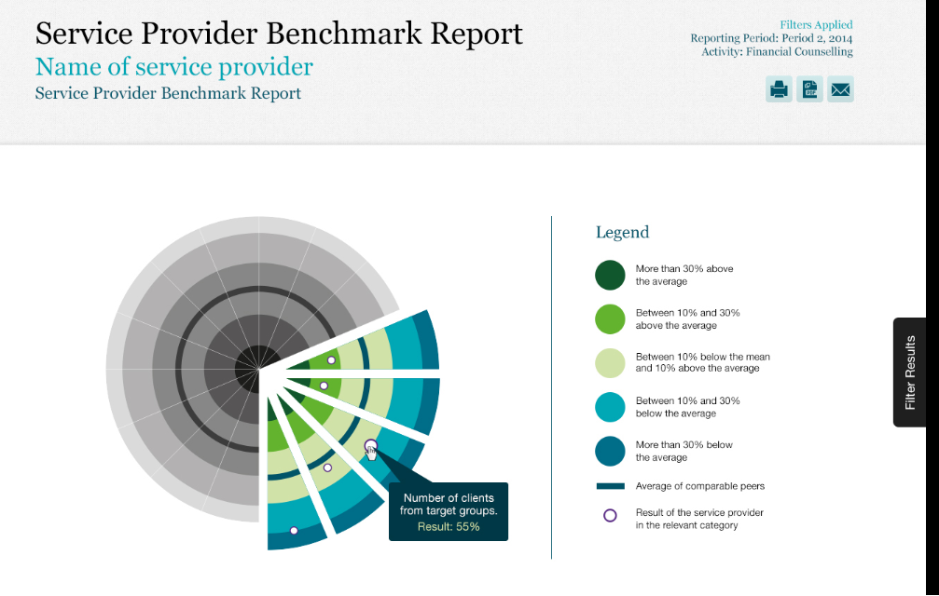

The partnership reporting suite will include a range of different reports that are intended to complement each other and ‘nudge’ service providers into exploring different aspects of the data.
For instance, the Benchmarking Report is intended to stimulate thinking and lead into viewing other self-service reports that examine related aspects of the data. Consequently, a service provider might look at the results for KPIs 4 and 5 in the Benchmark Report and then drill down into the detail of what type of outcomes are being achieved for clients by accessing the Outcomes Report. Alternatively, they may also wish to explore KPI 3 in more detail and seek to understand how trends of priority target groups accessing services compared to the population level demographics in their local community through the Community Profile Report. Finally, service providers may seek to understand how their collective benchmarking trends for all KPIs within their programme activity may differ when viewed from the perspective of each of their individual outlet locations using the Provider Outlet Benchmark Report.
Organisations will retain ownership of data for all self-service reports and be able to publish and distribute their self-service reports as they see fit. They can share their comparative data with other organisations in their comparison group, with peak bodies, and with other service providers if they wish.
The full mock-up designs of the Service Provider Benchmark Report are available at Appendix A.

Conclusion
The Data Exchange is intended to empower organisations with better information about what is happening ‘on the ground’; not just in their own service but in similar services operating in similar contexts.
Using benchmarking to measure and improve outcomes will involve cultural change within the Department and with our service providers in how we use programme performance data. As with the broader Data Exchange Framework the focus needs to be on what outcomes are being achieved, and how services respond to individual, family and community needs. Benchmarking provides a way for service providers and the Department to work together to improve the wellbeing of people and their families, as well as support them to achieve independence and participate in Australian society.

Glossary
Benchmarking | A process of comparing an organisation’s service delivery outcomes to those of organisations delivering a similar service in a similar context.
Comparative data | Data created from the benchmarking process.
Comparison groups | Groups of organisations delivering a ‘similar service in a similar context’
The Data Exchange Framework | The Department of Social Services’ new approach to programme performance reporting.
KPIs | Key Performance Indicators
Priority requirements | The small set of standard data items that all service providers must report as part of the Data Exchange.
Partnership approach | A voluntary arrangement in which a service provider can choose to report additional outcomes focused information in return for regular and relevant reports.
SCORE | Standard Client Outcomes Reporting – the outcomes measurement framework underpinning the Data Exchange.

Appendix A
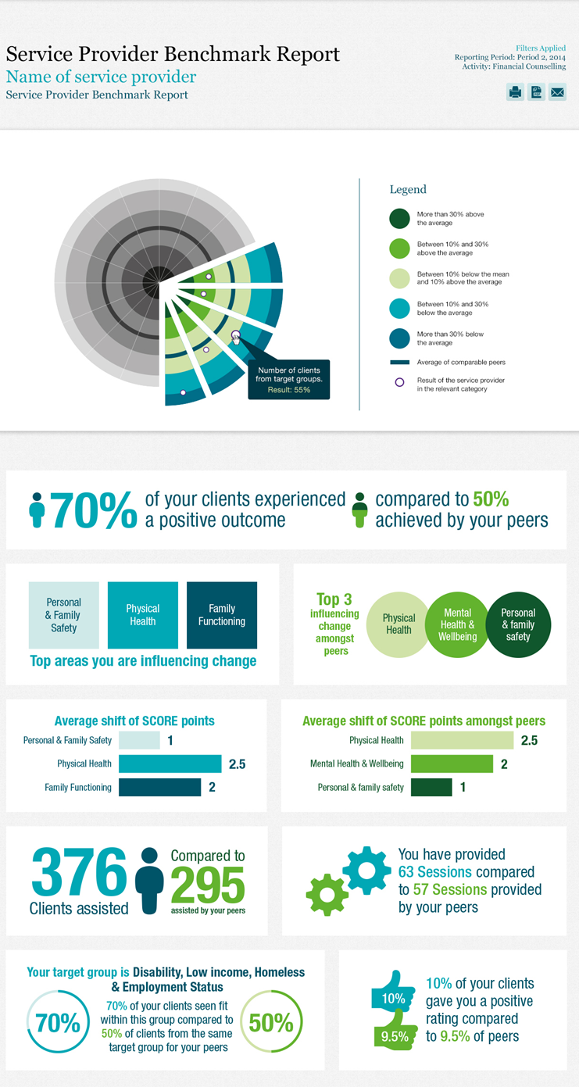
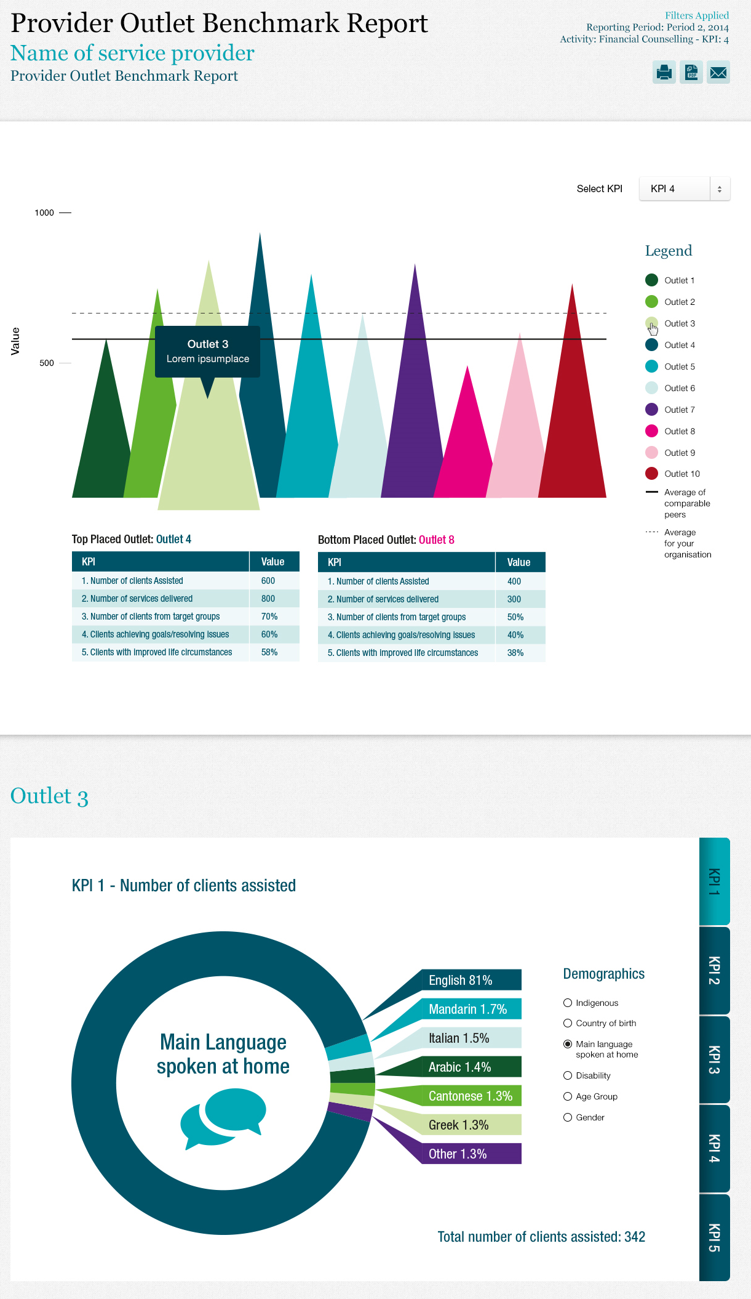

https://www.dss.gov.au...using-the-dss-data-exchange-web-based-portal/the-dss-data-exchange-framework-a-new-approach-for-streamlined-programme-performance-reporting
While the measurement constructs remain the same, the wording of these KPIs in grant agreements varies slightly to clearly align with the objectives of the programme activity being delivered. Organisations seeking to identify the exact wording of their KPIs should consult their grant agreement.
See for example Prasnikar, J et al. 2005, ‘Benchmarking as a Tool of Strategic Management’, Total Quality Management, vol 16, No. 2, pp. 257-275: Macneil, J et al. 1994, Benchmarking Australia: Linking Enterprises to World Best Practice, Longman Business & Professional, Melbourne.
See for example: Queensland Government, ‘Benchmarking your business’, www.business.qld.gov.au/...market-customer-research/benchmarking-business
An organisation may participate in the partnership approach by reporting outcome data using their own outcomes measurement processes and reporting the data in the format of the Data Exchange SCORE. If an organisation chooses to report only the priority requirements, SCORE information may be able to be sourced directly from clients using the Data Exchange client surveys.
Productivity Commission, 2010, Contribution of the Not-for-Profit Sector, pp. 103-108.

