Find and edit a session

Task card
This task card discusses the following:
- Information on updating sessions
- Find a Session
  - Method 1 – From the Go to field
  - Method 2 – From the Find Case button
- Results section
- Edit a Session

KEY HIGHLIGHTS
- At least one session must be recorded during a reporting period for the session and associated clients to be counted in reports.
- A session can be updated any time only during the relevant reporting period.
- The use of special characters such as * & % # @ should not be included in the free text fields as they are used as search functions in the Data Exchange.

Information on updating sessions
A session records what service was delivered on a particular date within a reporting period, the type of service delivered and which clients attended. Sessions are a critical part of the service record of a service provider and drive the reporting function of the Data Exchange.

At least one session must be recorded as occurring within a reporting period for the session and associated clients to be counted in reports.

Find a session
There are a number of ways to find an existing session. Refer Figure 1.
Go to the Data Exchange home page and either:
- Enter information in the Go to field
- Select the Find Case action tile
Figure 1 - Data Exchange home page
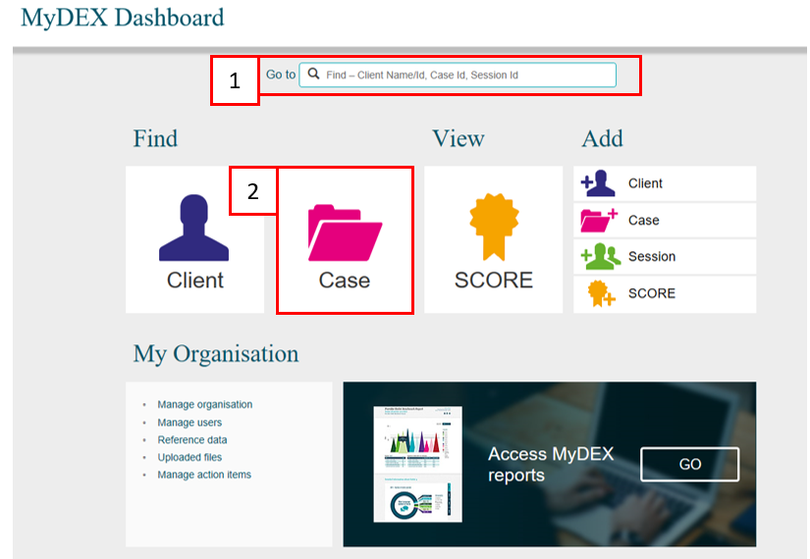

Method 1 – From the Go to field
Start typing the session ID (this could be numerical or alphabetical) in the Go to field
The field will provide a drop down list to select the required session. Refer Figure 2.
Figure 2 – Data Exchange home page - Go to field
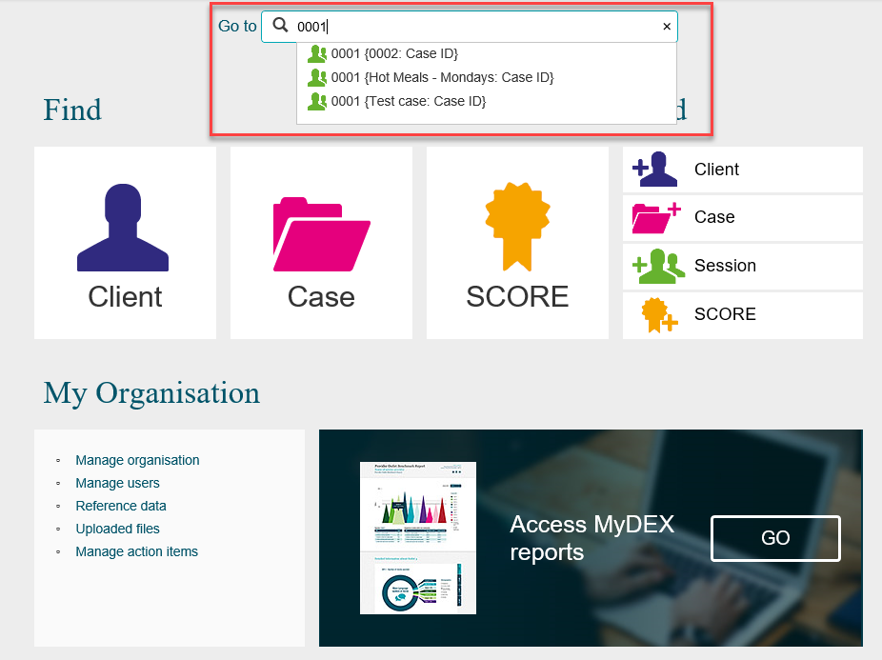

The Session details screen will display. Refer Figure 3.
Figure 3 – Session details screen
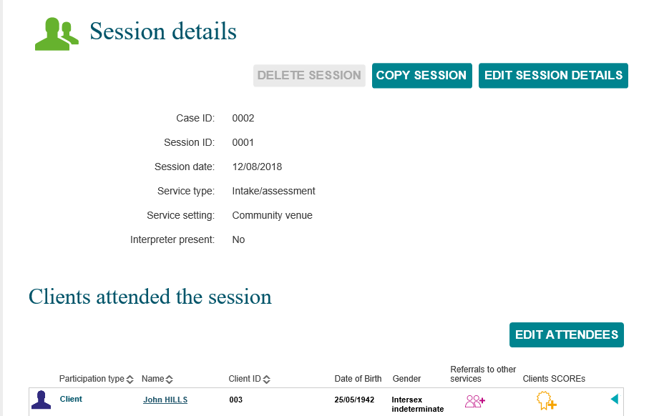

Refer to the Edit a session details in this task card for further instructions.

Method 2 – from the Find a Case button
The Find a case screen will display. Refer Figure 4.
Find your session by selecting the corresponding case
Figure 4 – Find a case screen
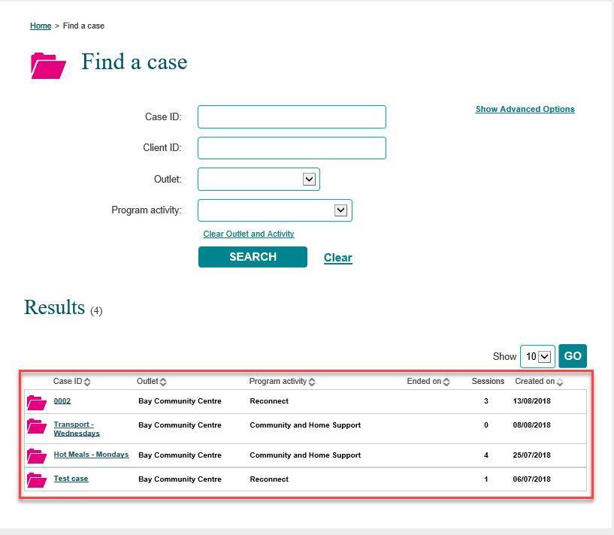

Results section
The most recently created cases will display in the Results section. Refer Figure 5.
- Select GO to change the amount of records displayed on the screen. The options are 10, 20 and 50.
- Click on the heading hyperlinks of Case ID, Outlet, etc. to filter columns from ascending to descending order and visa-versa either alphabetically or numerically.
- Click on the case hyperlink to select the case.
Figure 5 – Results section
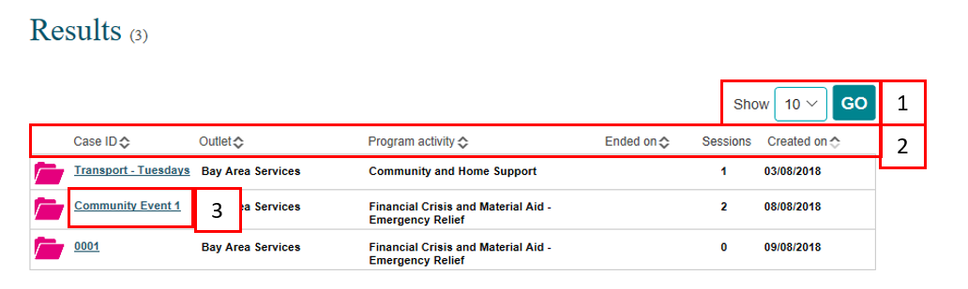

Select the relevant case hyperlink and the Case details screen will display. Refer Figure 6.
Figure 6 – Case details screen
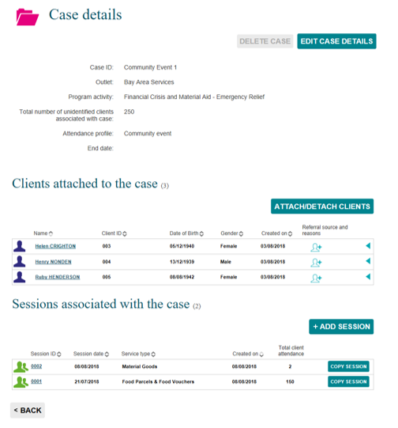

Select the relevant session hyperlink and session details will display. Refer Figure 7.
Figure 7 – Session screen
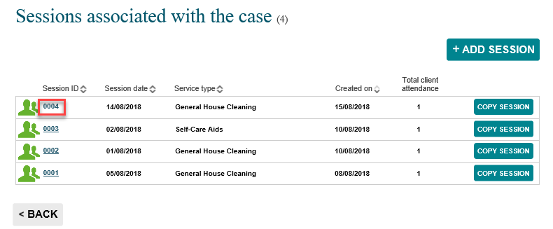

Refer to the Edit a session details in this task card for further instructions.

Edit a session
There are a number of ways to edit an existing session. Refer Figure 8.
- Delete a session
NOTE: you can only delete a session that is in the current reporting period.
- Copy a session
- Edit a session
NOTE: The use of Special characters such as * & % # @ should not be included in the free text fields as they are used as search functions in the Data Exchange.
- Edit Attendees

Figure 8 – Session details screen
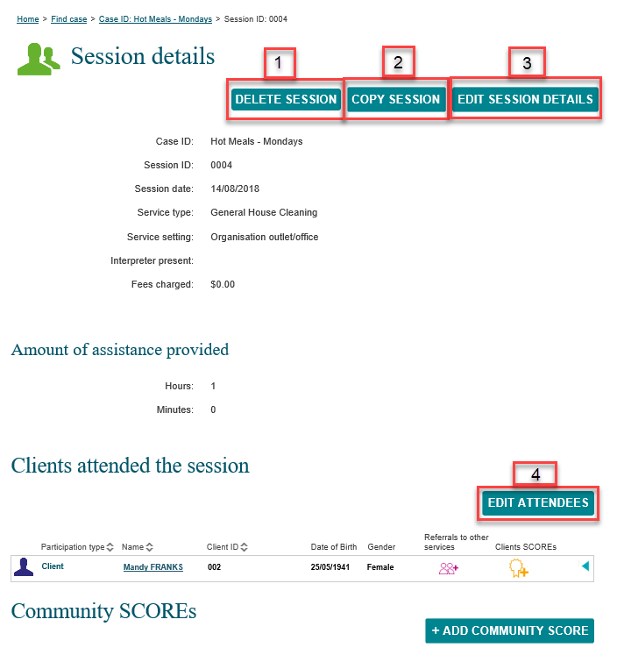

More information on outlets, clients, cases and sessions can be found in the Data Exchange Protocols and the Training resources tab.
For technical support; contact the Data Exchange Helpdesk by email dssdataexchange.helpdesk@dss.gov.au or on 1800 020 283 between 08.30am - 5.30pm (AEST/AEDT) Monday to Friday.

