Navigation guide

This task card explains the following:
- Data Exchange home page
- Navigation within the different screens
- Buttons and icons

Data Exchange home page

The home page of the Data Exchange web-based portal has a number of separate action tiles. Refer Figure 1.
- Go to – search for clients, cases and sessions
- Find action tile – clients and cases
- View action tile – SCORE assessments
- Add action tiles – clients, cases, sessions and SCORE assessments
- My Organisation – access for Data Exchange Organisation administrators only
- Access MyDEX reports – access self-service report functionality for data entered by your organisation

To access any of these areas, select either the action tile or hyperlink. To search in the Go to field, simply start typing.

Figure 1- Data Exchange home page
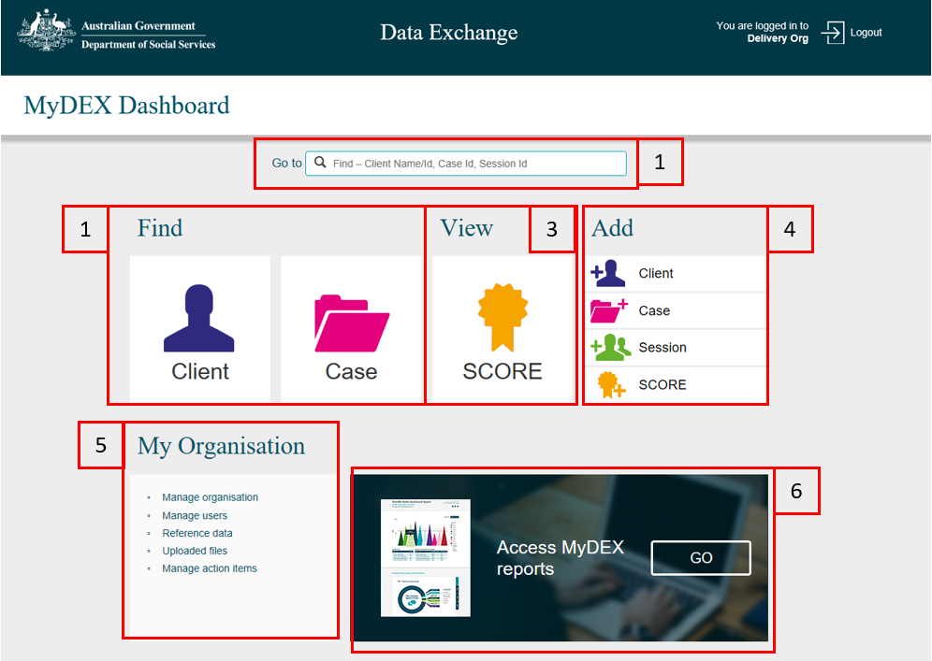

Navigation within the different screens
When you open a record (case, client, session or SCORE) the "I want to..." box will display on most pages on the right hand side. Refer Figure 2.
Links in this box are shortcuts to view or update records. There are also administrative functions that are only available to those with Data Exchange Organisation administrator access.

Figure 2 – “I want to…” box
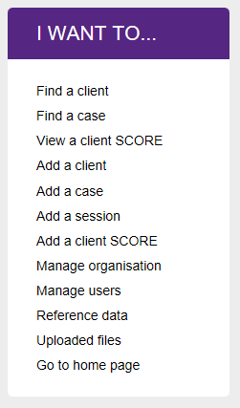

Buttons and icons
There are a number of buttons and icons used throughout the web-based portal. Table 1 provides a listing of the common button and icons. Please note this listing is not exhaustive.
Table 1 - Data Exchange web-based portal buttons and icons
IMAGE | DESCRIPTION
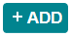 | Displays at the Tags field in the Add a client – Client details page. Select to add tags to the client record.
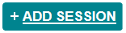 | Displays at the completed Case details screen. Select to add sessions to the case.
Displays when you have completed data entry on a session or case.
When you select the clients you wish to add, select the Attach button to add them to the session or case.
Displays when you have entered data and moved to a new data entry screen.
Select the Back button when you need to go back and correct data entered before the record is submitted.
The calendar function can be used when entering dates in any field, or you can type them.
- Select the calendar function icon.
- Use the arrows to move back and forward through the months.
- Select the relevant date – the field will be populated with that date.
 | The Case icon displays to identify a case has been created.
 | Select the Add a case icon at the home page to create a new case record.
 | The Client icon displays to identify a client has been created.
 | Select the Add a client icon at the home page to create a new client record.
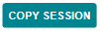 | Displays at the completed Case details screen. Select to copy an existing session(s) to the case.
Displays when you view a client, case or session record.
- If you create a record in error use the Delete button to remove the record.
- You must remove SCORE assessments before deleting sessions, and sessions before deleting cases. Any data for a previous reporting period cannot be deleted.
 | The Delete icon displays on a client record when you select to edit a referral or SCORE for a session.
The drop down box allows you to select information that has been pre-loaded.
- Select the down arrow to display the list.
- If the list is long you can scroll down to find the information, or type the first few letters of the word and select Enter.
Displays when you open a case, client or session record.
- Select the Edit button to make changes to a record.
- You may edit a record at any time within a reporting period.
 | Select on the edit icon to make changes to that record.
The Expand icon displays on all types of record lists (e.g.: client, case, outlet) to view more details on that record.
Select the expand icon to view a summary of data entered for a record.
 | The Error message icon displays when required information is missing from a page.
hyperlinks | Hyperlinks are used in many places on the Data Exchange web-based portal. Hyperlinked text is blue and underlined. When selected, hyperlinks will open extra fields, a record or perform a task.
 | The Information icon will display to advise information or tip for the client, case or session page.
Displays when you are viewing a record.
Select More to open up the record to display more detailed information.
Displays when you have completed a data entry step.
Select Next to go to the next step in a process.
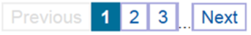 | If a record list (clients, cases, sessions, activities, users etc.) goes over more than one page you can move through the pages by using the paging/pagination function.  - The total number of records is shown next to Results at the top of the list.  - Select Next to go to the next page or select a page number to go to that page.
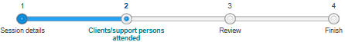 | The Progress Bar displays at the top of data entry screens. It shows the steps completed in the data entry process, and how many steps are needed to complete an action.
 | The Referral source and reasons ‘outline’ icon displays a client's record summary attached to a case. You can use this icon to add, delete or edit referrals to other services for a client.
 | The Referral source and reasons ‘coloured’ icon displays when the full quota of referrals has been added to a client's record summary attached to a case.
 | The Referral to other services ‘outline’ icon displays on a client's record summary attached to a session. You can use this icon to add, delete or edit referrals to other services for a client.
 | The Referral to other services ‘coloured’ icon displays when a referral has been added to a client's record summary attached to a session. One internal and one external referral type can be added per client per session.
 | The Referral to other services ‘tick’ icon displays when the full quota of referrals has been added to a client's record summary attached to a session.
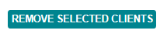 | Displays when clients have been added to a case or session.  Select Remove selected clients to detach clients that have been added to session or a case.
 | Select Save to keep changes that you have made to records.
 | The SCORE ‘outline’ icon displays on a client record summary attached to a session. You can use this icon to add, delete or edit SCORE assessment types (Goal, Circumstance or Satisfaction) for a client resulting from a session.
 | This SCORE ‘coloured’ icon displays when one SCORE assessment has been added to a client record at a session and another SCORE assessment can be added.
 | This SCORE ‘tick’ icon displays when the full quota of SCORE assessments have been added to a client record at a session.
 | This SCORE icon displays on a client record advising a SCORE assessment has been added to the client. Displays in the Find a client screen.
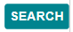 | Select the Search button after entering the search criteria.
 | The Search icon is found in the ‘Go to’ field and is used to search for client, case and session records.
 | The Session icon displays to identify a session has been created.
 | Select the Add a session icon found at the home page to create a new session record.
 | The Successfully added icon will display to highlight the creation of a case, client or session has been successful.
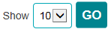 | Show Pages allows you to choose how many records you wish to display on any page.  - Go to the show box at the top right of any list.  - Select via the drop down box the number of records to show on a page.  - Select GO to change the view.
View a list of records in descending or ascending order by selecting the Sort icon.
Records are defaulted to show the most recently created record at the top.
Displays once you have completed data entry steps required to complete a case, session or client record.
Select Submit once you have reviewed and checked data you have entered.
A tick box is used to select a record to attach it to a case, session, outlet or user.
- Check the box to select the record.
- Select the Attach button to complete the attachment.
 | The Warning icon will display to highlight a possible issue with the record.

More information on outlets, clients, cases and sessions can be found in the Data Exchange Protocols and the Training tab.
For technical support; contact the Data Exchange Helpdesk by email dssdataexchange.helpdesk@dss.gov.au or on 1800 020 283 between 08.30am - 5.30pm (AEST/AEDT) Monday to Friday.

