Exploration Menu

Introduction
In all of the reports, there are a number of functions which can change how the reports look. This can be useful when building a story or to help make analysing data easier. These changes can be applied to any visualisation in Qlik including graphs, charts and tables.

Step | Action

Opening Exploration options
Right click on the visualisation that you want to change. A number of options will appear.
The appearance of a visualisation can be edited to improve design and enhance understanding. Open the Exploration screen from the visualisation you want to change.
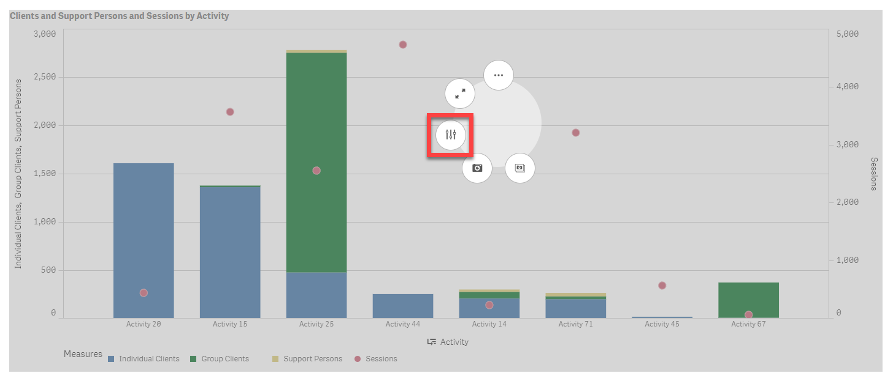
The visualisation will expand and a menu will appear on the right side of the screen. At the top, the data fields that relate to this visualisation will be listed (outlined in red).
At the bottom of the menu are the actions you can perform (outlined in gold).
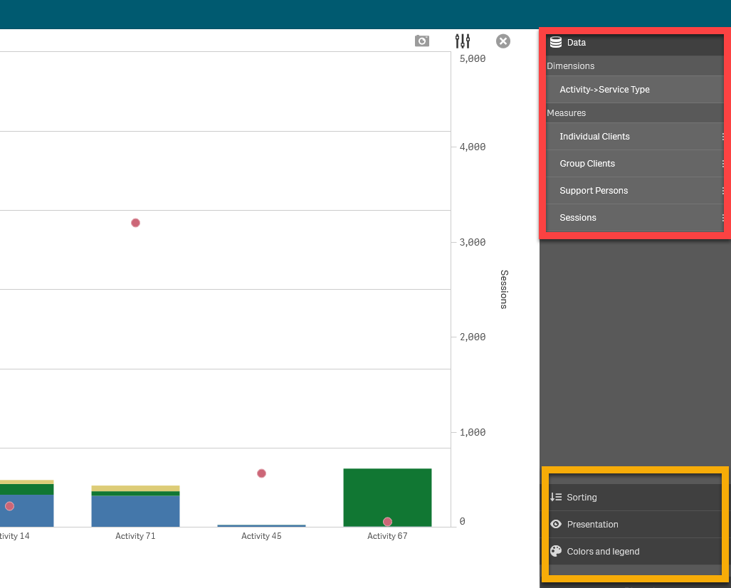
These options provide a number of ways to adjust the appearance of the visualisations.
Sorting: Allows you to sort the data in different ways.
Select the field/s that you want to move and drag up or down. This will change the visualisation to the new order.

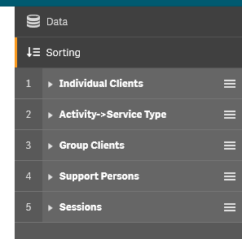
Presentation: Different visualisations have different options that can be adjusted to enhance the display of data.
For example, you can set bars in a bar chart to display as grouped or stacked, as well as vertically or horizontally.
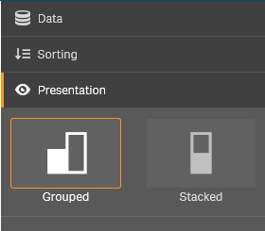
Colours and legend: Colouring is one of the best ways to highlight values in your visualisations. Qlik Sense provides a range of different colouring options.
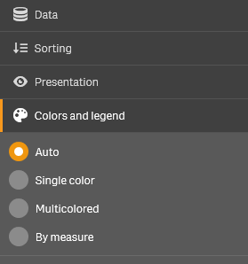
For example, if you select the “By measure” option, a variety of colour options are available.
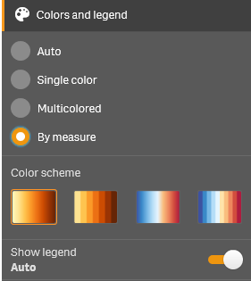
In the example below, we have changed the presentation style to “Grouped” and the Colours and Legend to “Multi-coloured”.
 | To return to the main report sheet, select the small X in the top right corner of the visualisation. To return to the original layout, select the Discard button in the bottom right corner. 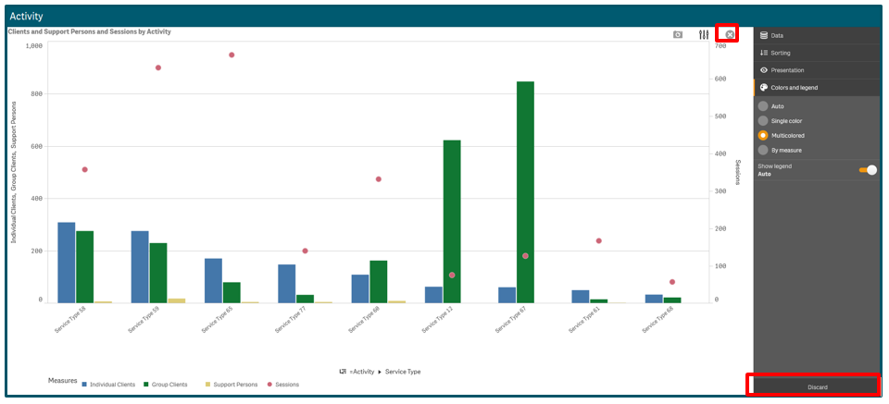
 | Note: Any changes made will only apply to the current session. Once you leave the report, the default settings will be applied next time you return to the report.

Supported browsers
In order to access the Data Exchange reports your computer needs to meet certain requirements. Select this link to view the list of supported browsers.

More information on reporting requirements are available in the Data Exchange Protocols.
Task Cards on reports functionality are available in the Training tab of the Data Exchange website.
For technical support, email dssdataexchange.helpdesk@dss.gov.au or call 1800 020 283 (option 3).
The Helpdesk is available between 8.30am - 5.30pm (AEST/AEDT) Monday to Friday.

