Add a Bookmark
The Data Exchange reports allow you to add Bookmarks to save your filters and selections for later use. Bookmarks can be created for reports you access on a regular basis. This task card describes the process of adding a Bookmark.
Bookmarks are saved against individual reports. For example, if a bookmark is created in the Organisation Overview report it can only be accessed in that report.
Step | Action
Creating a bookmark
Open a report and select the desired sheet. Make your selections by adding the filters you require.
Refer to the Applying Filters task card for further information on how to apply a filter.
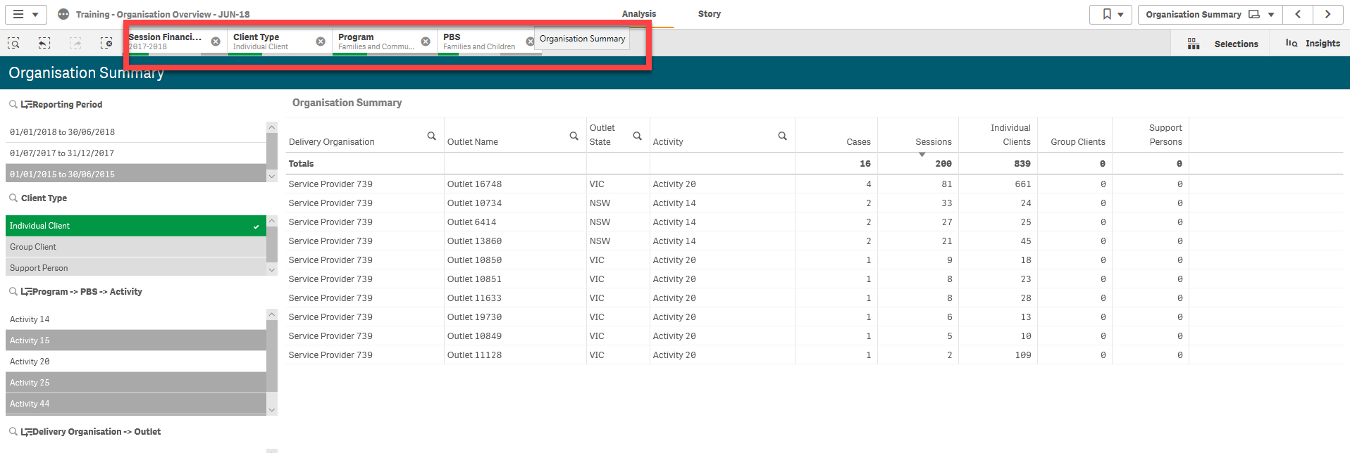
Select the bookmark icon located in the top right hand corner.
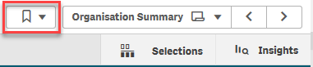
Click ‘Create new bookmark’.
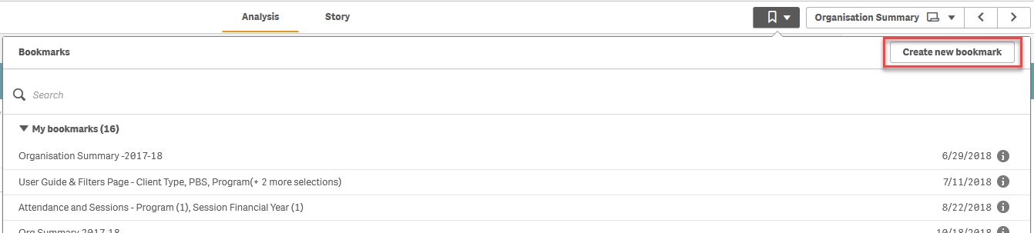
Enter a Title and Description of the bookmark.
To save the bookmark click the green tick icon.
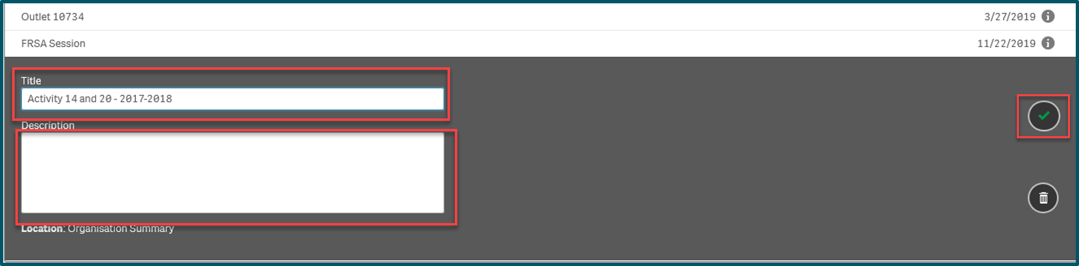
Accessing a bookmark
Navigate to the report where the bookmark was saved. Click on the Bookmarks icon underneath the report information.
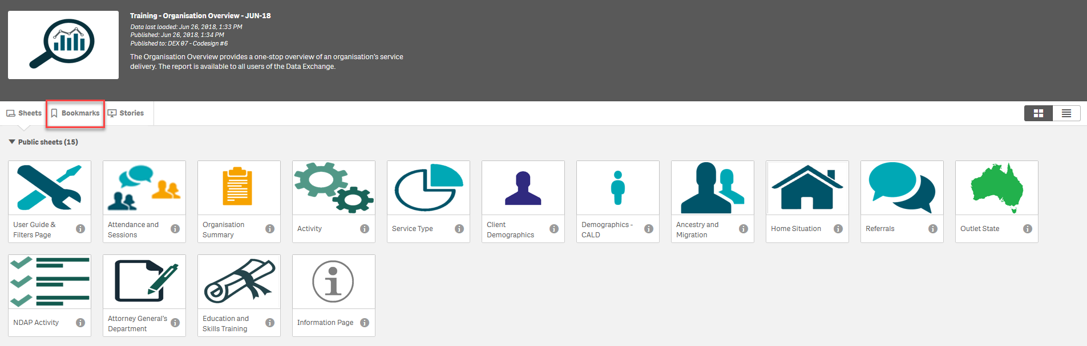
Your bookmarks will display under the My Bookmarks heading. Click on the bookmark you require.
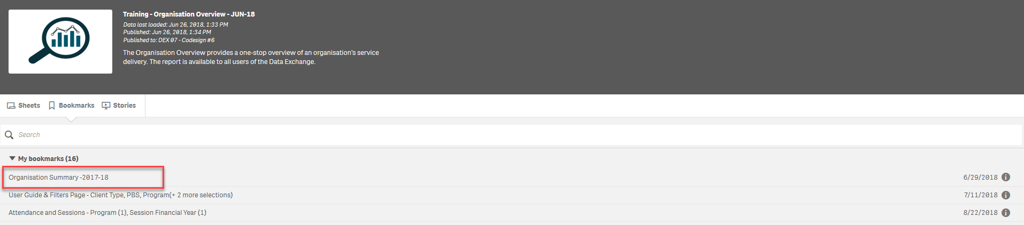

More information on reporting requirements are available in the Data Exchange Protocols.
Task Cards on reports functionality are available in the Training tab of the Data Exchange website.
For technical support, email dssdataexchange.helpdesk@dss.gov.au or call 1800 020 283 (option 3).
The Helpdesk is available between 8.30am - 5.30pm (AEST/AEDT) Monday to Friday.

