System Re-opening Request form

Task card

For Organisations
Step | Action
On the Data exchange home page, select the IT access and portal support dropdown arrow.
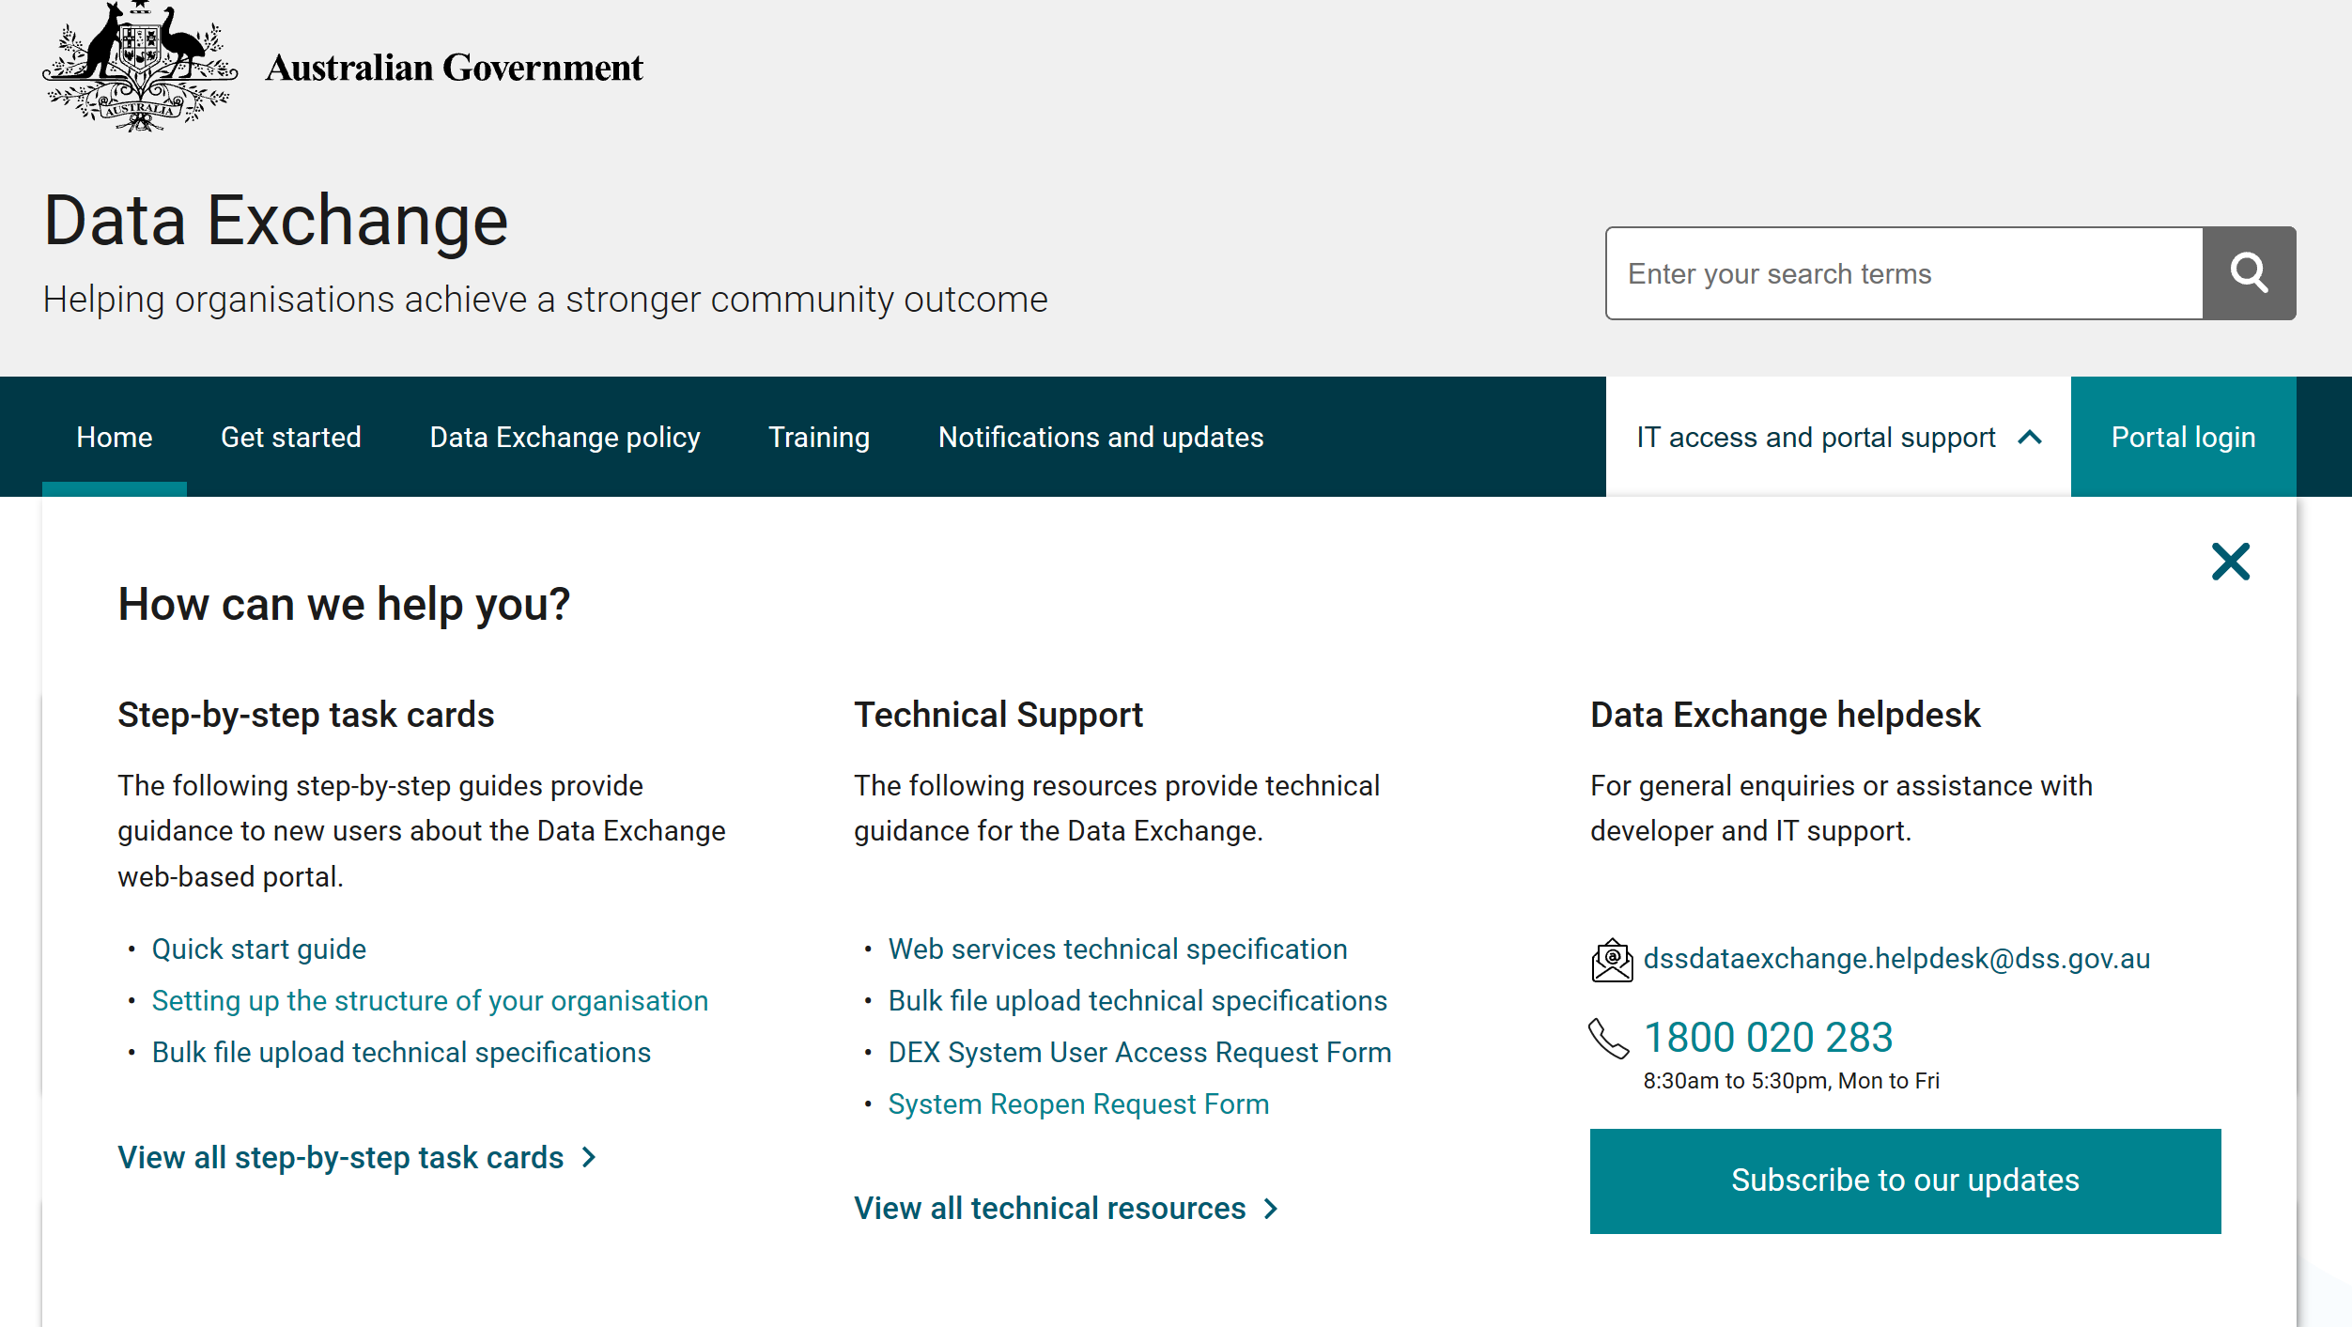
 | Select System reopen request form option
A new window will appear.
- For new requests select Complete Form.
- To open a saved form select Open Saved Form
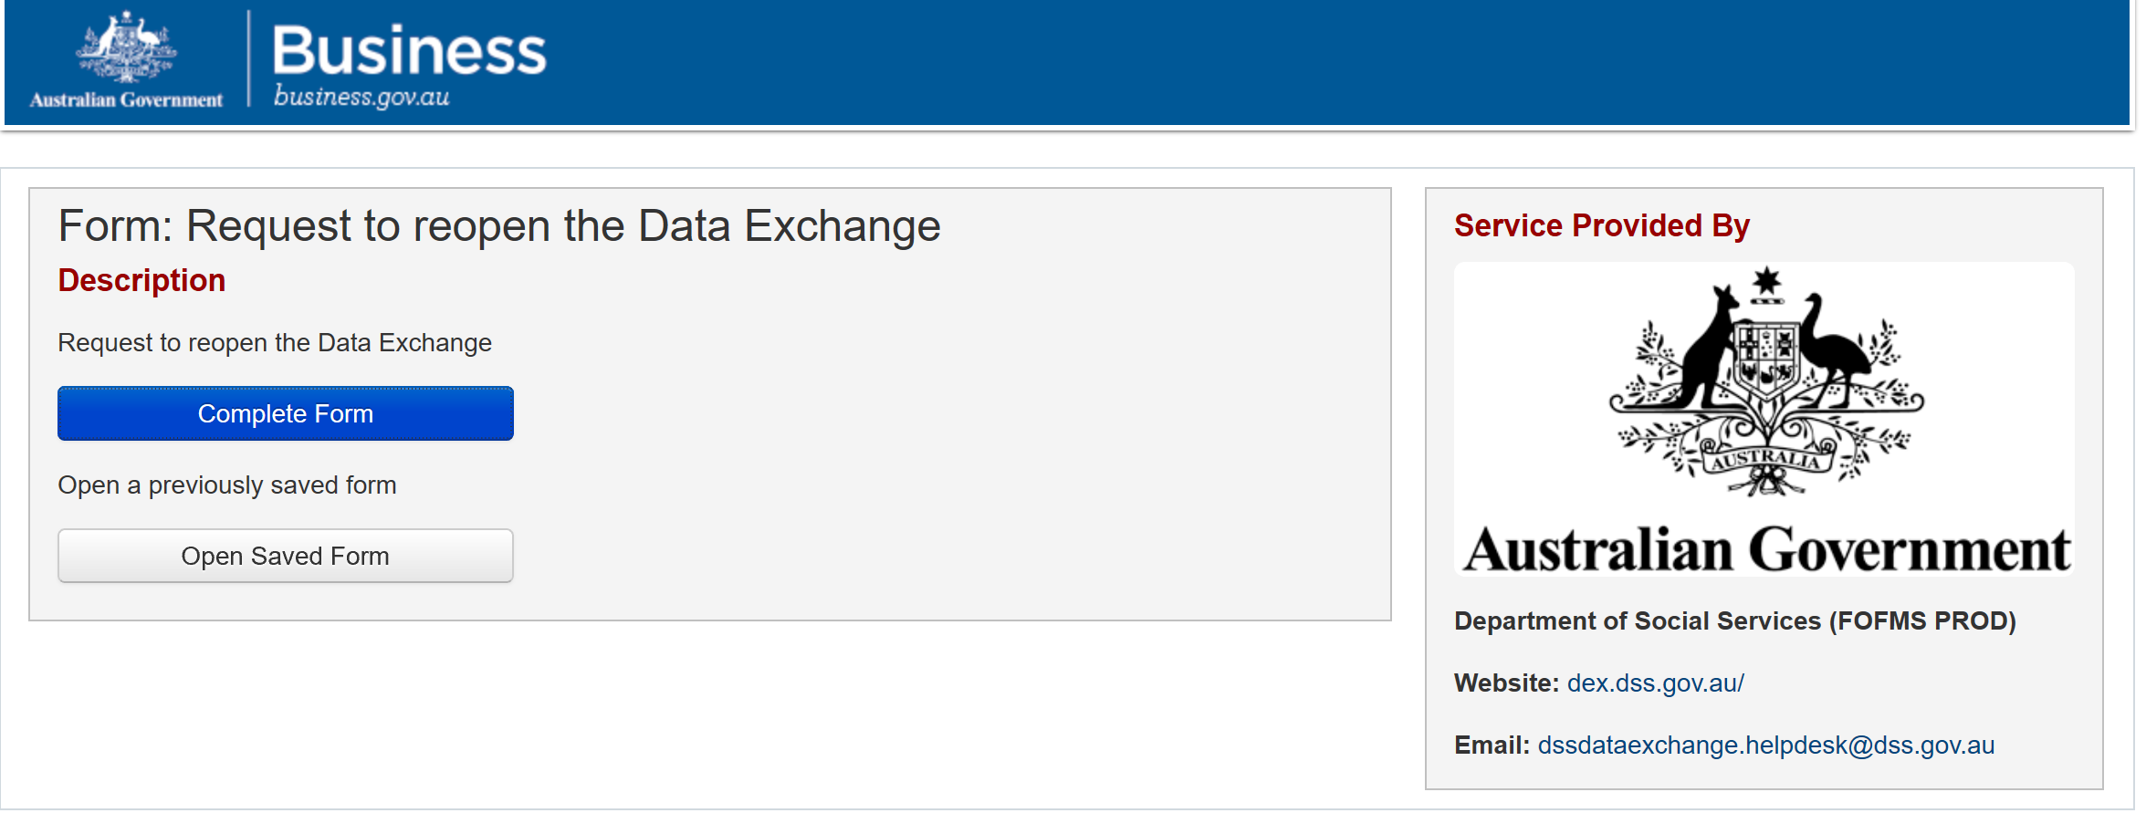
2.
1.
Opening a saved form
You will be asked to enter your Tracking Code and Access Code to open an existing form.
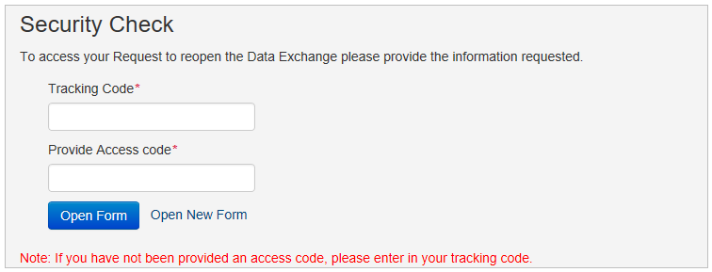
The Request to reopen the Data Exchange form will appear.
Please Note:
- The reasons that are not considered ‘exceptional circumstances’.
- Delivery and community partners will need to complete their own extension requests.
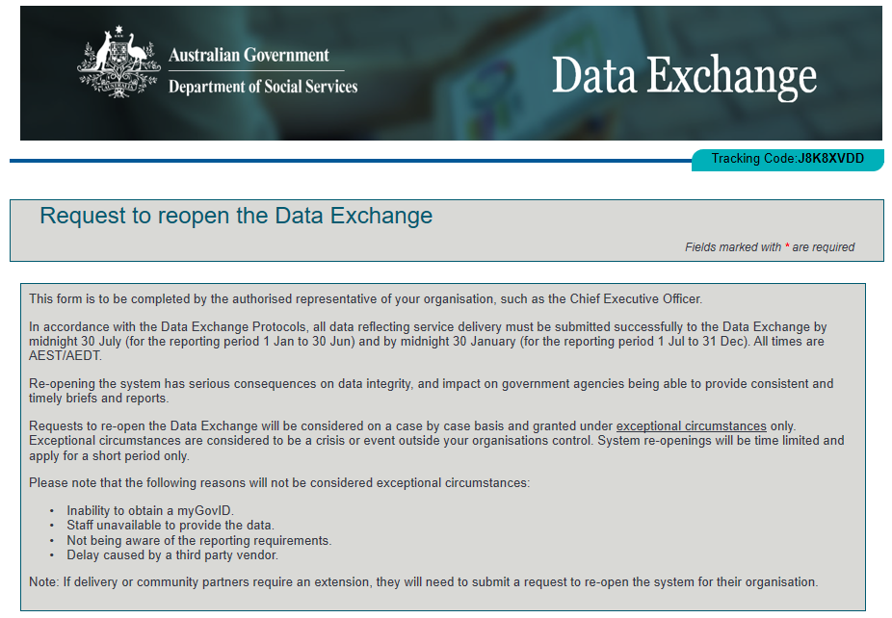
Complete all fields marked with a red asterisk throughout the form.

Organisation legal name and Organisation ID can be the found in the MyDEX Dashboard under Administration/ Manage Organisation under Source Organisation Name and Source Organisation ID.
6 | Answer the questions –  - Select No if this is the first reporting period in the Data Exchange for the program requiring the extension.  - Selecting Yes will ask if you have requested an extension for a previous period.  Then select the program activities you are seeking an extension for - use the button to move activities to the ‘chosen activities box’. If you make a mistake please use the button. You cannot exceed more than 15 activities.
7 | Submitting your data: Click the drop down arrow to select your method for submitting data.  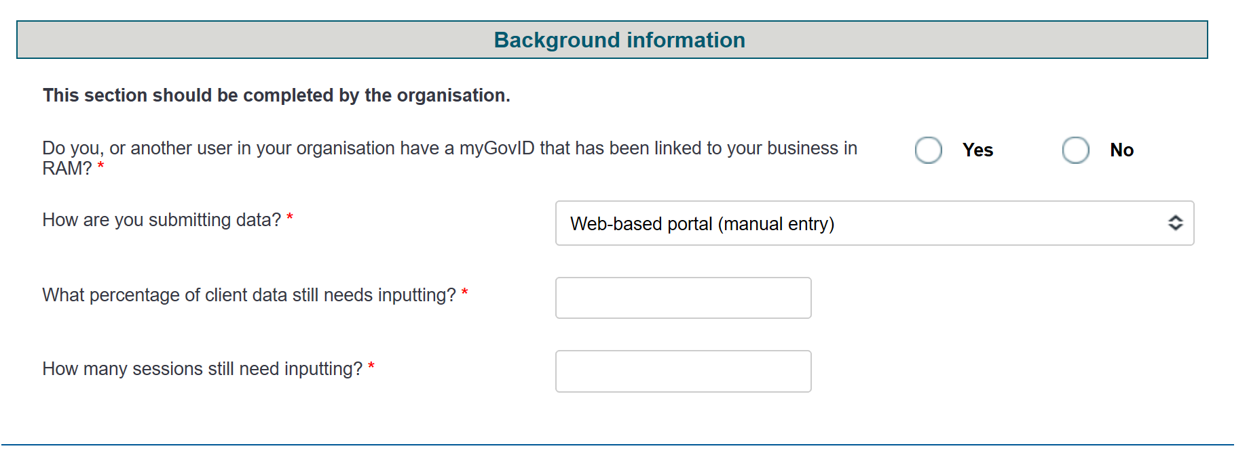  If you select System to system or Bulk XML additional Yes/No questions will appear for you to answer.  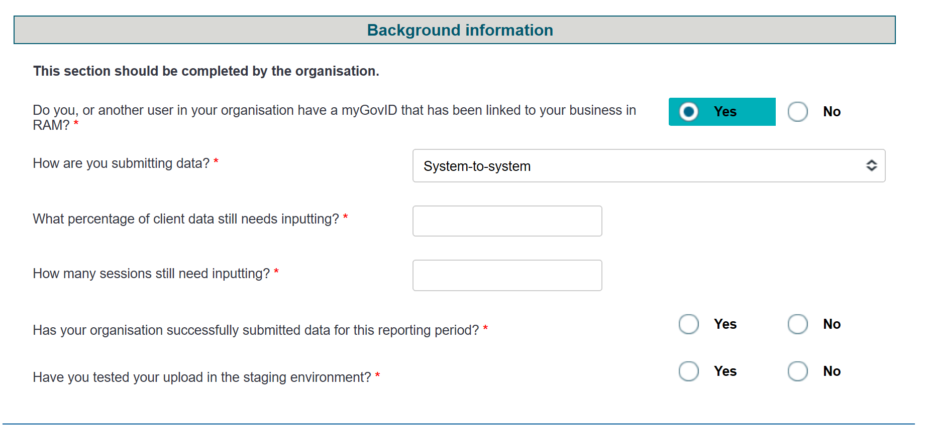
8 | Adding a reason for the request  - Click the drop down to select a reason from the list provided. Below is a text box to provide further details.  - Attach supporting documentation if you wish to do so. Attachments must not include identifiable client information. Select the Click to Upload button  - Select todays date from the calendar icon.  - Please ensure the Funding Arrangement Manager email address ends with @dss.gov.au  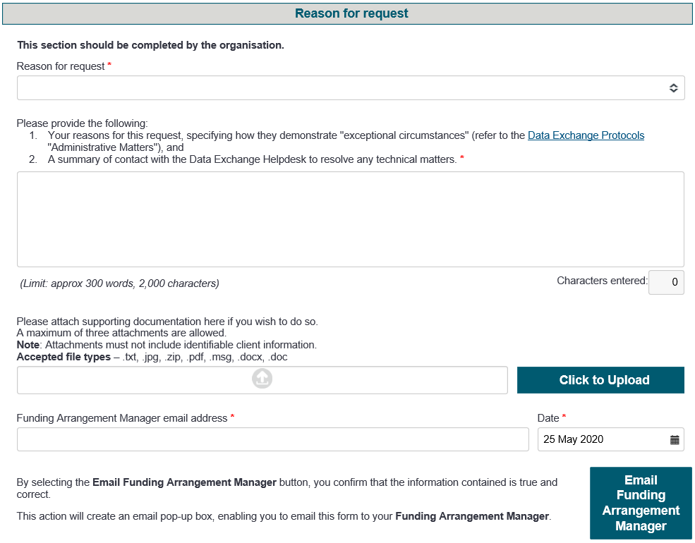

More information on the Data Exchange can be found in the Data Exchange Protocols and the Training Resources tab.
For technical support; contact the Data Exchange Helpdesk by email dssdataexchange.helpdesk@dss.gov.au or on 1800 020 283 between 08.30am - 5.30pm (AEST/AEDT) Monday to Friday.

